2022 VCE Mathematical Methods 2 external assessment report

General comments
There were some excellent responses to many questions. The following information will be helpful to remember when doing examinations.
Students should make good use of their reading time.
If a pencil is used, make sure it is a HB or darker pencil as the papers are scanned. Some light-coloured pens do not scan properly either.
Students need to read questions again after answering to make sure they are providing answers for all the required parts of the question. Many students did not give the domain as well as the rule in Question 4d., and the standard deviation as well as the expected value in Question 3aiv.
Appropriate working must be shown for questions worth more than one mark, as indicated in the instructions for Section B. Often this is the equation that is being solved as well as the answer. Some students gave answers only in Question 1dii., Question 2g., Question 3bii., Question 4bi. and Question 5e.
Students should be careful with their handwriting. In some cases, 1s looked like 2s and 4s looked like 9s. In Question 4, sometimes appeared as . and $x$ often looked similar.
Horizontal vinculums should be used for fractions. 1|32 is not a fraction. is not the same as .
Be careful with questions that move between exact and approximate answers. In Questions 4ai., 4aii. and 4aiv., exact answers were required, whereas Question 4aii. required an approximate answer. This often occurred in the probability question.
For questions that ask for an equation, make sure an equation is given, not just an expression. Equations were required in Questions 1a., 1c., 1di. and 5c.
Students need to practise ‘show that’ questions. There were three in this paper: Questions 2b., 4c. and 5b. Make sure adequate working is shown, the work is clearly set out and a conclusion is drawn.
Students must take care to distinguish between the average rate of change of a function and the average value of a function. Students often get the two concepts mixed up. Questions 2e. and 5d. were average value questions and Question 2f. was an average rate of change question.
Some students rounded incorrectly or did not have the float on their technology set to an adequate number of decimal places. In Question 2c. some students gave 5340 as their answer when 5339.46… correct to the nearest whole number is 5339. In Question 3ai. some students gave 0.0313 as their answer when the exact answer was 0.03125.
There were a number of transcription errors. Students need to check what they are transcribing from their technology. Transcription errors occurred in Question 1e. In Question 3ai., 0.3125 instead of 0.03125 was occasionally seen.
Finding the domains of functions remains a weakness, especially logarithmic functions, like the one in Question 13 of the multiple-choice section, and strictly increasing functions, such as in Question 4bii.
Students should revise concepts like finding the equation of the axis of symmetry (Question 1a.), finding the maximal domain over which a function is strictly increasing (Question 4bii.) and stating the value of a definite integral (Question 3bi.). Finding the using the binomial distribution was not answered well in Question 3aiii.
Some students did not use their technology efficiently. In Question 3cii., students were substituting into the rule for the confidence interval when they could obtain the answer directly from their technology as it was only a one-mark question. In Questions 1c., 1di. and 1e., the tangent and perpendicular lines could similarly be found directly on their technology. There is no need to show the by-hand steps. The answers to Question 4e. could easily be found by using a slider. In Question 2f. some students found the average value between the first minimum and the first maximum point because they solved the derivative equal to zero without checking where the first two maximum points occurred. Sketching a graph or using the fmax function on their technology would have been a more effective approach.
Students should provide answers specific to the context of the question. In Question 2aii. the minimum and maximum population of rabbits was asked for, not the coordinates of the turning point. In Question 2g., the time was required, not the number of rabbits.

Specific information
Note: This report provides sample answers or an indication of what answers may have included. Unless otherwise stated, these are not intended to be exemplary or complete responses.
The statistics in this report may be subject to rounding, resulting in a total of more or less than 100 per cent.

Section A – Multiple-choice questions
The table indicates the percentage of students who chose each option. Grey shading indicates the correct response.
Question | Correct answer | % A | % B | % C | % D | % E | % N/A | Comments
1 | B | 4 | 91 | 2 | 2 | 1 | 0
2 | A | 78 | 2 | 2 | 0 | 18 | 0
3 | E | 4 | 4 | 15 | 3 | 73 | 0
4 | D | 9 | 4 | 7 | 68 | 11 | 0
5 | C | 10 | 5 | 74 | 5 | 6 | 0
6 | C | 3 | 20 | 47 | 14 | 16 | 0 | The inverse of is , not .  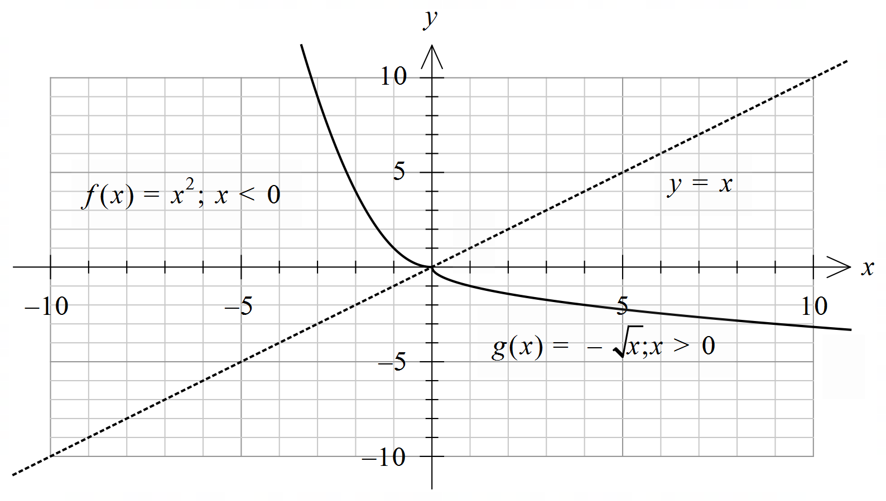
7 | E | 7 | 8 | 10 | 3 | 73 | 0
8 | E | 10 | 3 | 3 | 5 | 78 | 0
9 | D | 7 | 13 | 23 | 50 | 7 | 0
10 | D | 3 | 6 | 10 | 78 | 4 | 0
11 | C | 11 | 9 | 66 | 7 | 5 | 0
12 | A | 52 | 24 | 6 | 15 | 3 | 1
13 | C | 3 | 15 | 39 | 40 | 3 | 0 | ,  For the maximal domain solve for x .  The maximal domain is .
14 | B | 10 | 75 | 7 | 5 | 2 | 1
15 | E | 2 | 5 | 3 | 2 | 88 | 0
16 | B | 11 | 59 | 14 | 11 | 4 | 1
17 | A | 39 | 25 | 16 | 11 | 8 | 1 | ,  at  g is a many-to-one function.  An example is shown below using .  Let a = 1 and b = 3. The average rate of change is 0.5.  The gradient at x = 2 is negative.  So, g is a many-to-one function.  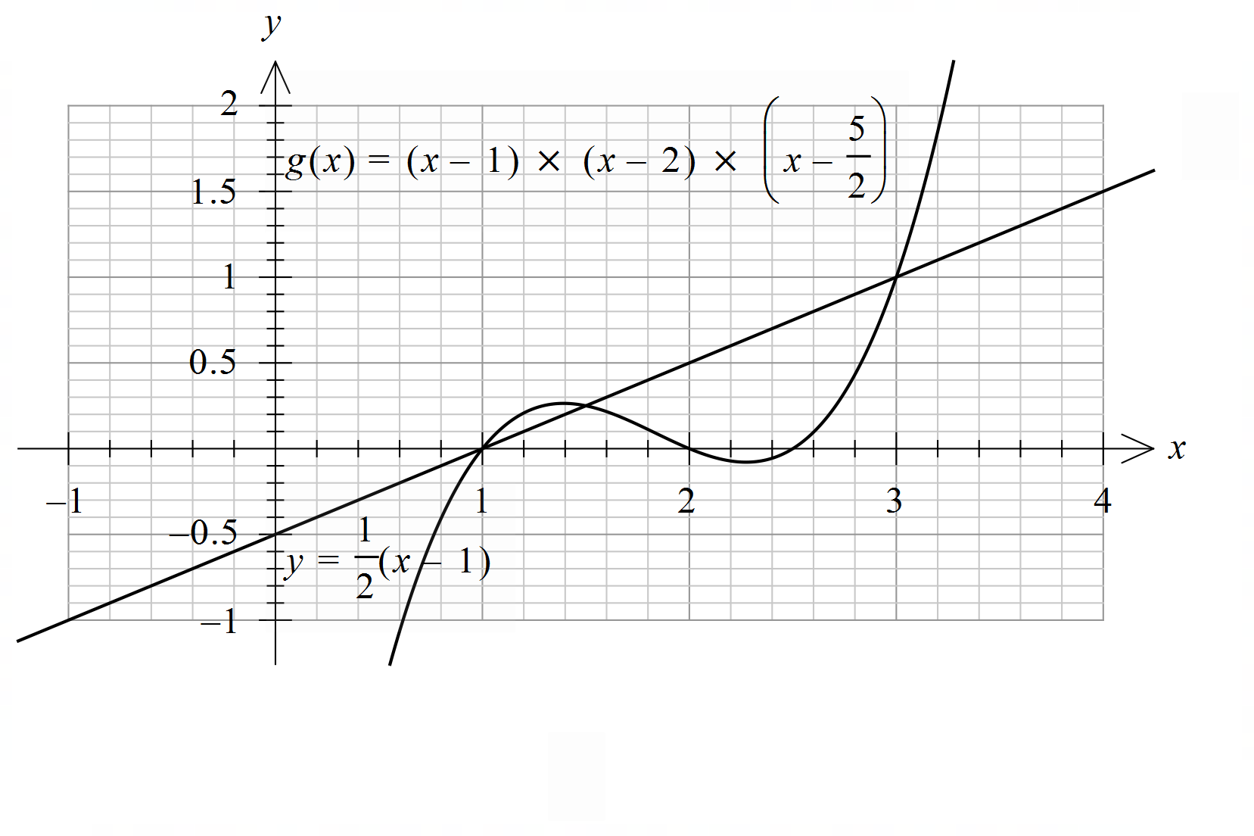
18 | B | 18 | 47 | 14 | 12 | 8 | 1 | As a < 16 in the options  .
19 | D | 8 | 34 | 13 | 34 | 9 | 1 | Solve for .  The maximum occurs at the smaller value.  An example is shown below for a general cubic function using and .  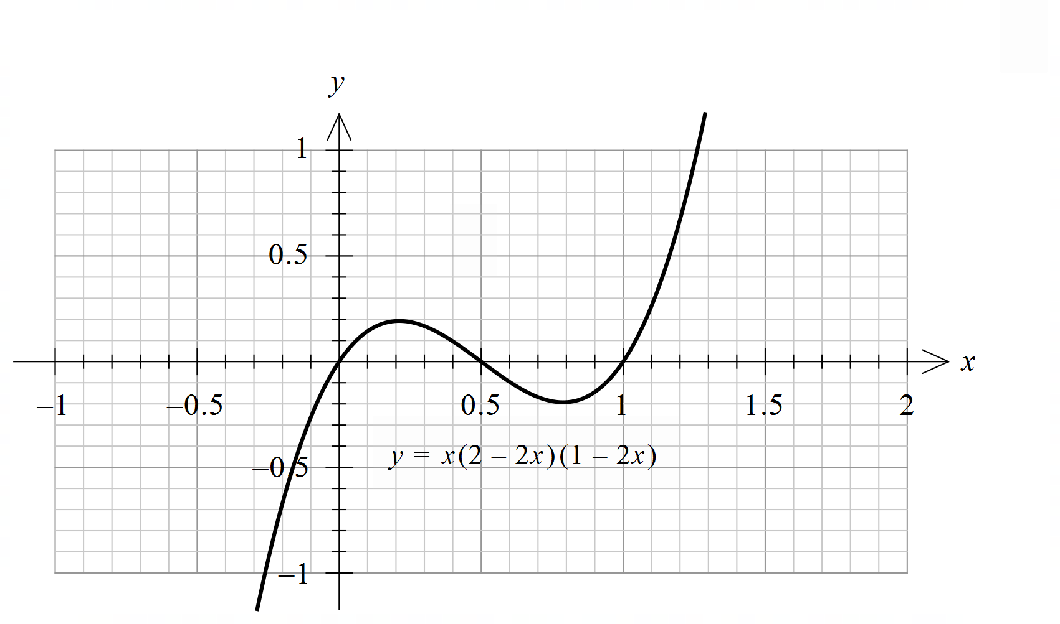
20 | A | 30 | 24 | 25 | 13 | 8 | 1 | Solve for or sketch the graphs.  correct to three decimal places

Section B

Question 1a.
Marks | 0 | 1 | Average
% | 31 | 69 | 0.7
This question only required students to find the axis of symmetry of the graph of a quadratic function, but it was not answered well. An equation was required. The most common errors were , 0, (0, 0), y-axis and .

Question 1b.
Marks | 0 | 1 | Average
% | 4 | 96 | 1.0
This question was answered well.

Question 1c.
Marks | 0 | 1 | 2 | Average
% | 21 | 5 | 73 | 1.5
,
An equation was required. Some students wrote only the expression . Others did not use their technology and often algebraic errors were seen in responses.
Several students found rather than solving .

Question 1di.
Marks | 0 | 1 | Average
% | 32 | 68 | 0.7
An equation was required for this question. As in Question 1c., those who did not use their technology tended to make algebraic errors. The most common incorrect answer was .

Question 1dii.
Marks | 0 | 1 | 2 | Average
% | 25 | 14 | 62 | 1.4
Students who attempted this question generally did well. Most were able to subtract from their perpendicular line. Some subtracted the perpendicular line from . Others used the tangent line and some had incorrect terminals.

Question 1e.
Marks | 0 | 1 | 2 | 3 | 4 | Average
% | 55 | 9 | 5 | 13 | 18 | 1.3
, ,
Many students were unable to find the equation of the perpendicular line. Some students did not subtract and evaluated . Others had incorrect terminals.
A common incorrect answer was

Question 2ai.
Marks | 0 | 1 | Average
% | 3 | 97 | 1.0
2500
This question was done very well.

Question 2aii.
Marks | 0 | 1 | Average
% | 11 | 89 | 0.9
800, 4200
Some students gave the coordinates (120, 800) and (40, 4200), without stating the minimum and maximum values. Others had the minimum as 700 and the maximum as 4000.

Question 2aiii.
Marks | 0 | 1 | Average
% | 16 | 84 | 0.9
160
A common incorrect answer was 80.

Question 2b.
Marks | 0 | 1 | 2 | Average
% | 19 | 13 | 68 | 1.5
,
As this was a ‘show that’ question, appropriate working needed to be shown. Students used a range of techniques to find the correct values of a and b. Many students substituted in points from the graphs and solved simultaneous equations. Other students took a similar approach using the derivative.

Question 2c.
Marks | 0 | 1 | Average
% | 62 | 38 | 0.4
5339
This question was not answered well. There were rounding errors, with 5340 as a common incorrect answer. A common incorrect approach was to add the maximum value of rabbits to the maximum value of foxes, without recognising that the maximum values for each animal occurred at different times.

Question 2d.
Marks | 0 | 1 | Average
% | 43 | 57 | 0.6
160
An exact answer was required. A common incorrect answer was 160.1.

Question 2e.
Marks | 0 | 1 | 2 | 3 | 4 | Average
% | 40 | 12 | 22 | 4 | 22 | 1.6
, , ,
Many students were able to do the transformation. Some did not add in the integral. 1600 was a common incorrect answer. Others subtracted . Some students used average rate of change instead of average value.

Question 2f.
Marks | 0 | 1 | 2 | Average
% | 54 | 5 | 41 | 0.9
Some students rounded their values too early. was often seen. Some students found the average rate of change between the maximum and the minimum populations. Others used instead of .

Question 2g.
Marks | 0 | 1 | 2 | Average
% | 69 | 12 | 19 | 0.5
,
Many students solved . A common incorrect answer was 41.8, Another common incorrect answer was 76 weeks. This is when the rate of change of the rabbit population is at its greatest negative value.

Question 2h.
Marks | 0 | 1 | Average
% | 44 | 56 | 0.6
2500
This question was reasonably well done. A common incorrect answer was 0.

Question 3ai.
Marks | 0 | 1 | Average
% | 10 | 90 | 0.9
This question was done well. An exact answer was required. Some students rounded their answer to 0.0313 or had their technology on the wrong float. 0.3125 was sometimes seen.

Question 3aii.
Marks | 0 | 1 | Average
% | 15 | 85 | 0.9
An exact answer was required. Some students rounded their answer to 0.813. Common incorrect answers were or .

Question 3aiii.
Marks | 0 | 1 | 2 | Average
% | 14 | 36 | 50 | 1.4
Many students had the correct denominator but evaluated in the numerator. Some rounded their answer to 0.8065 and others gave exact answers.

Question 3aiv.
Marks | 0 | 1 | 2 | Average
% | 21 | 22 | 57 | 1.4
,
Many students were able to find . Some wrote down the variance instead of the standard deviation. Common incorrect answers for the standard deviation were or 1.118. An exact answer was required. Some students set up a table of values rather than using the formulas and . This would have been time consuming. Other students found the mean and standard deviation of the sample proportion.

Question 3bi.
Marks | 0 | 1 | Average
% | 62 | 38 | 0.4
1
This question was not answered well. Many students gave as the answer.

Question 3bii.
Marks | 0 | 1 | 2 | 3 | Average
% | 41 | 14 | 11 | 34 | 1.4
Students needed to solve , and for a, b, c
, ,
Exact values were required. Some students had . Others set up the definite integrals correctly but did not find the answers.

Question 3biii.
Marks | 0 | 1 | Average
% | 94 | 6 | 0.1
This question was not answered well. Many students did not attempt it. Some wrote and .

Question 3ci.
Marks | 0 | 1 | Average
% | 32 | 68 | 0.7
Discrete, countable
This question was answered well.

Question 3cii.
Marks | 0 | 1 | Average
% | 34 | 66 | 0.7
This question was answered well. There were some rounding errors. Some students used the formula on the formula sheet but this was not necessary and would have been time consuming. Others did not give their answer as an interval.

Question 3ciii.
Marks | 0 | 1 | Average
% | 72 | 28 | 0.3
100
Common incorrect answers were 0, 10, 11, 50 and 101.

Question 4a.
Marks | 0 | 1 | Average
% | 18 | 82 | 0.8
R
This question was answered well. Some students gave the domain rather than the range. A common error was .

Question 4bi.
Marks | 0 | 1 | 2 | Average
% | 9 | 6 | 85 | 1.8
,
Many students were able to find . Some did not substitute into the derivative. A common incorrect answer was .

Question 4bii.
Marks | 0 | 1 | Average
% | 43 | 57 | 0.6
Common incorrect answers were , , , , and .

Question 4c.
Marks | 0 | 1 | Average
% | 28 | 72 | 0.7
Some students substituted incorrectly. Others substituted a value for .
was occasionally seen.

Question 4d.
Marks | 0 | 1 | 2 | 3 | Average
% | 12 | 14 | 23 | 51 | 2.2
Let , inverse swap x and y, solve for y,
, the domain is
Many students were able to swap x and y. Some wrote instead of . The tanh function is not part of the study design but the output on some students’ technology gave this function and it is correct. Other students did not find the domain. Some found . Some students did not use their technology and tried to find the inverse function by hand. This would have been time consuming.

Question 4ei.
Marks | 0 | 1 | Average
% | 94 | 6 | 0.1
This question was not answered well. Some incorrect responses were and .

Question 4eii.
This question has been redacted following the findings of the Independent Review into the VCAA’s Examination-Setting Policies, Processes and Procedures for the VCE.

Question 5a.
Marks | 0 | 1 | Average
% | 36 | 64 | 0.6
3
This question was answered well. A common incorrect answer was .

Question 5b.
Marks | 0 | 1 | Average
% | 40 | 60 | 0.6
Some students did not show enough working. was sometimes ignored.

Question 5c.
Marks | 0 | 1 | 2 | Average
% | 51 | 8 | 41 | 0.9
, or
An equation was required. Some used or .
Others wrote or .

Question 5d.
Marks | 0 | 1 | 2 | Average
% | 70 | 7 | 23 | 0.6
Those who used the average value formula were generally successful.
Some students substituted into , not .
was occasionally seen. was a common incorrect answer.

Question 5e.
Marks | 0 | 1 | 2 | 3 | Average
% | 62 | 12 | 4 | 22 | 0.9
, , , , ,
Some students were able to find . Others solved or but not both. Some gave values outside the domain.

