2023 VCE Mathematical Methods 1 external assessment report

General comments
The 2023 VCE Mathematical Methods examination 1 consisted of nine short-answer questions worth a total of 40 marks.
This examination was completed without the use of technology or notes.
There were some excellent responses observed, with Questions 3a., 7a. and 9a. among the highest scoring questions, while Questions 6c., 7d., 8c. and 9c. did not score as well.

Advice to students
Scanned images are used for assessment, so students should ensure their answers can be clearly read. It is important that their responses are written in a dark colour (e.g. black or blue, non-erasable pen or 2B pencil) so they are readable when scanned. When writing in pencil, such as when sketching a graph, students should take care to make sure all aspects are legible when scanned; faint or dashed lines, such as those denoting asymptotes, can be hard to detect.
Students are urged to take great care with the presentation of their responses and are reminded that work presented for assessment should be clear and logically set out. If working-out space is needed and a final response is arrived at, then it should be apparent to an assessor that the answer is present and is intended by the student to be included for assessment. If multiple alternative final responses are presented by the student, full marks cannot be awarded. When marking finer details on a graph, such as labelling coordinates of intercepts, or equations on asymptotes, students are encouraged to make sure that their handwriting is legible and that the formation of digits is clear.
Students need to familiarise themselves with the language of mathematics. Terms such as ‘verify’, ‘show that’ and ‘hence, show’ have particular meanings, and students should ensure that they understand what approach is required to respond appropriately to the question. After completing a question, students should read the question again to ensure they are answering appropriately, and that all requirements of the question have been met. If a particular method is required, it should be clear to an assessor in student working that the required method has been used.
Mathematical notation is a precise language and students should pay attention to its use. In particular, students should use the names of functions as given in the stem of the question. If the question required f ′(x), it was not acceptable to write ‘y = ‘; nor, when asked to determine the maximum area, was it appropriate to name the derivative function A ′(x) when the variable being used was k. The proper representation of a logarithm has the base as a subscript, for example ${\text{log}}_{\text{e}}\left(x\right)$. An integral or integration statement must be accompanied by a ‘dx’, as in $\int{f\left(x\right)dx}$.
Students should check that graphs are sketched with care and that relevant features are displayed. Hyperbolas need to indicate asymptotic behaviour, with the graph line moving toward, but never intersecting with, asymptotes for limiting values of x. Graphs of inverse functions need to be symmetric about the line $y=x$. Students are encouraged to use the grid provided to ensure their graphs meet the specifications.
Students are reminded of the examination instructions written before Question 1: ‘In questions where more than one mark is available, appropriate working must be shown’.

Specific information
This report provides sample answers or an indication of what answers may have included. Unless otherwise stated, these are not intended to be exemplary or complete responses.
The statistics in this report may be subject to rounding, resulting in a total of more or less than 100 per cent.

Question 1a.
Marks | 0 | 1 | 2 | Average
% | 8 | 50 | 42 | 1.3
or or
This question was well attempted and required students to use either the product rule or quotient rule to find the derivative. The question required students to simplify their answers. Many students simplified the quadratic component but left the exponential terms unsimplified. Some students did not use brackets around terms and subsequently did not correctly develop the signs of terms, or collect ‘like terms’. For example, was a common incorrect response.

Question 1b.
Marks | 0 | 1 | 2 | Average
% | 9 | 26 | 65 | 1.6
Students generally responded to this question well. The question required students to use the product rule to differentiate and then evaluate the derivative at . There was no requirement to give the answer in a particular form. Some students did not demonstrate an understanding of how to differentiate correctly and produced responses that had a combination of and terms. Some students presented responses indicating that they did not know how to arithmetically engage with the surd terms in their answer.

Question 2
Marks | 0 | 1 | 2 | 3 | Average
% | 29 | 2 | 13 | 56 | 2.0
This question required students to solve an exponential equation by treating it as a quadratic equation in terms of $e^{x}$. The most direct approach was to form a quadratic equation set equal to zero, use the null factor law to factorise and then solve. Some students chose to use the quadratic formula, albeit not always successfully. Most students set up the quadratic equation correctly, however, some students did not proceed to factorise and solve. Some students arrived at both and then gave and as their solutions without discarding . Students need to keep in mind that only exists for.

Question 3a.
Marks | 0 | 1 | 2 | 3 | Average
% | 7 | 7 | 19 | 66 | 2.4
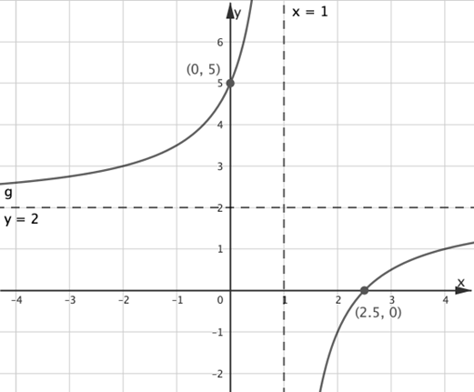
Most students presented graphs that were well drawn and appropriately labelled. Generally students included details and labels as required and produced smooth graph lines that displayed appropriately asymptotic behaviour. The most common errors were labelling the y-intercept as (5,0), the x-intercept as , the vertical asymptote as and horizontal asymptote as .

Question 3b.
Marks | 0 | 1 | Average
% | 62 | 38 | 0.4
This question required students to solve an inequation involving the function they had already sketched in part 3a. Unfortunately, many students did not use their graph from part 3a. to assist them to correctly identify the interval required, and many erroneously gave as their answer.

Question 4
Marks | 0 | 1 | 2 | Average
% | 35 | 20 | 45 | 1.1
From the formula sheet:
This question required that students use two trapeziums to approximate the area between the curve and the stated lines and axis. Therefore any attempt to calculate this area using integral calculus was not acceptable. Some students gave the formula as stated on the formula sheet; however, many did not proceed to identify and substitute the correct values into this formula to produce the correct answer. Some students set up two separate trapeziums and used to find the area; this approach was frequently successful. Common errors involved incorrect values of , given as instead of , and incorrect values of . Other errors were produced in setting up the formula and included having as the value for . Arithmetic manipulation errors (frequently) arose from dealing with the different denominators of the fractions.

Question 5a.
Marks | 0 | 1 | Average
% | 34 | 66 | 0.7
This question required students to evaluate a definite integral. Common errors were giving the antiderivative of as or stating instead of . Students are reminded that forms of common integrals are provided on the formula sheet.

Question 5b.
Marks | 0 | 1 | 2 | 3 | Average
% | 22 | 17 | 27 | 35 | 1.8

Using part a.,
This question was presented as a ‘hence, or otherwise’ question and, although not essential, most students did well at using their answer from part 5a. Common errors were made when students were unable to determine an appropriate exact value ratio (implying that their answer from part 5a$.$ was incorrect), and consequently they could not identify a reference angle. It is important to note that, since the range of lies within can never take a value outside of this range. Other approaches, such as trying to utilise the areas under graphs, were very rarely seen and tended to be unsuccessful.

Question 6a.
Marks | 0 | 1 | Average
% | 48 | 52 | 0.5
This question was well answered by students. Some errors included $\hat{p}$values greater than 1; students are reminded that $0≤\hat{p}≤1$ and that the span of the confidence interval is symmetric about $\hat{p}$.

Question 6b.
Marks | 0 | 1 | 2 | Average
% | 51 | 23 | 26 | 0.7
Many students were able to set up an equation involving by using either the lower or upper bound of the 95% confidence interval for the proportion, . Issues with arithmetic manipulation led to the most common errors of or .

Question 6c.
Marks | 0 | 1 | Average
% | 77 | 23 | 0.2
Confidence interval width is halved (reduced or decreased by a factor of 2; altered by a factor of ).
This question was not responded to well. The correct answer of was often given, with a number of students able to show rigorous working out. A significant number of students gave incorrect answers. A factor of was a common incorrect answer.

Question 7a.
Marks | 0 | 1 | Average
% | 10 | 90 | 0.9
This question was largely well answered. The most common errors involved stating the correct range values with incorrect brackets or swapping the interval values, as in . Students are reminded that mathematical notation is a precise language.

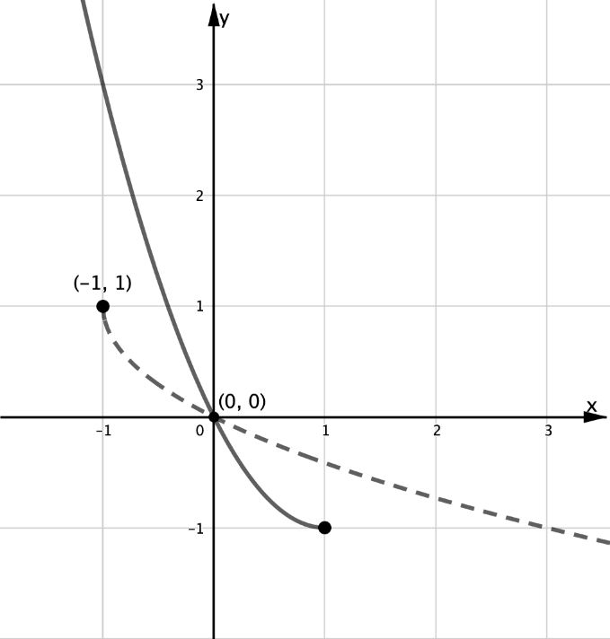
Question 7b.
Marks | 0 | 1 | 2 | Average
% | 33 | 20 | 47 | 1.1
This question was generally well answered. Many students were able to sketch the graph with accuracy and give points, as required, correctly labelled. Most students knew the graph of the inverse function, , was a reflection of in the line . Students are reminded that the grid should serve as a guide to ensure the graph is correctly presented.

Question 7c.
Marks | 0 | 1 | 2 | Average
% | 26 | 54 | 21 | 1.0
In turning point form:
Swap and :
Domain
This question was generally handled well. Students frequently wrote responses correctly signposting the need to interchange $x$ and $y$, however, some students did not know how to proceed and solve for $y$ once they had obtained . Most students recognised the domain of the inverse function as the range of the original and were thus able to give this component of their answer correctly, independent of their work in obtaining the equation of the inverse function. The most common error was writing the function as , the positive arm of the inverse. Students are reminded to use their graph drawn in part 7b. to assist. Students need to also use correct notation to denote the inverse function .

Question 7d.
Marks | 0 | 1 | 2 | Average
% | 71 | 10 | 19 | 0.5
Suggested methods include:
Method 1:
Method 2:
Method 3:
Use of valid triangle:
There were many ways to approach this question; however, in each case students needed to identify that there were two identical areas that needed to be calculated. Other approaches included making use of a modulus function or finding the area bounded by one of the curves, either or , and the -axis, and using this area with the area bounded by the line and the -axis. Using symmetry eliminated the need to evaluate an additional integration calculation, however, many students did not utilise this property. Most common errors arose from the signs of the terms: students intended to subtract from ; however, without appropriately using brackets they obtained rather than , and then proceeded to carry this error through subsequent calculations. Other errors involved finding , disregarding the mention of .

Question 8a.
Marks | 0 | 1 | Average
% | 57 | 43 | 0.4
Method 1:

Method 2:
There were two approaches students used to ‘show that’ .
They either formed an integral equation equal to 1, antidifferentiated, and then solved to find , or they evaluated the integral (without ) and then solved an equation equal to 1 and involving . Both used the fact that the total probability is equal to 1. This was a ‘show that’ question, so students were expected to be explicit and clear with their workings, and to arrive at the expected result in a logical, step-by-step manner. Common errors involved omitting the in the integral statement or writing instead. Students are reminded to be consistent in their use of variables.

Question 8b.
Marks | 0 | 1 | 2 | Average
% | 50 | 24 | 26 | 0.8
This question was well attempted. Most students knew to set up the integral . Some students incorrectly wrote , mixing their variables; students are reminded to pay attention to mathematical nomenclature.

Question 8c.
Marks | 0 | 1 | 2 | 3 | Average
% | 63 | 13 | 13 | 11 | 0.7

Alternatively, numerator and denominator can be evaluated separately as integrals:
Most students recognised this question as a conditional probability question and indicated this as the starting point of their working. Sometimes, however, the formulation was incorrect. Common errors included writing the conditional probability as , where students had incorrectly interpreted the mathematical meaning of ‘already queued for one minute’ as . There were also errors where students incorrectly identified the terminals of integration. The arithmetic manipulation of fractions presented a challenge for some students. Students are encouraged to look for ways to cancel factors in their fractions to assist with the arithmetic calculations.

Question 9a.
Marks | 0 | 1 | Average
% | 10 | 90 | 0.9
This question was frequently attempted successfully. Most students knew that in order to ‘verify’ the values they needed to show working to support this.

Question 9b.
Marks | 0 | 1 | 2 | Average
% | 34 | 36 | 30 | 1.0

OR
Turning point at:
Maxima of the graph; either use f or g:
This question required students to verify that both and have a turning point at P. It was not sufficient to assume by inspection that the tracks met at P. Some students misinterpreted the question and solved ; they stopped short of showing that the point of intersection was a turning point for both curves. Errors were involved in expanding the brackets of and finding . Some students just showed that had a turning point at , not addressing the turning points of . Some students incorrectly used the product rule to differentiate and gave . Most students were successful in finding the coordinates of P at (2,12).

Question 9c.
Marks | 0 | 1 | 2 | 3 | Average
% | 65 | 5 | 17 | 13 | 0.8
Area of triangle:
Maximum area at :
This question was not well attempted. Those students who did complete the question generally were able to state the equation for the area of the triangle as either or or an equivalent equation in terms of the variable . Many students were able to differentiate to get , although some students incorrectly wrote this as when the variable they were using was . Most students who were able to solve found or its equivalent, . Many arithmetic mistakes occurred when students tried to substitute the value of or into their expression of to find the maximum area.

