2024 VCE Mathematical Methods 1 external assessment report

General comments
The 2024 VCE Mathematical Methods examination 1 consisted of eight short-answer questions worth a total of 40 marks.
This examination was completed without the use of technology or notes.
There were some excellent responses observed, with Questions 5a, 7b.i and 1a among the highest-scoring questions, while responses to Questions 7b.ii, 7b.iii, 8d and 5b did not score as well.

Advice to students
Scanned images are used for assessing, so it is essential that students write clearly to ensure their answers are easily read. Responses should be written in a dark ink (e.g. black or blue), using a non-erasable pen or a 2B pencil to ensure legibility when scanned. When using a pencil, particularly for sketches of graphs, students should make sure that all elements will be clear and visible in the scan. Light or dashed lines, such as those representing asymptotes, may not be easily detected, so it is important that students make them dark enough to be visible.
Students are encouraged to pay careful attention to the presentation of their responses and are reminded that work presented for assessment should be clearly and logically set out. If additional working space is used, the final answer must be clearly identifiable as the intended final response for assessment. If multiple, conflicting final answers are provided, full marks cannot be awarded. When adding detailed elements to a graph, such as labelling intercept coordinates or indicating asymptote equations, students should ensure their handwriting is legible and that digits are formed clearly to avoid any ambiguity.
Students should sketch graphs using pencil and ensure that, if errors are made, unintended sketches are erased thoroughly. A graph is a visual representation of a functional relationship between variables and therefore students should ensure graphs are sketched with care and that relevant features are displayed. Students are encouraged to use the grid provided to ensure their graphs meet the specifications. In the case of a truncus, asymptotic behaviour needs to be displayed, with the graph line moving towards asymptotes for limiting values of x, as well as being symmetrical about the vertical asymptote. The graph of a derivative function needs to correspond to key points such as when the gradient is at a maximum, minimum or has a zero gradient value. Students are urged to observe this feature when sketching and forming derivative graphs.
Students should be familiar with the specific terminology used in mathematics. Command terms such as ‘verify’, ‘show that’ and ‘hence’ have precise meanings, and it is important that students understand what approach is needed to correctly answer the question. After completing a question, students should review it to confirm that their response is appropriate and that all aspects of the question have been addressed. If a particular method is specified, the student’s work should clearly demonstrate that the required method has been applied.
Mathematical nomenclature is a precise language and students should pay attention to its use. In particular, students should use the names of functions as given in the question. If a question defined a function as , it was not acceptable to write or as the derivative. Similarly, it is not true to say that and students are urged to think about the presentation of their calculations in such cases. An integral or integration statement must be accompanied by a ‘’ as inand the cube root of a number is written with a small number 3 just outside and above the radical symbol. Radicals need to extend completely over the radicand, or there needs to be brackets around the radicand. Brackets are an important part of mathematical formulation. Their use in algebra eliminates the potential for ambiguity or errors in calculations and ensures that the order of operations in the calculation process is clear. Brackets around an interval are essential to indicate that all values between the endpoints are included. Vinculums in fractions need to extend over the entire denominator to avoid ambiguity.
Students need to use correct mathematical language when describing transformations of graphs and students are encouraged to follow the study design for the correct expression of these descriptions. For dilations, students should be familiar with both ‘parallel to an axis’ and ‘from an axis’ descriptions.
Students are reminded of the examination instructions written before Question 1, ‘In questions where more than one mark is available, appropriate working must be shown’.

Specific information
This report provides sample answers or an indication of what answers may have included. Unless otherwise stated, these are not intended to be exemplary or complete responses.
The statistics in this report may be subject to rounding resulting in a total more or less than 100 per cent.

Question 1a.
Marks | 0 | 1 | Average
% | 18 | 82 | 0.8
This question was well attempted and required students to use the product rule to find the derivative. Many students did not tidy up the negative signs in their answer and left their answer as or . Some students did not use brackets around terms and this had the potential to be misinterpreted. Some students altered the argument of the sine term and wrote .

Question 1b.
Marks | 0 | 1 | 2 | Average
% | 31 | 15 | 54 | 1.2
This question was well attempted and required students to use the chain rule to find the derivative then evaluate the derivative at . Some students did not correctly execute the chain rule and omitted the numerator. Some students did not put brackets around the quadratic term; this created ambiguity in their solution process with the evaluation of the derivative at . A correct answer must emerge from correct working.

Question 2
Marks | 0 | 1 | 2 | 3 | Average
% | 22 | 22 | 18 | 37 | 1.7
There were a variety of methods that could be used to answer this question.
Method 1
Using ratios, we require that
(otherwise resulting in infinite solutions)
Solve the first quadratic equation:
Check the second equation or otherwise:
Hence, for the system to have no solution, .
Method 2
Using matrices, we form the determinant and set it equal to zero.
Then check solutions to find for no solution.

Method 3
Using gradients, we require the same gradient, but different y-intercept.

Then check y-intercept
So
Method 4
Setting equations equal to each other
gives infinite solutions (must discard)
only gives no solutions

There were multiple ways to approach this question; however, generally students approached this by one of the following: equating gradients and -intercepts separately; using a matrix/determinant method; forming ratios; or attempting to solve simultaneously. These methods were met with varying degrees of success. Those who knew that the two lines needed to have identical gradients were generally successful. Students using the determinant method often arrived at and and then did not justify which answer was the valid solution. Students who set the two initial equations equal to one another commonly found they had multiple variables to deal with and did not know how to solve for . The methods involving forming ratios or setting gradients equal to one another regularly led to the required quadratic. Some students struggled with applying an appropriate method to solve the quadratic equation. The quadratic was readily factorised by inspection, yet a large proportion of students used the quadratic formula or other techniques such as splitting the middle term and grouping. Some students incorrectly put as the final solution, rejecting , indicating confusion about the definition between ‘infinite solutions’ and ‘no solution’.

Question 3a.
Marks | 0 | 1 | 2 | 3 | Average
% | 8 | 16 | 35 | 42 | 2.1

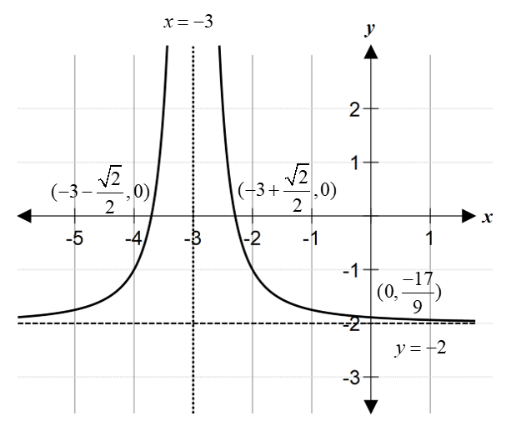
Most students presented graphs that were well drawn and appropriately labelled. Generally students included details and labels as required and produced smooth graph lines that displayed appropriate asymptotic behaviour, with asymptotes indicated as dashed or dotted lines. Common errors included not labelling the asymptotes with or , incorrectly determining the coordinates of -intercepts, and not indicating the symmetry of the curve. Some students mistakenly sketched a hyperbola.

Question 3b.
Marks | 0 | 1 | 2 | Average
% | 48 | 25 | 27 | 0.8

This question required students to find the area bounded by a graph below the x-axis using integral calculus. Students generally performed well on this question. Common errors included setting up the integral using an x-intercept for one of the terminals rather than 0 and −2, incorrect integration, and arithmetic errors in the substitution. Many students arrived at a negative answer and knew that the area needed to be positive, but did not provide correct reasoning steps (e.g. use absolute value sign, or state area must be positive) when they attempted to show the final answer as positive. Many simply wrote as the final answer.

Question 4a.
Marks | 0 | 1 | Average
% | 41 | 59 | 0.6

This question was well attempted. Some students found the variance instead of the standard deviation. Some students made arithmetic errors in calculating the product of the decimals.

Question 4b.
Marks | 0 | 1 | 2 | Average
% | 38 | 23 | 39 | 1.0

Many students correctly stated the binomial expansion with appropriate probability values and powers. However, some students struggled to expand and into the correct decimal or fraction form; some responses either included an extra zero or missed a zero. Some students only gave the .

Question 5a.
Marks | 0 | 1 | Average
% | 5 | 95 | 1.0

This question was completed very well.

Question 5b.
Marks | 0 | 1 | 2 | Average
% | 69 | 29 | 2 | 0.4

to have the same population when last measured.
Transformations:
Dilation of factor from the -axis / in the direction of -axis / parallel to -axis
Translation of 1500 units in the positive -direction / up / positive vertical direction

Or alternatively:
Translation of 3000 units in the positive -direction / up / positive vertical direction
Dilation factor of from the -axis / in the direction of -axis / parallel to -axis

Or as mapping notation, any one of the following:
This question was not responded to well. Many students were able to list one transformation, usually the dilation; however, frequently the incorrect axis or direction was specified. Students are urged to use the correct language when referring to transformations.

Question 5c.i.
Marks | 0 | 1 | 2 | Average
% | 19 | 37 | 44 | 1.3

Many students were able to find the standard deviation correctly. Students were not required to present their answer in a particular format. Some students encountered problems when they tried to simplify the surd expressions involving decimals and/or fractions. Some students incorrectly omitted brackets around the interval.

Question 5c.ii.
Marks | 0 | 1 | Average
% | 67 | 33 | 0.4

300
This question was well attempted. Many students were able to set up an expression involving for the standard deviation and equating that to the known value. Students who correctly set up the standard deviation formula were generally able to calculate the correct final answer.

Question 6
Marks | 0 | 1 | 2 | 3 | 4 | Average
% | 18 | 52 | 8 | 13 | 9 | 1.5

Most students demonstrated a knowledge of the logarithm laws needed to simplify this question; however, many did not employ the correct combination of these laws. Of those students who were able to use all logarithm laws effectively, many students showed good progress in factorising the cubic to find the quadratic factor. Some students did not solve the resultant cubic and subsequent quadratic equation correctly. Some students incorrectly identified or as a factor/solution. Although some students were able to find three possible solutions, many students overlooked the fact that the domain of this log function must be and, as a result, did not reject the two invalid solutions. Some students managed to engage with the implied domain of the problem.

Question 7a.
Marks | 0 | 1 | 2 | 3 | Average
% | 28 | 31 | 11 | 30 | 1.5
Key values for this question were:
Using the trapezium rule:
Or using a combination of triangles/trapeziums:
This question required that students use three trapeziums to approximate the area between the curve and the x-axis over the interval , as per the trapezium rule. Therefore, any attempt to calculate this area using integral calculus was not acceptable. Although many students knew the trapezium rule, some students did not apply it correctly, often writing , with the coefficient ‘2’ missing from the middle two terms. Some students gave the formula as stated on the formula sheet with values relevant to the question, however, many did not proceed to calculate and correctly. It is expected that students will have a way of remembering the exact values of for values of between 0 and inclusive, as specified in the key knowledge of the study design. While some students were able to identify the exact value of and , many did not multiply these by and $.$ The arithmetic manipulation of fractions and surds presented a challenge for some students, with some leaving their answer as the sum of two or three separate area parts, instead of combining them into a single term. Other errors included incorrectly evaluating as .

Question 7b.i.
Marks | 0 | 1 | Average
% | 16 | 84 | 0.9
Most students were able to apply the product rule appropriately. Students should be aware of the use of notation when naming their answer and use brackets to make their response clear.

Question 7b.ii.
Marks | 0 | 1 | Average
% | 80 | 20 | 0.2
Some students were able to substitute values effectively here to attain the correct endpoints of the interval. Some students were careless with notation and omitted the brackets or wrote curved parentheses. Some students, incorrectly, reversed the order of the interval. Students are encouraged to use the graph as a guide. A common incorrect answer was .

Question 7b.iii.
Marks | 0 | 1 | Average
% | 88 | 12 | 0.1
Since is continuous and at some point in the interval
Or since is continuous and includes 0 at some point in the interval
Or since is continuous and at some point in the interval
There were many ways students could use the values they found in Question 7b.ii to verify that has a stationary point in the interval . This question required students to ‘hence, verify […]’ so it was not appropriate to attempt to use a calculus technique. Students are reminded that the word ‘verify’ means to demonstrate or check the truth of a statement, so it was not sufficient to merely discuss the interval in terms of general positive or negative tendencies without referring to specific values and showing the ‘check’ had been completed. Of the students who attained the correct interval in Question 7b.ii, many were able to provide a correct explanation. A common error was to not recognise .

Question 7c.
Marks | 0 | 1 | 2 | 3 | Average
% | 45 | 16 | 24 | 15 | 1.1
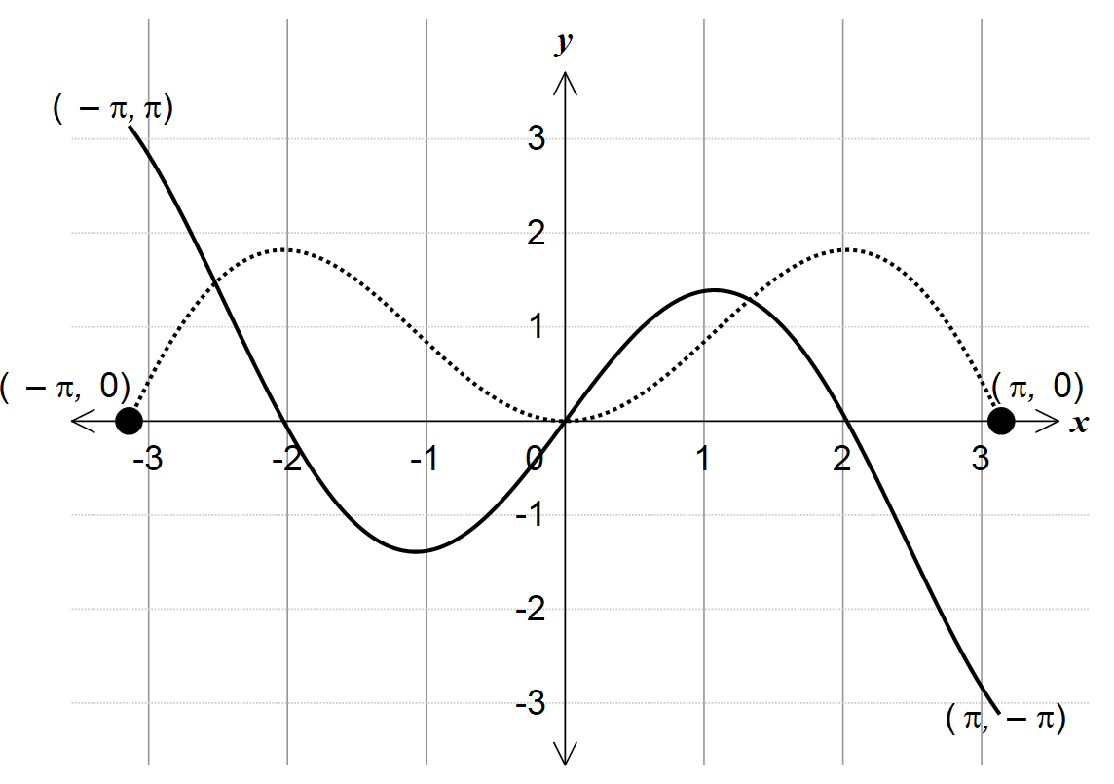
The graph of the derivative function needed to extend across the domain as specified. Many students calculated the coordinates of the endpoints correctly but then positioned them incorrectly. Some students failed to label the coordinates of the endpoints while others incorrectly had the endpoints on the x-axis. The gradient of the graph of is zero at approximately and at , and so the graph of needs to have x-intercepts at approximately and and at . The approximate coordinates of the local maxima and minima were given in the question and these needed to be positioned and represented correctly on the graph.

Question 8a.
Marks | 0 | 1 | Average
% | 39 | 61 | 0.6
or
Many students attained the y value of the intercept, but did not correctly write the answer in coordinate form, with correct brackets. Some students demonstrated difficulties in dealing with a negative sign inside a cube-root, noting the odd nature of the function. Some students incorrectly wrote the radical sign as and this often led to errors in later parts of Question 8.

Question 8b.
Marks | 0 | 1 | 2 | Average
% | 55 | 13 | 32 | 0.8
There were many ways the answer could be expressed in this question and students were not required to give their answer in a particular form. Some students confused the process involved in this question using integration instead of differentiation, leading to answers that involved an incorrect power of . Many students calculated the but mistakenly took the negative sign out, leaving their final response as . Some students did not manipulate or write the surds correctly.

Question 8c.
Marks | 0 | 1 | Average
% | 53 | 47 | 0.5
This question was well attempted.

Question 8d.
Marks | 0 | 1 | 2 | 3 | Average
% | 74 | 15 | 2 | 9 | 0.5
There were many ways that a response to this question could be attempted.
Method 1: Using derivatives in terms of k
Then find value as above
So
Or in terms of m
the required coordinates of Q
Method 2: Using symmetry of graph of g(x)
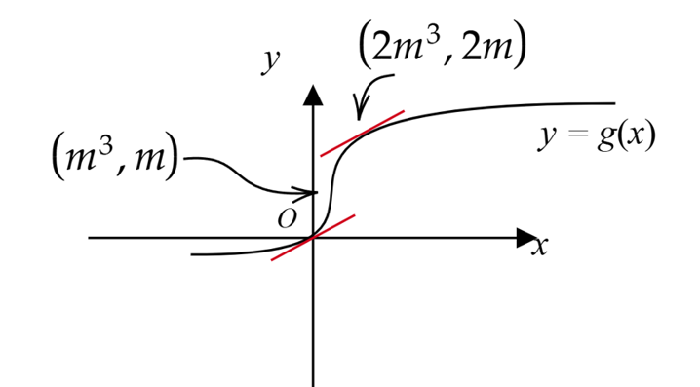

So

Method 3: Using inverse
Inverse is
This has a point of inflection at .
The inverse must also pass through the origin.
By symmetry, the gradient at the origin is equal to the gradient at
Then swap x and y values to get the coordinates of as

Method 4: Symmetry of graph of
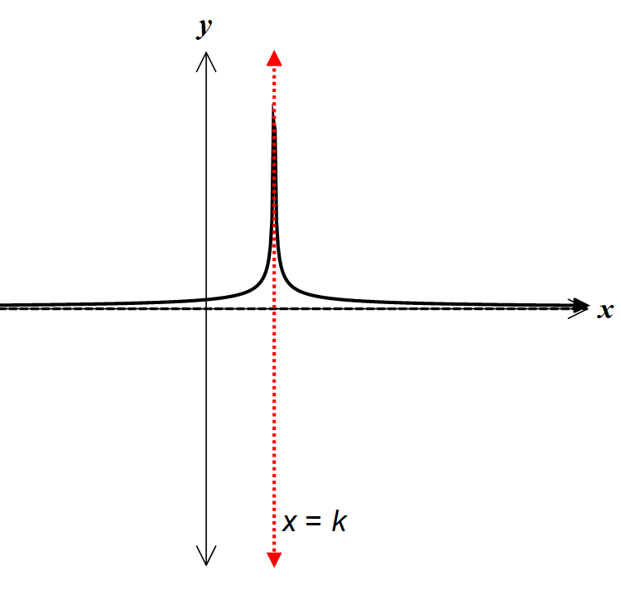
Gradient function is symmetrical about the line
So must be at .
So
Very few students were able to view this question visually; however, those who did usually achieved success. Many students noted they needed to equate derivatives from earlier questions, but some either had incorrect derivatives or used incorrect procedures to solve for . Students who successfully calculated the value were generally able to identify the correct coordinates.

