2024 VCE Mathematical Methods 2 external assessment report

General comments
There were some very good responses to the examination questions this year. The scanned papers were easy to read, which means most students used a HB or darker pencil or a dark blue or black pen.
In all questions where a numerical answer is required, students should give an exact value unless otherwise specified. Some students gave approximate rather than exact answers to Questions 1c.ii, 1d.i, 2f.ii, 5b.iii and 5b.iv.
Students should ensure they practise ‘show that’ questions. Most students substituted the correct values into the equation in Question 2f.i but Questions 4c.i and 5b.ii were not done well.
A number of students did not use interval notation correctly, writing the correct values in reverse order. For example, in Question 5a.ii was often expressed as and likewise in Question 5b.iv was often written as .
Some students made transcription errors when writing down the derivatives for Questions 3b.iii and 5b.i.
In general, brackets were not used well. When writing down coordinates, round brackets must be placed around the numbers. Students frequently did not write closing backets. For example, in Question 3b, (36, 5180 was often seen. With interval notation, square brackets were seen when round brackets were required and vice versa. Misuse of brackets occurred in Questions 1c.iii, 5a.ii, 5b.iv and 5d.
There were several transformation questions. In Question 1d.i, most students were able to correctly identify the horizontal translation but not the vertical translation. Questions 1d.ii and Question 3a.ii were not well answered.
Some students found the average value when the average rate of change was required. This occurred in Question 2b.
Appropriate working must be shown for questions worth more than one mark. Some students just put their final answers down for Questions 2f.iii, 3a and 4b.ii.
Students should re-read questions to make sure they are answering all the required parts. In Question 3a.i, d was often missing and in Question 3b.iv, the maximum instantaneous rate of change was not given by some students.
Students need to make sure they are answering the required question, especially those involving calculus. Some students misinterpreted Questions 2f.ii and 2f.iii and did not consider the area under the curve. In Question 3a.i, some students did not set the derivative equal to zero at the turning points. In Question 3b.iv, some students found the maximum value of , not the maximum instantaneous rate of change. In Question 4a, some students incorrectly set up a definite integral and in Question 4b.ii, some students incorrectly found the variance, not the standard deviation. In Question 5c.i, many students set up two definite integrals instead of one.
There was evidence of good use of technology, especially in Questions 1, 3a.i and 4e.i.

Specific information
This report provides sample answers or an indication of what answers may have included. Unless otherwise stated, these are not intended to be exemplary or complete responses.
The statistics in this report may be subject to rounding resulting in a total more or less than 100 per cent.

Section A – Multiple-choice questions
The table indicates the percentage of students who chose each option. Grey shading indicates the correct response.
Question | Correct answer | % A | % B | % C | % D | % N/A | Comments
1 | A | 74 | 2 | 3 | 20 | 0
2 | D | 10 | 4 | 5 | 81 | 0
3 | C | 7 | 11 | 67 | 14 | 0
4 | B | 7 | 70 | 12 | 9 | 0
5 | D | 18 | 9 | 21 | 52 | 0
6 | B | 31 | 50 | 7 | 12 | 0
7 | C | 7 | 15 | 68 | 9 | 1
8 | A | 65 | 15 | 16 | 3 | 0
9 | C | 4 | 18 | 66 | 11 | 1
10 | B | 26 | 38 | 16 | 20 | 1 | Possible graphs of and are shown below.  does not have to be strictly decreasing on .  does not have to be positive on .  does not have to have a local minimum at .  is many-to-one on , since changes sign. So does not have an inverse function.  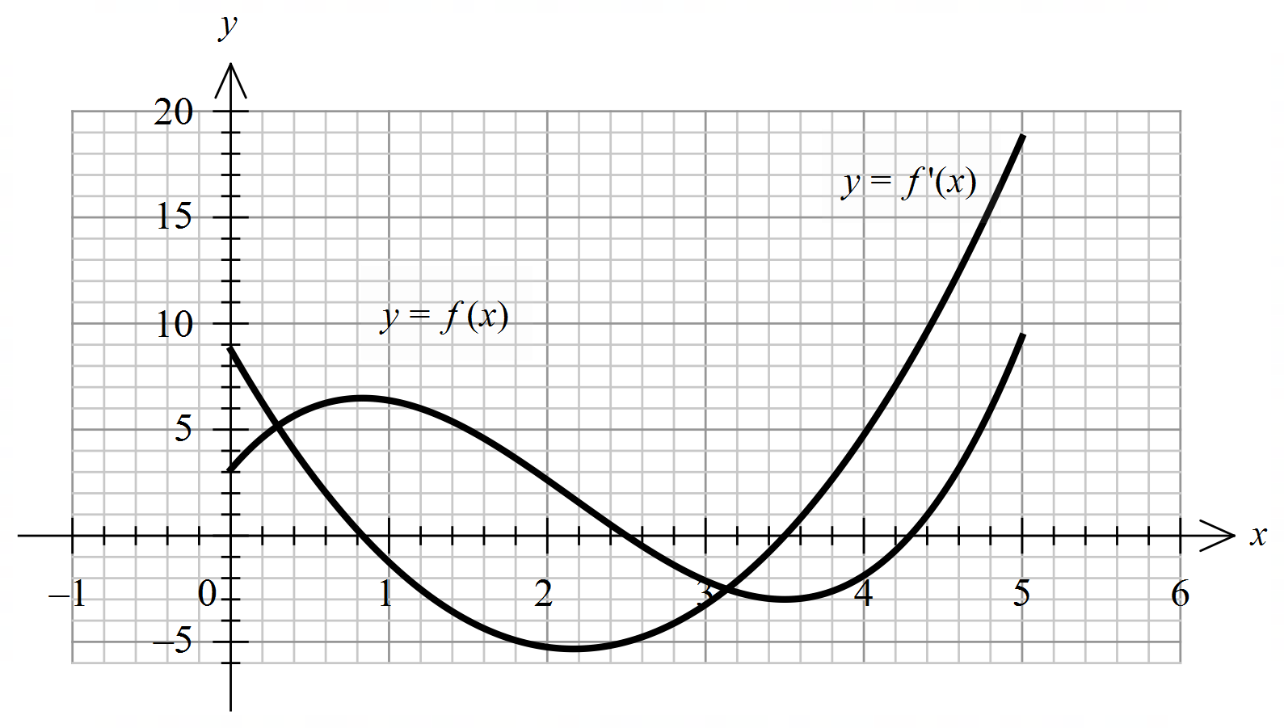
11 | B | 12 | 40 | 10 | 37 | 1
12 | A | 47 | 28 | 17 | 7 | 0 | The graph of has been dilated by a factor of from the y-axis and translated a unit left. The local minimum of is at approximately . This would become and then after each of the transformations.
13 | A | 45 | 24 | 17 | 14 | 0 | Dilate by a factor of from the y-axis:  .  Translate unit down:  .  The local minimum of is at .  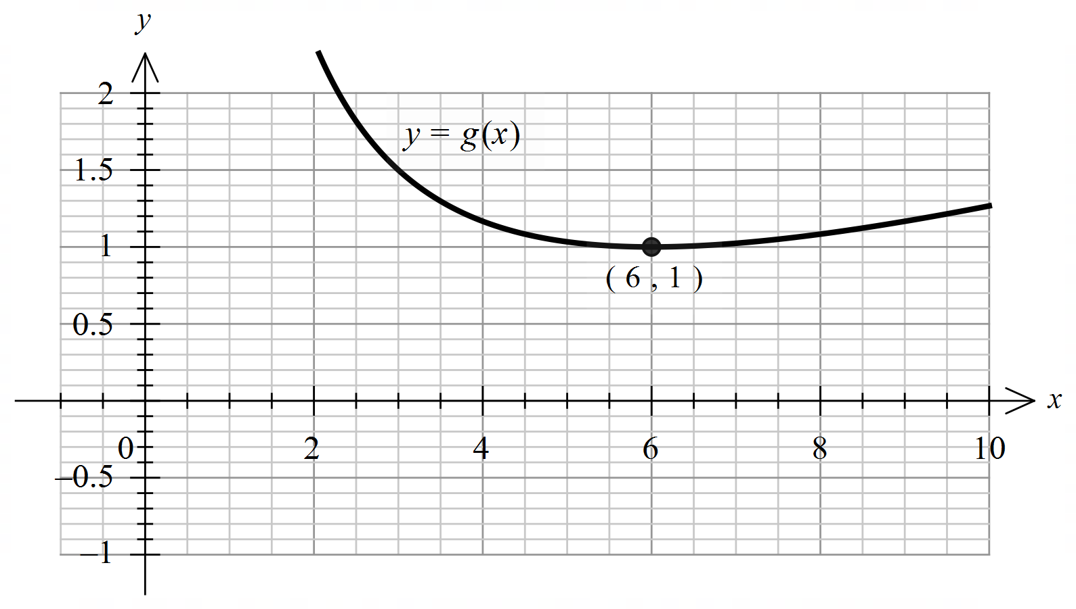
14 | B | 9 | 53 | 30 | 7 | 1
15 | A | 53 | 19 | 13 | 15 | 1
16 | D | 22 | 14 | 27 | 36 | 1
17 | D | 14 | 26 | 32 | 27 | 1 | ,  , …  , ,
18 | B | 18 | 58 | 12 | 10 | 1
19 | C | 10 | 19 | 57 | 13 | 1
20 | C | 20 | 23 | 41 | 14 | 1 | ,

Section B

Question 1a.
Marks | 0 | 1 | Average
% | 15 | 85 | 0.9
, , ,
This question was answered well.

Question 1b.i.
Marks | 0 | 1 | 2 | Average
% | 29 | 61 | 10 | 0.8
, , 0
Some of the values were often missing.

Question 1b.ii.
 | 0 | 1 | Average
% | 69 | 31 | 0.3
This question was not answered well. Some students did not exclude .

Question 1c.i.
Marks | 0 | 1 | Average
% | 5 | 95 | 1.0
This question was answered well.

Question 1c.ii.
Marks | 0 | 1 | Average
% | 24 | 76 | 0.8
or
Exact answers were required. was sometimes seen.

Question 1c.iii.
Marks | 0 | 1 | Average
% | 29 | 71 | 0.7
This question was answered well. Some students used square brackets instead of round brackets. Others put instead of .

Question 1c.iv.
Marks | 0 | 1 | 2 | Average
% | 32 | 17 | 51 | 1.2

, or ,
or , , or
This question was answered reasonably well. A common incorrect answer was .

Question 1d.i.
Marks | 0 | 1 | Average
% | 63 | 37 | 0.4
Translate unit to the right and units up.
Some students incorrectly translated to the left and down. Others had an incorrect value for the vertical translation such as . Exact answers were required. was sometimes seen.

Question 1d.ii.
Marks | 0 | 1 | 2 | Average
% | 76 | 19 | 5 | 0.3
Dilate by a factor of from the vertical axis, translate unit to the right, translate units up
OR translate units to the right, dilate by a factor of from the vertical axis, translate units up.
This question was not done well. The vertical translation could be completed at any stage in the sequence. The other transformations had to be in the correct order.

Question 2a.
Marks | 0 | 1 | 2 | Average
% | 11 | 41 | 48 | 1.4
or
Many students included in the domain.

Question 2b.
Marks | 0 | 1 | Average
% | 35 | 65 | 0.7
Average rate of change
A common incorrect answer was where was substituted into , giving .
Some students incorrectly found the average value of the temperature.

Question 2c.i.
Marks | 0 | 1 | Average
% | 5 | 95 | 1.0
This question was answered well.

Question 2c.ii.
Marks | 0 | 1 | Average
% | 15 | 85 | 0.9
,
Some students gave the exact answer. There were some rounding errors: and were occasionally seen.

Question 2d.
Marks | 0 | 1 | Average
% | 37 | 63 | 0.7
,
Some students incorrectly included but .

Question 2e.
Marks | 0 | 1 | Average
% | 71 | 29 | 0.3
A common incorrect answer was , which is the time when is a maximum. The maximum difference occurs when is a maximum or is a maximum.

Question 2f.i.
Marks | 0 | 1 | Average
% | 45 | 55 | 0.6

, , ,
Most students substituted the correct values into the equation. Students must make sure they show adequate working for ‘show that’ questions.

Question 2f.ii.
Marks | 0 | 1 | Average
% | 63 | 37 | 0.4
,
An exact answer was required. Some students solved for or found .

Question 2f.iii.
Marks | 0 | 1 | 2 | Average
% | 61 | 11 | 27 | 0.7

,
Some students solved for or found . Others just gave the answer. For questions worth more than 1 mark, appropriate working must be shown. Some students transcribed incorrectly into the function.

Question 3a.i.
Marks | 0 | 1 | 2 | 3 | Average
% | 30 | 16 | 12 | 42 | 1.7

, , ,
, , ,
, , ,
Some students only wrote the answers without showing adequate working. Others had only two correct equations.
Some had and . Others rounded to . The value of was sometimes missing.

Question 3a.ii.
Marks | 0 | 1 | 2 | Average
% | 65 | 9 | 26 | 0.6

,
Many students did not realise they only needed to translate the point to the point . Some gave solutions outside the domain. Others translated the local minimum, giving , as their answers. , was sometimes seen.

Question 3b.i.
Marks | 0 | 1 | 2 | Average
% | 19 | 18 | 63 | 1.5

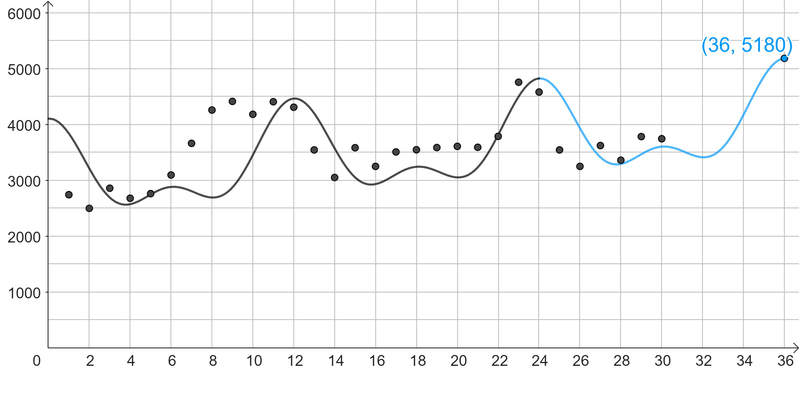
More care needs to be taken when sketching graphs. The turning points and endpoint needed to be in the correct positions. Some students labelled the endpoint incorrectly. Round brackets are required around the coordinates. Others made the graph discontinuous at .

Question 3b.ii.
Marks | 0 | 1 | Average
% | 41 | 59 | 0.6

A common incorrect answer was which is found by calculating .

Question 3b.iii.
Marks | 0 | 1 | Average
% | 23 | 77 | 0.8
This question was answered well. There were some transcription errors: was often omitted and brackets were not used well.

Question 3b.iv.
Marks | 0 | 1 | 2 | Average
% | 65 | 14 | 21 | 0.6
Maximum instantaneous rate of change
, ,
Many students gave extra values or only one value. Others did not give the maximum instantaneous rate of change or found the minimum instantaneous rate of change.

Question 4a.
Marks | 0 | 1 | Average
% | 21 | 79 | 0.8
This question was answered well. , and were common incorrect answers. There were some transcription errors when students tried to write instead of writing
.

Question 4b.i.
Marks | 0 | 1 | Average
% | 15 | 85 | 0.9
This question was answered well.

Question 4b.ii.
Marks | 0 | 1 | 2 | Average
% | 21 | 9 | 71 | 1.5

or
Some students worked out the variance. Others did not square the mean in the first method shown above. Some did not show any working.

Question 4b.iii.
Marks | 0 | 1 | 2 | Average
% | 31 | 18 | 52 | 1.2

Some students evaluated , giving an answer greater than one. Others incorrectly used in the denominator, . Some tried to use the normal distribution.

Question 4c.i.
Marks | 0 | 1 | Average
% | 64 | 36 | 0.4

This was a ‘show that’ question. Adequate working needed to be shown.

Question 4c.ii.
Marks | 0 | 1 | 2 | Average
% | 86 | 3 | 11 | 0.3

,
This question was not answered well. Some students attempted a tree diagram but were unable to get the correct values. Others left the question blank.

Question 4d.i.
Marks | 0 | 1 | 2 | Average
% | 50 | 18 | 33 | 0.9

,
was a common incorrect answer. Some students attempted to use the normal distribution.

Question 4d.ii.
Marks | 0 | 1 | 2 | Average
% | 67 | 15 | 18 | 0.5

Method 1
,
Method 2
,
Some students were able to find the standard deviation but then evaluated . Others used the normal approximation.

Question 4e.i.
Marks | 0 | 1 | Average
% | 44 | 56 | 0.6

This question was done reasonably well. Some students attempted to do it by hand and were unsuccessful.

Question 4e.ii.
Marks | 0 | 1 | Average
% | 92 | 8 | 0.1

,
Many students were able find the minimum value, , but not the maximum value. A common incorrect answer for the maximum value was . Others had as the minimum and as the maximum.

Question 5a.i.
Marks | 0 | 1 | Average
% | 31 | 69 | 0.7

or
This question was answered well. Some students gave an extra solution, .

Question 5a.ii.
Marks | 0 | 1 | Average
% | 37 | 63 | 0.6

Many students wrote . Others had incorrect brackets such as .
was a common incorrect answer.

Question 5b.i.
Marks | 0 | 1 | Average
% | 18 | 82 | 0.8

There were some transcription errors, such as incorrect positioning of brackets and writing instead of .

Question 5b.ii.
Marks | 0 | 1 | 2 | Average
% | 57 | 9 | 34 | 0.8
If , then , but has range . Hence, no solutions.
This question was not answered well. It was a ‘show that’ question. Many students were not able to find , giving or .

Question 5b.iii.
Marks | 0 | 1 | Average
% | 53 | 47 | 0.5

Some students did not give four values. Others gave approximate answers.

Question 5b.iv.
Marks | 0 | 1 | Average
% | 66 | 34 | 0.4

Exact answers were required. Some students used round brackets. Others wrote .

Question 5c.i.
Marks | 0 | 1 | Average
% | 68 | 32 | 0.3

or or or or
A single definite integral was required. Many students wrote two definite integrals.

Question 5c.ii.
Marks | 0 | 1 | Average
% | 55 | 45 | 0.5

was a common incorrect answer.

Question 5d.
Marks | 0 | 1 | 2 | Average
% | 80 | 11 | 9 | 0.3
Require , , , ,
Many students knew that the but were unable to produce the intervals. was a common incorrect answer.

