2025 VCE Mathematical Methods 2 external assessment report
The statistics in this report may be subject to rounding resulting in a total of more or less than 100 per cent.

Section A – Multiple-choice questions
The table indicates the percentage of students who chose each option. Grey shading indicates the correct response.
Question | Correct answer | % A | % B | % C | % D | % N/A | Comments
1 | C | 2 | 5 | 91 | 2 | 0 | The range is .
2 | A | 51 | 10 | 21 | 18 | 0 | ,  The period is 1.  The general solution for the equations of the asymptotes is .
3 | B | 4 | 71 | 12 | 13 | 0 | The graph of has been reflected in the y-axis and translated 2 units up to get the graph of.
4 | A | 55 | 13 | 19 | 12 | 1 | , or  When  , infinite solutions  When  . , no real solutions
5 | B | 6 | 76 | 13 | 5 | 0 | is a function and hence has an inverse function.
6 | B | 18 | 50 | 19 | 11 | 1 | The graph of is shown below with two trapeziums. The area of the trapeziums is larger than the exact area, .  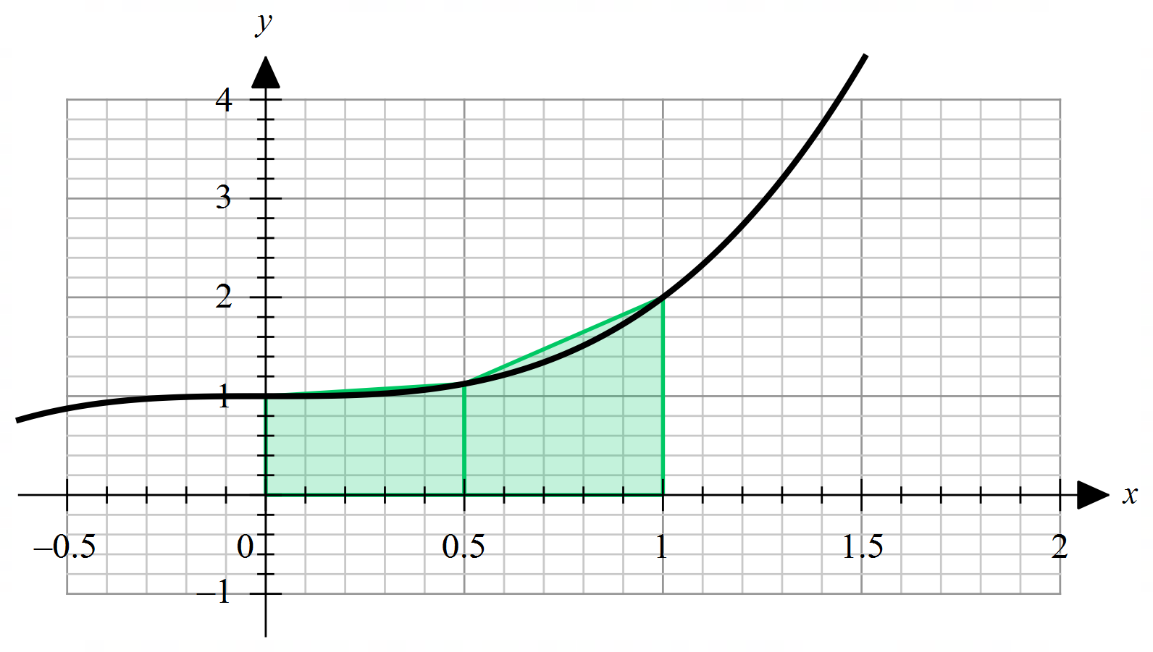
7 | C | 9 | 15 | 72 | 3 | 0 | end while  The printed values are 12, 7 and 2.
8 | C | 7 | 18 | 66 | 8 | 1 | 95% confidence interval is (0.248, 0.552), correct to three decimal places.  ,
9 | A | 57 | 19 | 16 | 7 | 1 | Let W be the event that a randomly selected student walks to school, and L be the event that the student takes at least 30 minutes.
10 | C | 10 | 15 | 57 | 17 | 1 | ,
11 | D | 4 | 4 | 16 | 75 | 0 | Use a ruler to draw line segments for each option. Then, select the line segment with the steepest gradient. Day 14 to day 28 has the greatest average rate of change.  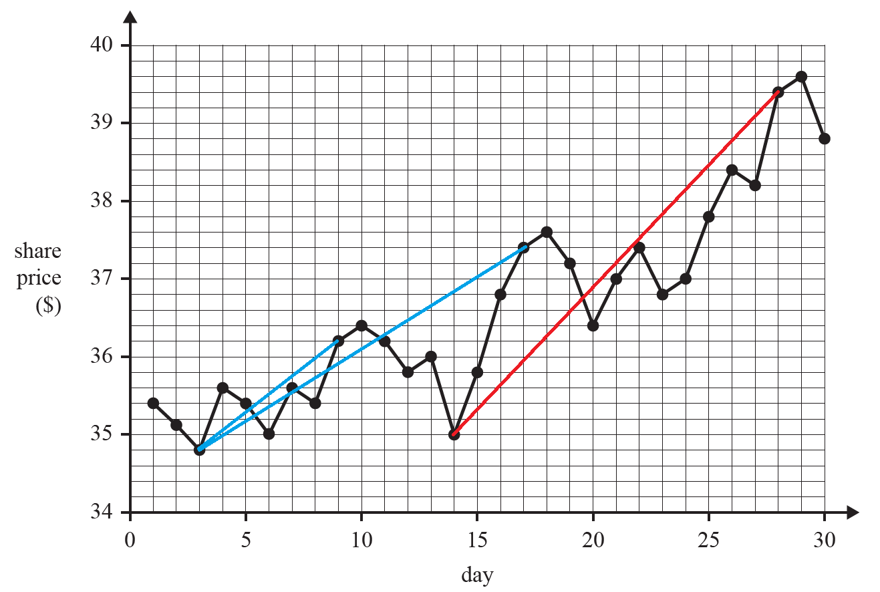  .
12 | D | 10 | 16 | 15 | 58 | 1 | ,  ,
13 | C | 12 | 17 | 45 | 25 | 0 | , where  The graph of g has been reflected in the y-axis and dilated by a factor of from the y-axis. Option C is the only graph developed through these transformations.  OR  Try sensible functions with similar characteristic curves for the rules; for example, let and and then sketch .  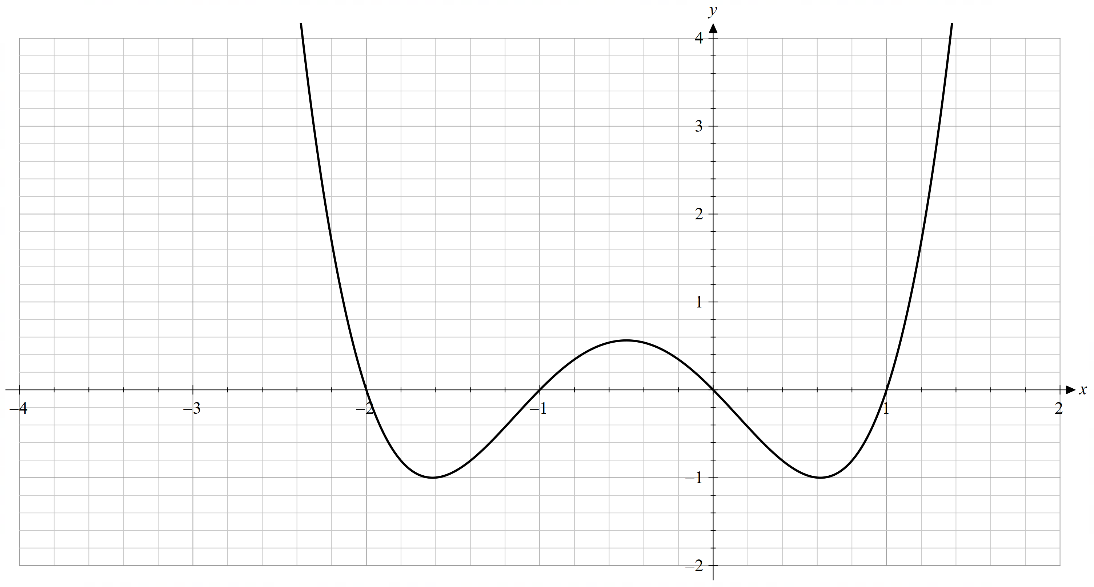
14 | B | 12 | 66 | 17 | 5 | 0 | Solve for k.
15 | B | 25 | 44 | 22 | 8 | 0 | Reflect in the x-axis gives .  Dilate by a factor of from the y-axis gives .  Translate 1 unit up and units to the right gives.
16 | D | 20 | 16 | 46 | 18 | 1 | ,  The two cases wherehas range are  and or and .  In both cases it must be true that .  Example 1 and .  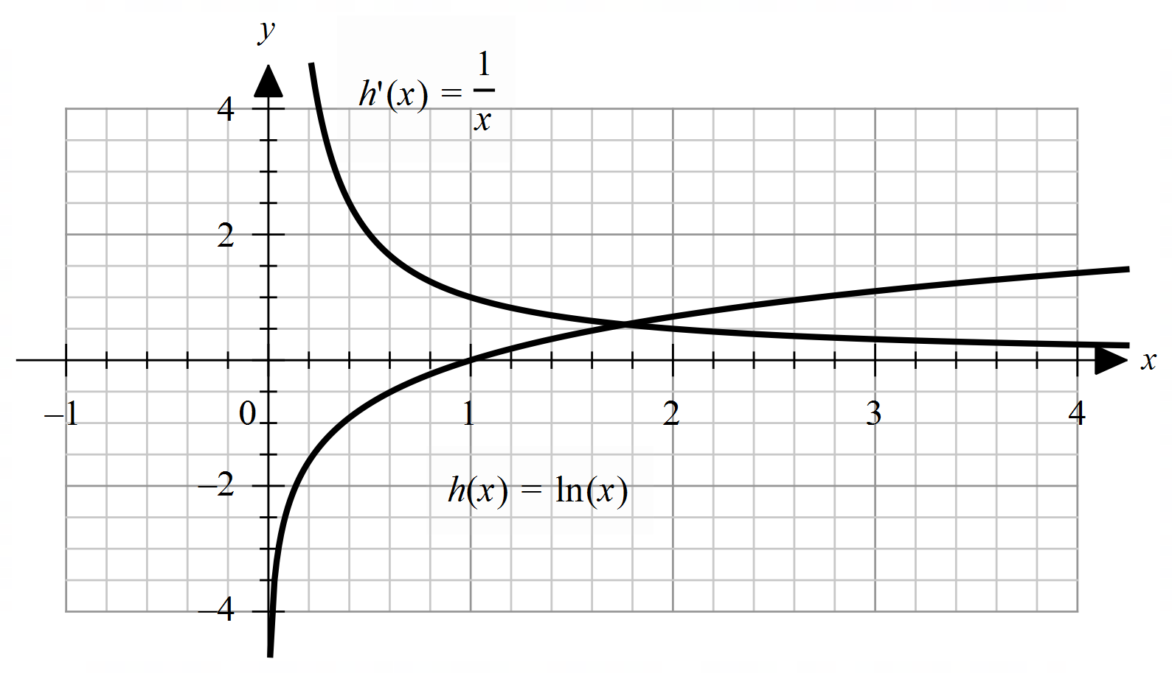  Example 2 and .  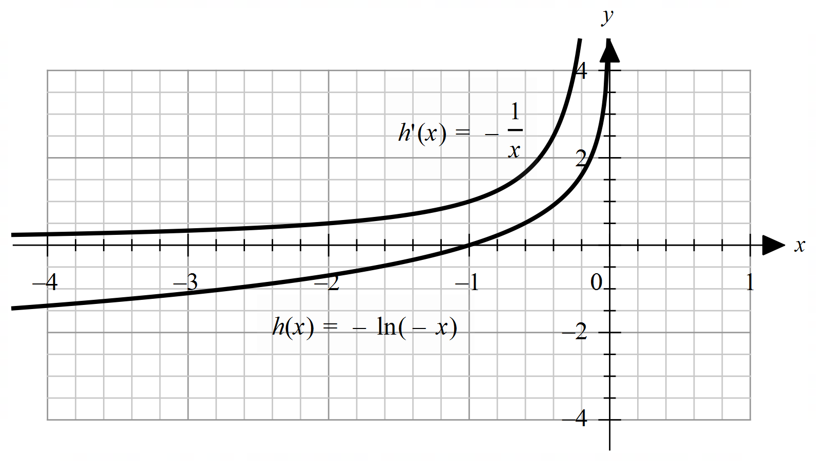
17 | A | 38 | 20 | 17 | 24 | 1 | The only graph for which the integral is negative is Option A.
18 | D | 16 | 17 | 17 | 50 | 0 | Probability mass functions II and IV both have a mean  equal to 3.
19 | D | 35 | 25 | 24 | 14 | 1 | Option D gives the shortest distance between and .  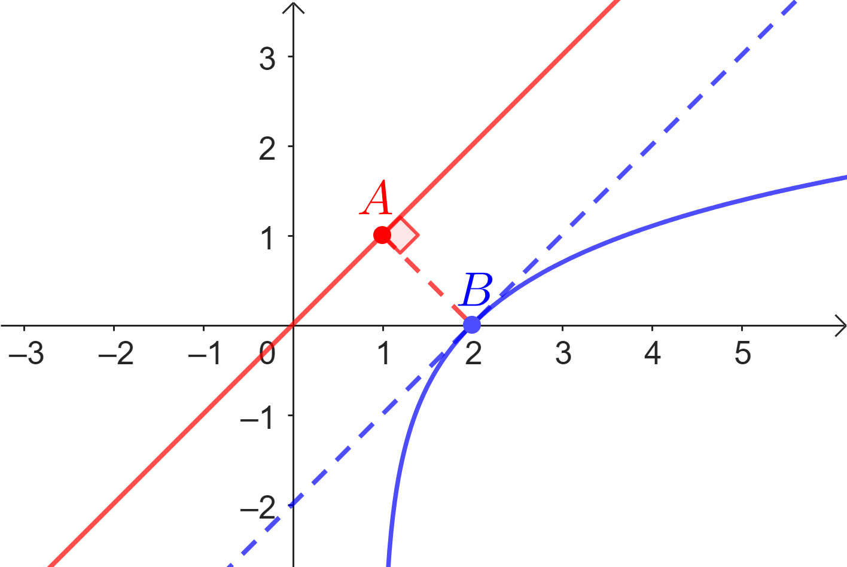  The shortest distance between the line and the curve must be a perpendicular distance.  At the point B, the gradient of the curve must be 1.  Let and.  Solving and gives .  Let be the distance between the point B and a point on the line .  Minimising gives , then solving gives or , but the value is not an available option, so .
20 | C | 24 | 18 | 36 | 21 | 1 | and  Dilation by a factor of a from the x-axis gives.  Dilation by a factor of from the y-axis gives.  Translating by 1 unit in the positive direction of the x-axis gives  .

Section B

Question 1a.
Marks | 0 | 1 | 2 | Average
% | 2 | 7 | 91 | 1.9
Solve for x.
or
,
This question was answered well. Some students, however, only gave the x-values. Both coordinates were required.

Question 1b.
Marks | 0 | 1 | 2 | Average
% | 7 | 31 | 62 | 1.6
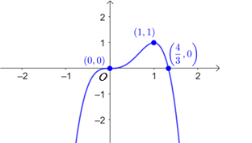
Some students did not include all the coordinates. was sometimes seen. Other students did not scale their graphs well on the axes. The x-intercept was often closer to 2 than 1. Some students did not draw the stationary point of inflection correctly.

Question 1c.
Marks | 0 | 1 | 2 | Average
% | 26 | 19 | 55 | 1.3
One possible way to complete the table is shown below.
Many students had (0, 0) in the third column. Some students did not enter values in the second row. Others used x-values which were greater than or equal to 1 in the fourth column. Some gave the values for instead of in the second row. Some students incorrectly assumed symmetry in their table of values.

Question 1d.
Marks | 0 | 1 | 2 | Average
% | 25 | 4 | 72 | 1.5
Some students worked out the average rate of change instead of the average value. Others evaluated or . Students should check the values they enter into their CAS as some students had the correct definite integral but ended up with an incorrect answer.

Question 1e.
Marks | 0 | 1 | 2 | 3 | Average
% | 30 | 41 | 9 | 20 | 1.2

Possible sequences of transformations are shown below. There are others.
1. Reflect in the y-axis. 1. Dilate by factor 2 from the y-axis.
2. Dilate by factor 2 from the y-axis. 2. Translate 1 unit left.
3. Translate 1 unit right. 3. Reflect in the y-axis.

1. Reflect in the y-axis. 1. Translate 0.5 units left.
2. Translate 0.5 units right. 2. Dilate by factor 2 from the y-axis.
3. Dilate by factor 2 from the y-axis. 3. Reflect in the y-axis.
Most students were able to describe the reflection. Students were required to use the correct wording in their descriptions and the transformations had to be in the correct order. Some students had the dilation factor as instead of 2.

Question 1f.
Marks | 0 | 1 | 2 | Average
% | 44 | 11 | 45 | 1.0
This was a ‘show that’ question and appropriate working needed to be shown. Some students worked out instead of . was sometimes omitted. Others attempted to find but often left it incomplete or had ineffective use of brackets.

Question 2a.
Marks | 0 | 1 | 2 | 3 | Average
% | 22 | 35 | 12 | 31 | 1.5

Divide (2) by (1)
Substitute back into (1)
This was a ‘show that’ question and students were required to show the algebraic steps. Many students were able to set up the two simultaneous equations; but some unnecessarily solved when the values were on the diagram. Some used a combination of their CAS and algebraic steps and were unable to gain full marks.

Question 2b.
Marks | 0 | 1 | Average
% | 45 | 55 | 0.6
or
Common incorrect responses were and .

Question 2c.
Marks | 0 | 1 | 2 | Average
% | 13 | 10 | 77 | 1.6

or or
Some students set up the correct definite integral but had the wrong answer. Other students who wrote the definite integral in terms of x sometimes made transcription errors.

Question 2di.
Marks | 0 | 1 | Average
% | 29 | 71 | 0.7
=
This question was answered well. However, some students just wrote or .
Others wrote the expression for , not . There were also some transcription errors.

Question 2dii.
Marks | 0 | 1 | Average
% | 44 | 56 | 0.6
The maximum value of is .
This question was answered reasonably well. Some students just gave the x-value, Others gave the coordinates of the turning point without stating the maximum value. was a common incorrect answer.

Question 2e.
Marks | 0 | 1 | 2 | Average
% | 26 | 12 | 62 | 1.4
Method 1: Method 2:
is the inverse of
Solve for .
The points of intersection are and .
This question was answered well. Some students, however, just gave the x-values or the equation for the inverse function .

Question 2fi.
Marks | 0 | 1 | 2 | Average
% | 41 | 21 | 39 | 1.0
Method 1: Method 2:
but when , but when
cannot have two different values So cannot pass through .
Method 3:
So cannot pass through .
A common incorrect answer was . Some students substituted and incorrectly into , obtaining the wrong values. Others found but then assumed .

Question 2fii.
Marks | 0 | 1 | 2 | Average
% | 62 | 11 | 28 | 0.7
,
and
Some students multiplied by instead of . Others did not multiple their values by , using . Some attempted to solve their equations by hand and made algebraic errors giving incorrect answers; was a common incorrect answer.

Question 3ai.
Marks | 0 | 1 | Average
% | 13 | 87 | 0.9
This question was answered well. was an occasional incorrect response. Some students used the incorrect formula for the mean. Others made transcription errors when transcribing the formula.

Question 3aii.
Marks | 0 | 1 | 2 | Average
% | 17 | 18 | 65 | 1.5
Method 1: Method 2:
Some responses were not awarded full marks because while they worked out the variance, they did not proceed to compute the standard deviation. Others gave the correct answer but did not show any working. Some students gave the approximate answer 5.34… and were not awarded full marks.

Question 3bi.
Marks | 0 | 1 | Average
% | 19 | 81 | 0.8
or or
This question was answered well. was an occasional incorrect response.

Question 3bii.
Marks | 0 | 1 | 2 | Average
% | 28 | 10 | 62 | 1.3
Method 1: Method 2:
Some students just gave the answer without showing appropriate working. Other students rounded their answer incorrectly, giving instead of . Some students incorrectly multiplied by .

Question 3biii.
Marks | 0 | 1 | 2 | Average
% | 45 | 6 | 49 | 1.0

Let
Some students did not show appropriate working and were not awarded full marks.

Question 3biv.
Marks | 0 | 1 | 2 | Average
% | 67 | 16 | 17 | 0.5
Method 1: Method 2:
was a common incorrect answer. An integer value was required. Many students tried to solve . Some students correctly used trial and error. Others just gave the answer, without showing appropriate working as required.

Question 3ci.
Marks | 0 | 1 | Average
% | 21 | 79 | 0.8

This question was answered well.

Question 3cii.
Marks | 0 | 1 | Average
% | 52 | 48 | 0.5
This question was not answered well. and were common incorrect responses.

Question 3d.
Marks | 0 | 1 | 2 | Average
% | 41 | 16 | 42 | 1.0

Some students had the second and fifth columns correct but not the third and fourth columns, often interchanging these two columns. Others did not attempt the question or appeared to guess the answers as their probabilities were unreasonable. Some put , instead of .

Question 4a.
Marks | 0 | 1 | Average
% | 7 | 93 | 0.9
This question was answered well. Some students, however, left their answer as or gave an approximate value when an exact answer was required.

Question 4b.
Marks | 0 | 1 | Average
% | 22 | 78 | 0.8
Solve for
Some responses only had , or the first two solutions, or put instead of . Others incorrectly gave extra solutions or a general solution, not considering the restricted domain.

Question 4c.
Marks | 0 | 1 | 2 | Average
% | 59 | 26 | 15 | 0.6
,
Many students were able to find the value but not the value. , and were common incorrect responses. and were also occasional incorrect responses.

Question 4d.
Marks | 0 | 1 | Average
% | 30 | 70 | 0.7
An equation was required. There were some transcription errors. Some students inefficiently attempted to find the equation by hand, rather than selecting to use their CAS, and made errors.

Question 4ei.
Marks | 0 | 1 | Average
% | 35 | 65 | 0.6
The incorrect response of was occasionally seen.

Question 4eii.
Marks | 0 | 1 | Average
% | 72 | 28 | 0.3
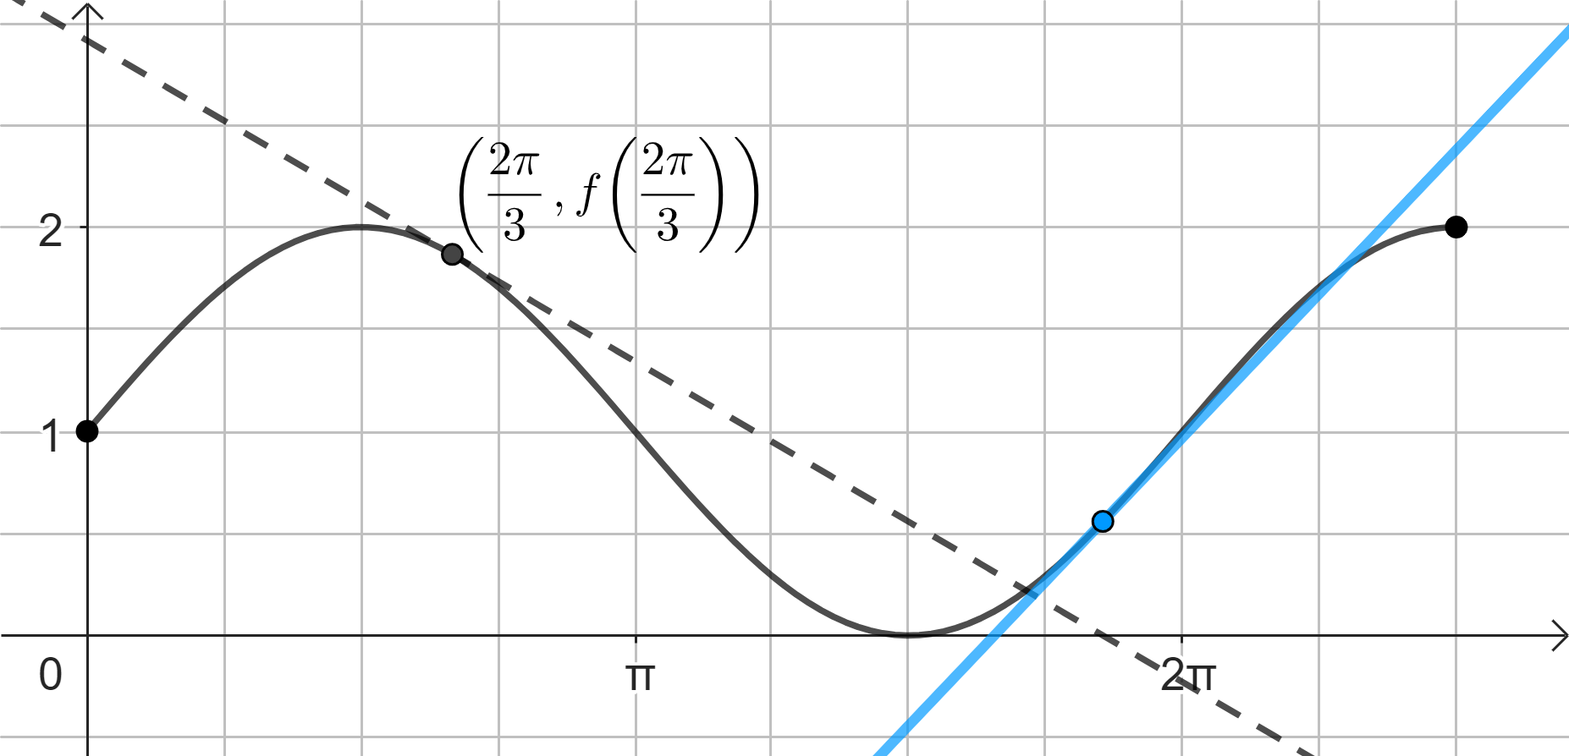
Many students did not attempt this question. Some students drew lines which were not tangential to the curve at any point. Some drew a line that clearly cut the curve at Others were unable to
find. Students should use a ruler when drawing lines.

Question 4fi.
Marks | 0 | 1 | 2 | Average
% | 34 | 17 | 49 | 1.1
Method 1: Method 2:
Use the point Use the point
This was a ‘show that’ question and appropriate working needed to be shown. Many students were able to find the gradient. Some students did not express correctly, writing . Others used , claiming .

Question 4fii.
Marks | 0 | 1 | 2 | Average
% | 72 | 5 | 23 | 0.5
Minimum occurs when , Maximum occurs when .
,
Exact answers were required. Some students gave their answers in coordinate form without stating the minimum and maximum values of the y-intercept. Others labelled the values incorrectly, giving and . Some had the minimum value as 1 and the maximum value as 2. and were other occasionally seen answers.

Question 4fiii.
Marks | 0 | 1 | 2 | Average
% | 65 | 25 | 10 | 0.4
The x-intercept of occurs at .
Solve for
or
was often included in the response and was not awarded full marks. Other common incorrect responses were and .

Question 4gi.
Marks | 0 | 1 | 2 | Average
% | 27 | 5 | 68 | 1.4
This was a ‘show that’ question. Appropriate working needed to be shown. Some students substituted rather than .

Question 4gii.
Marks | 0 | 1 | 2 | Average
% | 63 | 8 | 29 | 0.7
Solve for and
This question was well done by those who attempted it. A common incorrect method was . Some students gave their answer in exact form, not correct to two decimal places as required by the question.

Question 4giii.
Marks | 0 | 1 | 2 | Average
% | 67 | 19 | 14 | 0.5
and
Exact answers were required. However, some students gave only approximate answers. Others just had the LHS of the equations, and .

