2020 VCE Specialist Mathematics 1 examination report

General comments
In 2020 the Victorian Curriculum and Assessment Authority produced an examination based on the VCE Mathematics Adjusted Study Design for 2020 only.
For Specialist Mathematics in 2020 only, the Probability and Statistics area of study was removed, and consequently there were no questions based on this content in the examinations. The 2020 VCE Specialist Mathematics 1 examination comprised nine questions worth a total of 40 marks.
The examination showed several areas of strength and weakness in students’ responses. Students are reminded to read questions carefully and present their responses according to instructions and in the form specified. For example, Question 3 required students to express their answers in polar form.
Where questions require a given result to be shown (for example, Question 6a.), it is important that students present sufficient evidence of the working leading to the given result for marks to be awarded.
Areas of strength included:
- resolving forces parallel and perpendicular to a plane (Question 1)
- expressing a complex number in polar form and using De Moivre’s theorem (Question 3)
- using calculus to show a given result (Questions 6a. and 7a.)
- graph sketching (Question 6c.)
- recognising the correct form to use in a partial fraction decomposition problem (Question 8).
Areas of weakness included:
- efficiently evaluating integrals using appropriate substitutions
- solving quadratic equations (Questions 4 and 5a.)
- knowledge of exact values arising from trigonometric expressions
- simplification of algebraic and arithmetic expressions.

Specific information
This report provides answers or an indication of what answers may have included. Unless specifically stated these are not intended to be exemplary or complete responses.
The statistics in this report may be subject to rounding resulting in a total more or less than 100 per cent.

Question 1a.
Marks | 0 | 1 | 2 | Average
% | 37 | 11 | 52 | 1.1
Students were required to find the normal reaction force. If the normal reaction force was denoted by , this resulted in an equation such as (or equivalent) appearing. Some students failed to recognise that there were two vertical components that needed to be incorporated in their calculations. Another common mistake was for students to include an ‘N’ in their calculations: for example,.

Question 1b.
Marks | 0 | 1 | 2 | Average
% | 25 | 8 | 67 | 1.4
This question was handled well by the majority of students. As , a correct equation of motion was . Some students made errors with exact values.

Question 1c.
Marks | 0 | 1 | Average
% | 49 | 51 | 0.5
The majority of students who successfully answered this question used the constant acceleration formula . A number of students applied an incorrect formula. A small number of students attempted repeated integration but were generally less successful.

Question 2
Marks | 0 | 1 | 2 | 3 | 4 | Average
% | 26 | 14 | 17 | 16 | 28 | 2.1
The most straightforward way to evaluate this integral was to use the linear substitution leading to the integral
Other substitutions were possible (for example, ) but were not often carried out correctly by students.
A number of students split the integral into two: .
This does not simplify the problem and a substitution is still required in this case. Various errors with exponents and with arithmetic were observed. Students are reminded to include a ‘’ or ‘’ as appropriate in the integral.

Question 3
Marks | 0 | 1 | 2 | 3 | Average
% | 23 | 30 | 10 | 37 | 1.6
, ,
Students should be able to express in polar form by recognition (possibly with the aid of a small diagram). Some students had difficulty with this first step and gave an incorrect argument or modulus. De Moivre’s theorem or a geometric approach could be used to find the three cube roots of . Some students neglected to give the arguments for their final answers using principal values as required by the question. Some students found the cube of rather than the cube roots.

Question 4
Marks | 0 | 1 | 2 | 3 | 4 | Average
% | 22 | 20 | 22 | 24 | 12 | 1.8
The intersection of the graphs of and occurs when . A quick sketch was helpful:
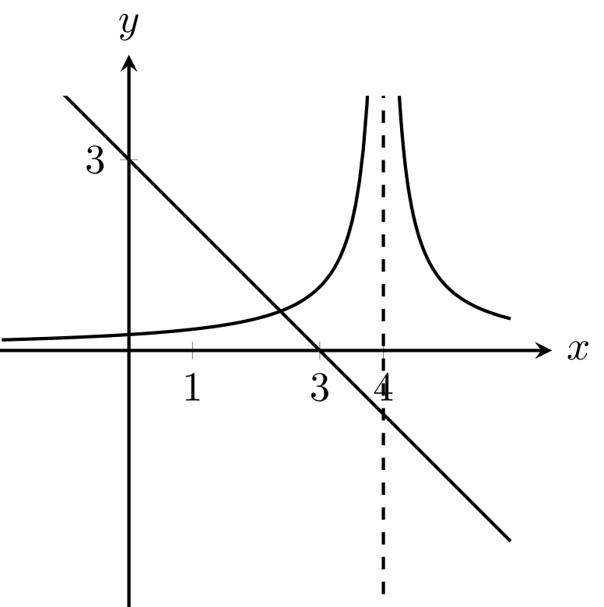
As , the inequality to be solved was . This led to the inequality , which could be solved using the quadratic formula. A number of students who found that did not receive full marks as they did not write the final answer in interval notation.
Students who approached this problem algebraically were often unsure how to deal with the inequality signs.

Question 5a.
Marks | 0 | 1 | 2 | 3 | Average
% | 17 | 12 | 27 | 44 | 2.0
Using the formula for the vector resolute, it is found that . This resulted in the quadratic equation giving as the solution ( is an integer).
Students who factorised to solve the quadratic equation were generally more successful than those who used the quadratic formula.

Question 5b.
Marks | 0 | 1 | Average
% | 73 | 28 | 0.3
Some students did not attempt this question as they were unable to find an integer value of in Question 5a. to use in their calculation. Of those who did attempt this question, arithmetic errors often caused them not to be awarded the mark.

Question 6a.
Marks | 0 | 1 | Average
% | 12 | 88 | 0.9
This question was answered very well. Students needed to demonstrate the use of the chain rule to find the (given) answer.

Question 6b.
Marks | 0 | 1 | 2 | Average
% | 25 | 66 | 9 | 0.8
Most students showed, by using the chain or quotient rules, that when . Few students attempted to justify that a point of inflection occurred at this point.

Question 6c.
Marks | 0 | 1 | 2 | Average
% | 26 | 22 | 51 | 1.3
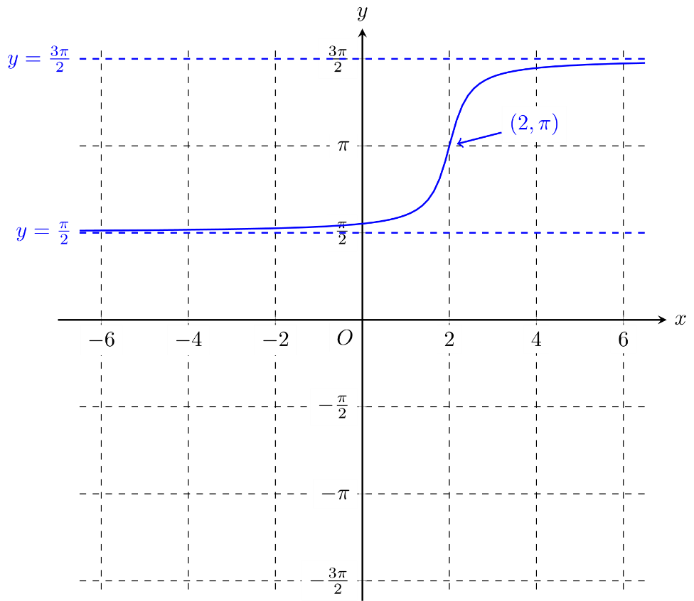
Most students sketched a smooth curve with the appropriate shape. The asymptotes and as well as the point of inflection needed to be labelled. The y-intercept was not required.
Students are reminded that when a grid is provided for them to draw their graphs, sufficient area should be utilised so that all features of the graph can be shown. Some students drew their graphs on such a limited domain that the asymptotic behaviour was not shown.

Question 7a.
Marks | 0 | 1 | 2 | Average
% | 33 | 7 | 60 | 1.3
,
This question was answered well. If is continuous at then .
Also and so in order for to be continuous at .

Question 7b.
Marks | 0 | 1 | 2 | 3 | Average
% | 17 | 14 | 16 | 54 | 2.1
This question involved routine integrals and was answered well.
A few students recognised that the region enclosed by the graph between and was a trapezium and so were able to avoid evaluating one of the integrals. Several students incorrectly applied results from the formula sheet. In particular,

Question 8
Marks | 0 | 1 | 2 | 3 | 4 | 5 | Average
% | 14 | 22 | 16 | 11 | 16 | 20 | 2.5
Many students identified the correct form of the partial fraction decomposition for the integrand:
This led to the integral
A number of students used a substitution to evaluate the integral

Question 9a.
Marks | 0 | 1 | 2 | Average
% | 16 | 35 | 49 | 1.3
,
Students needed to find and then square the result. As the result was given, students needed to show relevant working rather than just writing the answer.

Question 9b.
Marks | 0 | 1 | 2 | 3 | Average
% | 41 | 40 | 5 | 14 | 0.9
Many students could correctly substitute and into the formula for the arc length of a curve defined parametrically, which is given on the formula sheet.
Most students who successfully answered this question were able to identify the perfect square, which allowed the square root in the integrand to be removed. If s denotes the arc length then:
Few students who tried to write the term inside the square root as a single algebraic fraction were able to see the problem through to the conclusion. Transcription errors were noted in this question. Some students confused with , which led to incorrect results.

