2020 VCE Specialist Mathematics 2 examination report

General comments
In 2020 the Victorian Curriculum and Assessment Authority produced an examination based on the VCE Mathematics Adjusted Study Design for 2020 only.
The exam was comprised of 20 multiple-choice questions (worth a total of 20 marks) and five extended-answer questions (worth a total of 60 marks).
There were two questions (Questions 4bi. and 5bi.) where students needed to show that a given result was reached. In these cases, steps that led to the given result needed to be clearly and logically set out to obtain full marks.
Answers were generally given in the required forms; however, there were indications in Section B that students did not always correctly read and respond to questions, particularly where there was more than one aspect to the question. Examples of this were:
- Some students did not give the equation of the tangent to the path in Question 1bi. after correctly stating the required derivative.
- Some students did not state the radius in Question 2e. despite indications in their working that they had otherwise solved the problem.
- Not all required details on graphs were correctly given or values rounded appropriately.
The examination revealed areas of strength and weakness in student performance.
Areas of strength included:
- determining cartesian forms of parametrically defined curves
- expressing relations in the complex plane in cartesian form
- sketching the curve of a given function
- use of CAS technology.
Areas of weakness included:
- reading and responding to all aspects of questions
- appreciating the distinction between velocity and speed
- explicitly justifying an answer when required
- carefully noting changing conditions in a mechanics problem.

Specific information
This report provides sample answers or an indication of what answers may have included. Unless otherwise stated, these are not necessarily intended to be exemplary or complete responses.
The statistics in this report may be subject to rounding resulting in a total more or less than 100 per cent.

Section A
The table below indicates the percentage of students who chose each option. The correct answer is indicated by shading.
Question | % A | % B | % C | % D | % E | % N/A | Comments
1 | 4 | 8 | 6 | 70 | 11 | 0
2 | 18 | 42 | 24 | 10 | 5 | 0 | Use transformations on.
3 | 68 | 20 | 4 | 5 | 2 | 0
4 | 4 | 4 | 14 | 50 | 28 | 0 | Options C, D and E have the correct rule but only option E has the correct range. The range must include  as is a maximum at .
5 | 66 | 4 | 13 | 9 | 8 | 0
6 | 6 | 2 | 79 | 5 | 7 | 0
7 | 39 | 18 | 12 | 26 | 5 | 0 | Option A results from not considering that .
8 | 34 | 29 | 15 | 11 | 11 | 0
9 | 12 | 35 | 17 | 22 | 13 | 1
10 | 1 | 4 | 4 | 76 | 14 | 0
11 | 4 | 16 | 59 | 19 | 3 | 0
12 | 2 | 12 | 59 | 17 | 9 | 0
13 | 6 | 10 | 7 | 5 | 72 | 0
14 | 8 | 76 | 8 | 5 | 3 | 0
15 | 10 | 10 | 18 | 23 | 38 | 1 | Use then antidifferentiate twice to find the position vector.
16 | 3 | 10 | 15 | 69 | 3 | 0
17 | 21 | 58 | 11 | 5 | 5 | 1
18 | 8 | 7 | 7 | 11 | 67 | 1
19 | 3 | 72 | 9 | 8 | 7 | 1
20 | 43 | 27 | 9 | 10 | 10 | 1 | The reading on the spring balance is the magnitude of the upwards force on the object.

Section B

Question 1a.
Marks | 0 | 1 | 2 | Average
% | 14 | 12 | 73 | 1.6
This question was generally done well. Some students found the distance from the point when rather than from the origin.

Question 1bi.
Marks | 0 | 1 | 2 | 3 | Average
% | 12 | 9 | 22 | 56 | 2.2
Most students were able to correctly apply the chain rule to find the derivative in terms of t. Some students made a subsequent sign error, giving.

Question 1bii.
Marks | 0 | 1 | 2 | Average
% | 38 | 27 | 35 | 1.0
Many students gave the (scalar) magnitude of the velocity rather than the required velocity.

Question 1biii.
Marks | 0 | 1 | 2 | Average
% | 40 | 7 | 53 | 1.1
The magnitude of the acceleration is 3.
Errors here generally arose from using a form of in Question 1bii. rather than .

Question 1c.
Marks | 0 | 1 | Average
% | 30 | 70 | 0.7

Question 1d.
Marks | 0 | 1 | 2 | Average
% | 37 | 9 | 54 | 1.2
, correct to 3 decimal places.
Errors included missing dt or giving the distance to fewer decimal places than required.

Question 2a.
Marks | 0 | 1 | 2 | 3 | Average
% | 9 | 7 | 7 | 77 | 2.5
Most students were able to set up modulus expressions and successfully solve for y with or without the use of technology. Students who used a geometric approach were generally less successful.

Question 2b.
Marks | 0 | 1 | 2 | Average
% | 8 | 18 | 74 | 1.7
The diagram below shows the solutions to Question 2b. (the points and line) and Question 2di. (the ray).
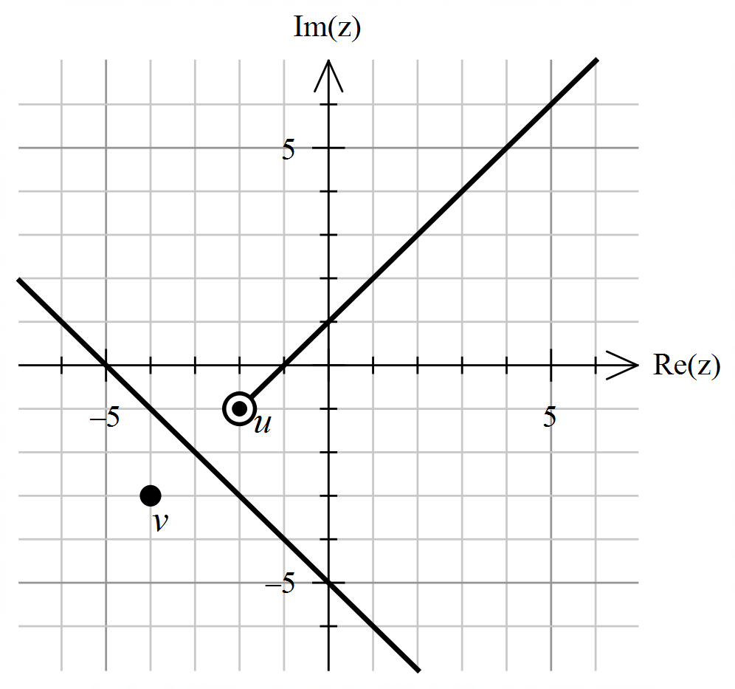
This question was generally done well. Some students who were unable to find the cartesian form in Question 2a. were still able to plot the relation using their geometric understanding.

Question 2c.
Marks | 0 | 1 | Average
% | 46 | 54 | 0.5
The line is the perpendicular bisector of the line segment joining the points represented by u and v.
A variety of reasonable responses were accepted. Insufficiently precise responses such as ‘a linear line’ or responses that did not explicitly interpret the line in relation to the points were not accepted.

Question 2di.
Marks | 0 | 1 | Average
% | 45 | 55 | 0.5
Refer to the diagram in Question 2b.
Incorrect responses frequently extended through the point representing u; in some cases, a line was sketched instead of a ray.

Question 2dii.
Marks | 0 | 1 | Average
% | 75 | 25 | 0.2
While a high proportion of students gave the correct rule, many did not fully describe the function as they did not include the domain.

Question 2e.
Marks | 0 | 1 | 2 | 3 | Average
% | 52 | 10 | 7 | 32 | 1.2
Students struggled with this question. While many were able to set up suitable cartesian or complex equations, fewer were then able to proceed further. Students familiar with the functionality of CAS were able to use it effectively. Some students correctly foundbut did not also state the radius.

Question 3a.
Marks | 0 | 1 | 2 | Average
% | 1 | 7 | 91 | 1.9
Students handled this question very well. Students who did not score well stated the derivative only and did not give the coordinates of the stationary points.

Question 3b.
Marks | 0 | 1 | Average
% | 27 | 73 | 0.7
Some students incorrectly gave an additional vertical asymptote such as.

Question 3c.
Marks | 0 | 1 | 2 | 3 | Average
% | 3 | 11 | 41 | 45 | 2.3

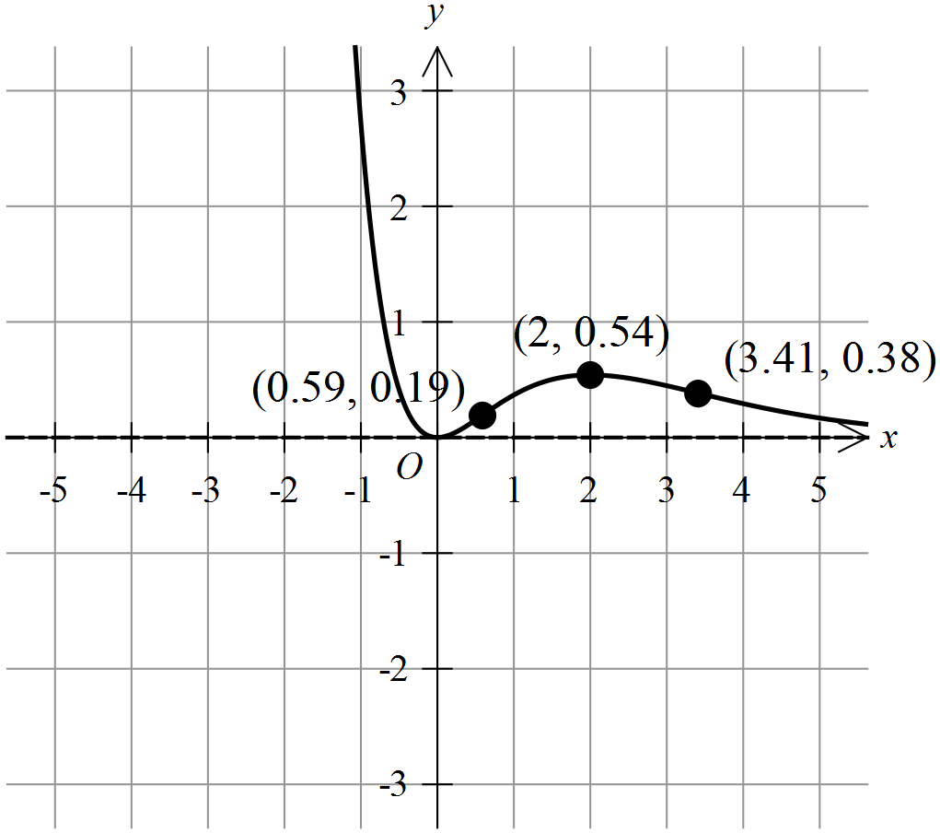
This question was done quite well, with the turning point almost universally correctly labelled and the points of inflection usually correctly labelled. However, students lost marks either for sketching a poor shape in the second quadrant or for incorrectly labelling points of inflection, including having the x-value of the left-most point of inflection rounded to 0.58 instead of 0.59.

Question 3d.
Marks | 0 | 1 | Average
% | 9 | 91 | 0.9
or
Students responded with a variety of correct forms for the second derivative, with the two above being the most common.

Question 3ei.
Marks | 0 | 1 | Average
% | 11 | 89 | 0.9
(restrictions not required)
Students generally handled this question well.

Question 3eii.
Marks | 0 | 1 | 2 | Average
% | 84 | 14 | 2 | 0.2

Number of points of inflection | Value(s) of n  (where )
0
1 | 1
2
3
Some students gave intervals of real numbers for n. The majority of responses indicated gave zero points of inflection andgave one point. However, very few students were able to distinguish between even and odd values of n when considering multiple points of inflection.

Question 4a.
Marks | 0 | 1 | 2 | 3 | Average
% | 15 | 19 | 19 | 47 | 2.0

Most students were able to make a satisfactory start by correctly finding the velocity. Of those who proceeded to find the speed, quite a few were unable to find the maximum speed.

Question 4bi.
Marks | 0 | 1 | 2 | Average
% | 14 | 8 | 78 | 1.6
This question was generally done well, with most students showing sufficient steps to obtain the given result.

Question 4bii.
Marks | 0 | 1 | 2 | 3 | Average
% | 12 | 11 | 22 | 55 | 2.2
The diagram below shows the solutions to Question 4bii. (the ellipse) and Question 4c. (the parabola) along with the required additional details.
Most students drew a correct ellipse, but the required information was not always correctly shown. The starting position and coordinates may have been missing or not made explicit or the direction of travel was not always indicated.

Question 4c.
Marks | 0 | 1 | 2 | 3 | Average
% | 25 | 6 | 17 | 52 | 1.9
Refer to the diagram in Question 4bii.
Most students sketched a parabola with the correct shape and intercepts; however, the coordinates of the points of intersection were occasionally rounded incorrectly.

Question 4d.
Marks | 0 | 1 | 2 | 3 | Average
% | 31 | 9 | 9 | 51 | 1.8
Students attempted a variety of satisfactory approaches. In addition to the approach above, many students listed all solutions within the domain for each equation, correctly noting that they had no solutions in common. It was not sufficient to simply assert that the pair of equations had no solution.

Question 5a.
Marks | 0 | 1 | 2 | Average
% | 19 | 29 | 52 | 1.3
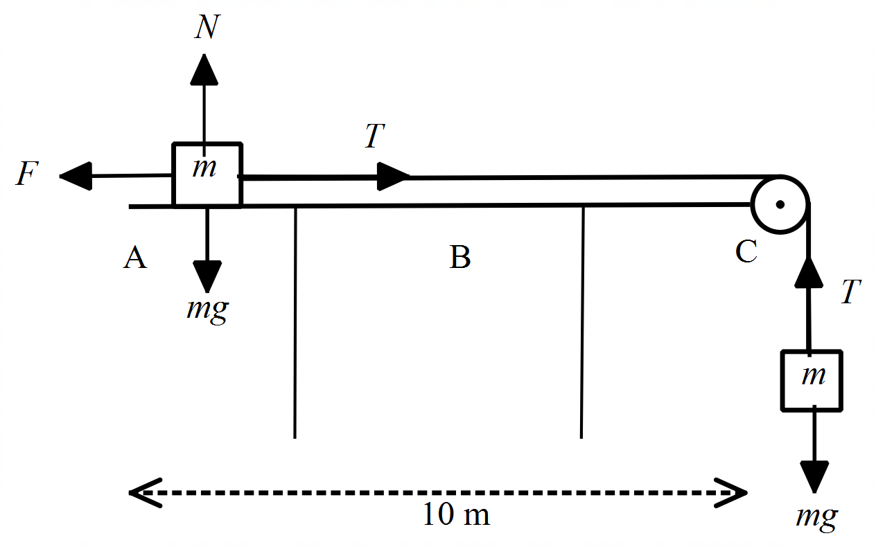
Students handled this question reasonably well. Common errors included not labelling the forces correctly or missing a force, most commonly the weight force or the normal contact force on the mass on the left.

Question 5bi.
Marks | 0 | 1 | 2 | Average
% | 28 | 5 | 67 | 1.4
In addition to the approach above, some students successfully used a ‘whole system’ approach. Errors included assuming equilibrium by equating T and mg or using m as the total mass of the system instead of 2m.

Question 5bii.
Marks | 0 | 1 | Average
% | 55 | 45 | 0.4
As the question states that , students were not required to indicate that . However, many responses included incorrect lower bounds such as or .

Question 5c.
Marks | 0 | 1 | 2 | Average
% | 27 | 19 | 54 | 1.3
Most students used constant acceleration formulas effectively, but a frequent issue was the incorrect simplification of answers. A variety of equivalent expressions were accepted.

Question 5d.
Marks | 0 | 1 | 2 | Average
% | 32 | 20 | 48 | 1.2
Students who obtained correct answers to Question 5c. were usually successful here.

Question 5e.
Marks | 0 | 1 | 2 | 3 | 4 | Average
% | 49 | 12 | 10 | 8 | 21 | 1.4
Many students did not attempt this question. Of those who did, errors included using constant acceleration formulas, failing to appreciate that the masses were no longer connected and inconsistencies in signs and directions.

