2021 VCE Specialist Mathematics 2 external assessment report

General comments
The 2021 VCE Specialist Mathematics examination 2 was comprised of 20 multiple-choice questions (worth a total of 20 marks) and six extended-answer questions (worth a total of 60 marks). Students may use approved CAS technology in this examination.
There were three questions (Questions 3bi., 4a. and 4d.) for which students needed to show how a given result was reached. In these cases, steps that led to the given result needed to be clearly and logically set out to obtain full marks.
Answers were generally given in the required forms; however, there were indications in Section B that students did not always correctly read and respond to questions, particularly where there was more than one aspect to the question. Examples of this were:
- many students did not provide all of the required information in their graph in Question 1c.
- some students gave only one of the required numbers in Question 3bii.
- some students did not give the required range of values in Question 6d.
The examination revealed areas of strength and weakness in student performance.
Areas of strength included:
- sketching relationships on the complex plane
- setting up a definite integral for the volume of a solid of revolution
- using the chain rule in a situation involving related rates
- drawing a force diagram
- use of CAS technology (students should be discerning in their technology use and are encouraged to have alternative approaches when their technology does not perform as desired).
Areas of weakness included:
- reading and responding to all aspects of questions
- using the correct angle to determine the gradient of a line
- explicitly justifying an answer when required
- carefully noting changing conditions in a mechanics problem.
It has been noted that an error in the text occurred within the context narrative on page 27. Although the word ‘mean’ was printed as ‘main’, the average marks and the student responses obtained across the cohort for question 6c. indicate that students were not disadvantaged by this.

Specific information
Note: This report provides sample answers, or an indication of what answers may have included. Unless otherwise stated, these are not intended to be exemplary or complete responses.
The statistics in this report may be subject to rounding resulting in a total more or less than 100 per cent.

Section A – Multiple-choice questions
The table below indicates the percentage of students who chose each option.
Question | Correct answer | % A | % B | % C | % D | % E | Comments
1 | B | 7 | 66 | 20 | 5 | 2
2 | E | 3 | 2 | 15 | 4 | 76
3 | E | 8 | 14 | 10 | 17 | 51
4 | A | 35 | 11 | 21 | 29 | 3
5 | D | 42 | 6 | 18 | 32 | 2
6 | A | 23 | 15 | 30 | 24 | 8 | The square of any z with the argument given in option A will be real.
7 | E | 9 | 18 | 10 | 23 | 39
8 | C | 5 | 10 | 72 | 8 | 5
9 | B | 18 | 38 | 12 | 9 | 22 | The antiderivative of the expression in option B is a quartic with a turning point but no point of inflection. Alternatively, the sign of the second derivative changes around x=3 for option B.
10 | D | 4 | 7 | 17 | 68 | 3
11 | B | 5 | 69 | 6 | 14 | 6
12 | D | 5 | 11 | 17 | 60 | 6
13 | E | 22 | 9 | 14 | 8 | 46
14 | D | 16 | 10 | 15 | 56 | 2
15 | A | 53 | 6 | 11 | 14 | 15
16 | B | 5 | 48 | 18 | 14 | 14
17 | E | 5 | 20 | 13 | 11 | 50
18 | C | 6 | 14 | 65 | 10 | 5
19 | D | 4 | 12 | 24 | 51 | 8
20 | C | 9 | 18 | 43 | 15 | 14

Section B

Question 1a.
Mark | 0 | 1 | Average
% | 21 | 79 | 0.8

Question 1b.
Mark | 0 | 1 | 2 | Average
% | 4 | 29 | 67 | 1.7
The most common error was to give only the vertical asymptotes, leaving out the horizontal asymptote.

Question 1c.
Mark | 0 | 1 | 2 | 3 | Average
% | 24 | 32 | 23 | 22 | 1.5
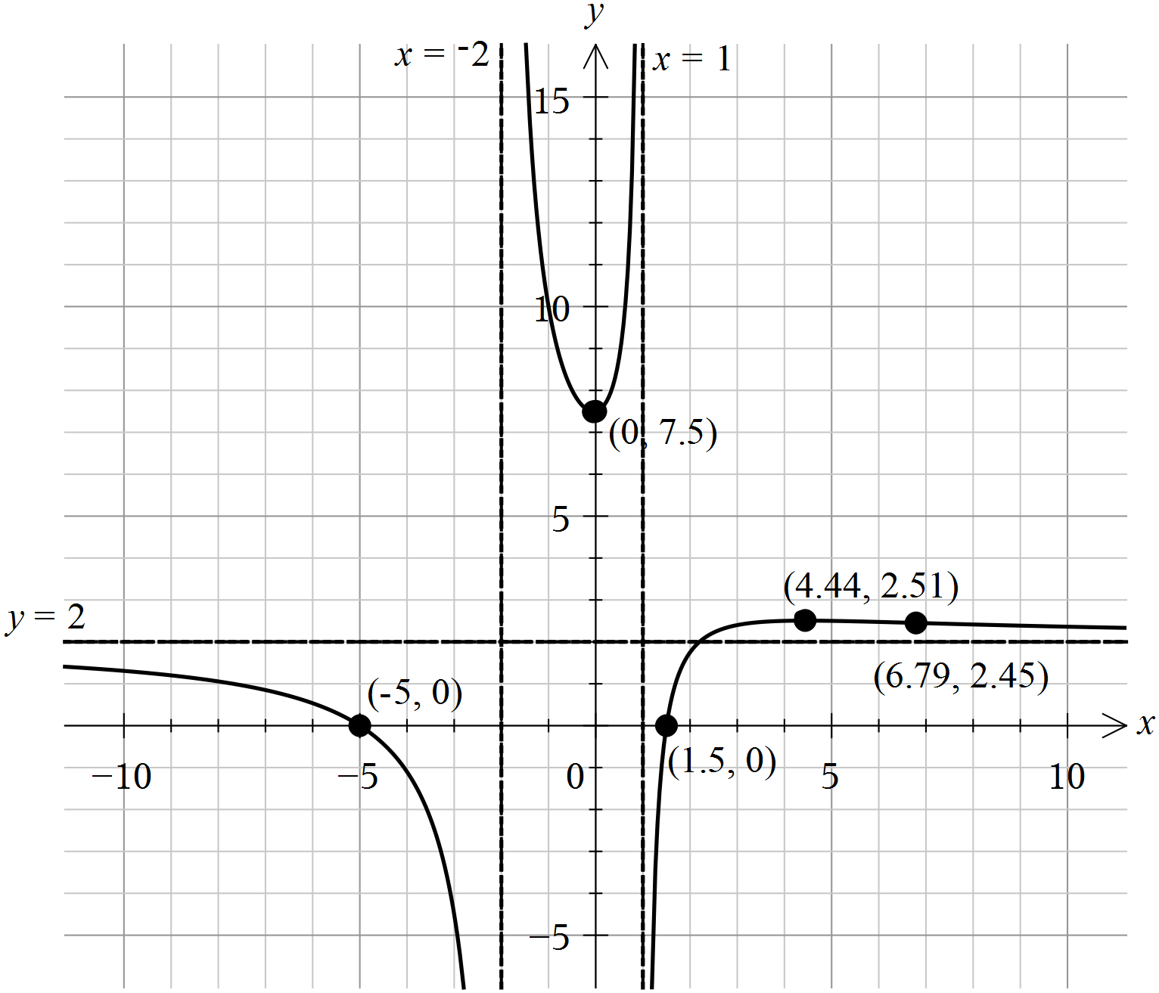

A significant number of responses did not include the middle branch. Setting the calculator screen to match the grid provided would help avoid this error. Many responses lacked at least one of the required details such as coordinates of the point of inflection or coordinates of one of the axial intercepts. Students need to read the question carefully and fully address the requirements of the question.

Question 1di.
Mark | 0 | 1 | 2 | Average
% | 58 | 36 | 6 | 0.5
Very few students gave all three values. Many responses included only one value: .

Question 1dii.
Mark | 0 | 1 | 2 | Average
% | 82 | 5 | 13 | 0.3
A common error was to include other incorrect values of k. Many students left this question blank.

Question 2ai.
Mark | 0 | 1 | Average
% | 27 | 73 | 0.8

Question 2aii.
Mark | 0 | 1 | 2 | 3 | Average
% | 28 | 39 | 10 | 23 | 1.3
Many students used in the expanded form, which was less productive than using the factorised form directly.
An alternative solution involving purely real z values was possible yielding .
Where working was correct and complete across Questions 2ai. and 2aii., these answers were accepted.

Question 2b.
Mark | 0 | 1 | 2 | Average
% | 41 | 28 | 31 | 0.9
The diagram below shows the solutions to Question 2b. (the ray) and Question 2ci. (the circle).
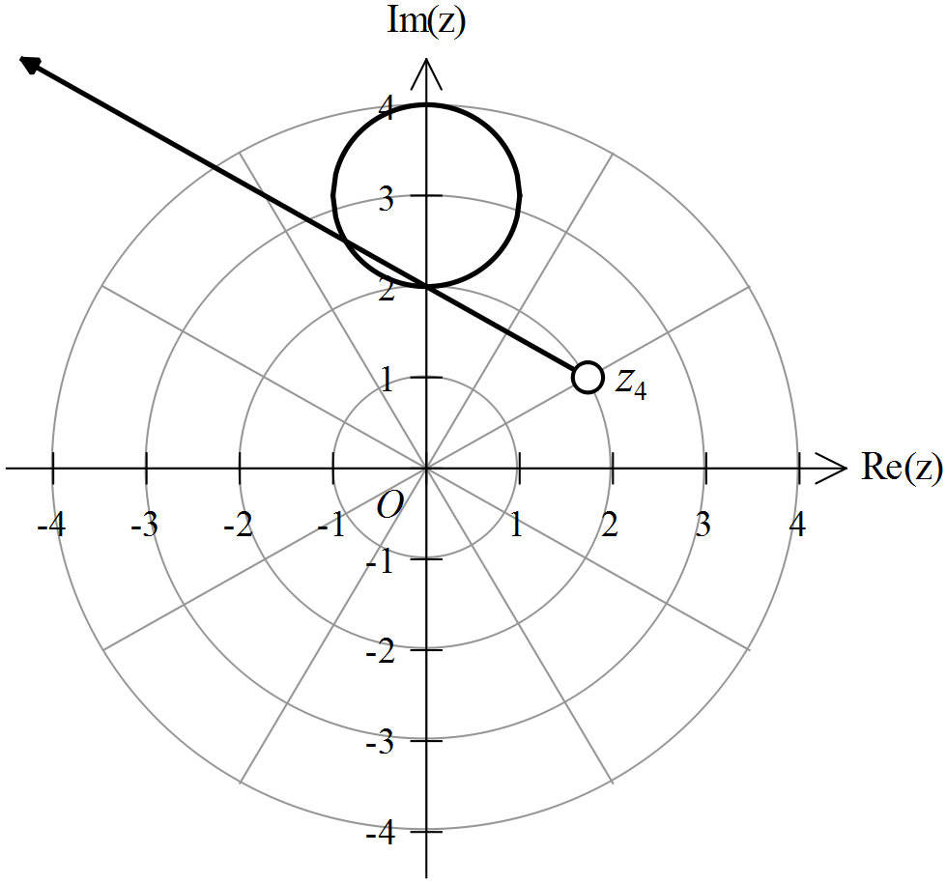
Where drawn, the ray generally had the correct argument. The point of emanation is not part of required ray and should be shown as an open circle. This was not always shown or placed correctly, sometimes due to an apparent lack of precision rather than an obvious mathematical error.

Question 2ci.
Mark | 0 | 1 | Average
% | 25 | 75 | 0.8
Refer to the diagram in Question 2b.

Question 2cii.
Mark | 0 | 1 | 2 | Average
% | 62 | 16 | 22 | 0.6
Students who scored highly correctly applied a segment area formula. A smaller proportion correctly used a definite integral. Some students who used an area formula, either of segments or triangles, had difficulty determining the required angle.

Question 3ai.
Mark | 0 | 1 | Average
% | 20 | 80 | 0.8

Question 3aii.
Mark | 0 | 1 | Average
% | 41 | 59 | 0.6
A variety of equivalent forms were accepted. A common error concerned notation, such as incorrectly placing 32 outside the bracket or using h rather than H.

Question 3bi.
Mark | 0 | 1 | 2 | Average
% | 10 | 12 | 77 | 1.7
Students handled this question well, correctly applying the chain rule to obtain the required form.

Question 3bii.
Mark | 0 | 1 | 2 | Average
% | 37 | 41 | 22 | 0.9

Question 3biii.
Mark | 0 | 1 | Average
% | 77 | 23 | 0.3
Equivalent forms, such as , were accepted. A number of students did not proceed past writing .

Question 3c.
Mark | 0 | 1 | 2 | 3 | Average
% | 77 | 9 | 2 | 12 | 0.5
Obtaining this answer required an appreciation of the physical situation, sound calculus skills and careful use of a CAS. Relatively few students made a productive start. Of those who did, about half reached the correct answer.

Question 4a.
Mark | 0 | 1 | Average
% | 43 | 57 | 0.6
Some students used the Pythagorean identity and eliminated , which was unproductive.

Question 4b.
Mark | 0 | 1 | 2 | Average
% | 51 | 10 | 40 | 0.9
Incorrect approaches using vector calculus were frequently seen. Some incorrect responses swapped the values when substituting into the cartesian equation. Some students who were unsuccessful in Question 4a. used the given cartesian equation and gained full marks in this question.

Question 4c.
Mark | 0 | 1 | 2 | 3 | Average
% | 80 | 9 | 5 | 6 | 0.4
Many students did not provide a response. Very few students were able to use the information given to state two correct equations. Of those that showed some working, a common error was to incorrectly use , rather than the correct , or .
It should be noted that can be isolated by hand by solving the simultaneous equations by elimination.

Question 4d.
Mark | 0 | 1 | 2 | Average
% | 50 | 19 | 31 | 0.8
A number of incorrect responses inappropriately used a constant acceleration formula. Of those that correctly used an appropriate form of acceleration, a number did not explicitly include a constant of integration or demonstrate that to show the given result.

Question 4e.
Mark | 0 | 1 | 2 | 3 | Average
% | 87 | 10 | 1 | 3 | 0.2
Distance from A to B: ,
Let d be the distance before B and u be the speed at W.

Question 5a.
Mark | 0 | 1 | 2 | Average
% | 43 | 11 | 46 | 1.0
Many students did not appreciate that here.

Question 5bi.
Mark | 0 | 1 | Average
% | 35 | 65 | 0.7
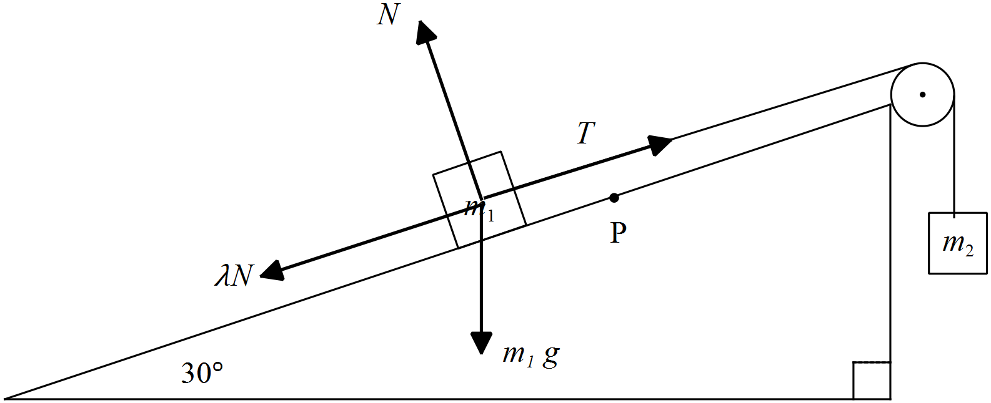
This was generally well done. The most common error was showing resistance acting up the plane or omitting one of the forces.

Question 5bii.
Mark | 0 | 1 | 2 | Average
% | 39 | 37 | 24 | 0.9
A variety of correct equivalent forms were given. Common errors here included assuming or not using .

Question 5c.
Mark | 0 | 1 | 2 | Average
% | 78 | 11 | 11 | 0.4
Many incorrect solutions had acceleration in terms of or T. There was evidence of confusion between the initial and final velocities.

Question 5d.
Mark | 0 | 1 | 2 | 3 | Average
% | 87 | 8 | 2 | 3 | 0.2
A common error was to assume that time for the motion down the plane was the same as for up the plane. Only a minority of students took account of the change of direction of the resistance force.

Question 6a.
Mark | 0 | 1 | 2 | Average
% | 73 | 13 | 14 | 0.4
Weight of n people,
Successful students used a trial-and-error approach or used a standardised value to solve for n. A common error was to approach this as a sampling problem with .

Question 6b.
Mark | 0 | 1 | 2 | Average
% | 73 | 3 | 24 | 0.5
Time to make 4 cups of coffee:
There was evidence of confusion between the correct sum of four random variables and incorrectly scaling a random variable by a factor of four.

Question 6ci.
Mark | 0 | 1 | Average
% | 25 | 75 | 0.8
Most students correctly stated the hypotheses for a one-sided test.

Question 6cii.
Mark | 0 | 1 | Average
% | 30 | 70 | 0.7
Students generally handled this question well.

Question 6ciii.
Mark | 0 | 1 | Average
% | 45 | 55 | 0.6
As , the campaign was effective.
Some students stated a correct conclusion but did not give a reason by referencing the p-value.

Question 6d.
Mark | 0 | 1 | Average
% | 84 | 16 | 0.2
Using inverse normal distribution, .
Some students calculated 63,108.7 but did not proceed to answer the question correctly as a range of values.

Question 6e.
Mark | 0 | 1 | 2 | Average
% | 89 | 2 | 9 | 0.2
Critical value for for on the right tail is
Most students who found were able to go on to find the required probability.

