2022 VCE Specialist Mathematics 1 external assessment report

General comments
The 2022 VCE Specialist Mathematics 1 examination was comprised of 10 questions worth a total of 40 marks.
Students were not permitted to bring technology or notes into the examination.
Questions 1, 2, 3b., 5a. and 6a. were among the highest scoring questions. A smaller proportion of students were able to obtain full marks on Questions 3a., 4, 7, 9 and 10a.
There were no ‘show that’ questions on this examination. However, in Questions 1a., 7 and 10b., students were required to give their answer in a specified form. This can give students both guidance towards the answer and confidence that their solution is correct.
Areas of strength included:
- integration (Questions 2, 4, 8, 9 and 10b.); in particular, students often made appropriate use of substitutions, terminals, rarely missed (or similar) terms and included arbitrary constants where needed
- basic vectors (Question 6)
- kinematics and mechanics (Questions 5 and 8).
Areas of weakness included:
- probability (Question 3a.)
- poor manipulation of the integrand in Question 4
- the decision made by students to expand the trigonometric term using trigonometric identities prior to implicit differentiation in Question 7. This resulted in quite onerous manipulation of trigonometric terms being required.
Quite a few students set up the differential equations in Questions 2 and 9 as definite integrals. While the method is sound, students need to use a ‘dummy’ variable in such problems. The majority of students who successfully solved these problems approached them using a more traditional method.

Specific information
This report provides sample answers or an indication of what answers may have included. Unless otherwise stated, these are not intended to be exemplary or complete responses.
The statistics in this report may be subject to rounding resulting in a total more or less than 100 per cent.

Question 1a.
Mark | 0 | 1 | Average
% | 21 | 79 | 0.8
This question was answered well, with most students recognising the need to complete the square. Some arithmetic errors were observed.

Question 1b.
Mark |  |  |  |  | 0 | 1 | 2 | Average
% | 10 | 19 | 70 | 1.6
Students could either use the result from Question 1a. as shown above or use the quadratic formula to find the solution to the equation.

Question 2
Mark | 0 | 1 | 2 | 3 | Average
% | 12 | 19 | 9 | 60 | 2.2
A small number of students correctly separated and integrated to find an answer in terms of inverse cosine leading to the result .
This question was answered well with most students recognising and attempting to solve the separable differential equation.

Question 3a.
Mark | 0 | 1 | 2 | Average
% | 59 | 9 | 31 | 0.7
The time to dispense four cups of coffee is a normally distributed random variable with a mean of 40 seconds and a standard deviation of 3 seconds.
If , then the probability that the wait time is greater than 34 is
Rounding to two decimal places gives 0.98.
A large number of students did not find the correct standard deviation and so were unable to move towards evaluating while others were unable to determine . Students who successfully evaluated often drew diagrams of the probability density function and were aware of the approximate probabilities for a normal distribution.

Question 3b.
This question has been redacted following the findings of the Independent Review into the VCAA’s Examination-Setting Policies, Processes and Procedures for the VCE.

Question 4
Mark | 0 | 1 | 2 | 3 | 4 | Average
% | 21 | 6 | 7 | 29 | 36 | 2.5
The appropriate partial fraction decomposition for the integrand was
A small number of students realised that
This removed the need to use partial fractions. Many students used elements of both the above methods with some initial algebraic work followed by one or more applications of partial fractions. Such approaches were inefficient and often resulted in students doing significantly more work than would otherwise be required.
A number of students did not include absolute value signs in the logarithmic term or failed to include the arbitrary constant in their answer. A small number of students integrated incorrectly.

Question 5a.
Mark | 0 | 1 | 2 | Average
% | 20 | 25 | 55 | 1.3
The acceleration of the mass down the plane is where . Therefore . The result is obtained using the constant acceleration formula (or equivalent).
This question was answered well with a number of equivalent correct answers given by students. Successful students often annotated the diagram in order to resolve the forces.

Question 5b.
Mark | 0 | 1 | Average
% | 52 | 48 | 0.5
Equivalent answers were acceptable.

Question 6a.
Mark | 0 | 1 | 2 | Average
% | 12 | 11 | 76 | 1.6
This question was answered very well. A majority of students utilised the approach shown above. Some arithmetic errors were observed.

Question 6bi.
Mark | 0 | 1 | Average
% | 39 | 61 | 0.6
This question was answered well. Occasional sign errors were made.

Question 6bii.
Mark | 0 | 1 | 2 | 3 | Average
% | 27 | 15 | 10 | 47 | 1.8
Therefore, the vectors and are perpendicular.
In this question students were required to make use of the scalar (dot) product. Some algebraic errors were made and incorrect conclusions drawn.

Question 7
Mark | 0 | 1 | 2 | 3 | Average
% | 33 | 18 | 15 | 34 | 1.5
Differentiating implicitly using the chain and product rules gives
Substituting and gives
Therefore
A large number of students used a trigonometric identity to expand before differentiating. Only a minority of students who used this approach were able to find the correct answer, with many students finding themselves overwhelmed by the large number of terms produced using this method.

Question 8
Mark | 0 | 1 | 2 | 3 | 4 | Average
% | 29 | 7 | 6 | 22 | 37 | 2.3
When , and so .
Therefore
choosing the negative square root as when .
Many students were able to use an appropriate acceleration equivalent, either or .
A number of students chose the incorrect sign for their final answer.

Question 9
Mark | 0 | 1 | 2 | 3 | 4 | Average
% | 32 | 10 | 15 | 10 | 34 | 2.0
With ,
When :

Therefore
Alternative correct answers were acceptable.
A number of students attempted to manipulate the integrand using trigonometric identities prior to integration, often with little success. Of those who used an appropriate substitution, errors including integrating to get or were often seen.

Question 10a.
Mark | 0 | 1 | 2 | 3 | Average
% | 23 | 17 | 46 | 13 | 1.5
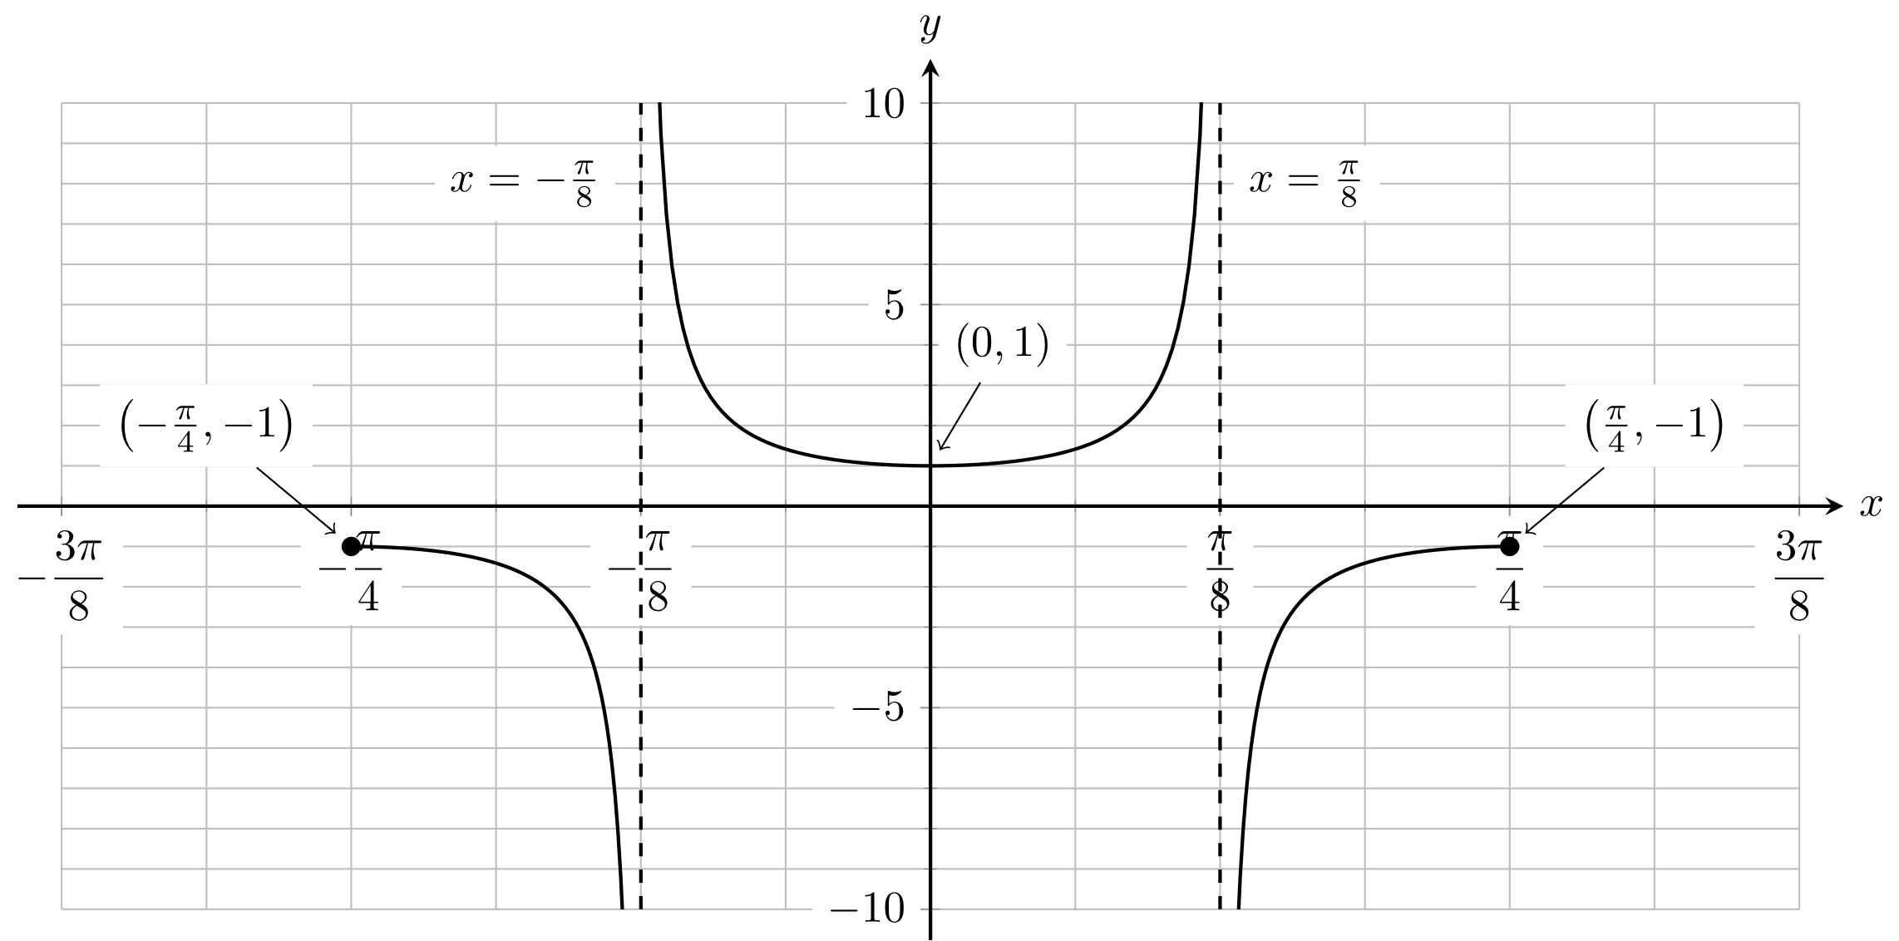
Many students correctly identified the vertical asymptotes, turning point and endpoints. Occasionally a horizontal asymptote was implied. Some graphs were drawn inaccurately, showing the wrong shape or failing to be symmetric around the vertical axis.

Question 10b.
Mark | 0 | 1 | 2 | 3 | Average
% | 15 | 29 | 31 | 25 | 1.7
Equivalent answers in the correct form such as were acceptable.
Most students wrote down a correct integral for the volume of revolution and many made progress by realising that was an antiderivative of .
Students needed to determine the value of . The most common approaches were via a double angle formula involving or recognising that . Some students had difficulty solving the quadratic equation arising from the double angle formula or chose the wrong solution.
Students who used the difference formula often ran into arithmetic difficulties.

