2022 VCE Specialist Mathematics 2 external assessment report

General comments
The examination was comprised of 20 multiple-choice questions (worth a total of 20 marks) and six extended-answer questions (worth a total of 60 marks). Students were permitted to use approved CAS technology in this examination.
There were four questions (Questions 2ai., 3aii., 5a. and 5c.) for which students needed to show that a given result was reached. In these cases, steps that led to the given result needed to be clearly and logically set out to attract full marks.
Answers were generally given in the required forms; however, there were indications in Section B that students did not always correctly read and respond to questions, particularly where there was more than one aspect to the question. Examples of this were:
- many students did not sketch the ray in Question 2c.
- some students did not plot the required point in Question 3bii.
- some students did not give the required time in Question 4bii.
The examination revealed areas of strength and weakness in student performance.
Areas of strength included:
- determining asymptotes and sketching rational functions
- working with speed and velocity involving vector functions of time
- resolving forces and setting up and solving equations of motion
- using the chain rule in a situation involving related rates
- hypothesis testing
- use of CAS technology.
Areas of weakness included:
- reading and responding to all aspects of questions
- considering limiting behaviour of a function involving inverse tangent
- working with random variables that are functions of other variables.

Specific information
This report provides sample answers or an indication of what answers may have included. Unless otherwise stated, these are not intended to be exemplary or complete responses.
The statistics in this report may be subject to rounding, resulting in a total of more or less than 100 per cent.

Section A – Multiple-choice questions
Question | Correct answer | % A | % B | % C | % D | % E | Comments
1 | B | 2 | 85 | 8 | 3 | 3
2 | E | 2 | 18 | 7 | 13 | 59
3 | E | 41 | 5 | 8 | 8 | 38 | so only one vertical asymptote in this instance.
4 |  |  |  |  |  |  | This question has been redacted following the findings of the Independent Review into the VCAA’s Examination-Setting Policies, Processes and Procedures for the VCE.
5 | A | 62 | 14 | 4 | 11 | 9
6 | E | 9 | 9 | 10 | 12 | 59
7 | D | 2 | 23 | 5 | 68 | 2
8 | C | 3 | 13 | 74 | 6 | 4
9 | B | 7 | 66 | 13 | 8 | 6
10 | E | 38 | 7 | 23 | 10 | 21 | At , .  Both of these, with lead to a negative value of .
11 | A | 66 | 6 | 15 | 8 | 4
12 | A | 69 | 7 | 12 | 5 | 6
13 | B | 3 | 76 | 10 | 4 | 6
14 | D | 9 | 7 | 49 | 28 | 7
15 | E | 6 | 15 | 49 | 4 | 26 | Option C is incorrect as the particle may be accelerating and moving up the plane.
16 | A | 17 | 63 | 8 | 9 | 3 | The angle between the head and tail of the 5 and 7 N forces is .
17 | C | 4 | 6 | 74 | 14 | 2
18 | B | 16 | 42 | 13 | 14 | 15
19 |  |  |  |  |  |  | This question has been redacted following the findings of the Independent Review into the VCAA’s Examination-Setting Policies, Processes and Procedures for the VCE.
20 | C | 13 | 24 | 41 | 12 | 8 | Requires the probability that the total mass on the right is greater than the total mass on the left.

Section B

Question 1a.
Mark | 0 | 1 | 2 | Average
% | 2 | 18 | 81 | 1.8
Generally well done.

Question 1b.
Mark | 0 | 1 | 2 | 3 | Average
% | 6 | 23 | 28 | 43 | 2.1
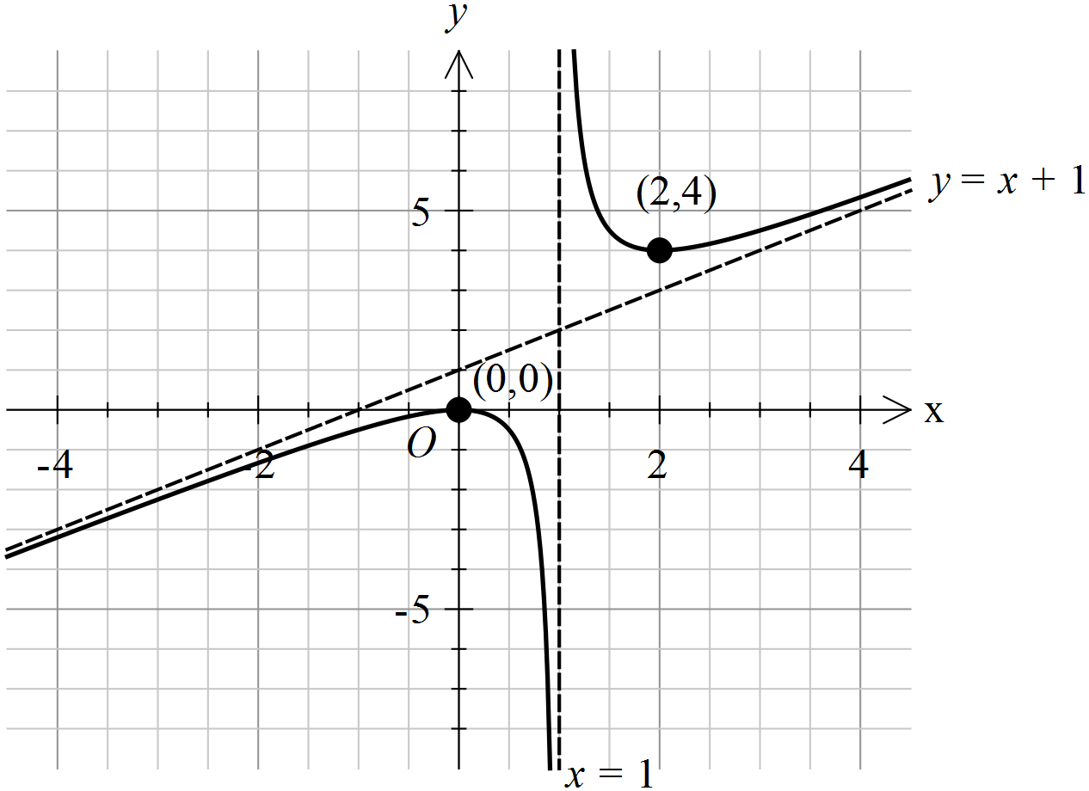
Setting the calculator screen to match the grid provided will help students sketch graphs correctly. Some responses did not show appropriate asymptotic behaviour. The oblique asymptote was occasionally sketched hastily without due regard to accurate position.

Question 1ci.
Mark | 0 | 1 | Average
% | 24 | 76 | 0.8
Success in parts 1a. and 1b. was generally followed by correct responses here.

Question 1cii.
Mark | 0 | 1 | 2 | Average
% | 22 | 33 | 45 | 1.2
Turning points and
Distance
Students generally applied a distance formula successfully, but many did not restrict their final answer to positive values.

Question 1di.
Mark | 0 | 1 | 2 | Average
% | 19 | 36 | 45 | 1.3
Most students found correct terminals and stated integrals with the factor of and the operator. A significant number of responses incorrectly contained the integrand , i.e. students stated the square of the difference rather than the difference of the squares.

Question 1dii.
Mark | 0 | 1 | Average
% | 63 | 37 | 0.4
As expected, most students who answered part 1di. correctly were successful here, but some students who correctly included in their integral earlier did not include it in their evaluation of the volume.

Question 2ai.
Mark | 0 | 1 | 2 | Average
% | 27 | 39 | 34 | 1.1
In a ‘show that’ question, students are required to clearly and logically show the steps that lead to the given result. A number of students apparently used a CAS to solve the given equation and then substituted their answers, again using CAS to verify the given result.

Question 2aii.
Mark | 0 | 1 | Average
% | 31 | 69 | 0.7
Most students gave at least one correct answer; some students gave the negatives of the values provided.

Question 2b.
Mark | 0 | 1 | 2 | Average
% | 20 | 20 | 60 | 1.4
The diagram below shows the solutions to Question 2b. (the points) and Question 2c. (the ray).
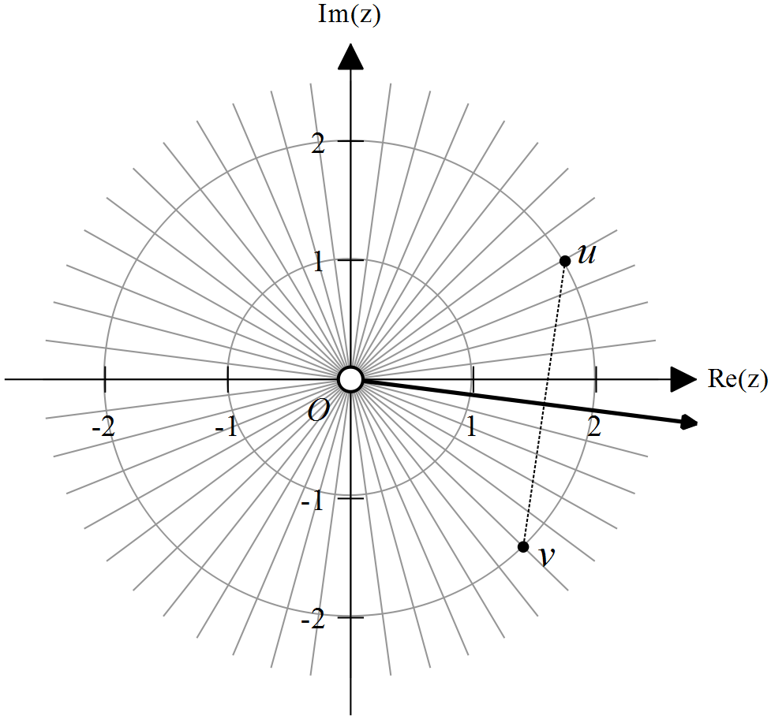
Some students appeared to use the Cartesian values to plot the approximate position of the points rather than the more successful approach of considering the polar form, resulting in accurate positions. Students should be aware of the polar grid provided, which enables them to plot the required points precisely. Most students labelled their points.

Question 2c.
Mark | 0 | 1 | 2 | Average
% | 48 | 27 | 25 | 0.8
A common incorrect argument was . Many students did not draw a ray; in some cases this appeared to be an unfortunate slip as some of these gave a correct argument.

Question 2d.
Mark | 0 | 1 | 2 | Average
% | 52 | 16 | 32 | 0.8
Most successful students correctly applied a segment area formula. A smaller proportion correctly used a definite integral but this approach usually led to error. Some students who used an area formula, either of segments or triangles, had difficulty.

Question 3ai.
Mark | 0 | 1 | Average
% | 15 | 85 | 0.9

Question 3aii.
Mark | 0 | 1 | 2 | Average
% | 17 | 10 | 73 | 1.6
This question was generally well responded to. Errors involving fractions in the initial integration were apparent.

Question 3bi.
Mark | 0 | 1 | Average
% | 77 | 23 | 0.2
Relatively few students gave a correct response. Common incorrect responses were or .

Question 3bii.
Mark | 0 | 1 | 2 | Average
% | 19 | 50 | 31 | 1.1
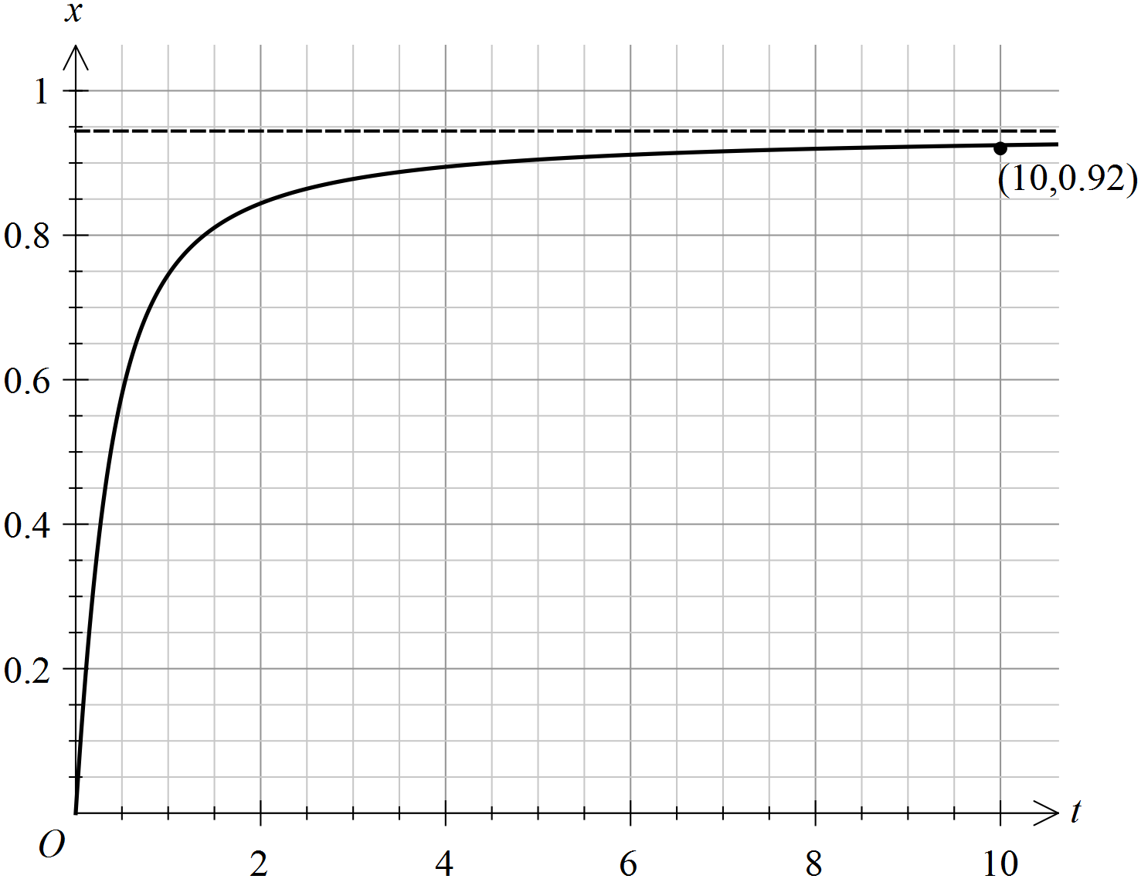
A significant number of responses lacked the required precision.

Question 3c.
Mark | 0 | 1 | Average
% | 21 | 79 | 0.8

Question 3d.
Mark | 0 | 1 | Average
% | 23 | 77 | 0.8
Alternatively, many students correctly substituted into the two expressions, quickly verifying the required result.

Question 3e.
Mark | 0 | 1 | 2 | Average
% | 27 | 12 | 50 | 1.1
A variety of correct equivalent expressions were seen depending on CAS tools used.

Question 4a.
Mark | 0 | 1 | 2 | Average
% | 44 | 21 | 35 | 0.9
Other successful approaches involved using the parametric expressions to find using the chain rule. Some students successfully used the scalar product . The complementary angle, was the most frequent incorrect response.

Question 4bi.
Mark | 0 | 1 | 2 | Average
% | 22 | 5 | 73 | 1.5
This question was well responded to, including by some students who did not find the velocity in Question 4a.

Question 4bii.
Mark | 0 | 1 | 2 | Average
% | 43 | 8 | 49 | 1.1
Minimum speed = 2 when t = 2.
Some students with a correct minimum speed gave other incorrect values of t.

Question 4c.
Mark | 0 | 1 | 2 | 3 | Average
% | 50 | 3 | 9 | 38 | 1.4
A small number of students approached the question using perpendicularity, but this was less frequently successful.

Question 4d.
Mark | 0 | 1 | 2 | Average
% | 49 | 6 | 45 | 1.0
A number of incorrect student responses incorrectly found the straight-line distance between the endpoints of the travel. Some students used the Cartesian form of the curve to find the integrand, but very few of these used the correct limits, incorrectly using the time values.

Question 5a.
Mark | 0 | 1 | 2 | Average
% | 14 | 14 | 72 | 1.6
This question was quite well done. Some students did not clearly or logically show the steps required for a question with the ‘show that’ command term. Some responses had trigonometry errors, such as confusing sine and cosine.

Question 5b.
Mark | 0 | 1 | Average
% | 29 | 71 | 0.7
7.5
While most students successfully found the change of momentum, some students incorrectly used an initial velocity of zero.

Question 5c.
Mark | 0 | 1 | 2 | Average
% | 30 | 12 | 58 | 1.3
Just as in other ‘show that’ questions, sufficient detail was required. Students that used a calculus approach frequently neglected to reckon with constants of integration.

Question 5d.
Mark | 0 | 1 | 2 | Average
% | 26 | 7 | 66 | 1.4
Some students correctly applied a calculus approach or an alternative constant acceleration formula. As in Question 5b., some students incorrectly set .

Question 5e.
Mark | 0 | 1 | 2 | 3 | Average
% | 43 | 11 | 11 | 35 | 1.4
A number of students did not acknowledge the fact that the stated forces no longer acted on the mass.

Question 6a.
Mark | 0 | 1 | Average
% | 15 | 85 | 0.9
Some incorrect responses involved hypotheses for a two-tailed test.

Question 6b.
Mark | 0 | 1 | Average
% | 22 | 78 | 0.8

Question 6c.
Mark | 0 | 1 | Average
% | 29 | 71 | 0.7
As the claim is not supported.
Generally well done but some students did not justify their response with reference to the p value.

Question 6d.
Mark | 0 | 1 | Average
% | 40 | 60 | 0.7
14.95
Students generally responded well to this question. Some transcription errors were apparent, giving 14.59 as the answer.

Question 6e.
Mark | 0 | 1 | 2 | Average
% | 48 | 12 | 40 | 0.6
Most students understood that the difference meant that . Some students stated a correct conclusion but did not give a reason by referencing the p value.

Question 6f.
This question has been redacted following the findings of the Independent Review into the VCAA’s Examination-Setting Policies, Processes and Procedures for the VCE.

