2023 VCE Specialist Mathematics 1 external assessment report

General comments
The 2023 VCE Specialist Mathematics Examination 1 comprised 10 questions worth a total of 40 marks.
New topics tested in 2023 included integration by parts (Question 5), area of a surface of revolution (Question 7), proof by induction (Question 8) and planes (Question 9). While some students had difficulty with proof by induction, a majority of students were able to demonstrate that they understood what was required in the questions on the new topics.
Many of the questions in this paper required students to show appropriate working, which may include algebraic manipulation, solving equations or using calculus. To attract full marks, it was important that students didn’t omit steps or otherwise abbreviate their working.
Areas of strength included:
- sketching rational functions (Question 1b.)
- integration by parts (Question 5)
- calculating the mean and standard deviation of the sum of independent random variables (Question 6a.)
- using substitution techniques to evaluate integrals (Question 7)
- working with planes and evaluating cross products (Question 9)
- using trigonometric identities (Question 10).
Areas of weakness included:
remembering to use an alternative form for acceleration, for example (Question 3a.)
- evaluating simple limits (Question 3b.)
- using the product and/or chain rule when performing implicit differentiation (Question 4)
- proof by induction (Question 8).

Specific information
Note: This report provides sample answers, or an indication of what answers may have been included. Unless otherwise stated, these are not intended to be exemplary or complete responses.
The statistics in this report may be subject to rounding resulting in a total more or less than 100 per cent.

Question 1a.
Mark | 0 | 1 | Average
% | 13 | 87 | 0.9
This question was answered well. Various approaches were seen, including long and synthetic division. Some students made algebraic or arithmetic errors in their calculations.

Question 1b.
Mark | 0 | 1 | 2 | 3 | Average
% | 18 | 20 | 23 | 39 | 1.9
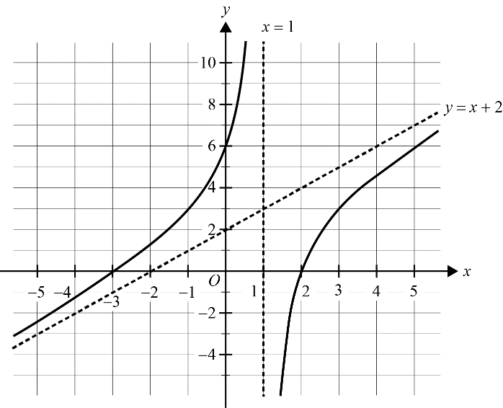
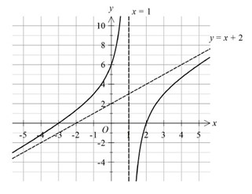
The graph needed to have both asymptotes, and , correct and labelled. While the axial intercepts did not need to be labelled, the graph line needed to pass through the correct points.
Some graphs did not display asymptotic behaviour, retreating from the asymptotes. The oblique asymptote was sometimes missing, even when a graph with reasonable asymptotic behaviour was drawn.

Question 2
Mark | 0 | 1 | 2 | 3 | Average
% | 38 | 14 | 11 | 37 | 1.5
and so .
Some students used graphical approaches or expanded; for example,
If then since .

Question 3a.
Mark | 0 | 1 | 2 | Average
% | 44 | 21 | 35 | 0.9
Students needed to use an appropriate alternative form for acceleration:
When , .
A smaller number of students evaluated when to obtain the same result.
A large number of students evaluated at and proceeded no further.

Question 3b.
Mark | 0 | 1 | Average
% | 50 | 50 | 0.5
Some students separated the fraction to find the limit:
Other students divided both the numerator and denominator by to find the limit.
Many students wrote for their answer or .

Question 4
Mark | 0 | 1 | 2 | 3 | Average
% | 25 | 6 | 32 | 37 | 1.8
Using implicit differentiation,
At the point ,
and so
Alternative approaches were possible.
Students were required to demonstrate appropriate use of the product and/or chain rule (depending on the approach taken). This was often not done well. Students who performed the implicit differentiation well were often able to proceed through to the answer.

Question 5
Mark | 0 | 1 | 2 | 3 | Average
% | 23 | 10 | 14 | 53 | 2.0
Using integration by parts,
Integration by parts is a new topic for 2023 and many students were able to answer this question reasonably well.
Some students did not consistently evaluate the definite integral, and some final responses included the independent variable .
A number of students selected the function to differentiate and the function to antidifferentiate incorrectly. Some idiosyncratic methods were also observed.

Question 6a.
Mark | 0 | 1 | 2 | Average
% | 6 | 19 | 75 | 1.7
, and
So
and
While many students correctly found the mean, a large number of students gave the standard deviation as (the sum of the standard deviations of the random variables).

Question 6b.
Mark | 0 | 1 | 2 | Average
% | 47 | 13 | 40 | 0.9
Then
Therefore and . The symmetric result, and , was not often seen.
This question was not answered well. A common error was to use an incorrect standard deviation:
and were seen frequently.

Question 7
Mark | 0 | 1 | 2 | 3 | 4 | Average
% | 17 | 24 | 13 | 15 | 31 | 2.2
The area of the surface is
Letting , the integral becomes
Depending on how students elected to manipulate the integrand, various substitutions would lead to the same result. A small number of students successfully expressed the curve in Cartesian form and evaluated an appropriate integral to obtain the correct result.
Some students did not use a substitution and instead tried to rely on inspection or recognition to find an antiderivative. This approach was not always successful. Doing an explicit substitution was the more reliable approach.

Question 8
Mark | 0 | 1 | 2 | 3 | 4 | Average
% | 16 | 17 | 39 | 9 | 21 | 2.1
and so the statement is true for .
Assume that the statement is true for some . That is
then
and so the statement is true for .
Therefore, by the principle of mathematical induction, the statement is true for all .
Many students were able to begin the proof by showing the base step and making an assumption for the case. Students were then required to differentiate with respect to to show that the case followed. A number of students either did not differentiate the function or differentiated incorrectly. Many students appeared to be thinking of index laws and assumed that was equal to .

Question 9a.
Mark | 0 | 1 | Average
% | 9 | 91 | 0.9
This question was answered very well.

Question 9b.
Mark | 0 | 1 | Average
% | 9 | 91 | 0.9
and
This question was also answered well and allowed students to confirm their answer from part 9a.

Question 9c.
Mark | 0 | 1 | 2 | Average
% | 21 | 23 | 56 | 1.4
A vector normal (perpendicular) to the plane is
Therefore, the Cartesian equation of the plane is
or
Most students realised that a cross product could be used to find a vector perpendicular to the plane. Some arithmetic errors were seen, both in the calculation of the cross product and in the substitution of a point to find the Cartesian equation of the plane.

Question 9d.
Mark | 0 | 1 | Average
% | 38 | 62 | 0.6
If lies on the plane then
This question was answered well, with students realising that they needed to substitute the coordinates of into the equation of the plane and solve the resulting linear equation.

Question 9e.
Mark | 0 | 1 | Average
% | 43 | 57 | 0.6
The area of the parallelogram is
A small number of students gave the area of rather than of the parallelogram. A common error was to calculate the area of the parallelogram by computing the product .

Question 10a.
Mark | 0 | 1 | Average
% | 20 | 80 | 0.8
This question was answered very well. A small number of students gave as their answer.

Question 10b.
Mark | 0 | 1 | 2 | Average
% | 25 | 6 | 69 | 1.4
So
therefore
Students needed to use a double angle formula to express in terms of and then use another trigonometric identity to show that the Cartesian equation of the path was the circle .

Question 10c.
Mark | 0 | 1 | Average
% | 64 | 36 | 0.4
Some students were able to apply a geometric argument or use circle mensuration, , to obtain the answer. A number of students correctly evaluated an integral for the arc length to find the value of .

Question 10d.
Mark | 0 | 1 | 2 | Average
% | 44 | 49 | 7 | 0.6
and are perpendicular when
therefore
While many students realised that they needed to solve , many were not able to get to the final result.

