2023 VCE Specialist Mathematics 2 external assessment report

General comments
The examination comprised 20 multiple-choice questions (worth a total of 20 marks) and six extended-answer questions (worth a total of 60 marks). Students were permitted to use approved CAS technology (calculator or software) in this examination.
There were three questions (Questions 1a., 2fii. and 5a.) for which students needed to show that a given result would emerge. In these cases, steps that led to the given result needed to be clearly and logically set out to attract full marks.
Student final responses were generally given in the required forms; however, there were indications in Section B that students did not always correctly read and respond to questions. Examples of this were:
- some students did not verify the smooth nature of the join in Question 1b.
- some students did not label the points meaningfully in Question 2c.
- many students did not account for the ends of the solid in Questions 3c. and 3d.
- some students did not express the second derivative in terms of Q for Question 4ei.
The examination revealed areas of strength and weakness in student performance.
Areas of strength included:
- finding the Cartesian equation of a parametrically defined path
- finding volumes and curved surface areas of solids of revolution
- hypothesis testing
- use of CAS technology.
Areas of weakness included:
- reading and responding to all aspects of questions
- careful sketching of a portion of an ellipse
- careful annotation of key features of a graph
- determining sample size to achieve a given change in the width of a confidence interval.

Specific information
This report provides sample answers, or an indication of what answers may have included. Unless otherwise stated, these are not intended to be exemplary or complete responses.
The statistics in this report may be subject to rounding, resulting in a total of more or less than 100 per cent.

Section A – Multiple-choice questions
The table indicates the percentage of students who chose each option. Grey shading indicates the correct response.
Question | Correct answer | % A | % B | % C | % D | % E | Comments
1 | C | 2 | 1 | 85 | 6 | 5
2 | B | 10 | 59 | 13 | 14 | 2
3 | E | 3 | 6 | 14 | 4 | 72
4 | B | 11 | 62 | 6 | 17 | 4
5 | E | 15 | 20 | 13 | 18 | 34
6 | C | 2 | 12 | 69 | 14 | 2
7 | D | 5 | 3 | 14 | 68 | 10
8 | A | 37 | 6 | 13 | 14 | 29
9 | D | 4 | 13 | 13 | 65 | 5
10 | A | 33 | 10 | 23 | 7 | 25 | Comments on next page.
11 | E | 8 | 6 | 22 | 18 | 46
12 | A | 54 | 9 | 12 | 16 | 8
13 | E | 4 | 10 | 22 | 19 | 45
14 | B | 7 | 48 | 16 | 9 | 19
15 | D | 22 | 24 | 32 | 18 | 3 | Comments on next page.
16 | D | 8 | 13 | 23 | 32 | 23 | Max. height = 13 m; 2 × 13 = 26 m  Ball thrown from a height of 1.5 m (), so total vertical distance travelled is 26.0 – 1.5 = 24.5 m
17 | C | 5 | 8 | 73 | 6 | 7
18 | C | 6 | 10 | 74 | 7 | 3
19 | B | 5 | 67 | 17 | 7 | 3
20 | A | 63 | 12 | 13 | 7 | 4

Question 10.

Question 15.
If the sum of two unit vectors is a unit vector, then an equilateral triangle will be formed, such as the one in this diagram.
The difference of the two vectors can be represented as
By the cosine rule,

Section B

Question 1a.
Mark | 0 | 1 | Average
% | 22 | 78 | 0.8
This question was answered well.

Question 1b.
Mark | 0 | 1 | 2 | Average
% | 27 | 13 | 61 | 1.4
Most students recognised that they needed to evaluate the derivative of both component functions at . Some students showed only that the functions met at the point without showing that they joined smoothly.

Question 1ci.
Mark | 0 | 1 | Average
% | 8 | 92 | 0.9

Question 1cii.
Mark | 0 | 1 | Average
% | 9 | 91 | 0.9

Question 1d.
Mark | 0 | 1 | 2 | Average
% | 11 | 8 | 81 | 1.7
This was generally well done. A small proportion of students (correctly) expressed explicitly as a function of in the first quadrant.

Question 1e.
Mark | 0 | 1 | Average
% | 78 | 22 | 0.2
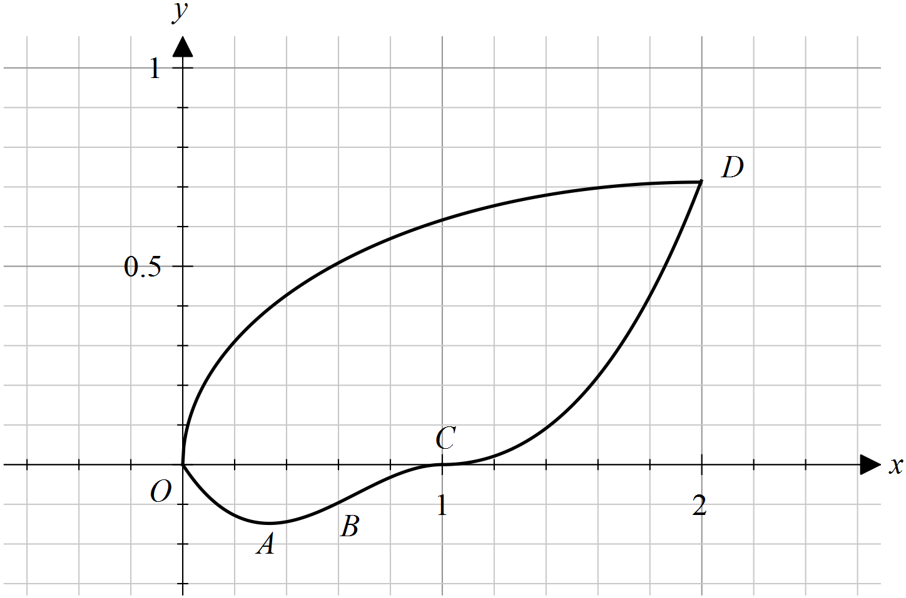
The quarter ellipse was often sketched without sufficient accuracy. While the curves drawn mostly connected point D to the origin, the quarter ellipse curves were often not vertical at the origin and horizontal at D.

Question 1fi.
Mark | 0 | 1 | Average
% | 34 | 66 | 0.7
The most frequent error was to use terminals 0 and 2. A variety of correct equivalent forms of the integrand were seen.

Question 1fii.
Mark | 0 | 1 | Average
% | 34 | 66 | 0.7
Most students who answered Question 1fi. correctly were successful here.

Question 2a.
Mark | 0 | 1 | Average
% | 37 | 63 | 0.6

Question 2b.
Mark | 0 | 1 | Average
% | 39 | 61 | 0.6
, , , , ,
Most students were able to give at least some of the required solutions. Omitting was a common error. A range of equivalent polar forms were seen and accepted.

Question 2c.
Mark | 0 | 1 | 2 | Average
% | 35 | 12 | 53 | 1.2
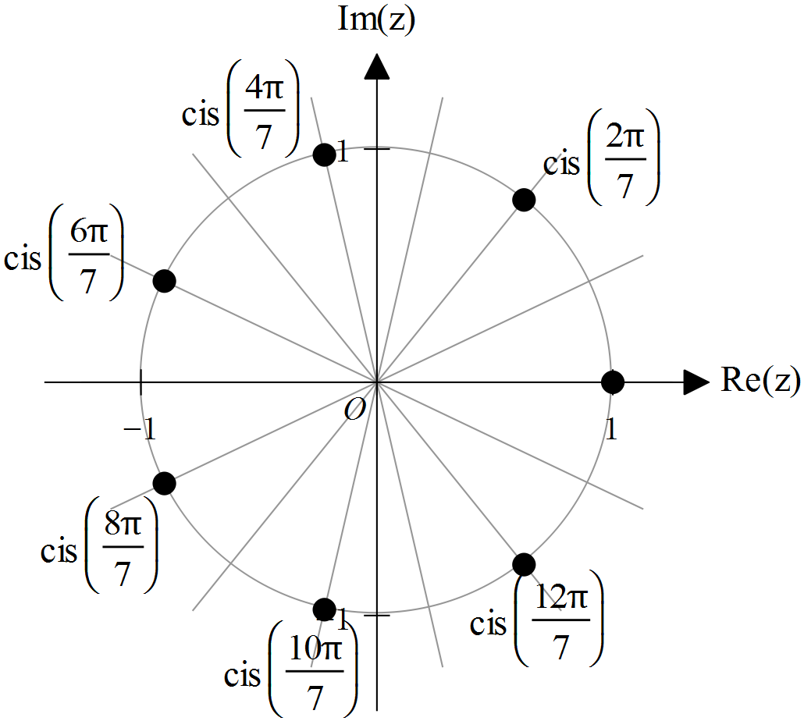
The majority of students were aware that the roots of unity are evenly spaced around the unit circle. Those who answered Question 2b. correctly were usually able to do well here. Some students failed to recognise that the sectors shown had angles of and incorrectly estimated the required locations.

Question 2di.
Mark | 0 | 1 | Average
% | 58 | 42 | 0.4
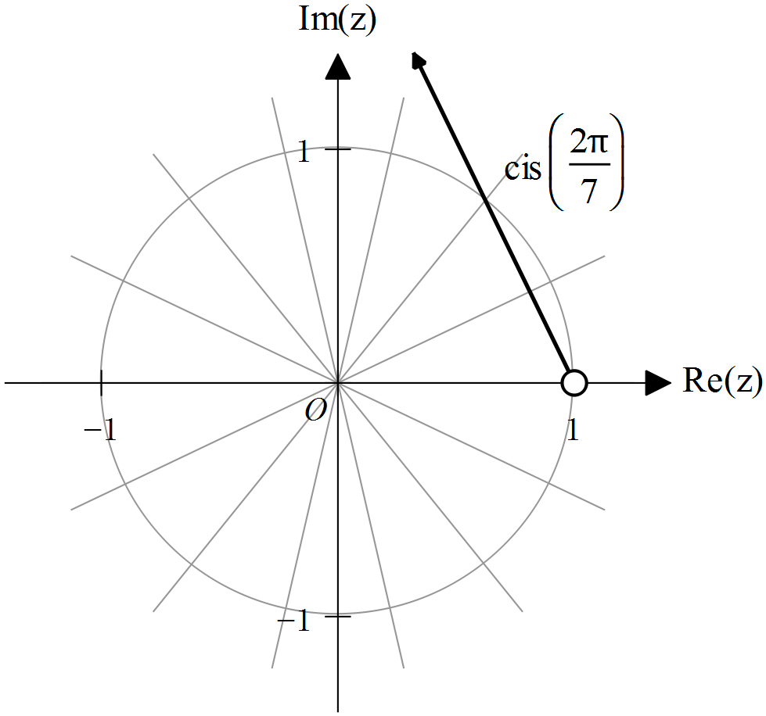

Question 2dii.
Mark | 0 | 1 | Average
% | 82 | 18 | 0.2
While many students correctly identified that , finding the correct angle was a challenge for most. A common incorrect angle was .

Question 2e.
Mark | 0 | 1 | Average
% | 46 | 54 | 0.5
Expanding:
Most students expanded the brackets to attempt to show the resulting expression simplified to . A significant proportion of students attempted polynomial long division. While some were successful, many did not see the process through to completion.

Question 2fi.
Mark | 0 | 1 | Average
% | 53 | 47 | 0.5
There were a range of approaches to this question. Most successful students correctly applied prior work, recognising equivalent trigonometric expressions. Students who appeared to use technology were sometimes unsuccessful in converting to a cosine equivalent.

Question 2fii.
Mark | 0 | 1 | 2 | Average
% | 85 | 8 | 7 | 0.2
This question was not well done. Many students were able to express the given equation in terms of powers of w but most students did not ‘show that’ the required result arose through a series of logical steps.

Question 3ai.
Mark | 0 | 1 | Average
% | 11 | 89 | 0.9
Some students incorrectly applied a formula for surface area.

Question 3aii.
Mark | 0 | 1 | Average
% | 15 | 85 | 0.9
Some students did not include in their answer, despite it being present in their integral expression in Question 3ai.

Question 3bi.
Mark | 0 | 1 | 2 | Average
% | 13 | 25 | 62 | 1.5
This was quite well done. Of those students who set up the integral correctly, most obtained the correct form.

Question 3bii.
Mark | 0 | 1 | Average
% | 45 | 55 | 0.6
Incorrect rounding to was a frequent final response. Students are reminded to set their calculators to display sufficient decimal places.

Question 3c.
Mark | 0 | 1 | 2 | Average
% | 38 | 24 | 38 | 1.0
Many students found the curved surface area only and did not include one or both ends. Of those who included two ends, errors with an incorrect radius were frequent.

Question 3d.
Mark | 0 | 1 | 2 | 3 | Average
% | 27 | 27 | 23 | 24 | 1.5
Most students were successful in obtaining a value for . Omission of the ends of the solid, and ends with incorrect radii, were the most frequent errors. Some errors in the final value appeared to be due to a lack of brackets when entering expressions into a calculator.

Question 4a.
Mark | 0 | 1 | Average
% | 52 | 48 | 0.5

Question 4b.
Mark | 0 | 1 | Average
% | 43 | 57 | 0.6

Question 4c.
Mark | 0 | 1 | Average
% | 21 | 79 | 0.8

Question 4d.
Mark | 0 | 1 | Average
% | 15 | 85 | 0.9

Question 4ei.
Mark | 0 | 1 | Average
% | 79 | 21 | 0.2
A variety of correct equivalent forms were seen.
A common error involved not recognising the need to use the chain rule when differentiating with respect to . Some students did not express their answers in terms of .

Question 4eii.
Mark | 0 | 1 | 2 | Average
% | 32 | 11 | 57 | 1.3
Most students correctly eliminated to give the correct answer. Some students gave the maximum rate as their final answer.

Question 4f.
Mark | 0 | 1 | 2 | Average
% | 30 | 28 | 43 | 1.1
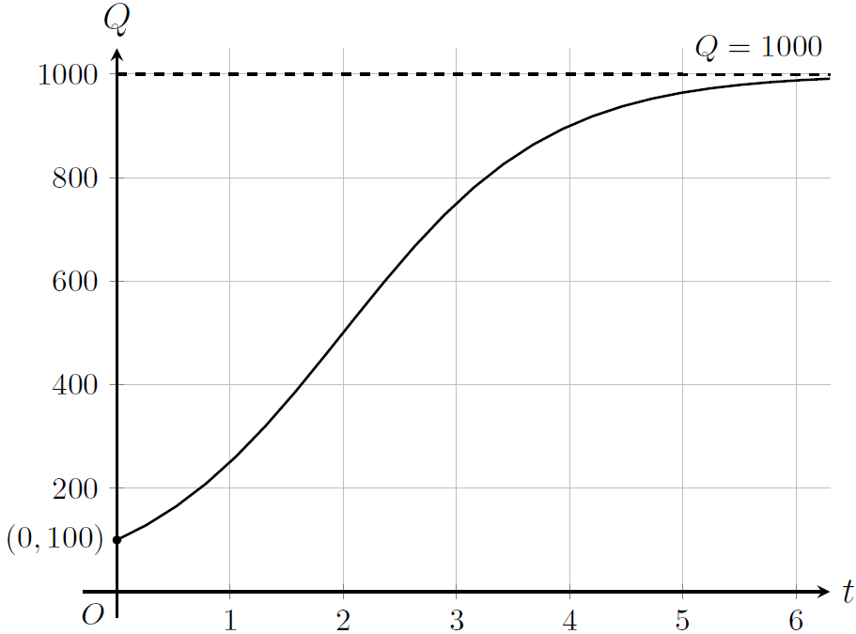
Many students incorrectly labelled the asymptote with the equation and some students did not follow the instruction to label the Q-intercept with its coordinate. Most students sketched the shape of the logistic curve well.

Question 4g.
Mark | 0 | 1 | Average
% | 60 | 40 | 0.4

Question 5a.
Mark | 0 | 1 | 2 | Average
% | 8 | 29 | 63 | 1.6
Most students successfully obtained the required vectors. Not all of those students were able to ‘show that’ the required area was 1.5 square units. Subsequent to finding the vectors, a variety of correct alternative approaches were used.

Question 5b.
Mark | 0 | 1 | 2 | Average
% | 60 | 11 | 29 | 0.7
A wide variety of valid approaches were applied by successful students.

Question 5c.
Mark | 0 | 1 | 2 | Average
% | 29 | 21 | 50 | 1.2
A significant number of students did not proceed beyond finding the angle of .

Question 5d.
Mark | 0 | 1 | Average
% | 48 | 52 | 0.5
was also accepted.

Question 5e.
Mark | 0 | 1 | 2 | Average
% | 37 | 7 | 55 | 1.2
Many students who did not initially use absolute values, inappropriately dealt with inconvenient negative values, with working such as ‘’.

Question 5f.
Mark | 0 | 1 | 2 | Average
% | 53 | 13 | 34 | 0.8
Most students recognised that the use of the parametric form from Question 5d. was an efficient approach. Some other approaches were seen but these were generally less successful.

Question 6a.
Mark | 0 | 1 | Average
% | 16 | 84 | 0.8
This routine question was handled well. Many students recognised that the confidence interval should be expressed with brackets in the form (a, b).

Question 6b.
Mark | 0 | 1 | Average
% | 42 | 58 | 0.6

Question 6c.
Mark | 0 | 1 | Average
% | 72 | 28 | 0.3
This question was challenging for students.

Question 6d.
Mark | 0 | 1 | Average
% | 12 | 88 | 0.9
Students were generally successful with this question. Incorrect responses such as ‘’ were occasionally seen.

Question 6ei.
Mark | 0 | 1 | Average
% | 20 | 80 | 0.8

Question 6eii.
Mark | 0 | 1 | Average
% | 22 | 78 | 0.8
.
Some students stated a correct conclusion but did not give a reason by referencing the p value.

Question 6f.
Mark | 0 | 1 | Average
% | 40 | 60 | 0.6
was also accepted).

Question 6g.
Mark | 0 | 1 | Average
% | 61 | 39 | 0.4
was also accepted.

Question 6h.
Mark | 0 | 1 | Average
% | 0 | 100 | 1.0
Following the identification of an error in the question stimuli, this question was invalidated.

