2024 VCE Specialist Mathematics 1 external assessment report

General comments
The 2024 VCE Specialist Mathematics Examination 1 comprised 10 questions worth a total of 40 marks.
New topics from 2023 were again tested in 2024. In particular, proofs (Question 2), the cross product (Question 4b and Question 10) and lines in space (Question 10). It was pleasing to see that many students were able to partially or fully answer these questions.
There were several questions that required students to show that a particular result was obtained. In such questions, full marks will only be awarded where appropriate and correct working is provided.
Students completed this examination without the use of a CAS or references other than the standard formula sheet supplied with the examination paper. Algebraic and arithmetic errors were often seen. Formulas from the formula sheet were occasionally used incorrectly (for example, the derivative in Question 9b). Students may also have needed to recall or derive a formula (Question 10).
Areas of strength included:
- direct proof (Question 2)
- working with vectors (including the cross product) (Question 4)
- volume of a solid of revolution (Question 5)
- solving a separable differential equation (Question 7)
- implicit differentiation (Question 8a).
Areas of weakness included:
- graph sketching (Question 3c)
- kinematics (as an application of calculus) (Question 9b)
- distances between lines (Question 10).

Specific information
This report provides sample answers or an indication of what answers may have included. Unless otherwise stated, these are not intended to be exemplary or complete responses.
The statistics in this report may be subject to rounding, resulting in a total of more or less than 100 per cent.

Question 1a.
Marks | 0 | 1 | Average
% | 27 | 73 | 0.8
By the factor theorem then is a factor of hence so too is .
Alternatively, one can directly factorise .
This question was answered well, with most students either finding the correct factorisation of the cubic polynomial or showing that . When evaluating , some students made arithmetic errors in their calculations and so were ineligible for the mark.

Question 1b.
Marks | 0 | 1 | 2 | Average
% | 30 | 22 | 48 | 1.2
Students typically found the quadratic factor (which may have been found in Question 1a and then solved a cubic equation. However, some students neglected to show that they were solving an equation and moved directly from the factorised form of the polynomial to writing down the solutions of . With the known root , a small number of students tried inappropriately to apply the conjugate root theorem.

Question 1c.
Marks | 0 | 1 | Average
% | 51 | 49 | 0.5

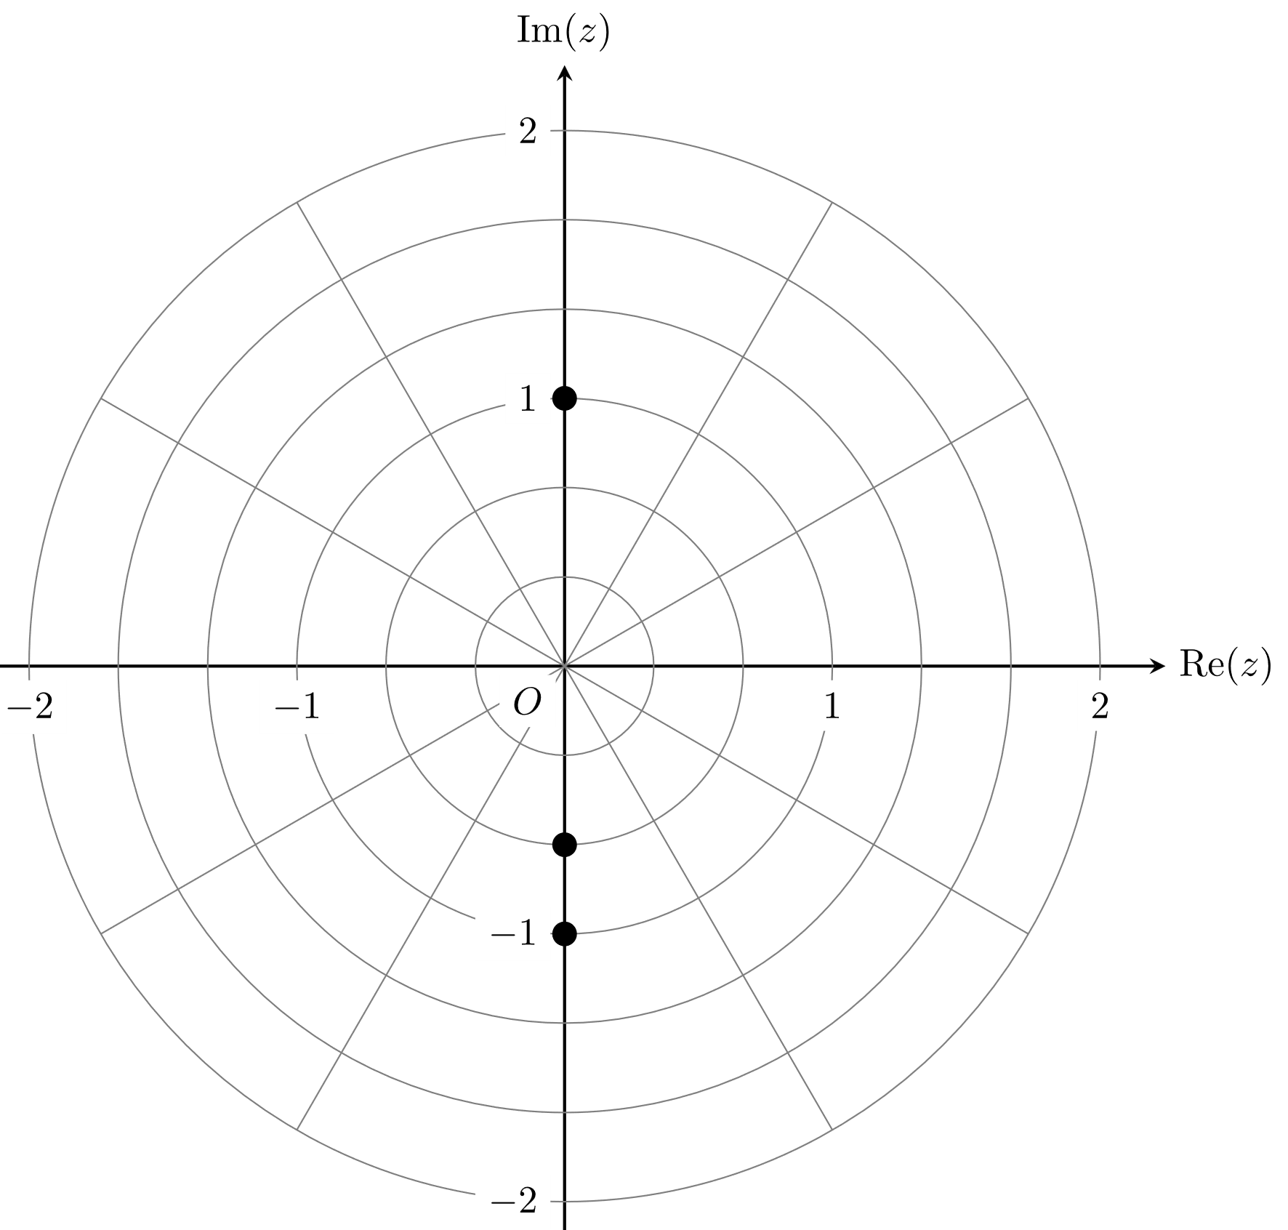

Students needed to plot the correct solutions to on the Argand diagram. Most students who found the solutions in Question 1b were able to do this quite successfully. Some students did not recognise that the radii of the circles on the Argand diagram were positive integer multiples of and so did not place the point correctly. Some students, with the correct solutions, incorrectly plotted them along the real axis, rather than the imaginary axis.

Question 2
Marks | 0 | 1 | 2 | 3 | Average
% | 8 | 4 | 23 | 65 | 2.5
As is an odd integer, we may let where .
Alternatively, it may be observed directly that if is odd then is even, is odd, and is odd, so that is the sum of one even and two odd integers, hence even.
This question was answered well by students. Substituting (or ) for in the expression and obtaining (or ), hence a multiple of 2 and so even, was a reasonable approach. Occasional arithmetic or algebraic errors were seen.

Question 3a.
Marks | 0 | 1 | Average
% | 37 | 63 | 0.7
, ,
Various methods could be applied here. Although not necessarily efficient, a common approach was to perform the division, showing that . Partial fractions could then be applied to the rational function to obtain the desired result.
Some students made errors in manipulating the rational functions.

Question 3b.
Marks | 0 | 1 | 2 | Average
% | 12 | 23 | 65 | 1.6
Since , the turning point is .
Students needed to solve . Many students achieved this by applying the quotient rule to . To avoid using the quotient rule, students could simply differentiate the expanded form of the rational function to obtain .
Some students gave the answer with little or no evidence of working. Additional incorrect coordinates were sometimes given.

Question 3c.
Marks | 0 | 1 | 2 | 3 | Average
% | 51 | 13 | 25 | 10 | 1.0
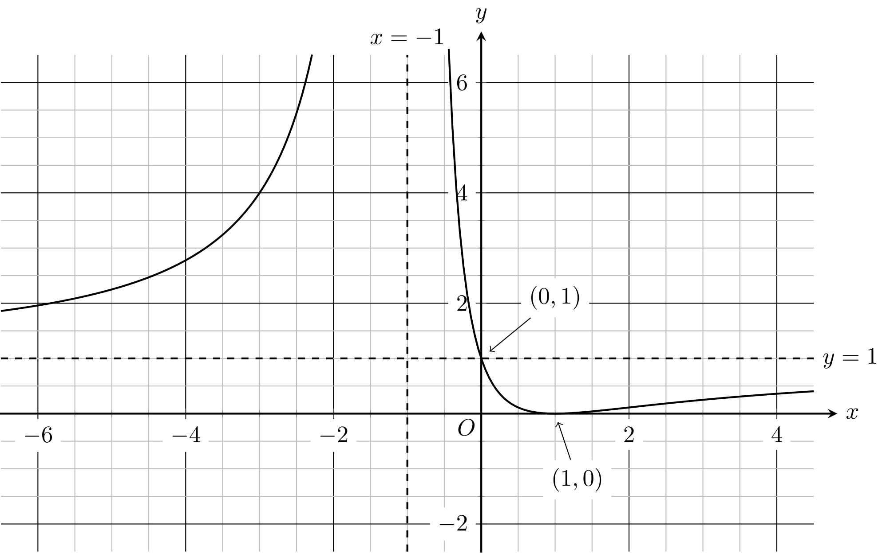
The graph sketching was not done well, and many students gave no clear indication of the correct behaviour of the graph. Additional or incorrect asymptotes were submitted, and some students who did have reasonable-looking graphs did not label asymptotes or axis intercepts appropriately.
Some students only drew the right-hand branch of the graph. Students were much more successful in showing the correct behaviour of the graph on the left-hand side if they evaluated the function at several points.

Question 4a.
Marks | 0 | 1 | 2 | Average
% | 10 | 45 | 45 | 1.4
Let be the angle between and $.$
or
While many students successfully found that , not all were able to find the correct angle (in degrees or radians) between the vectors. The result was frequently seen.

Question 4b.
Marks | 0 | 1 | 2 | Average
% | 11 | 29 | 60 | 1.5
This question was answered well, with many students making good progress towards finding .
Occasional transcription errors were observed, as were algebraic errors. Some students did not give both values of .

Question 5
Marks | 0 | 1 | 2 | 3 | Average
% | 22 | 11 | 9 | 59 | 2.1
The volume is given by .
Most students were able to apply the formula for the volume of the solid obtained by rotating the given region about the -axis. Some students tried to apply a formula for the surface area of the solid.
Some algebraic errors were observed. Students are reminded to be careful to avoid sign errors: responses often included incorrect expressions following the integration, such as .

Question 6a.
Marks | 0 | 1 | Average
% | 21 | 79 | 0.8
The total time to produce one weed trimmer is .
This question was answered well, with most students able to find the correct mean and variance of the total time required to produce one weed trimmer.

Question 6b.
Marks | 0 | 1 | 2 | Average
% | 48 | 15 | 37 | 0.9
The total cost to produce one weed trimmer is .
Some students did not apply the formula for the variance of a sum of independent and identically distributed random variables, frequently forgetting to square either the cost values or the standard deviation at each stage. Of those students who correctly applied the formula, some made arithmetic errors.

Question 6c.
Marks | 0 | 1 | 2 | Average
% | 45 | 10 | 45 | 1.0
Let . As a linear combination of normally distributed variables, is also normally distributed.
Students needed to find or (equivalently) .
This required finding the expected value and the variance (or going directly to the standard deviation) of the difference of the two random variables. Using the given result allowed the final answer to be obtained. Some arithmetic errors were observed and some students gave the correct final answer with little or no evidence of appropriate working.

Question 7
Marks | 0 | 1 | 2 | 3 | 4 | Average
% | 17 | 13 | 21 | 22 | 27 | 2.3
Thus . Since then .
Alternatively
Most students recognised that this was a separable differential equation. Occasional errors in integration were seen. Some students did not give their answer in the form of as a function of as required by the question, instead writing their final answer as . Some students failed to choose the correct sign and gave as their answer.

Question 8a.
Marks | 0 | 1 | 2 | Average
% | 15 | 31 | 54 | 1.4
The implicit differentiation was done very well. Some students made algebraic errors and some students moved too quickly to the final answer. Students needed to present evidence, typically consisting of clear and correct factorisation such as .

Question 8b.
Marks | 0 | 1 | 2 | Average
% | 37 | 30 | 32 | 1.0
By part a, we have precisely when (provided that ). Making the substitution into the given equation yields
Therefore, the points are (1, 1) and (−1, −1).
Some students, while recognising the relationship , neglected to consider that the points lay on the graph of .
Some students who did find an equation such as had difficulty solving it or found incorrect coordinates in addition to and .

Question 9a.
Marks | 0 | 1 | Average
% | 68 | 32 | 0.3
for the speed detection device to be activated.
At ,
Therefore, the speed detection device is activated.
Many students incorrectly assumed that the speed detection device would be activated by the car travelling at a speed greater than 40 km/h. Students needed to show that and that when ,
.
Some students did not use the result that .

Question 9b.
Marks | 0 | 1 | 2 | 3 | Average
% | 29 | 19 | 17 | 35 | 1.6

or
or
When ,
Alternatively,
When ,

Using the acceleration form was the most direct approach. Of students who chose this method, some made errors in differentiation and the factor was occasionally ignored.
The chain rule could be used to differentiate the function. Alternatively, the formula from the formula sheet could be applied. In both instances, the negative sign was sometimes omitted.
Some students elected to work with . Only a small proportion of those students who chose this solution pathway also proceeded to correctly substitute into the acceleration form in order to obtain the correct final answer. Some students only wrote an expression for .

Question 10
Marks | 0 | 1 | 2 | 3 | Average
% | 59 | 14 | 13 | 14 | 0.8
A small number of students drew diagrams of skew lines and parallel planes to help motivate an appropriate formula for the distance between two skew lines. Other students tried to work from memory with varying results.
Some students considered only or and so did not find both values of .

