2024 VCE Specialist Mathematics 2 external assessment report

General comments
The 2024 VCE Specialist Mathematics Examination 2 comprised 20 multiple-choice questions (worth a total of 20 marks) and six extended questions (worth a total of 60 marks). Students were permitted the use of an approved CAS technology and access to a single bound reference.
To ensure their work is clearly visible when scanned, students should write using a pen or a dark lead pencil. Additionally, legible handwriting is crucial; several responses were difficult to read.
Students should note some key instructions for the examination generally:
- Answers must be left in exact form unless a specific number of decimal places is required.
- Students must carefully read the questions and ensure their answers comply with the stated conditions.
- The number of marks allocated to a question indicates the level of detail required in the response. Answers without supporting work will not earn method marks.
The examination highlighted both strengths and weaknesses in student performance. Some areas of strength were:
- identifying asymptotes and demonstrating asymptotic behaviour
- solving problems involving complex numbers
- applying statistical methods.
Areas of weakness were:
- producing accurate graphs
- reading and responding to questions with precision.

Specific information
This report provides sample answers or an indication of what answers may have included. Unless otherwise stated, these are not intended to be exemplary or complete responses.
The statistics in this report may be subject to rounding, resulting in a total more or less than 100 per cent.

Section A – Multiple-choice questions
The table indicates the percentage of students who chose each option. Grey shading indicates the correct response.
Question | Correct Answer | % A | % B | % C | % D | Comments
1 | C | 20 | 3 | 72 | 6 | Asked for contrapositive – therefore, switch the hypothesis and the conclusion and negate both.
2 | A | 48 | 10 | 4 | 37
3 | C | 13 | 11 | 70 | 6 | Solving assuming no cancellation yields . For no turning points we require so . If or then cancels to a linear function which also has no turning points.
4 | A | 27 | 23 | 38 | 10 | Take positive root since so
5 | C | 13 | 13 | 70 | 4
6 | D | 12 | 6 | 5 | 77
7 | C | 7 | 15 | 72 | 6
8 | C | 7 | 23 | 60 | 9 | Solve for
9 | A | 45 | 11 | 29 | 14 | Since for .
10 | A | 74 | 9 | 15 | 2
11 | B | 13 | 58 | 12 | 16
12 | C | 5 | 30 | 50 | 13
13 | B | 4 | 81 | 10 | 4 | Let the two vectors be and .
14 | B | 14 | 36 | 33 | 17 | Vector resolute of in the direction of  so hence .  Scalar resolute or in the direction of .
15 | A | 36 | 12 | 44 | 8 | The motion has period . Starting at at , after visiting  at and at , the body returns to at .
16 | A | 43 | 30 | 19 | 7 | is the only solution.
17 | B | 8 | 58 | 28 | 6
18 | D | 8 | 9 | 14 | 68
19 | A | 68 | 8 | 8 | 15
20 | B | 9 | 48 | 25 | 17

Section B

Question 1a.
Mark | 0 | 1 | 2 | 3 | Average
% | 2 | 16 | 65 | 17 | 2.0

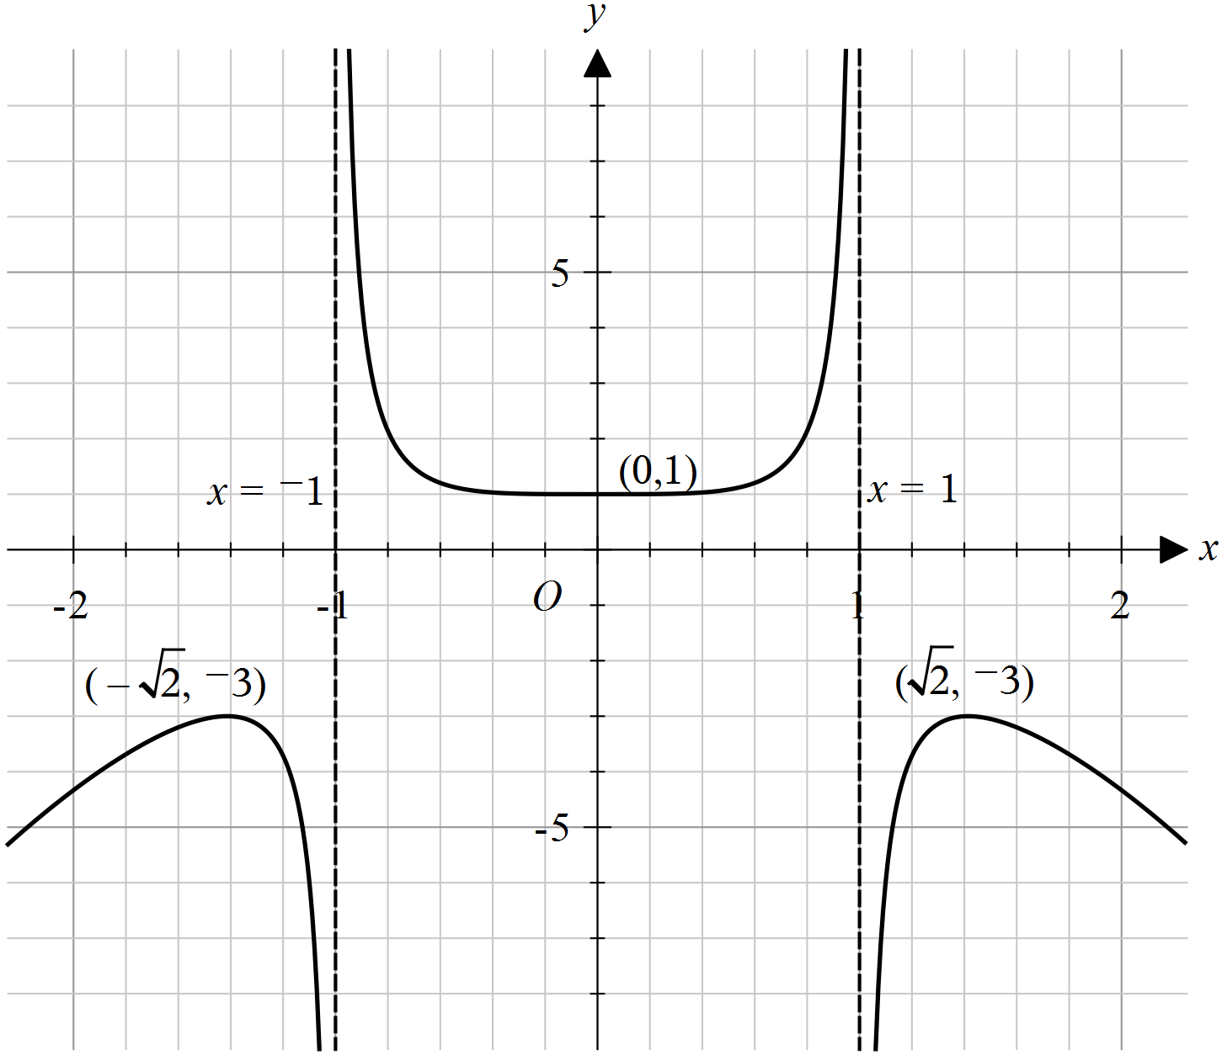
- Many students did not draw this graph accurately. To improve accuracy, students can sketch the function on their CAS calculator and set the domain, range and scale to match those provided in the question.
- The graph must be flatter near the -intercept, with turning points and end points precisely positioned.
- Students generally succeeded in drawing and labelling the asymptotes and demonstrated asymptotic behaviour effectively.

Question 1b.i.
Mark | 0 | 1 | 2 | Average
% | 22 | 22 | 56 | 1.4

- Students were expected to write an expression for within the definite integral instead of stating the generic formula.
- Many students made transcription errors when transferring their answer from their CAS to the script.

Question 1b.ii.
Mark | 0 | 1 | Average
% | 44 | 56 | 0.6

11.2
Success in part i generally resulted in an accurate answer in this part.

Question 1c.
Mark | 0 | 1 | Average
% | 28 | 72 | 0.7

Since polynomial division yields there are no asymptotes precisely when ,
i.e.

Question 1d.i.
Mark | 0 | 1 | Average
% | 73 | 27 | 0.3

Since g’(0) = 0$,$ to obtain only one stationary point, there must be no solutions to
so (numerator never zero) or (LHS simplifies to 1). Hence
Of those students who attempted this part, the most frequent incorrect response was .

Question 1d.ii.
Mark | 0 | 1 | Average
% | 73 | 27 | 0.3

Three stationary points are found when has precisely two nonzero real solutions.
From above, . We have so and .
We must have to obtain only two nonzero real solutions, i.e.
Many students did not include the equality sign.

Question 1d.iii.
Mark | 0 | 1 | Average
% | 75 | 25 | 0.3

Five stationary points are found when has four nonzero real solutions, i.e. all four
possibilities for are nonzero and real. This happens when and , i.e.

Question 2a.
Mark | 0 | 1 | 2 | Average
% | 13 | 24 | 63 | 1.5

The given equation is equivalent to , by collecting real and imaginary components, which simplifies to , or . Writing in terms of yields
Alternatively, the line of points equidistance from and is their perpendicular bisector.
The line joining and has gradient , so their perpendicular bisector has gradient and
passes through i.e. . Thus it has equation where ,
i.e. .
- This question part was generally answered well.
- Some students did not provide sufficient working to gain both marks.
- Several students made sign errors when substituting into the distance formula.
- Students who used the perpendicular bisector method mostly found the gradient correctly. However, some of those students did not correctly use the coordinates of the midpoint to find the equation.

Question 2b.
Mark | 0 | 1 | 2 | Average
% | 30 | 26 | 44 | 1.2

The centre of the circle is the midpoint of the diameter so .
The radius is half the length of the diameter, .
So the circle has equation
- Students who showed working to find the midpoint and diameter usually answered the question successfully.
- Some students did not divide the diameter by 2 to find the radius.
- Several students did not use the midpoint formula accurately to find the centre of the circle.

Question 2c.
Mark | 0 | 1 | 2 | Average
% | 9 | 17 | 74 | 1.7

To find imaginary axis intercepts, let so ,
hence and .
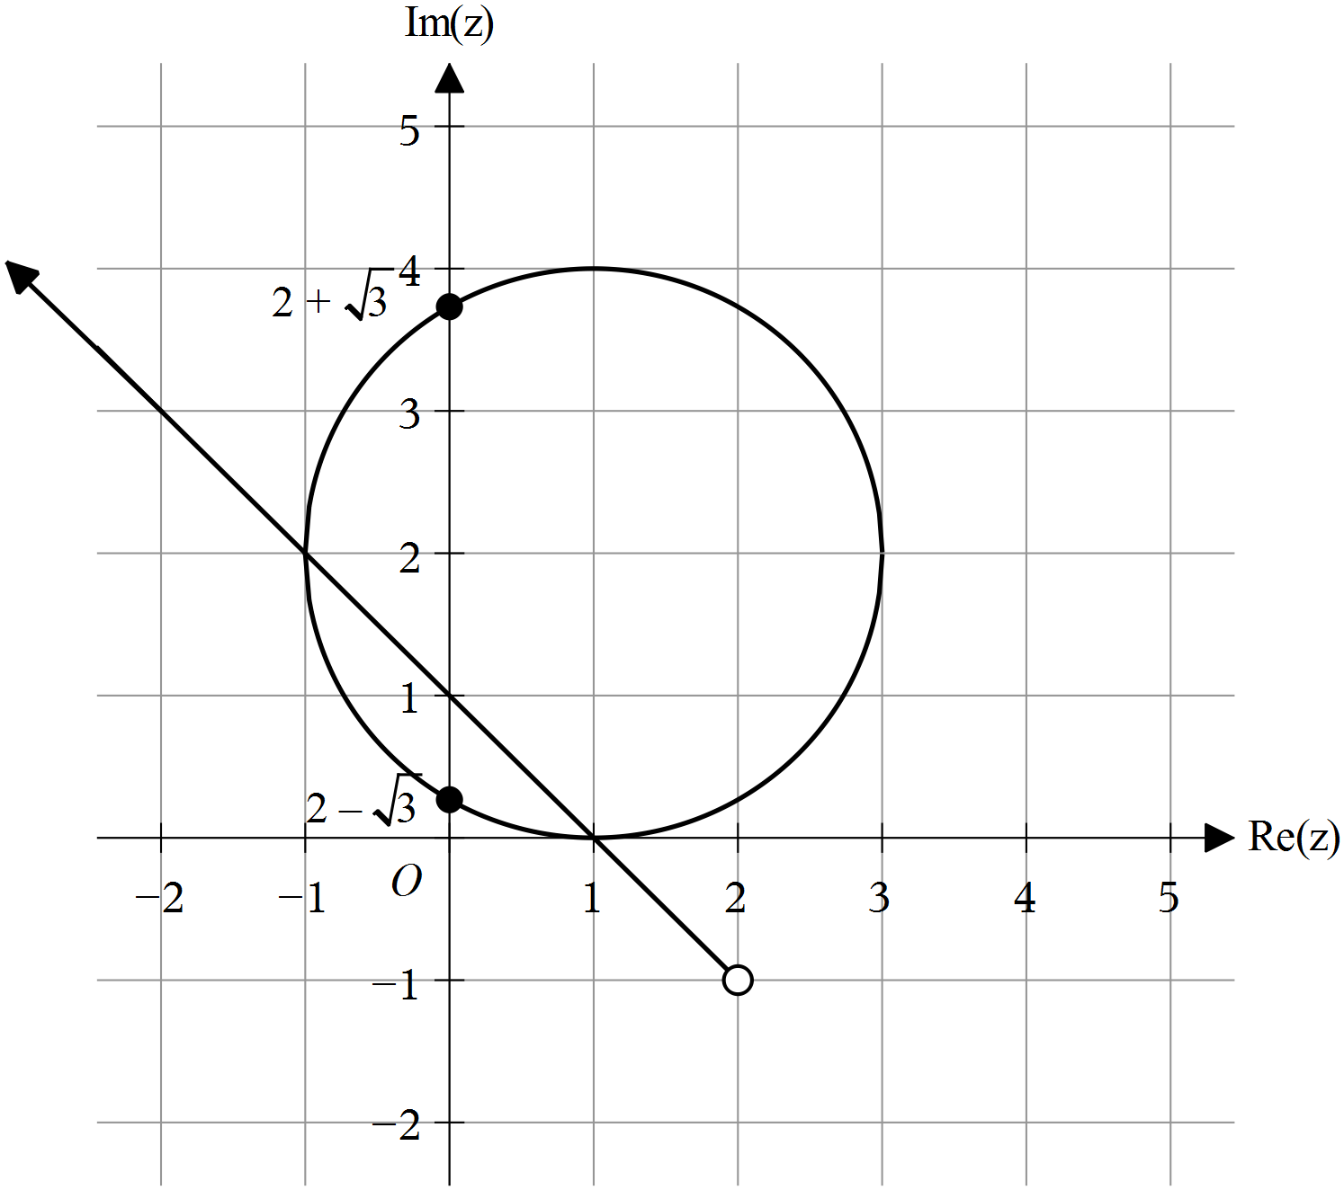
- Students should be mindful that the circle should be drawn smoothly through the four extreme points and should not have a pointed shape.
- Most students correctly labelled the imaginary axis intercepts.

Question 2d.i.
Mark | 0 | 1 | Average
% | 41 | 59 | 0.6

The position of the ray was generally well done.

Question 2d.ii.
Mark | 0 | 1 | Average
% | 44 | 56 | 0.6

Most students who were successful in part d.i were able to find the correct equation for the ray.
The most common error was to quote the argument as .

Question 2e.
Mark | 0 | 1 | 2 | Average
% | 27 | 21 | 52 | 1.3

As the circle has radius and the minor segment has angle , its area is ,
so
Most students were successful when applying the area formula of a segment. Some students used the incorrect angle.

Question 3a.
Mark | 0 | 1 | Average
% | 24 | 76 | 0.8

The maximum rate occurs when , so ,
so as then , at which time cubic metres per day.
(cubic metres per day) when

Question 3b.
Mark | 0 | 1 | 2 | 3 | Average
% | 35 | 11 | 17 | 37 | 1.6
Let be the radius in metres, so and hence .
When we have .
Also substituting we obtain which yields
- Students who recognised this as a related rates question managed this well.
- Some students did not convert the depth measurement to metres.

Question 3c.i.
Mark | 0 | 1 | Average
% | 39 | 61 | 0.6

We have t and , so and

Question 3c.ii.
Mark | 0 | 1 | Average
% | 45 | 55 | 0.6

Students must be careful to write their answers in the required form.

Question 3d.
Mark | 0 | 1 | 2 | Average
% | 73 | 10 | 17 | 0.5

Since volume = surface area , surface area is given by .
As the surface area approaches .
181.38
- Many students skipped this question without making an attempt to answer it.
- As the depth of the pond is constant, the surface area can be found by dividing the volume by the depth.

Question 3e.
Mark | 0 | 1 | 2 | Average
% | 79 | 17 | 4 | 0.3

- Many students skipped this question without attempting to answer it.
- The most common error was not taking the 5-day delay into account.

Question 4a.
Mark | 0 | 1 | Average
% | 22 | 78 | 0.8

A ‘show that’ question requires logical steps set out to indicate how the solution could be found. In this case an appropriate trigonometric identity like needed to be used.

Question 4b.
Mark | 0 | 1 | 2 | Average
% | 36 | 22 | 41 | 1.0

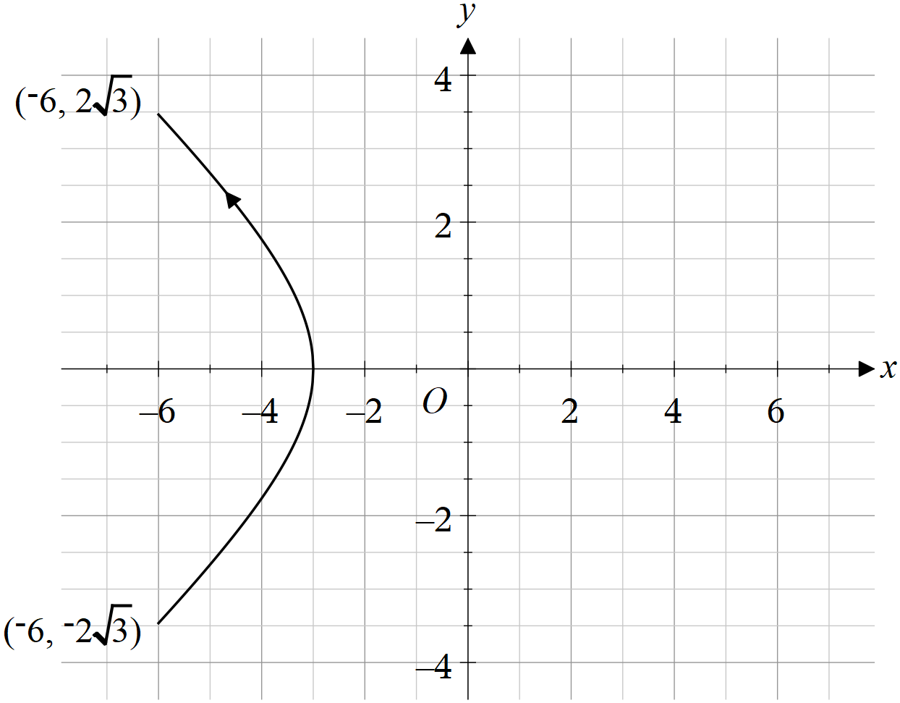
- Students often did not draw this graph well, and it was often not symmetrical over the -axis.
- Negative signs were often left off the coordinates of the end points.
- The direction of the path of the yacht was often left out or in the wrong direction.

Question 4c.i.
Mark | 0 | 1 | Average
% | 77 | 23 | 0.3

so
- Many students did not answer in terms of .
- Several students did not find the square of the speed, but left the answer as a velocity or speed.

Question 4c.ii.
Mark | 0 | 1 | Average
% | 39 | 61 | 0.6

Differentiating the expression for speed squared from the previous part yields
. The term in brackets is always positive,
and for only when , the first derivative test shows it is a minimum.

Some students did not answer in exact form.

Question 4c.iii.
Mark | 0 | 1 | Average
% | 52 | 48 | 0.5

Substituting gives speed squared as , so speed is 2 m/min.
2
The common error was that some students forgot to take the square root of the square of the speed.

Question 4c.iv.
Mark | 0 | 1 | Average
% | 46 | 54 | 0.6

Common errors were due to mistakes such as reversing the coordinates or forgetting the negative sign.

Question 4d.i.
Mark | 0 | 1 | Average
% | 39 | 61 | 0.6

This question was answered well; however, students need to be careful to use brackets appropriately.

Question 4d.ii.
Mark | 0 | 1 | Average
% | 43 | 57 | 0.6

Question 4e.
Mark | 0 | 1 | 2 | Average
% | 65 | 10 | 24 | 0.6

The distance is given by .
Numerically minimising over gives
This question part was often not attempted. Students who found the correct expression for the distance were generally able to progress.

Question 5a.
Mark | 0 | 1 | Average
% | 45 | 55 | 0.6

Many correct answers exist, including:
and
Some students did not use the correct notation. A common error was to write the vector rather than the vector equation of the line.

Question 5b.
Mark | 0 | 1 | 2 | 3 | Average
% | 26 | 11 | 13 | 50 | 1.9

- Students used many different techniques to solve this problem.
- Some students used the wrong line equation, using their answer to part a rather than the one given.

Question 5c.
Mark | 0 | 1 | 2 | 3 | Average
% | 15 | 3 | 15 | 67 | 2.4

Most students answered this question very well. Students should be aware that their CAS technology can help them find cross products accurately.

Question 5d.i.
Mark | 0 | 1 | Average
% | 37 | 63 | 0.7

, ,

Question 5d.ii.
Mark | 0 | 1 | 2 | Average
% | 44 | 10 | 46 | 1.0

Common errors were:
- incorrectly determining the spanning vectors
- omitting the division of the cross product by 2 to find the area
- incorrectly assuming the triangle was either isosceles or right-angled.

Question 6a.
Mark | 0 | 1 | Average
% | 9 | 91 | 0.9

,

Question 6b.i.
Mark | 0 | 1 | Average
% | 15 | 85 | 0.9

Sample mean has standard deviation , so p-value =
Some students did not divide the standard deviation by 3 to account for the sample size.

Question 6b.ii.
Mark | 0 | 1 | Average
% | 25 | 75 | 0.8

, so pause the machine
This question was generally well done; however, some students did not fully answer the question regarding whether or not the machine should be paused.

Question 6c.
Mark | 0 | 1 | 2 | Average
% | 45 | 11 | 44 | 1.0

Letting be the sample mean, the null hypothesis will be rejected when where
, i.e. , so .
Thus the probability of type II error is

0.31
Common errors were:
- students sometimes did not find the critical value for when is true
- students used the wrong tail.

Question 6d.
Mark | 0 | 1 | Average
% | 42 | 58 | 0.6

The sample mean has mean 1000 and standard deviation
Solve and numerically.
,

Question 6e.
Mark | 0 | 1 | Average
% | 18 | 82 | 0.8

95% confidence interval

Question 6f.
Mark | 0 | 1 | Average
% | 49 | 51 | 0.5

38
Some students incorrectly used 50 rather than 40 as the number of samples.

Question 6g.
Mark | 0 | 1 | Average
% | 54 | 46 | 0.5

The confidence interval extends each side of the mean, so solve .
This yields . As is an integer, then .
62

