2025 VCE Specialist Mathematics 1 external assessment report

Specific information
This report provides sample answers or an indication of what answers may have included. Unless otherwise stated, these are not intended to be exemplary or complete responses.
The statistics in this report may be subject to rounding, resulting in a total of more or less than 100 per cent.

Question 1
Marks | 0 | 1 | 2 | 3 | 4 | Average
% | 10 | 3 | 27 | 12 | 48 | 2.9
Method 1
At :

Method 2
At :
Students used implicit differentiation to find the tangent to the curve at a given point. While the implicit differentiation was often performed successfully, arithmetic errors prevented some students from obtaining the correct gradient.
A small number of students who successfully found the value of the gradient at the given point neglected to give the equation of the tangent at that point and were not awarded full marks.

Question 2
Marks | 0 | 1 | 2 | 3 | Average
% | 14 | 13 | 15 | 59 | 2.2
Equating components:
Solving (using any two of the equations) gives and .
Substituting gives the point of intersection: .
Students needed to express the two lines in parametric form using different parameters for each line and solving the resulting equations for the parameters. Substituting back gave the point of intersection of the lines.
It was common for students to use the same parameter for both lines. This did not result in viable equations to solve. In this case, students were ineligible for full marks.

Question 3a
Marks | 0 | 1 | Average
% | 29 | 71 | 0.7
When , and so .
Therefore .
In this question the result was given. While this question was generally well answered, some students did not correctly apply the initial condition in order to find the value of the constant of integration.

Question 3b
Marks | 0 | 1 | 2 | Average
% | 19 | 24 | 57 | 1.4
Students needed to apply the quotient rule (or the chain rule) to find . The quotient rule was not always applied correctly so while the correct value for the initial acceleration may have been given, full marks would not have been obtained due to the incorrect derivative.

Question 3c
Marks | 0 | 1 | 2 | Average
% | 49 | 23 | 28 | 0.8
Some ineffective attempts at rearranging and squaring were seen in some responses. Only a small proportion of students were able to arrive successfully at the correct answer.

Question 4a
Marks | 0 | 1 | 2 | 3 | Average
% | 32 | 23 | 9 | 37 | 1.5
By partial fractions, and so
Students should know how to find the expected value (mean) of a continuous random variable. This question required partial fractions to be applied. A small number of students did not realise this and were unable to progress with the problem. A significant number of responses were not awarded full marks, either because:
- the initial expression missed the ‘’ term on the numerator, or
- the coefficients for the partial fractions were incorrect, or
- the working towards the given answer was unclear.

Question 4b
Marks | 0 | 1 | 2 | Average
% | 34 | 17 | 49 | 1.2
and .
Many students were able to find the mean and standard deviation of the sampling distribution. Some students drew a diagram to aid in identifying the required area under the standard normal curve. A common incorrect response was .

Question 5a
Marks | 0 | 1 | Average
% | 6 | 94 | 0.9
Consider the component of the position vectors of particles and when :
and so .
This question was answered very well.

Question 5b
Marks | 0 | 1 | 2 | Average
% | 33 | 37 | 30 | 1.0
and .
and
When , so .
Therefore or
Students needed to recognise that the dot (scalar) product of the two velocity vectors was zero and that when .
A common incorrect response to the equation was in addition to .

Question 5c
Marks | 0 | 1 | Average
% | 75 | 25 | 0.2
, and .
Then giving and .
Some students gave and in addition to the correct solution. In this case, students were not awarded the mark for this question.

Question 6
Marks | 0 | 1 | 2 | 3 | 4 | Average
% | 16 | 13 | 13 | 20 | 38 | 2.5
The integral could be evaluated using a substitution or using integration by parts.
Method 1 (substitution)
, .

Method 2 (integration by parts)
Therefore .
Most students were able to make some progress with this question, recognising that a substitution (or integration by parts) would be necessary. Common errors included:
- missing factor of through working
- neglecting to adjust the terminals for the definite integral if a substitution was used
- incorrect terminals for definite integral if a substitution was used
- algebraic and arithmetic errors.

Question 7
Marks | 0 | 1 | 2 | 3 | 4 | Average
% | 11 | 8 | 18 | 34 | 29 | 2.6
Various methods of presenting the proof by induction were seen. One example is shown below.
Let be the proposition that
for all .
LHS of .
RHS of .
Assume the proposition is true for :
.
LHS of :
This question was not answered well. Some common errors included:
- Not properly verifying the base case .
- Misstating the assumption. For example,
Suppose the proposition is true for . Then .
- Assuming equality at the beginning of the inductive step
.

Question 8a
Marks | 0 | 1 | Average
% | 16 | 84 | 0.8
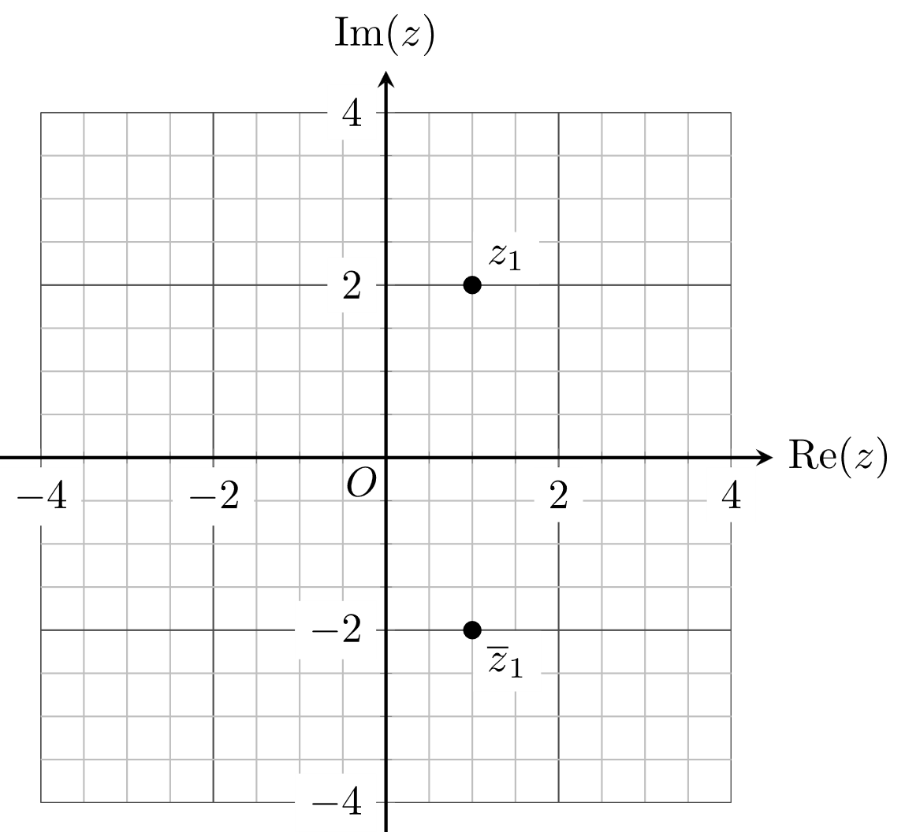
Most students correctly placed and labelled the points and on the Argand plane. A small number of students either placed the points incorrectly, labelled the points incorrectly or neglected to label the points.

Question 8b
Marks | 0 | 1 | 2 | Average
% | 19 | 20 | 61 | 1.4
is also a solution and so a quadratic factor is
Most students realised that the complex conjugate of the given solution was also a solution to the equation . Some algebraic errors were observed. A number of students anticipated Question 8c and gave two quadratic factors; if correct, students were not penalised.

Question 8c
Marks | 0 | 1 | 2 | Average
% | 37 | 21 | 42 | 1.1
Another quadratic factor is , which may be found by division or by comparison (equating) coefficients.
Solving gives the remaining two solutions and .
The majority of students attempted to find the second quadratic factor and to solve the quadratic equation. Students who used comparison of coefficients to find the quadratic factor were generally more successful than those who used long or synthetic division. Students who completed the square rather than using the quadratic formula to solve the quadratic equation were also generally more successful.

Question 9a
Marks | 0 | 1 | 2 | Average
% | 22 | 33 | 45 | 1.2
Students could use long division or manipulate the expression using algebraic techniques into the required form. Various acceptable methods were seen. Two examples are shown below.
Method 1

Method 2
Students needed to be very careful to ensure that their working actually produced the required result. Some poor algebraic working was observed.

Question 9b
Marks | 0 | 1 | Average
% | 54 | 46 | 0.5
This question required a numerical answer.

Question 9c
Marks | 0 | 1 | 2 | 3 | Average
% | 50 | 16 | 18 | 16 | 1.0
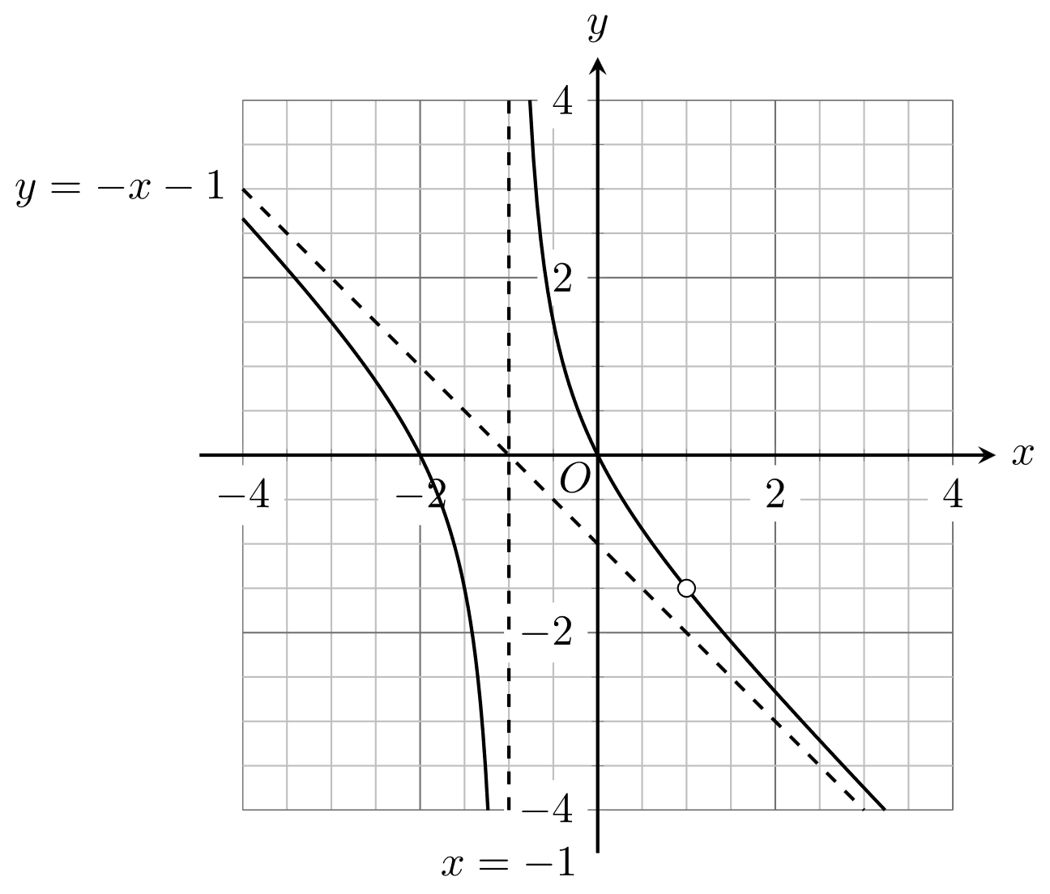
Students were required to label the asymptotes with their equations. An open circle to indicate the point of discontinuity at needed to be shown.
A number of students included an incorrect vertical asymptote or had curves that did not pass through the axis intercepts at and . The point of discontinuity at was often missing or was placed incorrectly.
Students who were most successful used a ruler to draw the asymptotes and had graphs that did not curve away from the asymptotes.

