2025 VCE Specialist Mathematics 2 external assessment report

Areas for improvement
This examination was accessible for the majority of students; few questions were classified as hard or very hard.
Students should ensure that their responses are not difficult to read. Students are reminded to either write in pen or use a dark lead, 2B or similar. It is also important that the writing is clear, not written over another response and is in the right size to fit inside the given space.
Questions need to be read carefully and answers in the required format. Exact answers are expected unless told otherwise. Attention should be given to the number of marks a question is allocated as this is an indication of the number of steps of working required to earn method marks. ‘Show that’ questions require clear steps of working that lead to the given answer. If the question asked for equations of asymptotes or other similar equations, then the responses must be written as individual equations.
It is also important to take care when graphing. Students should set up their CAS calculators to match the given scale and make sure the shape is accurate, including asymptotic behaviour. When asked to sketch a graph on polar axes, make sure the solution is clear and visible. Graphs should also be drawn using pencil to enable incorrect responses to be erased.

Specific information
This report provides sample answers or an indication of what answers may have included. Unless otherwise stated, these are not intended to be exemplary or complete responses.
The statistics in this report may be subject to rounding, resulting in a total more or less than 100 per cent.

Section A – Multiple-choice questions
The table indicates the percentage of students who chose each option. Grey shading indicates the correct response.
Question | Correct Answer | % A | % B | % C | % D | Comments
1 | C | 5 | 2 | 93 | 0 | The question asked for contrapositive, which occurs when switching the hypothesis and the conclusion and negating both.
2 | D | 5 | 6 | 40 | 48 | To show a point of inflection exists at x = 0, the second derivative must equal zero at x = 0 and there must be a change of sign of the second derivative either side of x = 0. CAS can be used to determine this in the algebra menu, or students could use the graphing menu to see the shape of the graph.
3 | A | 68 | 8 | 13 | 11 | The given expression can be expanded using CAS, which allows the student to equate coefficients with the given oblique asymptote. In addition, they should equate y (0), the y intercept, to −2.  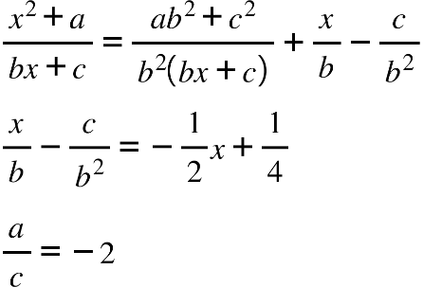
4 | B | 9 | 72 | 15 | 3 | Work through the algorithm methodically as shown below:  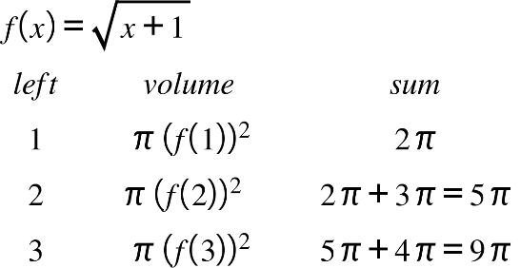
5 | A | 69 | 16 | 9 | 6 | Either use substitution and then equate coefficients or use the conjugate root theorem as shown below.  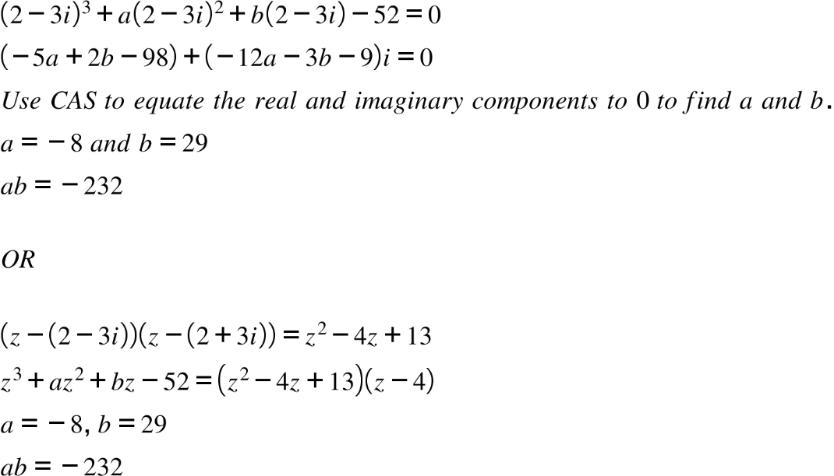
6 | C | 8 | 11 | 70 | 10 | 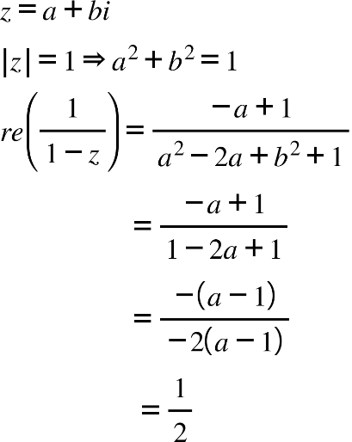
7 | D | 4 | 11 | 6 | 79 | 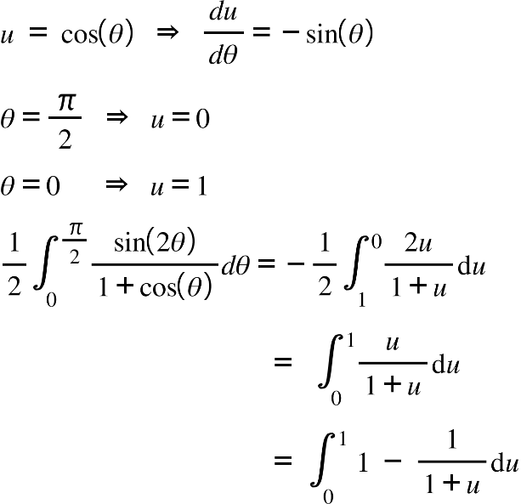
8 | A | 80 | 10 | 4 | 6 | In this direction field, it can be seen that the gradients for positive x values are the same as those for negative x values, indicating the x value is squared. When x = 0 and y > 0, the gradient is negative, indicating A is the best response.
9 | C | 8 | 15 | 49 | 29 | Apply the formula for the surface area of a curve rotated about the x-axis.  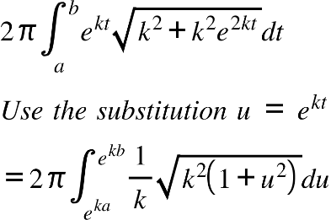
10 | D | 8 | 12 | 11 | 69 | Equate the formula for the volume of revolution to the given expression.  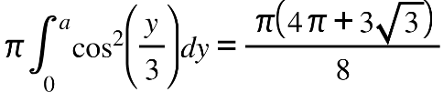

Question | Correct Answer | % A | % B | % C | % D | Comments
11 | B | 12 | 55 | 23 | 10 | Use the DE solve functionality on CAS to solve the given differential equation and then find the domain of the solution. Alternatively, use separation of variables to solve the differential equation manually.  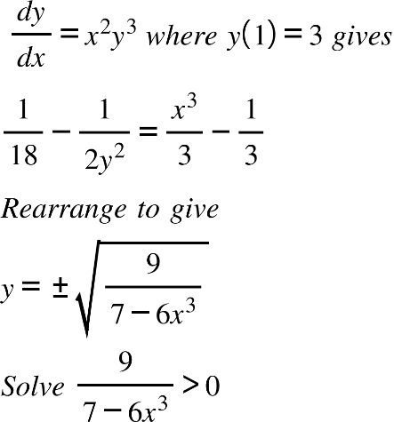
12 | D | 33 | 13 | 20 | 33 | Use the constant acceleration formulas to find the velocity at the midpoint.  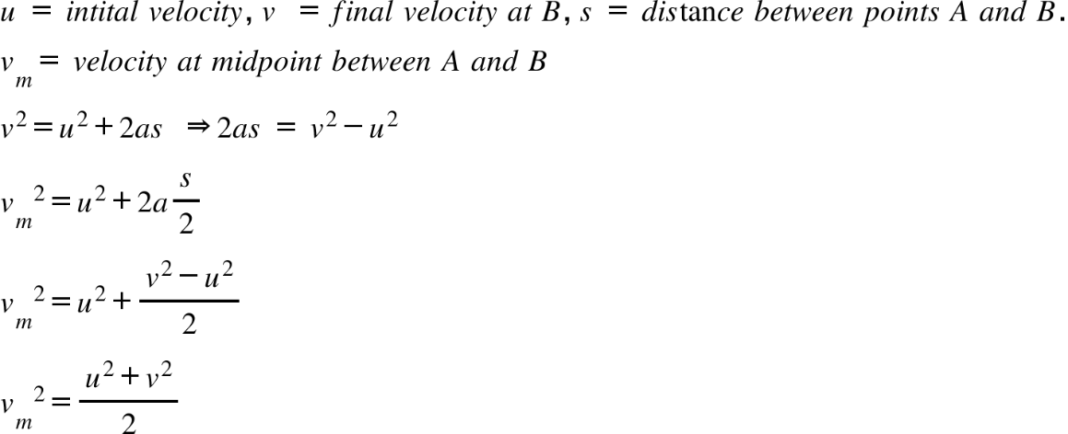
13 | B | 12 | 55 | 25 | 7 | Constant acceleration formulas may be used. However, care must be taken with the signs. Taking upwards as positive then:  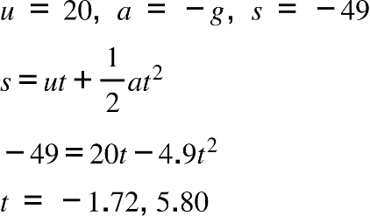
14 | B | 17 | 48 | 30 | 5 | Use the definitions of vectors
15 | A | 52 | 20 | 14 | 14 | The angle between planes is the same as the angle between the normals to the planes.  Knowing what the two normals are:
16 | C | 5 | 12 | 67 | 15 | This question may be completed manually or using CAS. Find the velocity and acceleration vectors through differentiation and then substitute . The dot product of these two vectors is 0 as they are perpendicular.
17 | C | 24 | 17 | 52 | 7 | Care needs to be taken to include a constant vector of integration when integrating the acceleration vector to find the velocity. Students could use a definite integral.
18 | D | 9 | 23 | 19 | 49 | Knowing the lines intersect at the point (4, 3, t) allows simultaneous equations to be developed and solved.  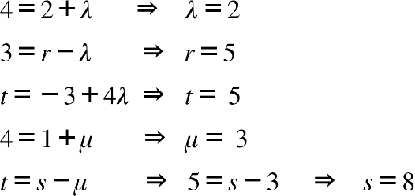
19 | B | 18 | 59 | 14 | 8 | The axis intercepts of the plane are (a, 0, 0), (0, a, 0), (0, 0, a). Connecting these points forms an equilateral triangle of side length 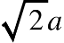, which allows us to find the area using  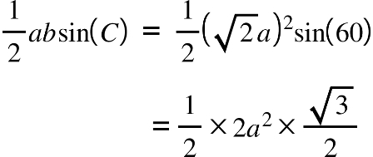
20 | A | 54 | 9 | 27 | 10 | 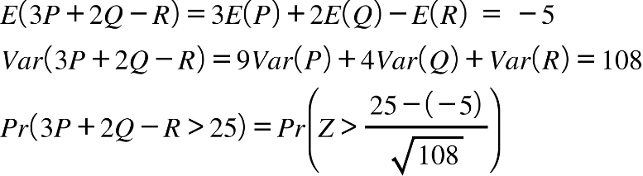

Section B

Question 1a.
Mark | 0 | 1 | 2 | 3 | Average
% | 6.97 | 17.07 | 35.07 | 40.9 | 2.09

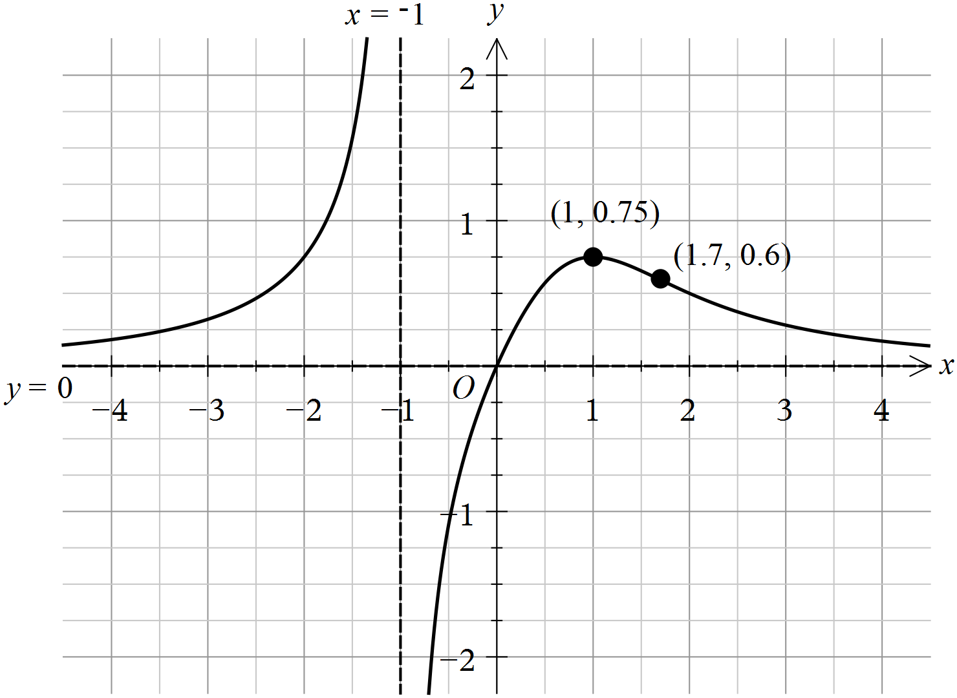
Many graphs were not accurately drawn. To improve accuracy, students can sketch the function on their CAS calculator and set the domain, range and scale to match those provided in the question.
Some responses did not include the coordinates of the maximum in exact form, but rounded to 1 decimal place.
Care must be taken with the shape of the graph, with asymptotic behaviour and smooth curves.
Several responses, incorrectly, sketched the point of inflection as a stationary one.
Many responses did not label the horizontal asymptote y = 0.

Question 1b.i.
Mark | 0 | 1 | Average
% | 9.9 | 90.1 | 0.9
Students must make sure variables are defined if they are being used in formulas.

Question 1b.ii.
Mark | 0 | 1 | Average
% | 18.51 | 81.49 | 0.81
2.29
This is obtained using CAS with the equation from part 1b.i.

Question 1c.
Mark | 0 | 1 | Average
% | 26.47 | 73.53 | 0.73
, ,
Vertical asymptotes are found by equating the denominator to 0.
This question specified that separate equations should be written for each asymptote, but many responses did not include this.

Question 1d.i.
Mark | 0 | 1 | Average
% | 15.68 | 84.32 | 0.84
The stationary point is where . So this coordinate is found by substituting into .

Question 1d.ii.
Mark | 0 | 1 | Average
% | 54.15 | 45.85 | 0.45
and
If there are no stationary points, then there must be an asymptote at and this gives . Solve to find the equations of the asymptotes.

Question 1d.iii.
Mark | 0 | 1 | 2 | Average
% | 20.12 | 9.09 | 70.78 | 1.5
Found by equating the second derivative at to .
Students must show an appropriate method to gain both marks.

Question 2a.
Mark | 0 | 1 | Average
% | 11.69 | 88.31 | 0.88
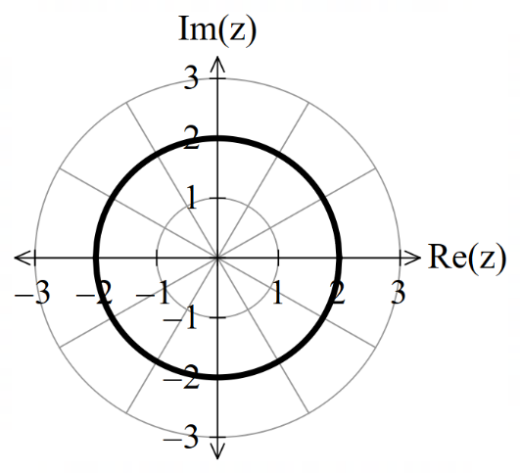

Students must make sure their sketch is visible. The use of a highlighter or colour was useful.

Question 2b.i.
Mark | 0 | 1 | 2 | Average
% | 13.34 | 12.21 | 74.45 | 1.61
This was a ’show that’ question which requires a full algebraic or a geometric approach to the question.
The algebraic approach is to equate the magnitudes of the complex expressions and then expand the brackets and simplify.
The geometric approach required finding the midpoint and the gradient of the line segment between and .
The midpoint is and the gradient is .

Question 2b.ii.
Mark |  | 0 | 1 | Average
% |  | 21.7 | 78.3 | 0.78
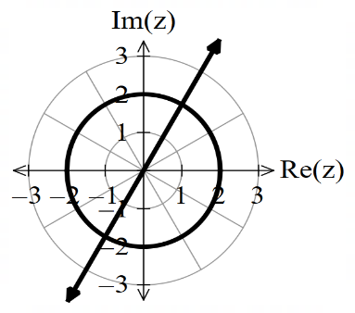

Some students drew the line slightly off the correct angle of 60° with the Re(z) axis.

Question 2c.i.
Mark | 0 | 1 | 2 | Average
% | 18.93 | 10.88 | 70.19 | 1.51
and
These points could be found by inspection of the graph or using simultaneous equations.

Question 2c.ii.
Mark | 0 | 1 | Average
% | 26.11 | 73.89 | 0.73
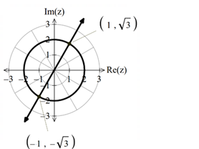

Students need to take care when labelling the points on the graph. If they are using coordinates, they must not have in the coordinate.
Some students did not record a response for this question.

Question 2d.
Mark | 0 | 1 | Average
% | 49.36 | 50.64 | 0.5
,
Many students stated the correct value for z₀ but did not correctly identify the argument. Students are reminded that drawing the ray on the graph may have made it easier to identify the angle. Principal values were expected.

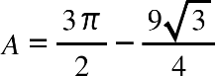
Question 2e.
Mark | 0 | 1 | 2 | Average
% | 23.49 | 15.44 | 61.07 | 1.37

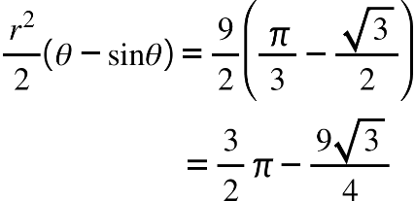
As the circle has radius and the minor segment has angle , its area is
Most students were successful when applying the area formula of a segment. Some responses, however, used the incorrect angle and others did not include the answer in the required form.

Question 3a.
Mark | 0 | 1 | Average
% | 79.57 | 20.43 | 0.2
The initial concentration which is smaller than the incoming concentration
kg/litre; hence, the quantity of salt increases.
Many responses did not quote the concentrations as required by the question.

Question 3b.
Mark | 0 | 1 | Average
% | 38.45 | 61.55 | 0.61
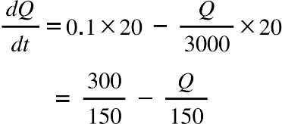
A ‘show that’ question, so development of the given formula was required. Many responses did not show sufficient development of the formula to be awarded the method marks.

Question 3c.
Mark | 0 | 1 | 2 | Average
% | 46.55 | 14.52 | 38.93 | 0.92
61.05
Euler’s method needed to be shown in some form to be awarded both marks. Several responses simply included the answer and did not show the development. A tabulated approach was acceptable as long as both and the final answer were shown.
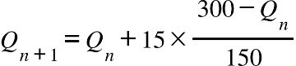
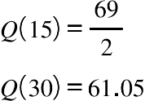

Question 3d.
Mark | 0 | 1 | 2 | 3 | Average
% | 11.24 | 12.17 | 17.3 | 59.3 | 2.24
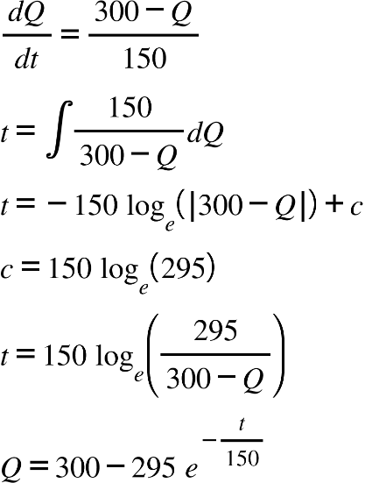
‘Use calculus’ means students are required to show the steps needed to find the solution to gain all 3 marks. Some responses used a definite integral instead of finding , which was acceptable. A frequently seen error was not using the initial condition to find the constant of integration.
Question 3e.
Mark | 0 | 1 | Average
% | 20.54 | 79.46 | 0.79
300 kg
This can be found by taking the limit as t approaches infinity of the answer to Question 3d. It could also be seen using the fact that an exponential function raised to a negative power is a decreasing function.

Question 3f.
Mark | 0 | 1 | Average
% | 39.3 | 60.7 | 0.6
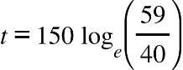
This question was well responded to by students who were able to solve the differential equation in part d.
Several responses left the answer as a decimal, rather than in exact form as required by the question.

Question 3g.
Mark | 0 | 1 | Average
% | 81.95 | 18.05 | 0.18
50
This can be found by equating the concentration to the given value 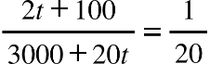.
The most common error was 25.

Question 4a.
Mark | 0 | 1 | Average
% | 6.56 | 93.44 | 0.93
(1, 0)
A common error was not presenting the answer in coordinate form.

Question 4b.
Mark | 0 | 1 | Average
% | 37.24 | 62.76 | 0.62
The direction was anticlockwise.
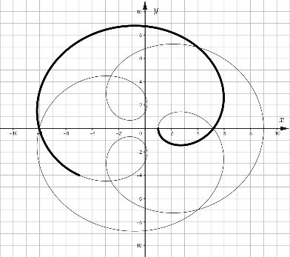
Many responses did not follow the instruction to base the direction arrow on the point (9, 0).

Question 4c.
Mark | 0 | 1 | Average
% | 47.08 | 52.92 | 0.52
Finding the lowest common multiple of the two periods and was the simplest method to find this.
Many responses quoted the answer as a decimal rather than exact form.

Question 4d.
Mark | 0 | 1 | 2 | 3 | Average
% | 16.82 | 27.94 | 19.68 | 35.56 | 1.73
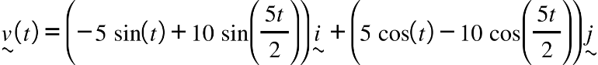
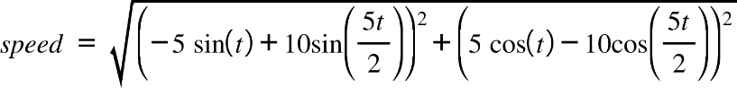
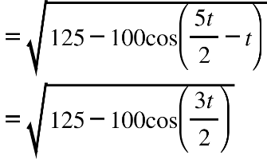
Another ‘show that’ question which required working that shows the use of trigonometric identities that are given on the formula sheet.
Speed = magnitude of the velocity vector.
The main reason some responses were not awarded full marks was taking short cuts and not showing the development of the solution.

Question 4e
Mark | 0 | 1 | Average
% | 27.06 | 72.94 | 0.72
15
Students could use the given result from part d to find this.

Question 4f.
Mark | 0 | 1 | Average
% | 34.22 | 65.78 | 0.65


Some students did not take care to finish their drawing at the point with coordinates (−5, −4).

Question 4g.
Mark | 0 | 1 | 2 | Average
% | 27.2 | 9.1 | 63.7 | 1.36
36.6
Several responses only included the answer without stating how it was found. The definite integral was required.
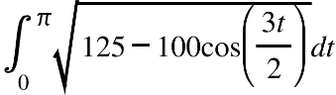

Question 5a.
Mark | 0 | 1 | Average
% | 26.49 | 73.51 | 0.73
(−5, 2, 2)
This could be found by solving the equations of the planes simultaneously.

Question 5b.i.
Mark | 0 | 1 | 2 | Average
% | 27.67 | 20.36 | 51.97 | 1.24
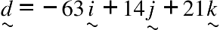
This could be found using the cross product of the normals to the two planes. Any equivalent form of this vector was accepted.
Several responses used CAS to find the solution to the two equations of the planes, but left the answer in parametric form or wrote it as the vector equation of a line. The response should have then identified the direction vector to answer the question.

Question 5b.ii.
Mark | 0 | 1 | Average
% | 48.82 | 51.18 | 0.51
, ,
There were many acceptable forms for these equations.
However, some responses gave the Cartesian equation of the line rather than the parametric equations and were not awarded the mark.

Question 5c.
Mark | 0 | 1 | 2 | Average
% | 22.49 | 12.54 | 64.97 | 1.42
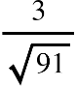
There were many different methods used to find this answer.
Several response included only the answer so they only gained the answer mark. It is essential that students show the mathematics behind their solution to be awarded the full marks.

Question 5d.i.
Mark | 0 | 1 | Average
% | 32.08 | 67.92 | 0.67
To show that two planes are parallel, the normals need to be a scalar multiple of each other. Many responses did not identify that they were working with the normal vectors of the planes and many mixed up the multiple, writing rather than 3.

Question 5d.ii.
Mark | 0 | 1 | 2 | 3 | Average
% | 41.82 | 13.61 | 10.77 | 33.79 | 1.36
1, 47
There are several methods that can be used to find this. Many responses did not demonstrate that the modulus needed to be used and consequently only one of the solutions was found.

Question 6a.i.
Mark | 0 | 1 | Average
% | 13.82 | 86.18 | 0.86
Some students wrote the variance rather than the standard deviation.

Question 6a.ii.
Mark | 0 | 1 | Average
% | 14.17 | 85.83 | 0.85
0.9696
Found using CAS and the mean and standard deviation found in part 6a.i.

Question 6b.
Mark | 0 | 1 | Average
% | 11.91 | 88.09 | 0.88
(748.2, 751.8)

Question 6c.
Mark | 0 | 1 | Average
% | 23.09 | 76.91 | 0.76
285
Found by seeking 95% of 300.

Question 6d.
Mark | 0 | 1 | Average
% | 46.89 | 53,11 | 0.53
97
Found solving the inequality
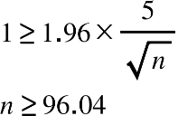
Some responses rounded down to quote 96, but this would have resulted in more than 1 mL.

Question 6e.
Mark | 0 | 1 | Average
% | 9.5 | 90.5 | 0.9
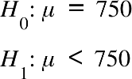

Question 6f.i.
Mark | 0 | 1 | Average
% | 14.77 | 85.23 | 0.85
0.0023

Question 6f.ii.
Mark | 0 | 1 | Average
% | 31.96 | 68.04 | 0.68
Yes, the company’s claim is correct as 0.0023 < 0.01 (the significance level).
Responses needed to comment on the company’s claim and also quote the significance level.

Question 6g.
Mark | 0 | 1 | Average
% | 37.05 | 62.95 | 0.62
748.355
Most responses identified the critical value for this significance level. Some responses used the wrong tail of the distribution.
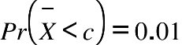

Question 6h.
Mark | 0 | 1 | Average
% | 46.35 | 53.65 | 0.53
0.113
Most students were able to find this Type II error if they were successful in part g.

