**BUWISBUDDYPH**

IT – ELDROID 1 – 84054 / 84064

Mon-Wed 4:30 – 5:30 PM – Lec | Fri 1:30 – 4:30 PM – Lab

IT – ELPHP – 84090 / 84104

Sat 1:30 – 4:30 PM – Lab | Fri 4:30 – 6:30 PM – Lec

Submitted by:

Acosta, Ivan Christopher

Cormanes, Kim Harold

Imus, Jemar

Japson, Immanuel Pon Elan

Mahusay, Kevin B.

**Entity Relatioship Diagram**

This is the entity relationship diagram of BuwisBuddyPH to easily understand and map out the relationship of every database, including the cardinalities of the database.

Figure 1: **BuwisBuddyPH Entity Relationship Diagram**

Figure 1 shows a database structure for managing BuwisBuddyPH involving users, communication, finances, and tax records. The User table connects to other tables like messages, documents, expenses, and forums, where each table stores specific information related to the user. It also includes accounting and tax-related tables like Tax Record, Tax Type, and Payment, which track income, expenses, taxes, and payments. Notifications are used to send user messages, while relationships between tables are defined using primary and foreign keys.

**USE Case Diagram**

This section visually represents the system's internal or business processes. Each use case describes a specific activity or series of user actions.

Figure 2: **BuwisBuddyPH USE Case Diagram**

This diagram shows how BuwisBuddyPH helps users, tax consultants/accountants, and tax authorities/admin manage tax-related tasks. Users can register, log in, manage profiles, declare income and expenses, and calculate taxes. Tax consultants provide guidance, help with tax planning, and assist users with filing and compliance. The platform also includes features like document management, notifications, payment processing, and report generation. It ensures regulatory compliance by connecting with tax authorities to streamline the tax process for everyone.

**DB Design**

This section presents the database dictionary, which includes the information collected on different tables with their respective attribute name, content, data type format, primary key, foreign key and referenced table.

Table 1

**Users**

|  |  |  |  |  |
| --- | --- | --- | --- | --- |
| Column Name | Date Type | Field Size | Null | Description |
| User_ID (PK) | INT |  | Not Null | Unique id of User, serving as a primary key |
| Name | VarChar | 50 | Not null | The name of a user |
| Email | VarChar | 50 | Not null | The email of the user |
| Role | VarChar | 50 | Not Null | The role of the user |

Table 2

**Message**

|  |  |  |  |  |
| --- | --- | --- | --- | --- |
| Column Name | Date Type | Field Size | Null | Description |
| Message_ID (PK) | INT |  | Not Null | Unique identifier for each message |
| Content | VarChar | 1000 | Not Null | The actual content or body of the message |
| Sent_Date | Date | 50 | Not Null | The date when the message was sent |
| Send_ID (FK) | INT |  | Not Null | The user who sent the message |
| Recipient_ID (FK) | INT |  | Not Null | The user who received the message |

Table 3

**Document**

|  |  |  |  |  |
| --- | --- | --- | --- | --- |
| Column Name | Date Type | Field Size | Null | Description |
| Document_ID (PK) | INT |  | Not Null | Unique identifier for each uploaded document |
| Name | VarChar | 50 | Not Null | The name of the uploaded document |
| Upload_Date | Date |  | Not Null | The date when the document was uploaded |
| Type | VarChar | 100 | Not Null | The type or category of the document |
| User_ID (FK) | INT |  | Not Null | The user who uploaded the document |

Table 4

**Expense List**

|  |  |  |  |  |
| --- | --- | --- | --- | --- |
| Column Name | Date Type | Field Size | Null | Description |
| Expense_ID (PK) | INT |  | Not Null | Unique identifier for each expense record |
| Description | VarChar | 100 | Not Null | A brief description of the expense |
| Amount | Decimal |  | Not Null | The amount of money spent on the expense |
| Date | Date |  | Not Null | The date when the expense was recorded |
| User_ID (FK) | INT |  | Not Null | The user who recorded the expense |

Table 5

**Forum**

|  |  |  |  |  |
| --- | --- | --- | --- | --- |
| Column Name | Date Type | Field Size | Null | Description |
| Forum_ID (PK) | INT |  | Not Null | Unique identifier for each forum post |
| Title | VarChar | 225 | Not Null | The title of the forum post, summarizing its content |
| Content | VarChar | 1000 | Not Null | The full content or body of the forum post |
| Posted_Date | Date |  | Not Null | The date when the forum post was created |
| User_ID (FK) | INT |  | Not Null | The user who authored the forum post |

Table 6

**Accounting**

|  |  |  |  |  |
| --- | --- | --- | --- | --- |
| Column Name | Date Type | Field Size | Null | Description |
| Accounting_ID (PK) | INT |  | Not Null | Unique identifier for each accounting record |
| Income | Decimal |  | Not Null | The total income recorded by the user |
| Expense | Decimal |  | Not Null | The total expenses recorded by the user |
| Tax_Due | Decimal |  | Not Null | The total tax amount owed by the user |
| Summary_Date | Date |  | Not Null | The date when the accounting summary was made |
| User_ID | INT |  | Not Null | The user to whom the accounting record belongs |

Table 7

**Tax Type**

|  |  |  |  |  |
| --- | --- | --- | --- | --- |
| Column Name | Date Type | Field Size | Null | Description |
| Tax_Type_ID (PK) | INT |  | Not Null | Unique identifier for each tax type |
| Name | VarChar | 50 | Not Null | The name of the tax type |
| Description | Varchar | 100 | Not Null | A brief description of the tax type |

Table 8

**Tax Record**

|  |  |  |  |  |
| --- | --- | --- | --- | --- |
| Column Name | Date Type | Field Size | Null | Description |
| Tax_Record_ID (PK) | INT |  | Not Null | Unique identifier for each tax filing record |
| Filling_Date | Date |  | Not Null | The date when the tax filing was submitted |
| Amount | Decimal |  | Not Null | The amount of tax involved in the filing |
| Status | VarChar | 100 | Not Null | The current status of the tax filing |
| User_ID (FK) | INT |  | Not Null | The user who filed the tax |
| Tax_Type_ID (FK) | INT |  | Not Null | The type of tax associated with this record |

Table 9

**Notification**

|  |  |  |  |  |
| --- | --- | --- | --- | --- |
| Column Name | Date Type | Field Size | Null | Description |
| Notification_ID (PK) | INT |  | Not Null | Unique identifier for each notification sent |
| Message | VarChar | 1000 | Not Null | The content or message of the notification sent to users |
| Sent_Date | Date |  | Not Null | The date when the notification was sent |
| User_ID (FK) | INT |  | Not Null | The user who received the notification |

Table 10

**Payment**

|  |  |  |  |  |
| --- | --- | --- | --- | --- |
| Column Name | Date Type | Field Size | Null | Description |
| Payment_ID (PK) | INT |  | Not Null | Unique identifier for each payment transaction |
| Payment_Date | Date |  | Not Null | The date when the payment was made |
| Amount | Decimal |  | Not Null | The amount paid for the tax record |
| Tax_Record_ID (FK) | INT |  | Not Null | The tax record linked to this payment |

**User Interface**

This section shows the user interface design of BuwisBuddyPH, showcasing how the application looks and its functionality. The user interface is created to be accessible to users, making its functionality user-friendly.

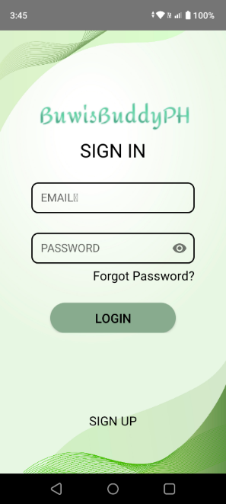

Figure 3: **BuwisBuddyPH Sign In / Sign Up Page**

|  |  |  |
| --- | --- | --- |
| Name | Description | Params |
| App Logo | The logo of the app displayed at the top with text "BuwisBuddyPH". | Text: "BuwisBuddyPH" |
| Sign In Heading | A heading indicating the purpose of the screen (Sign In). | Text: "SIGN IN" |
| Email Input Field | Text field for users to enter their email address. | Hint: "EMAIL" |
| Password Input Field | Text field for users to enter their password with an eye icon for visibility toggle. | Hint: "PASSWORD", Icon: Eye |
| Forgot Password Link | A clickable text link for users to recover their password if forgotten. | Text: "Forgot Password?" |
| Login Button | A button that initiates the login process. | Text: "LOGIN", Style: Rounded button |
| Sign Up Link | A link at the bottom of the screen for new users to create an account. | Text: "SIGN UP" |
| Background Pattern | A subtle background design with gradient waves, adding to the aesthetics of the screen. | Background: Light green wave pattern |

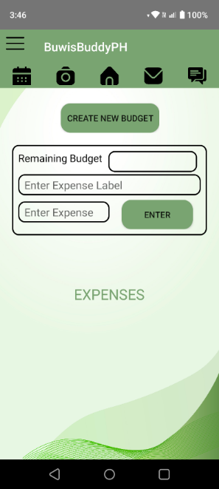

Figure 4: **BuwisBuddyPH Home Page**

|  |  |  |
| --- | --- | --- |
| Name | Description | Params |
| App Logo | The logo of the app displayed at the top with text "BuwisBuddyPH". | Text: "BuwisBuddyPH" |
| Navigation Icons | A set of icons representing various features or sections of the app. | Icons: Calendar, Camera, Home, Mail, Chat |
| Create New Budget Button | A button for creating a new budget entry. | Text: "CREATE NEW BUDGET", Style: Rounded button |
| Remaining Budget Field | Text field displaying the remaining budget amount. | Placeholder: "Remaining Budget" |
| Expense Label Field | Input field for entering the label or name of the expense. | Placeholder: "Enter Expense Label" |
| Expense Amount Field | Input field for entering the expense amount. | Placeholder: "Enter Expense" |
| Enter Button | Button to submit the expense entry. | Text: "ENTER", Style: Rounded button |
| Expenses Heading | A heading indicating the expense section of the app. | Text: "EXPENSES", Style: Green color |
| Background Pattern | A subtle background design with gradient waves, adding to the aesthetics of the screen. | Background: Light green wave pattern |

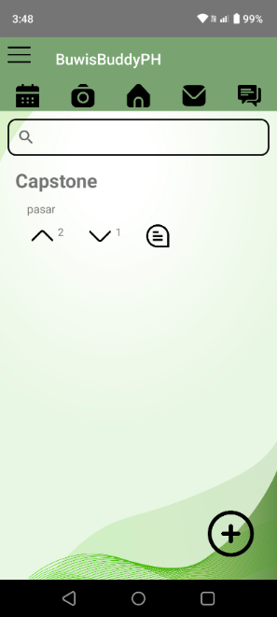

Figure 5: **BuwisBuddyPH Forum Page**

|  |  |  |
| --- | --- | --- |
| Name | Description | Params |
| App Logo | The logo of the app displayed at the top with text "BuwisBuddyPH". | Text: "BuwisBuddyPH" |
| Navigation Icons | A set of icons at the top representing various features or sections of the app. | Icons: Calendar, Camera, Home, Mail, Chat |
| Search Bar | An input field at the top allowing users to search randomly. | Icon: Magnifying glass, Placeholder: "Search" |
| Capstone Label | A label displaying the word "Capstone" or the title of the forum. | Text: "Capstone", Font: Bold |
| Capstone Description | A short description or subtext below the title "Capstone." It is the content of the forum. | Text: "pasar" |
| Arrow Icon (Up) | An icon represents an upward arrow, representing a like or reaction for the forum. | Icon: Upward arrow |
| Number Indicator (2) | A number indicating a count or value associated with the upward arrow. It counts how many reacted or like the forum. | Text: "2" |
| Arrow Icon (Down) | An icon represents a downward arrow, representing a dislike reaction for the forum. | Icon: Downward arrow |
| Number Indicator (1) | A number indicating a count or value associated with the downward arrow. It counts how many reacted or dislike the forum. | Text: "1" |
| Document Icon | An icon resembling a document, representing comments of the forum. | Icon: Document |
| Floating Action Button (FAB) | A circular button at the bottom right for adding new items or entries in the forum. | Icon: Plus (+), Style: Circular, Color: Green |
| Background Pattern | A subtle background design with gradient waves, adding to the aesthetics of the screen. | Background: Light green wave pattern |

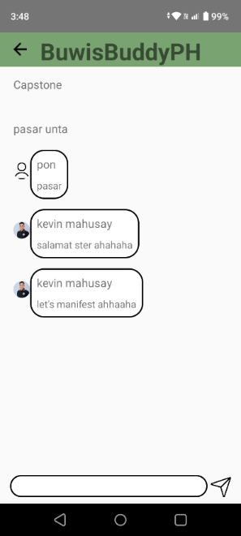

Figure 6: **BuwisBuddyPH Forum - Comment Page**

|  |  |  |
| --- | --- | --- |
| Name | Description | Params |
| App Logo | The logo of the app displayed at the top with text "BuwisBuddyPH". | Text: "BuwisBuddyPH" |
| Capstone Label | A label displaying the word "Capstone" or the title of the forum. | Text: "Capstone", Font: Bold |
| Capstone Description | A short description or subtext below the title "Capstone." It is the content of the forum. | Text: "pasar unta" |
| User Message Bubble 1 | A message/comment bubble containing the user "pon" and their message "pasar". | User Icon: Person icon, Text: "pon - pasar" |
| User Profile Image | Profile image of the user "kevin mahusay" in each message/comment bubble. | Image: Profile picture |
| Comment Message Bubble 1 | A message bubble from "kevin mahusay" containing the text "salamat ster ahahaha". | Text: "kevin mahusay - salamat ster ahahaha" |
| Comment Message Bubble 2 | A second message bubble from "kevin mahusay" containing the text "let's manifest ahahaha". | Text: "kevin mahusay - let's manifest ahahaha" |
| Message Input Field | Input field at the bottom of the screen for typing new comments. | Placeholder: "Type a message" |
| Send Button | An icon button to send the comments, displayed as a paper airplane icon. | Icon: Paper airplane |
| Background | Plain background for a clean, minimal chat interface. | Background: White |

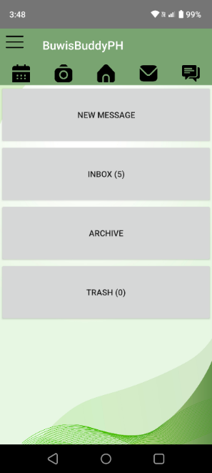

Figure 7: **BuwisBuddyPH Message Page**

|  |  |  |
| --- | --- | --- |
| Name | Description | Params |
| App Logo | The app's logo displayed at the top with text "BuwisBuddyPH". | Text: "BuwisBuddyPH" |
| Navigation Icons | A set of icons at the top represents various app features or sections. | Icons: Calendar, Camera, Home, Mail, Chat |
| New Message Button | A rectangular button for composing a new message. | Text: "NEW MESSAGE", Style: Light gray background |
| Inbox Button | A rectangular button displaying the inbox with a message count indicator. | Text: "INBOX (5)", Style: Light gray background |
| Archive Button | A rectangular button that navigates to the archive section. | Text: "ARCHIVE", Style: Light gray background |
| Trash Button | A rectangular button for viewing deleted messages, with a count indicator. | Text: "TRASH (0)", Style: Light gray background |
| Background Pattern | A subtle background design with gradient waves, adding to the aesthetics of the screen. | Background: Light green wave pattern |

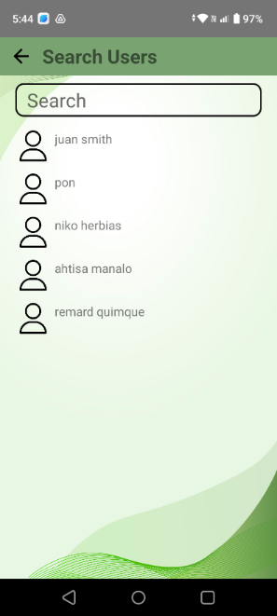

Figure 8: **BuwisBuddyPH Message – Search User Page**

|  |  |  |
| --- | --- | --- |
| Name | Description | Params |
| Back Button | A button allowing the user to navigate back to the previous screen. | Icon: Arrow pointing left |
| Screen Title | The title of the screen indicating the current function, "Search Users". | Text: "Search Users", Font: Bold |
| Search Bar | An input field at the top for searching users. | Icon: Magnifying glass, Placeholder: "Search" |
| User List Item | A list displaying user names along with icons representing each user. | Elements: User Icon, Text (User Name) |
| User Icon | An icon next to each username, representing individual users. | Icon: Person silhouette |
| User Name | A text label displaying the username. | Text: "juan smith" |
| Background Pattern | A subtle background design with gradient waves, enhancing the visual appeal of the screen. | Background: Light green wave pattern |

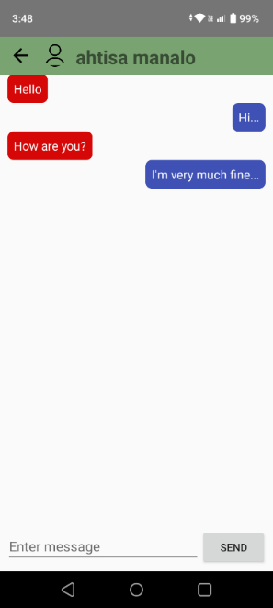

Figure 9: **BuwisBuddyPH New Message Page**

|  |  |  |
| --- | --- | --- |
| Name | Description | Params |
| Back Button | A button allowing the user to navigate back to the previous screen. | Icon: Arrow pointing left |
| User Profile Icon | An icon representing the profile of the user being chatted with. | Icon: Person silhouette |
| Screen Title | The name of the user currently being chatted with, displayed at the top. | Text: "ahtisa manalo", Font: Bold |
| Incoming Message Bubble 1 | A red message bubble on the left side with the text "Hello". | Text: "Hello", Style: Red background, White text |
| Outgoing Message Bubble 1 | A blue message bubble on the right side with the text "Hi...". | Text: "Hi...", Style: Blue background, White text |
| Message Input Field | Input field at the bottom for typing a new message. | Placeholder: "Enter message" |
| Send Button | A button to send the typed message. | Text: "SEND", Style: Light gray background |
| Background | Plain background for a clean, minimal chat interface | Background: White |

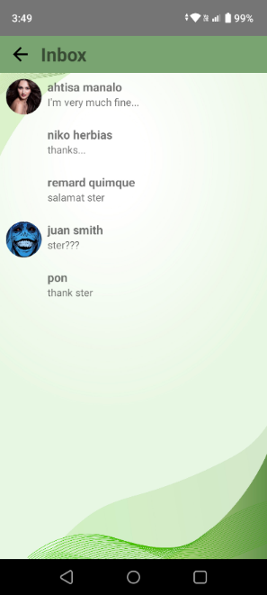

Figure 10: **BuwisBuddyPH Inbox Page**

|  |  |  |
| --- | --- | --- |
| Name | Description | Params |
| Back Button | A button allows the user to navigate back to the previous screen. | Icon: Arrow pointing left |
| Screen Title | The title of the screen indicates the current section, "Inbox". | Text: "Inbox", Font: Bold |
| Messages List Item | A list displaying user names, icons representing each user, and a preview of the latest message. | Elements: User Icon, Text (User Name, Messages) |
| User Profile Image | The user's profile image is displayed beside their message preview. | Image: Profile picture |
| User Name | A text label displaying the username. | Text: "ahtisa manalo" |
| Message Preview | A preview of the latest message from the user or the sender. | Text: "I'm very much fine..." |
| Background Pattern | A subtle background design with gradient waves, enhancing the visual appeal of the screen. | Background: Light green wave pattern |

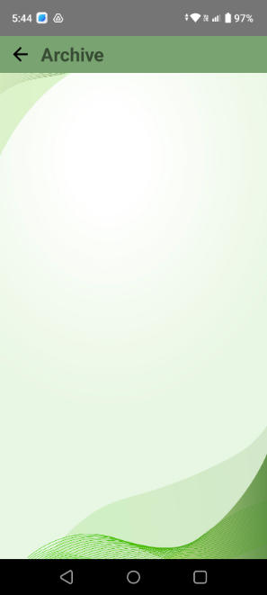

Figure 11: **BuwisBuddyPH Archive Page**

|  |  |  |
| --- | --- | --- |
| Name | Description | Params |
| Back Button | A button allowing the user to navigate back to the previous screen. | Icon: Arrow pointing left |
| Screen Title | The title of the screen indicating the current section, "Archive". | Text: "Archive", Font: Bold |
| Background Pattern | A subtle background design with gradient waves, enhancing the visual appeal of the screen. | Background: Light green wave pattern |

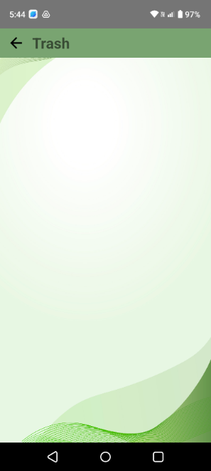

Figure 12: **BuwisBuddyPH Trash Page**

|  |  |  |
| --- | --- | --- |
| Name | Description | Params |
| Back Button | A button allowing the user to navigate back to the previous screen. | Icon: Arrow pointing left |
| Screen Title | The title of the screen indicating the current section, "Trash". | Text: "Trash", Font: Bold |
| Background Pattern | A subtle background design with gradient waves, enhancing the visual appeal of the screen. | Background: Light green wave pattern |

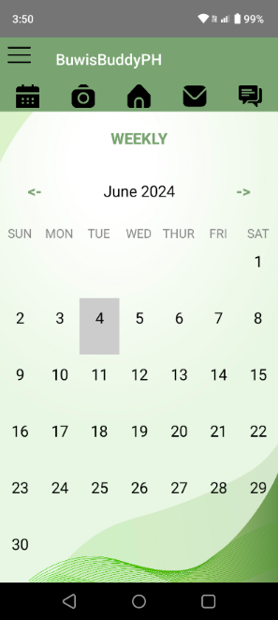

Figure 13: **BuwisBuddyPH Calendar Page**

|  |  |  |
| --- | --- | --- |
| Name | Description | Params |
| App Logo | The logo of the app displayed at the top with text "BuwisBuddyPH". | Text: "BuwisBuddyPH" |
| Navigation Icons | A set of icons at the top representing various features or sections of the app. | Icons: Calendar, Camera, Home, Mail, Chat |
| Calendar View Title | The title for the calendar view, indicating the type of view (Weekly). | Text: "WEEKLY", Font: Bold, Color: Green |
| Month and Year Display | Displays the current month and year being viewed on the calendar. | Text: "June 2024", Font: Regular |
| Navigation Arrows | Arrows on either side of the month display for navigating between months. | Icons: Left arrow, Right arrow |
| Weekday Headers | Labels for each day of the week (SUN, MON, TUE, WED, THU, FRI, SAT). | Text: Day abbreviations, Font: Regular |
| Date Cells | A grid displaying each day of the month with selectable dates. | Dates: 1 to 30, Style: Square cells |
| Selected Date Highlight | Highlights the selected date (e.g., June 4) in a different color or shade. | Highlighted Date: "4", Background Color: Light gray |
| Background Pattern | A subtle background design with gradient waves, adding to the aesthetics of the screen. | Background: Light green wave pattern |

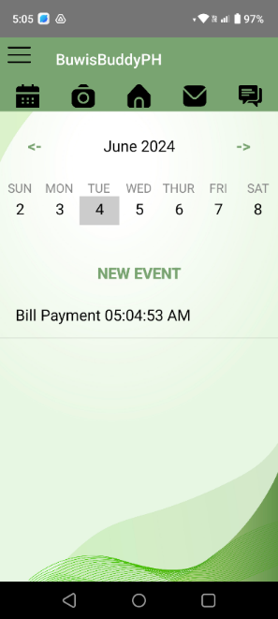

Figure 14: **BuwisBuddyPH Add Reminder Page**

|  |  |  |
| --- | --- | --- |
| Name | Description | Params |
| App Logo | The logo of the app displayed at the top with text "BuwisBuddyPH". | Text: "BuwisBuddyPH" |
| Navigation Icons | A set of icons at the top representing various features or sections of the app. | Icons: Calendar, Camera, Home, Mail, Chat |
| Month and Year Display | Displays the current month and year being viewed on the calendar. | Text: "June 2024", Font: Regular |
| Navigation Arrows | Arrows on either side of the month display for navigating between months. | Icons: Left arrow, Right arrow |
| Weekday Headers | Labels for each day of the week (SUN, MON, TUE, WED, THU, FRI, SAT). | Text: Day abbreviations, Font: Regular |
| Date Cells | A grid displaying each day of the month with selectable dates. | Dates: 1 to 8, Style: Square cells |
| Selected Date Highlight | Highlights the selected date (e.g., June 4) in a different color or shade. | Highlighted Date: "4", Background Color: Light gray |
| New Event Link | A link indicating the start of a new event section below the calendar. | Text: "NEW EVENT", Font: Bold, Color: Green |
| Event Details | Displays the details of a scheduled event on the selected date (e.g., "Bill Payment 05:04:53 AM"). | Text: "Bill Payment 05:04:53 AM", Font: Regular |
| Background Pattern | A subtle background design with gradient waves, enhancing the visual appeal of the screen. | Background: Light green wave pattern |

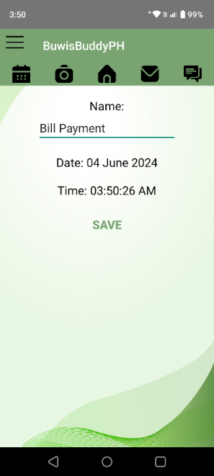

Figure 15: **BuwisBuddyPH Reminder Page**

|  |  |  |
| --- | --- | --- |
| Name | Description | Params |
| App Logo | The logo of the app displayed at the top with text "BuwisBuddyPH". | Text: "BuwisBuddyPH" |
| Navigation Icons | A set of icons at the top representing various features or sections of the app. | Icons: Calendar, Camera, Home, Mail, Chat |
| Field Label - Name | Label for the name field, indicating the purpose of the field. | Text: "Name:", Font: Regular |
| Name Input Field | A text field displaying the name of the item or reminder. | Text: "Bill Payment" |
| Field Label - Date | Label for the date field. | Text: "Date:", Font: Regular |
| Date Display | Text displaying the selected or current date for the reminder. | Text: "04 June 2024", Font: Regular |
| Field Label - Time | Label for the time field. | Text: "Time:", Font: Regular |
| Time Display | Text displaying the selected or current time for the bill payment. | Text: "03:50:26 AM", Font: Regular |
| Save Button | A button to save the reminder details. | Text: "SAVE", Style: Green text, Centered |
| Background Pattern | A subtle background design with gradient waves, enhancing the visual appeal of the screen. | Background: Light green wave pattern |

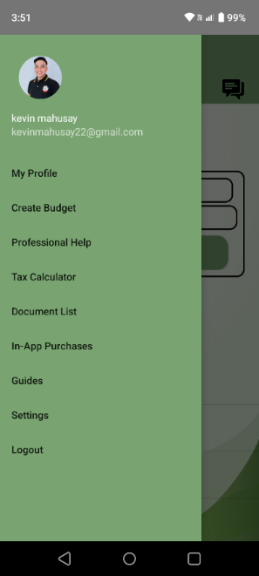

Figure 16: **BuwisBuddyPH Menu Page**

|  |  |  |
| --- | --- | --- |
| Name | Description | Params |
| User Profile Image | Profile picture of the logged-in user displayed at the top of the navigation drawer. | Image: Profile picture |
| User Name | Display of the user's name. | Text: "kevin mahusay" |
| User Email | Display of the user's email address. | Text: "kevinmahusay22@gmail.com" |
| Menu Item - My Profile | A navigation option to access the user's profile. | Text: "My Profile" |
| Menu Item - Create Budget | A navigation option to create a new budget. | Text: "Create Budget" |
| Menu Item - Professional Help | A navigation option for accessing professional help resources. | Text: "Professional Help" |
| Menu Item - Tax Calculator | A navigation option to open the tax calculator. | Text: "Tax Calculator" |
| Menu Item - Document List | A navigation option to view documents. | Text: "Document List" |
| Menu Item - In-App Purchases | A navigation option for in-app purchase features. | Text: "In-App Purchases" |
| Menu Item - Guides | A navigation option to access guides. | Text: "Guides" |
| Menu Item - Settings | A navigation option to open settings. | Text: "Settings" |
| Menu Item - Logout | A navigation option to log out of the app. | Text: "Logout" |
| Background Pattern | A plain green background color for the navigation drawer. | Background Color: Green |

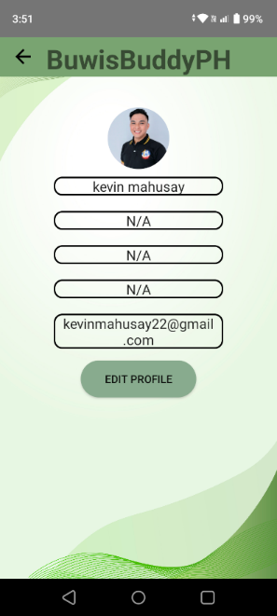

Figure 17: **BuwisBuddyPH Profile Page**

|  |  |  |
| --- | --- | --- |
| Name | Description | Params |
| Back Button | A button allows the user to navigate back to the previous screen. | Icon: Arrow pointing left |
| App Logo | The app's logo is displayed at the top with the text “BuwisBuddyPH". | Text: "BuwisBuddyPH" |
| User Profile Image | A profile picture of the user is displayed at the top of the profile screen. | Image: Profile picture |
| User Name Display | A field displaying the user's name. | Text: "kevin mahusay", Style: Rounded border |
| Info Field 1 | An information field currently showing "N/A". | Text: "N/A", Style: Rounded border |
| Info Field 2 | An information field currently showing "N/A". | Text: "N/A", Style: Rounded border |
| Info Field 3 | An information field currently showing "N/A". | Text: "N/A", Style: Rounded border |
| Email Display | A field displaying the user's email address. | Text: "kevinmahusay22@gmail.com", Style: Rounded border |
| Edit Profile Button | A button to edit the user's profile information. | Text: "EDIT PROFILE", Style: Rounded green button |
| Background Pattern | A subtle background design with gradient waves, enhancing the visual appeal of the screen | Background: Light green wave pattern |

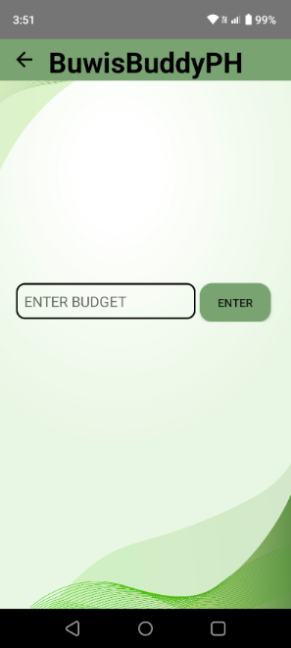

Figure 18: **BuwisBuddyPH Create Budget Page**

|  |  |  |
| --- | --- | --- |
| Name | Description | Params |
| Back Button | A button allowing the user to navigate back to the previous screen | Icon: Arrow pointing left |
| App Logo | The logo of the app displayed at the top with text "BuwisBuddyPH". | Text: "BuwisBuddyPH" |
| Budget Input Field | A text input field where users can enter their budget amount. | Placeholder: "ENTER BUDGET", Style: Rounded border |
| Enter Button | A button to submit the entered budget. | Text: "ENTER", Style: Rounded green button |
| Background Pattern | A subtle background design with gradient waves, enhancing the visual appeal of the screen. | Background: Light green wave pattern |

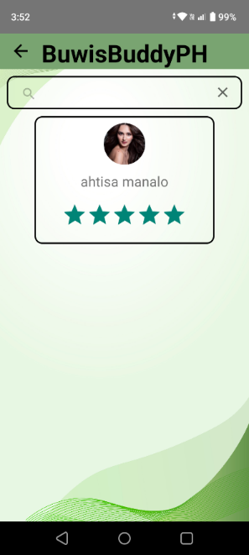

Figure 19: **BuwisBuddyPH Professional Help Page**

|  |  |  |
| --- | --- | --- |
| Name | Description | Params |
| Back Button | A button allowing the user to navigate back to the previous screen | Icon: Arrow pointing left |
| App Logo | The logo of the app displayed at the top with text "BuwisBuddyPH". | Text: "BuwisBuddyPH" |
| Search Bar | An input field at the top for searching users. | Icon: Magnifying glass, Placeholder: "Search" |
| User Profile Card | A card displaying the profile details of the searched user. | Style: Rounded border |
| User Profile Image | Profile picture of the user displayed within the profile card. | Image: Profile picture of "ahtisa manalo" |
| User Name | The name of the user displayed below the profile picture. | Text: "ahtisa manalo", Font: Regular |
| User Rating | A star rating display showing the user’s rating. | Stars: 5, Color: Green |
| Background Pattern | A subtle background design with gradient waves, enhancing the visual appeal of the screen. | Background: Light green wave pattern |

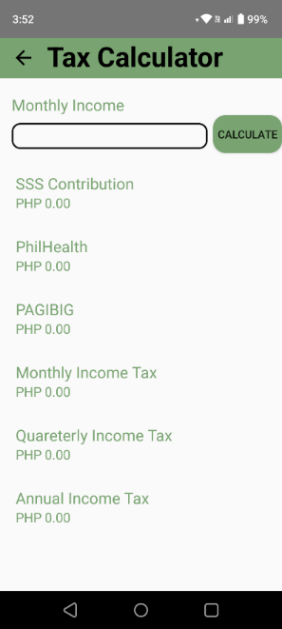

Figure 20: **BuwisBuddyPH Tax Calculator Page**

|  |  |  |
| --- | --- | --- |
| Name | Description | Params |
| Back Button | A button allowing the user to navigate back to the previous screen. | Icon: Arrow pointing left |
| Screen Title | The title of the screen indicating the current section, "Tax Calculator". | Text: "Tax Calculator", Font: Bold |
| Monthly Income Input Field | A text input field where users can enter their monthly income. | Placeholder: "Monthly Income", Style: Rounded border |
| Calculate Button | A button to calculate the tax and contributions based on the entered monthly income. | Text: "CALCULATE", Style: Rounded green button |
| SSS Contribution Display | Text displaying the calculated SSS contribution based on the entered income. | Label: "SSS Contribution", Value: "PHP 0.00" |
| PhilHealth Display | Text displaying the calculated PhilHealth contribution based on the entered income. | Label: "PhilHealth", Value: "PHP 0.00" |
| PAGIBIG Display | Text displaying the calculated PAGIBIG contribution based on the entered income. | Label: "PAGIBIG", Value: "PHP 0.00" |
| Monthly Income Tax Display | Text displaying the calculated monthly income tax based on the entered income. | Label: "Monthly Income Tax", Value: "PHP 0.00" |
| Quarterly Income Tax Display | Text displaying the calculated quarterly income tax based on the entered income. | Label: "Quarterly Income Tax", Value: "PHP 0.00" |
| Annual Income Tax Display | Text displaying the calculated annual income tax based on the entered income. | Label: "Annual Income Tax", Value: "PHP 0.00" |
| Background | Plain background for a clean, minimal layout. | Background: White |

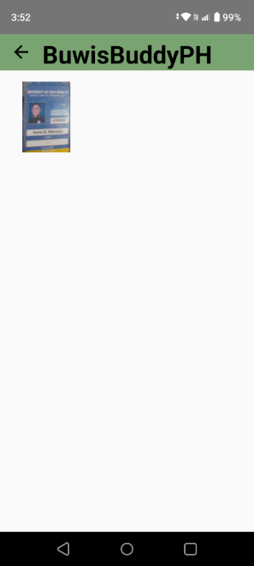

Figure 21: **BuwisBuddyPH Document List Page**

|  |  |  |
| --- | --- | --- |
| Name | Description | Params |
| Back Button | A button allowing the user to navigate back to the previous screen | Icon: Arrow pointing left |
| App Logo | The logo of the app displayed at the top with text "BuwisBuddyPH". | Text: "BuwisBuddyPH" |
| Displayed Image | An image of scanned documents is shown on the screen. | Image: Thumbnail of document |
| Background | Plain background for a clean, minimal interface. | Background: White |

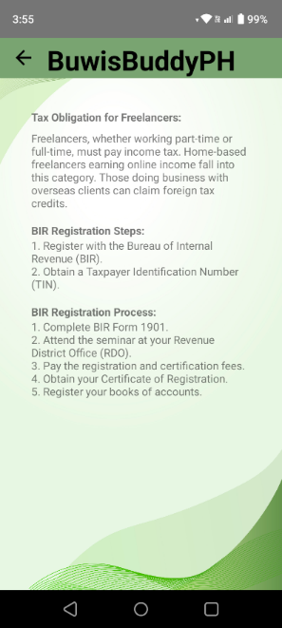

Figure 22: **BuwisBuddyPH Guide Page**

|  |  |  |
| --- | --- | --- |
| Name | Description | Params |
| Back Button | A button allowing the user to navigate back to the previous screen. | Icon: Arrow pointing left |
| App Logo | The logo of the app displayed at the top with text "BuwisBuddyPH". | Text: "BuwisBuddyPH" |
| Section Title | The main title or heading of the informational section. | Text: "Tax Obligation for Freelancers", Font: Bold |
| Informational Text | Detailed information on tax obligations for freelancers, including registration steps and processes. | Text: Content on tax obligations, steps, and process |
| Subheading - BIR Registration Steps | A subheading for the section detailing BIR registration steps. | Text: "BIR Registration Steps:", Font: Bold |
| Registration Steps | A list of steps required for freelancers to register with the Bureau of Internal Revenue (BIR). | Text: Numbered list under "BIR Registration Steps" |
| Subheading - BIR Registration Process | A subheading for the section detailing the full registration process. | Text: "BIR Registration Process:", Font: Bold |
| Registration Process | A detailed list of the full registration process for freelancers. | Text: Numbered list under "BIR Registration Process" |
| Background Pattern | A subtle background design with gradient waves, enhancing the visual appeal of the screen. | Background: Light green wave pattern |

**Test Plan**

|  |  |  |
| --- | --- | --- |
| Project Name: | **BuwisBuddyPH** | **The None-Chalant** |
| Module Name: | **Sign in** |
| Created by: | **The None-Chalant** |
| Date of Creation: | **10/18/2024** |
| Date of Review: |  |

|  |  |  |  |  |  |  |  |  |  |
| --- | --- | --- | --- | --- | --- | --- | --- | --- | --- |
| Test Case ID | Test Case Scenario | Test Case | Pre-Condition | Test Steps | Test Data | Expected Result | Post Condition | Actual Result | Status  (Pass/Fail) |
| TC_SI01 | Valid login of account | Enter a valid username gmail and password | Need a valid account that use for signup | 1. Enter username  2. Enter password  3. Click ‘Login’ Button | <Valid Gmail>  <Valid password> | Successful login |  |  |  |
| TC_SI02 | Valid login of account | Enter a valid gmail and wrong password | Need a valid account that use for signup | 1. Enter username  2. Enter password  3. Click ‘Login’ Button | <Valid gmail>  <Invalid password> | Cannot login |  |  |  |
| TC_SI03 | Valid login of account | Enter a wrong gmail and password | Need a valid account that use for signup | 1. Enter username  2. Enter password  3. Click ‘Login’ Button | <Invalid Gmail>  <Valid password> | Cannot login |  |  |  |

|  |  |  |
| --- | --- | --- |
| Project Name: | **BuwisBuddyPH** | **The None-Chalant** |
| Module Name: | **Sign up** |
| Created by: | **The None-Chalant** |
| Date of Creation: | **10/18/2024** |
| Date of Review: |  |

|  |  |  |  |  |  |  |  |  |  |
| --- | --- | --- | --- | --- | --- | --- | --- | --- | --- |
| Test Case ID | Test Case Scenario | Test Case | Pre-Condition | Test Steps | Test Data | Expected Result | Post Condition | Actual Result | Status  (Pass/Fail) |
| TC_SU01 | Signup valid user info | Enter all info valid | All fields are required | 1. Enter all fields valid  2. Click ‘Create Account’ button  3. Click ‘Create Account’ button | <Valid other fields> | Create account successfully |  |  |  |
| TC_SU02 | Signup valid user info | Enter all info valid except email account | All fields are required | 1. Enter all fields valid  2. Input invalid Gmail  3. Click ‘Create Account’ button | <Valid other fields>  <Invalid Gmail> | Cannot create account |  |  |  |
| TC_SU03 | Signup valid user info | Enter all info valid but leave the name empty | All fields are required | 1. leave name field empty  2. Enter other fields balid  2. Click ‘Create Account’ button | <Invalid name>  <Valid other fields> | Cannot create account |  |  |  |

|  |  |  |
| --- | --- | --- |
| Project Name: | **BuwisBuddyPH** | **The None-Chalant** |
| Module Name: | **Messages** |
| Created by: | **The None-Chalant** |
| Date of Creation: | **10/18/2024** |
| Date of Review: |  |

|  |  |  |  |  |  |  |  |  |  |
| --- | --- | --- | --- | --- | --- | --- | --- | --- | --- |
| Test Case ID | Test Case Scenario | Test Case | Pre-Condition | Test Steps | Test Data | Expected Result | Post Condition | Actual Result | Status  (Pass/Fail) |
| TC_M01 | Message other user | Enter a message and do not send it press back and open it again |  | 1. Message other user.  2. Enter a message  3. Do not send press back  4. Open again | <Valid message> | Can see the message again |  |  |  |
| TC_M02 | Message other user | Enter a message |  | 1. Message other user.  2. Enter a message  3. Send | <Valid message> | The other user can see the message |  |  |  |