I am giving excellent solutions to various kinds of practical problems; developing many types of Mobile, Web, Desktop applications and games, Engines for multi platforms.
Programming Languages and Frameworks we are based on:
★ Front-end technology
- Nodejs express server and Websocket communications.
- Familiar with JQuery、Webpack、Vue.js、Vue-cli、Sass、Less、Bootstrap、Nw.js、Electron
★ Back-end technology
- Java frameworks including Spring、Spring Boot、Hibernate、MyBatis、Shiro
- Familiar with Nginx、Redis、Jenkins、Docker、Kafka、ActiveMQ
- Also Familiar with Spark、Storm、Hadoop、Flink、HBase - Database management using MySQL、 MongoDB、Mariadb.
★ Mobile technology
- Mobile app development for iOS and Android for both Native and Hybrid.
- Familiar with Cordova、Flutter 、Framework7
Projects:
- Big e-Library System
This system is e-library system which was composed of database management system and browsing system of data.
MongoDB was used in database management system and used MODS schema.
The database management system parse MODS schema to store database into MongoDB.
And there is Admin system and used solr Search Engine.
and used 100 milions records, in order to display data. and tested for few months.
and used DSpace framework(Java Spring Boot Framework) which was widely used in the world.
so backend is Java Spring Boot Framework and used Vue.js including vuex technology as frontend.
The development period is almost a year and testing period is 2 months.
The number of team members are 4 members including 3 full stack java developers, 1 pure frontend vue.js developer.
This system was developed internally for one university.
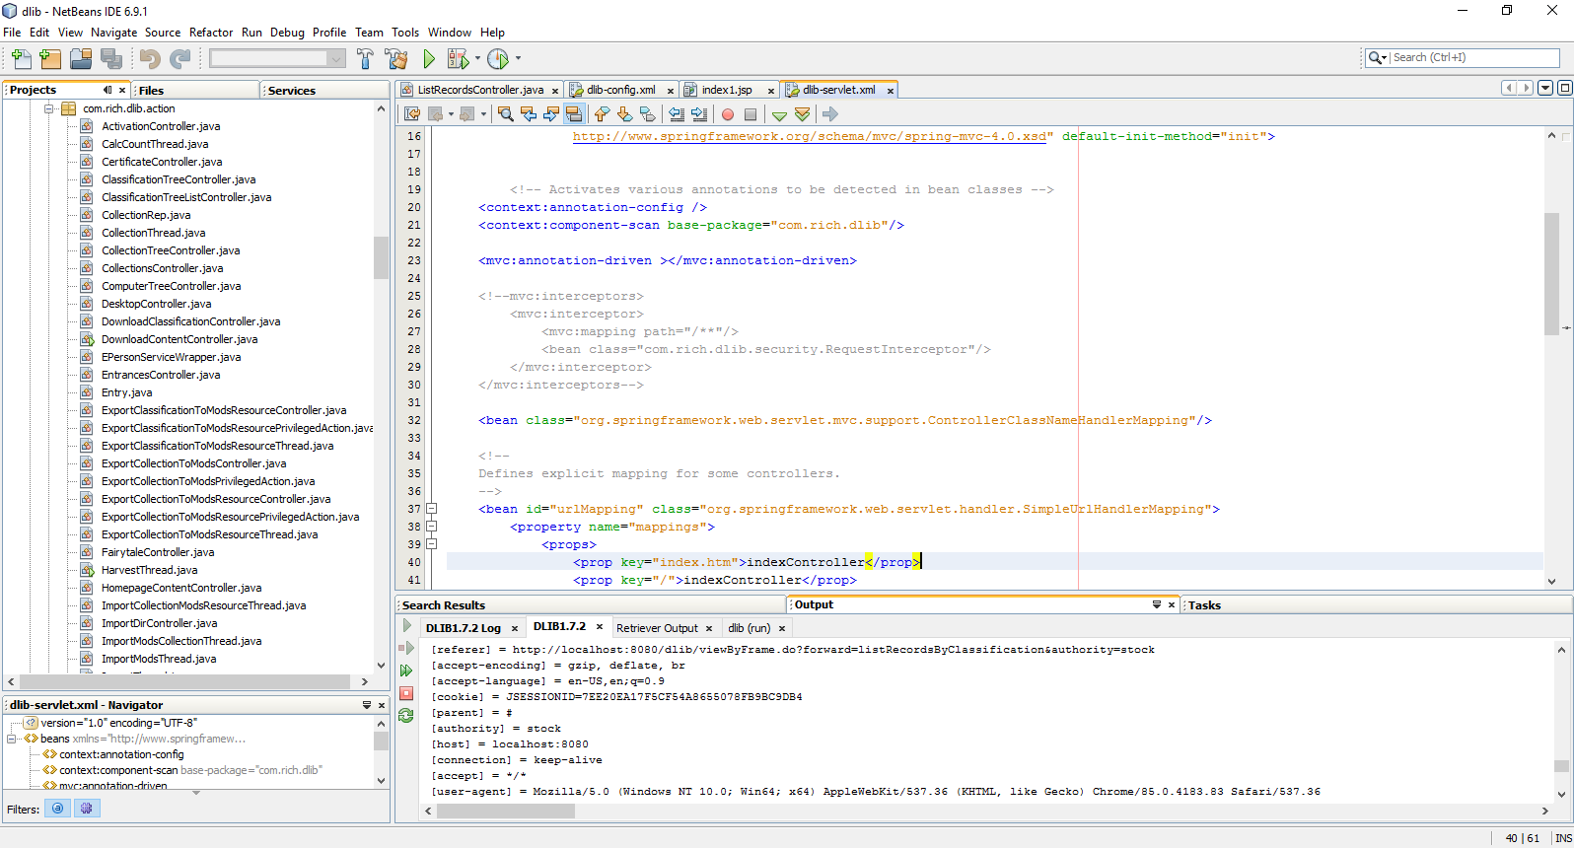
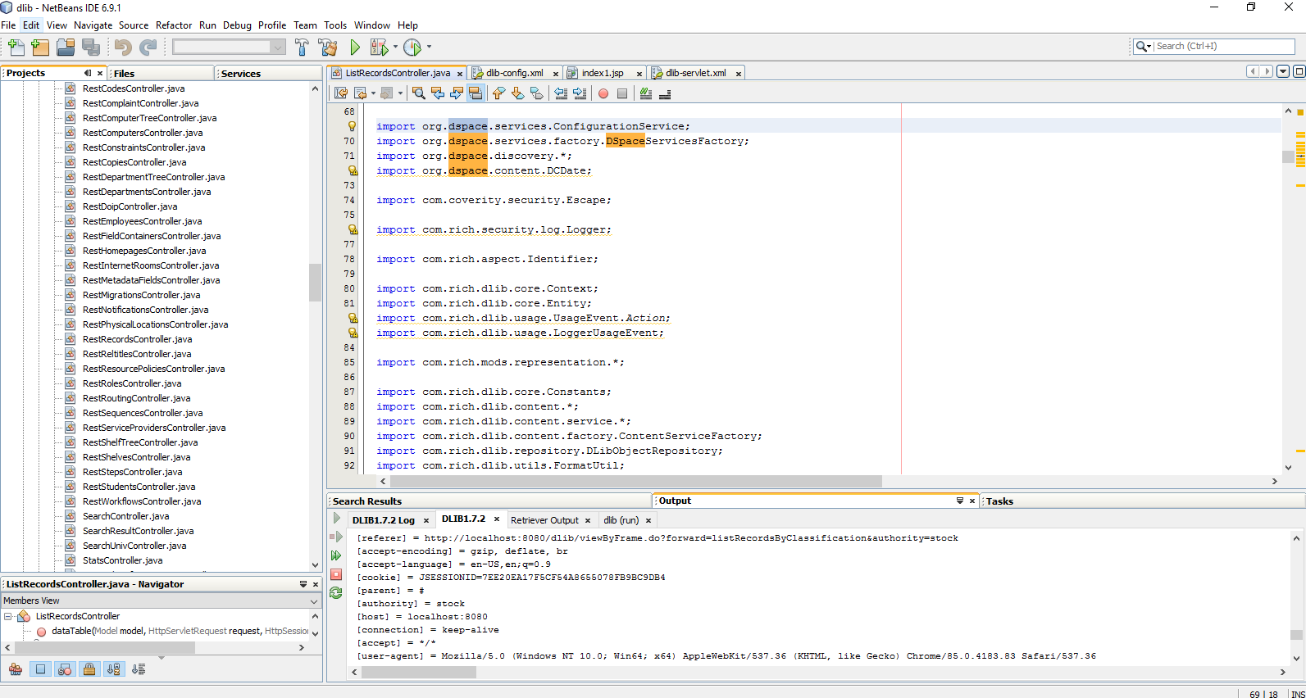
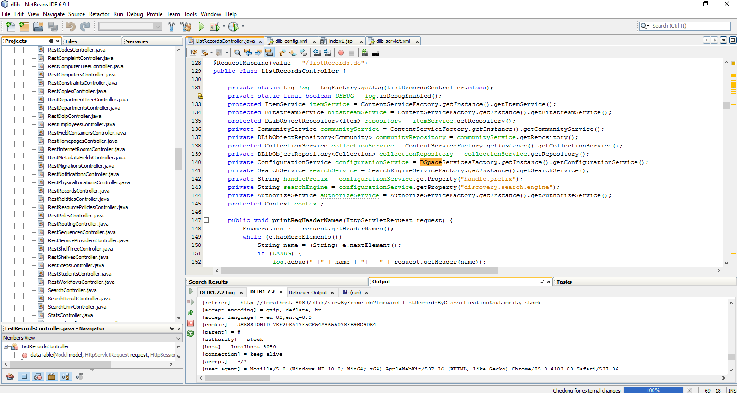
- Vancouver Public Library
This is also e-library system that is developed using SpringBoot framework
https://www.vpl.ca/

- Library – City of Carmel
This is library system.
https://ci.carmel.ca.us/library

…

Beside of these project, I have developed a lot of projects.

I’m possible in almost kind of projects.
I'm always ready to start your project.

Thanks.

