1. Dynamo DB design
2. Categories table

categoryid(S), categoryname(S), createdby(S), createdtime(S), updatedby(S), updatedtime(S), deletedby(S),deletedtime(S)

1. Courses table

courseid(S), categoryid(S), coursename(S), currency(S), price(S), expiryduration(S), coursephoto(S), highlights(S), createdby(S), createdtime(S), updatedby(S), updatedtime(S) , deletedby(S),deletedtime(S)

1. Coursehighlights table

highlightid(S), courseid(S), name(S), value(S), updatedby(S), updatedtime(S)

1. Sections table

sectionid(S), courseid(S), sectionname(S), createdby(S), createdtime(S), updatedby(S), updatedtime(S) , deletedby(S), deletedtime(S)

1. Topics table

topicid(S), sectionid(S), topicname(S), videofile(S), content(S), uploadedfile(S), createdby(S), createdtime(S), updatedby(S), updatedtime(S) , deletedby(S),deletedtime(S)

1. Orders table

orderid(S), userid(S), status(S), updatedby(S), updatedtime(S)

1. OrderItems table

orderitemid(S), orderid(S), ordertype(S), productid(S), currency(S), price(S), updatedby(S), updatedtime(S)

1. Payments table

paymentid(S), orderitemid(S), useremail(S), courseid(S), chargeid(S), is_refunded(N), updatedby(S), updatedtime(S)

1. Refunds table

refundid(S), paymentid(S), amount(S), adminemail(S), updatedby(S), updatedtime(S)

1. UI design
2. Admin Page

* Categories -- IOT, Machine learning 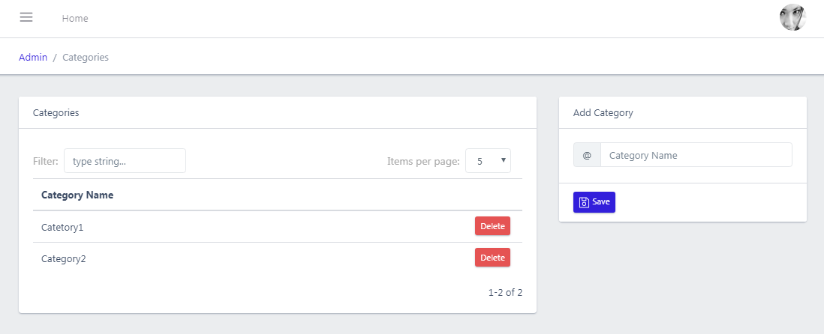
* Courses -- IOT Beginer, IOT Intermediate

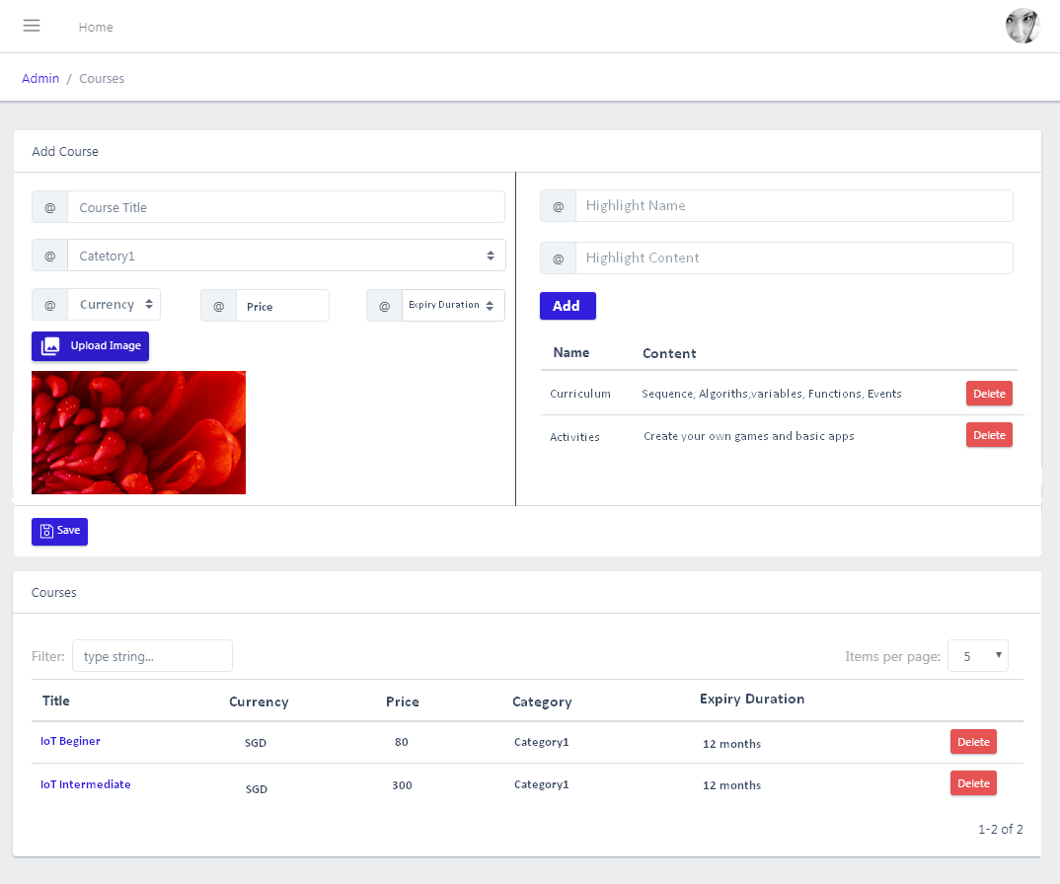

* Sections - (Getting started with Microbit, Visual Programing using the block editor)

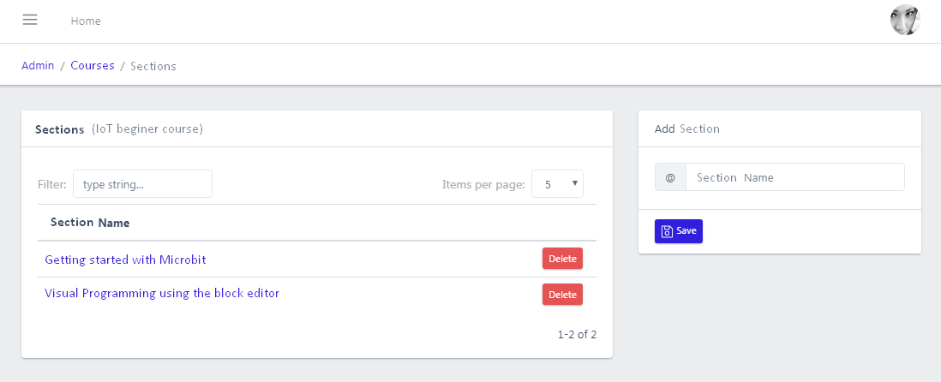

* Topics - (eg: Getting started with Microbit --> Introduction to course, Getting to know about microbit)

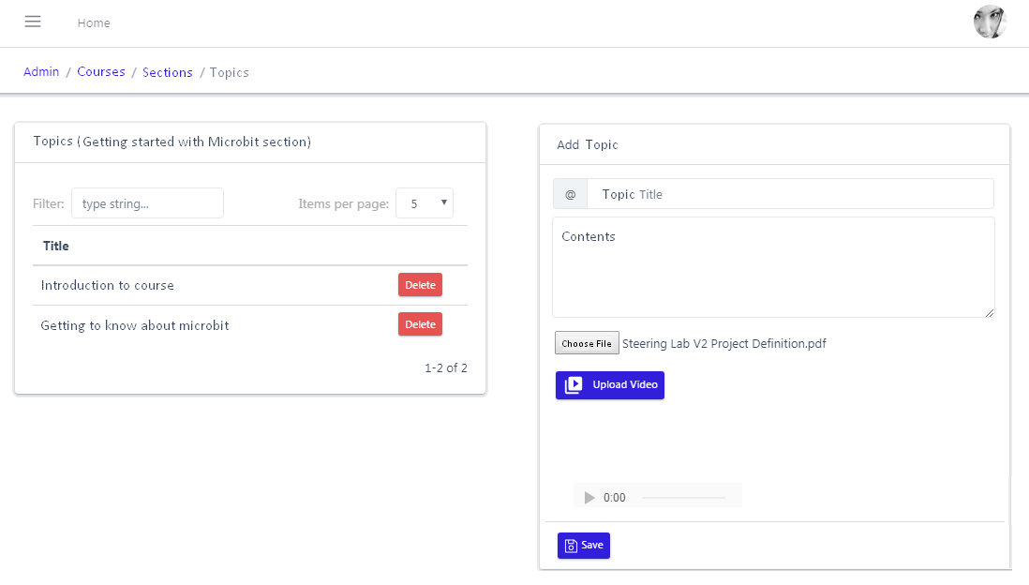

* Orders

In this case, whenever admin active or inactive users for courses, order is creaeted with userid and status, and then orderitem is created with orderid and courseid .

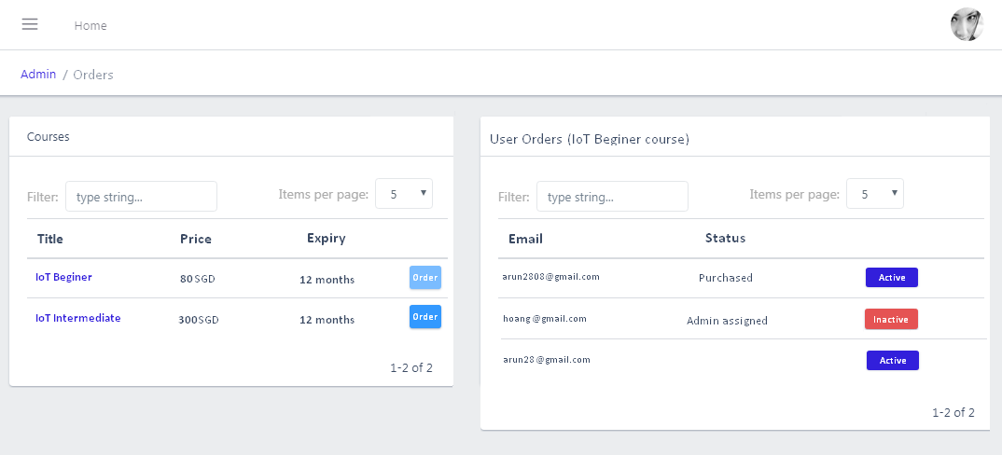

* Payments

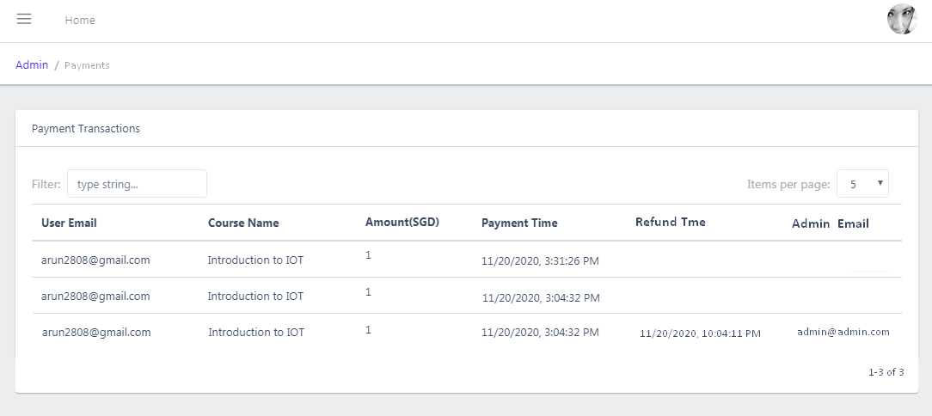

* Refunds

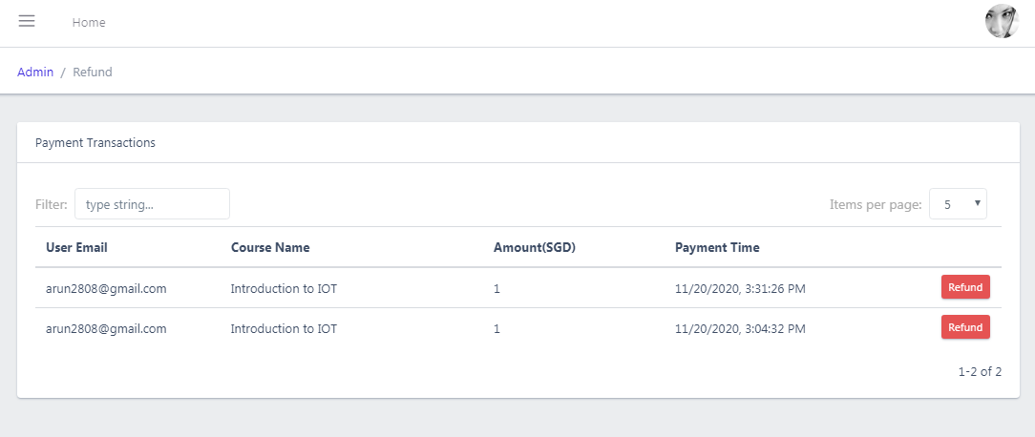

1. Front Page

* Home Page

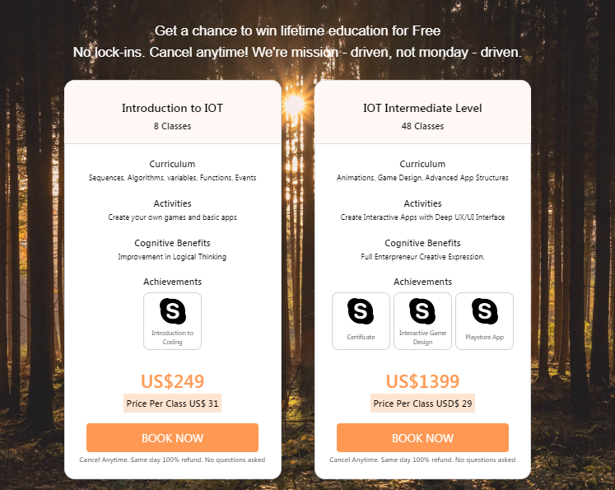

* My Courses Page

After a person buys or course is assigned by admin, need to check whether current time is greater than orderdatetime+expiryduration .

We should show only those courses in mycourses page

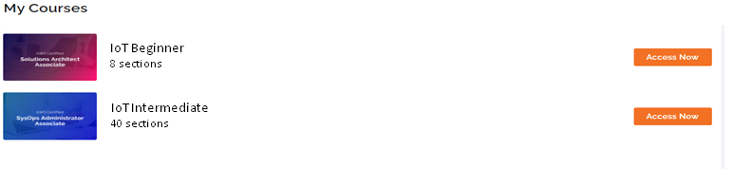

* Sections Page

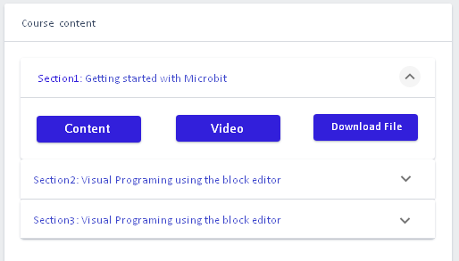

* Topics Page

