CS5243 Advanced UNIX Programming

Assignment 10 (5 pts)

Due: Oct 14, 2023, at 23:59:59

**Notice**

1. Please name your file properly; 2 pts will be taken out for incorrectly-named files.
2. Late submission is not allowed. You will receive 0 point in that case.
3. Plagiarism is not allowed. We will pass your source codes through a tool called “moss”, which is an anti-plagiarism service provided by Stanford University to determine the similarity of programs. If your program has > 20% similarity with your classmates, you will receive 0 point; no exception will be made. (Hint: Please do not share your code with fellow students. Discuss with them instead.)

**What to hand in**

1. A report that contains explanations of how you implemented your code. You should name it “***Group_id*.pdf**”.
2. Please upload all the code files separately and the pdf (do not zip them) to eeclass.

**Specifications**

**getenv** is a standard C library function which can retrieve the value of a environment variable.

In figure 12.13 in the textbook, there is a thread-safe version of **getenv**

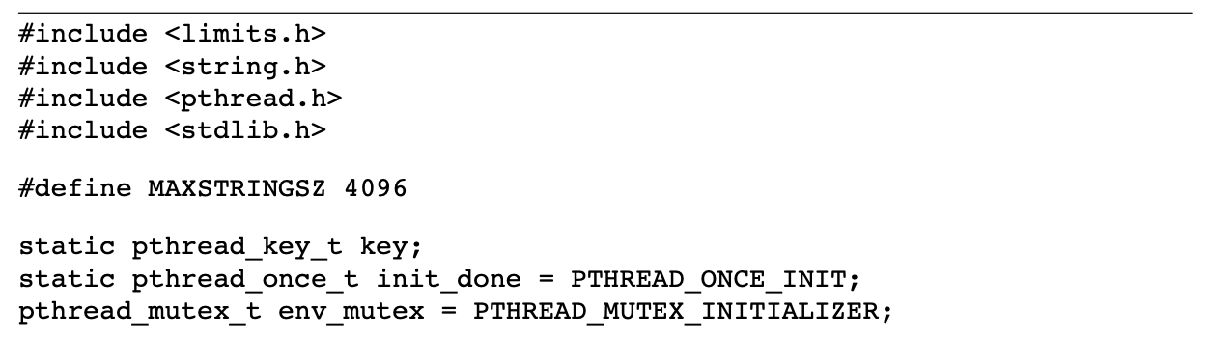

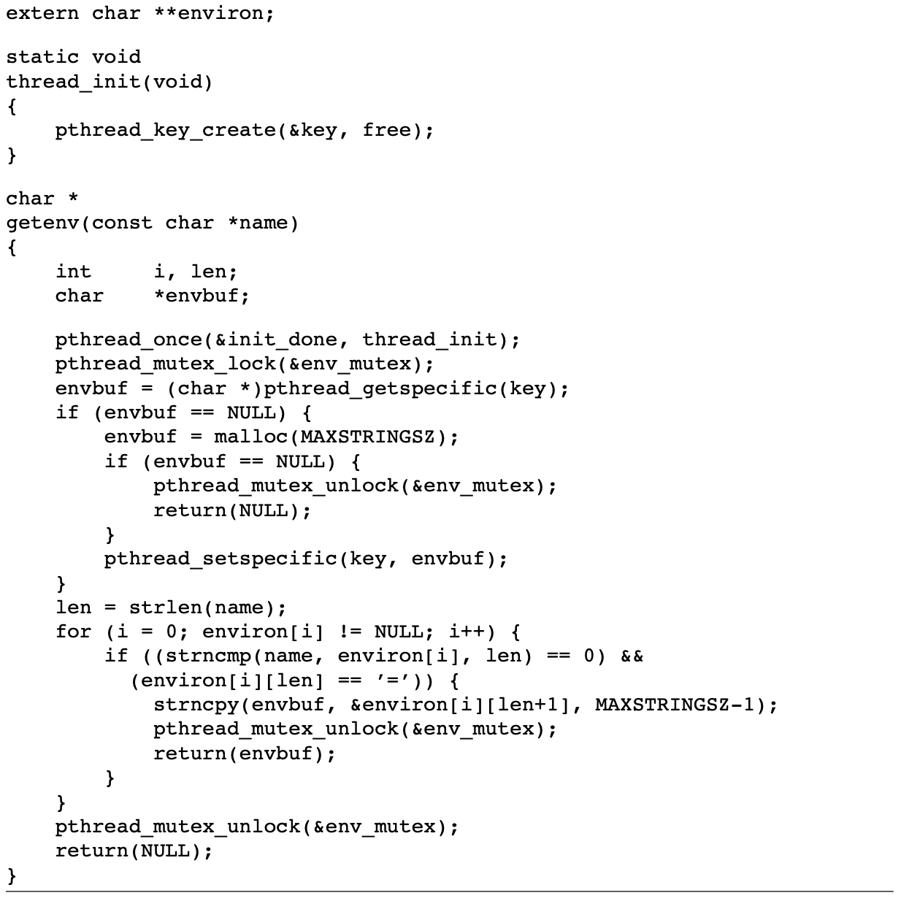

According to the version of **getenv** above, please answer the following questions in your report:

1. **(2 pt)** Is it possible to make this getenv function **async-signal safety** by temporarily blocking signals at the beginning of the function and then restoring the previous signal mask before the function returns? Explain.
2. **(3 pt)** Please run **assignment10.c** on FreeBSD and see if it can run successfully. If not, try to explain what happened. You can use **gdb** to help you find out why it crashes.