11210CS 543200 Advanced UNIX Programming

Assignment 5 (5 pts)

Due: Oct 14, 2023, at 23:59:59

**Notice**

1. Please name your file properly; 2 pts will be taken out for incorrectly-named files.
2. Late submission is not allowed. You will receive 0 point in that case.
3. Plagiarism is not allowed. We will pass your source codes through a tool called “moss”, which is an anti-plagiarism service provided by Stanford University to determine the similarity of programs. If your program has > 20% similarity with your classmates, you will receive 0 point; no exception will be made. (Hint: Please do not share your code with fellow students. Discuss with them instead.)

**What to hand in**

1. Your implementation code. You should name it “**assignment5.c**”.
2. A makefile that can compile your code. You should name it “**Makefile**”.
3. A report that contains the answer to the questions, screenshots of your results, and explanations of how you implemented your code. You should name it “***Group_id*.pdf**”.
4. Please upload all the code files separately and the pdf (do not zip them) to eeclass.

**Specifications**

At the end of Section 7.10, we showed how a function can’t return a pointer to an automatic variable.

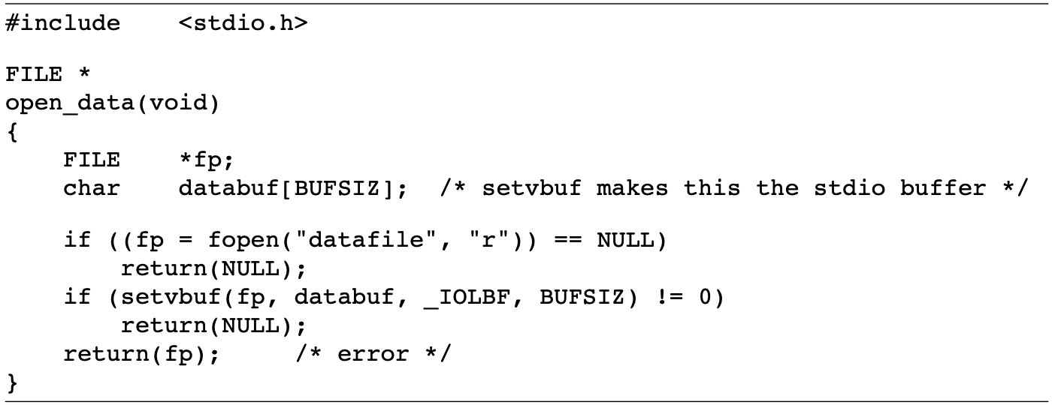

The problem is that when open_data returns, the space it used on the stack will be used by the stack frame for the next function that is called. But the standard I/O library will still be using that portion of memory for its stream buffer.

Then, is the following code correct?

int f1(int val)

{

int num = 0;

int *ptr = &num;

if (num == 0)

{ /* text had val == 0, but val is not in scope */

int val;

val = 5;

ptr = &val;

}

return(*ptr + 1);

}

In this assignment, you should:

1. **(2 pt)** Answer the question above. You need to explain why it is correct/incorrect in your report.
2. Implement a C program to verify your answer.
   1. **(1 pt)** Create a variable called val and set its value to “5” in the main function.
   2. **(1 pt)** Get the address of val in the f1 function. (Getting the address in the main function directly is forbidden!)
   3. **(1 pt)** Print the value and the address of val as the sample output shows.

**Additional Notes**

1. **Printing the words directly is forbidden**! We will check your source codes.
2. All of your code should be implemented within one .c file.
3. **Every output of your codes should follow the same format as the sample outputs** given below, otherwise, you will not get the points.

(We will compare your print results with the sample output.)

**Sample Output**

Value 5 is at 0x7ffee68b8598