Contents

Prepare OTCS Configuration 1

Attachment Folder 1

Enable properties for Search API 2

Enable Facet columns for Rest API sorting 3

API Deployment 7

Database setup 7

API setup 7

To deploy the API in IIS: 8

API tests 11

# Prepare OTCS Configuration

## Attachment Folder

The email browser api will automatically extracts the attachments of an email in content server, and place them in a “cache” folder in content server

A good place is to put this cache folder in is the “CS Applications Volume”, because this volume accepts any type of files:

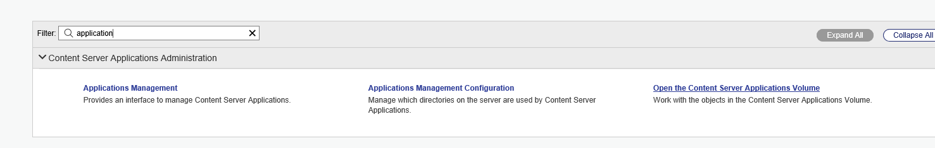

Create an inconspicuous folder called _system

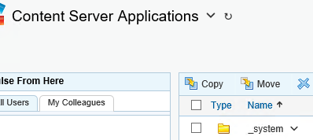

Make sure no one except the admin account or the email browser system admin account has any kind of permission to it, remove all the access:  
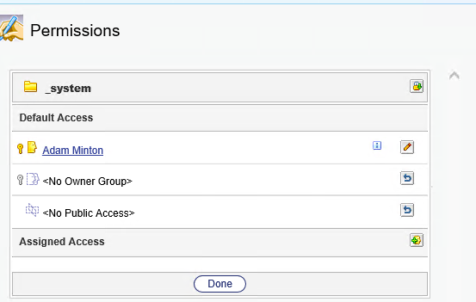

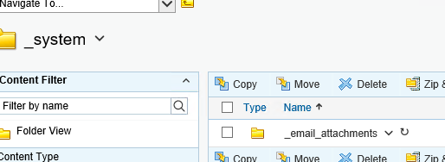

Create another folder inside this, you can name it anything. “email_attachments” is a good choice.

Take note of the id of this “email_attachments” folder, you will specify this in the email browser api config file.

## Enable properties for Search API

We are using the Content Server search api, so we need to enable the regions properties for the Search Manager

Open system object volume:  
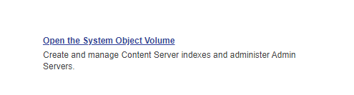

Go to the “Regions” of Enterprise Search Manager

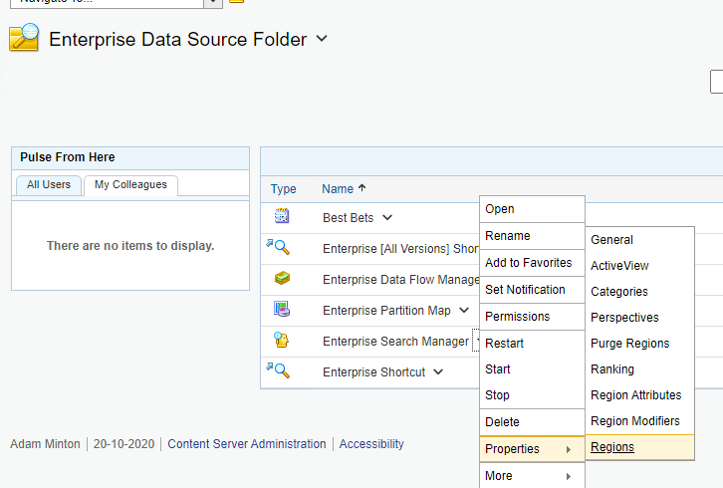

Make sure the following are ticked (yes)

|  |  |  |  |  |  |  |
| --- | --- | --- | --- | --- | --- | --- |
| Name | Display Name | Queryable | Displayable | Searchby Default | Sortable | Filter |
| OTLocation | Location |  | yes |  |  |  |
| OTDataSize | OTDataSize |  | yes |  |  |  |
| OTName | Name | Yes | Yes |  |  |  |
| OTSummary | OTSummary |  | Yes |  |  |  |
|  |  |  |  |  |  |  |









## Enable Facet columns for Rest API sorting

We are using the CS REST API to list out the emails in a paginated way, and in order for this to support sorting, we have to create the required facet columns in the system.

We can store the facet columns in a folder:

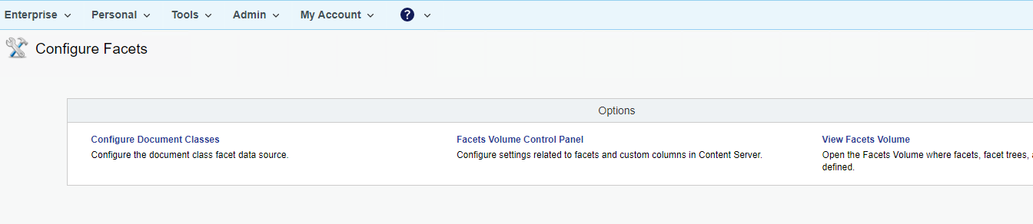

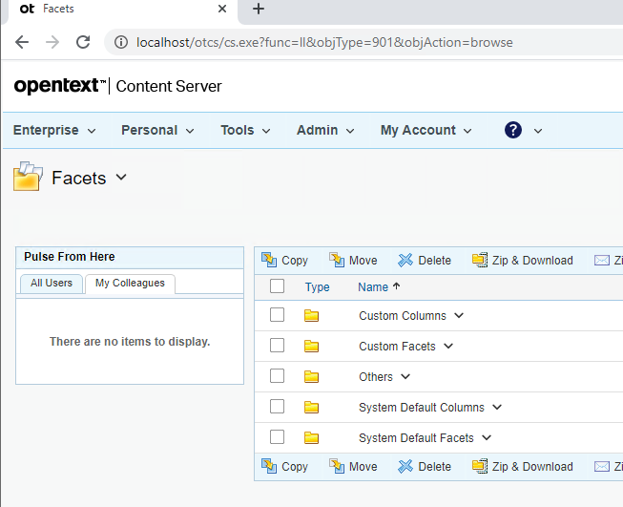

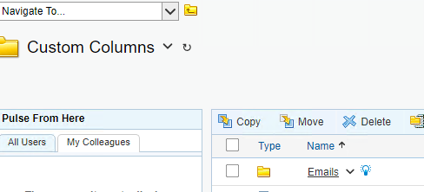

In the emails facet folder:

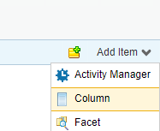

Add column, name doesn’t really matter, **Make sure it’s SORTABLE**

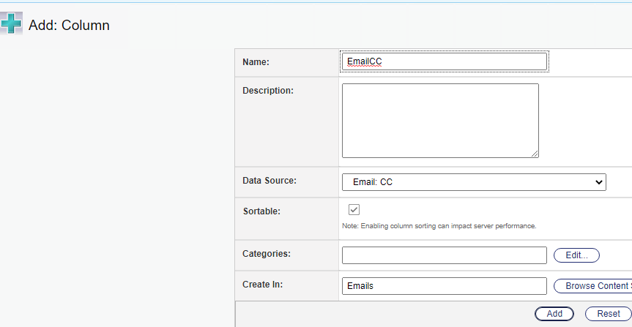

Repeat for the following, make sure they are all SORTABLE

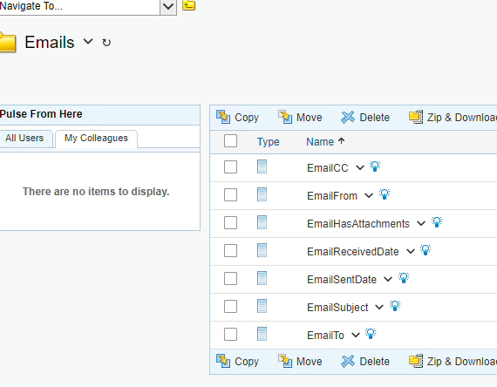

Make sure they are all available:

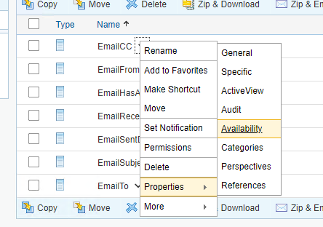

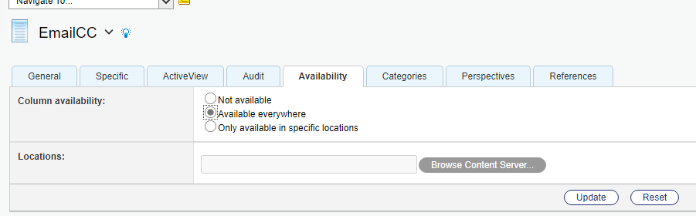

# API Deployment

## Database setup

Create the tables in /Setup/emailbrowser_tables.sql

Take note to create them not as “dbo.” But as the same schema name as what Content Server is using.

## API setup

Copy and extract the zip file [emailbrowserapi.zip] and put it somewhere appriopiate (I’d suggest /Apps/emailbrowser/emailbrowserapi):  
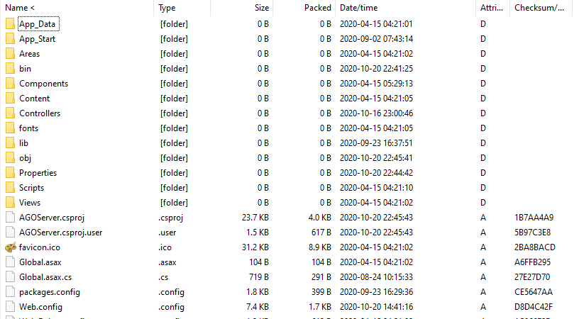

In the web.config of the emailbrowserapi, update the following highlighted fields

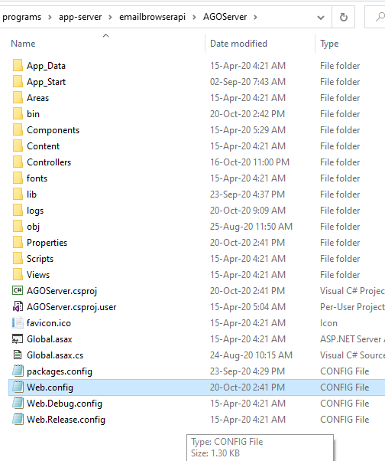

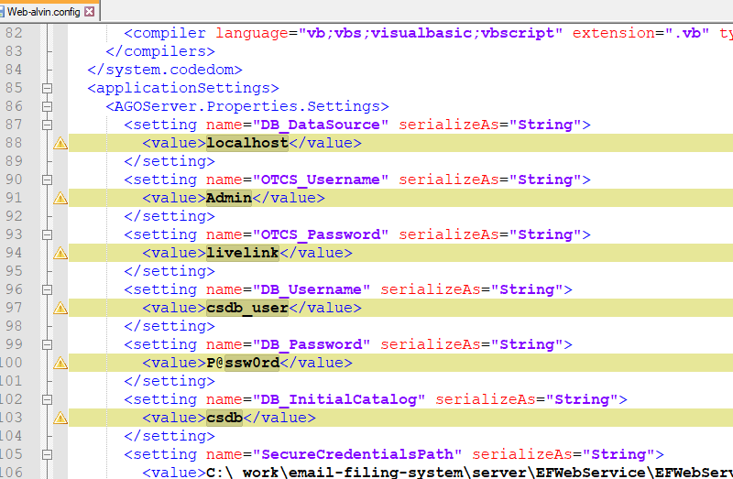

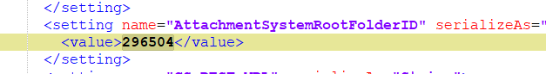

This “AttachmentSystemRootFolderID” is the id of the “email_attachments” folder that you have created earlier.

Note: This api is intended to be used with windows authentication turned on in production, but for testing, you can turn off the UseWindowsAuthentication in the config for now if you not able to use windows authentication, at least until you have verified that the setup is working.

### To deploy the API in IIS:

Create an app pool, name doesn’t matter, I’d say use “emailbrowserapi” for consistency

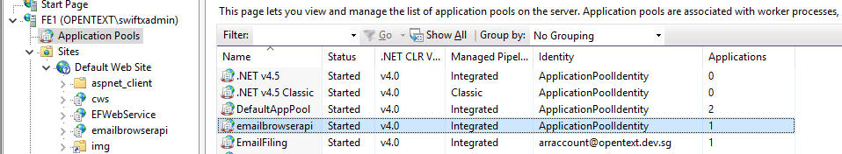

Add Application to “Default web site”, using the respective app pool. Browse to AGOServer folder for the path:  
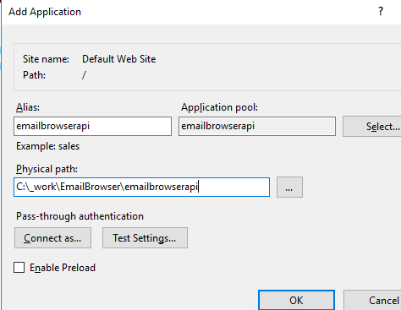  
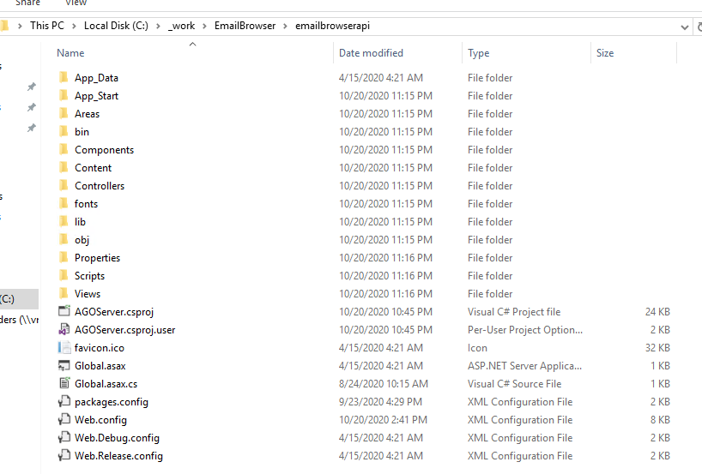

Set windows authentication to be enabled, disable the rest of the authentication:  
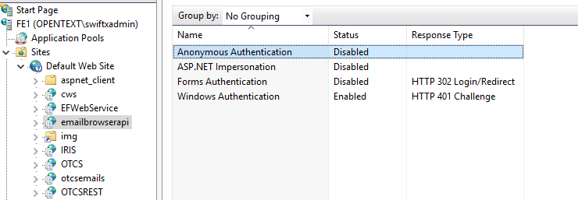

Make sure the application pool is running under an account used for SPN

Make sure application is set to use application pool credentials

## API tests

Do a simple test on the api by going to <http://localhost/emailbrowserapi/swagger> you should see this:

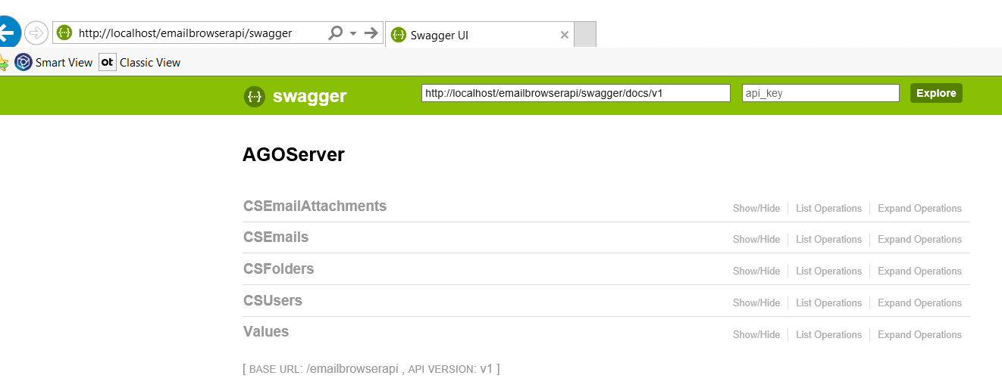

Make sure you have a user in CS created, with the same exact name (without domain) as your windows login name (windows command line: whoami)

Click on “Try it out!” for CSUsers, leave the username blank (since you are using windows authentication:  
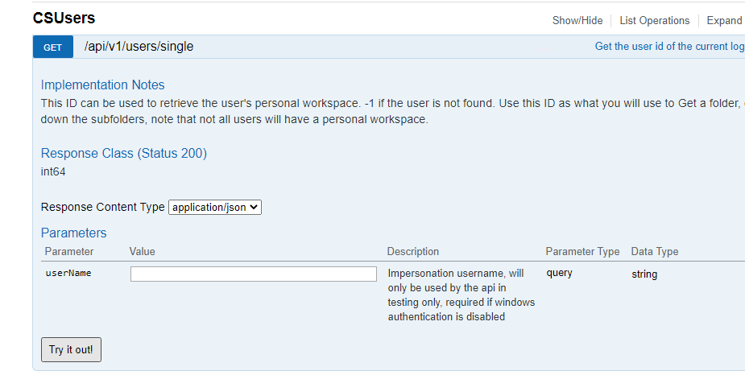

It should give you an user id:  
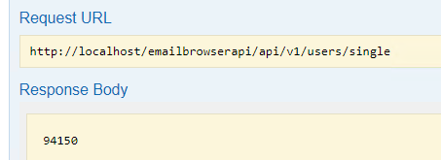

Use this user id to invoke CSFolders…/folders/single  
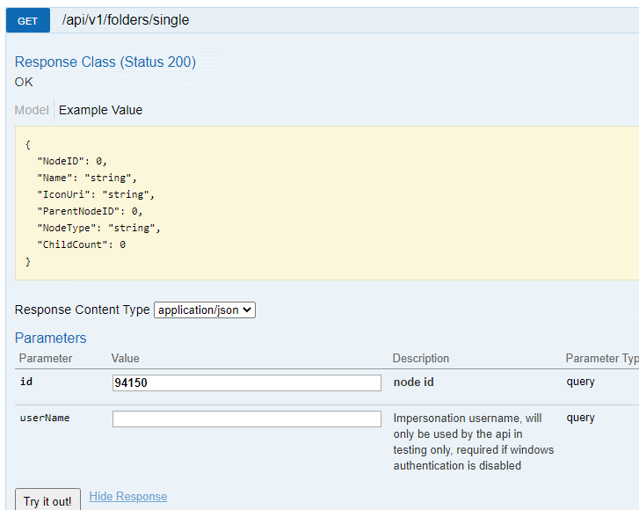

You should get the info for the personal workspace:  
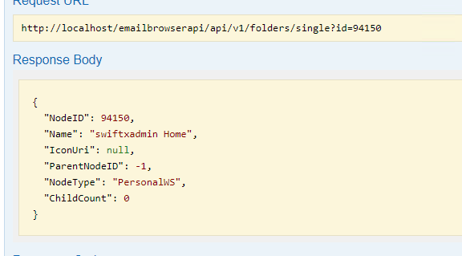

Next test out getting of folders:  
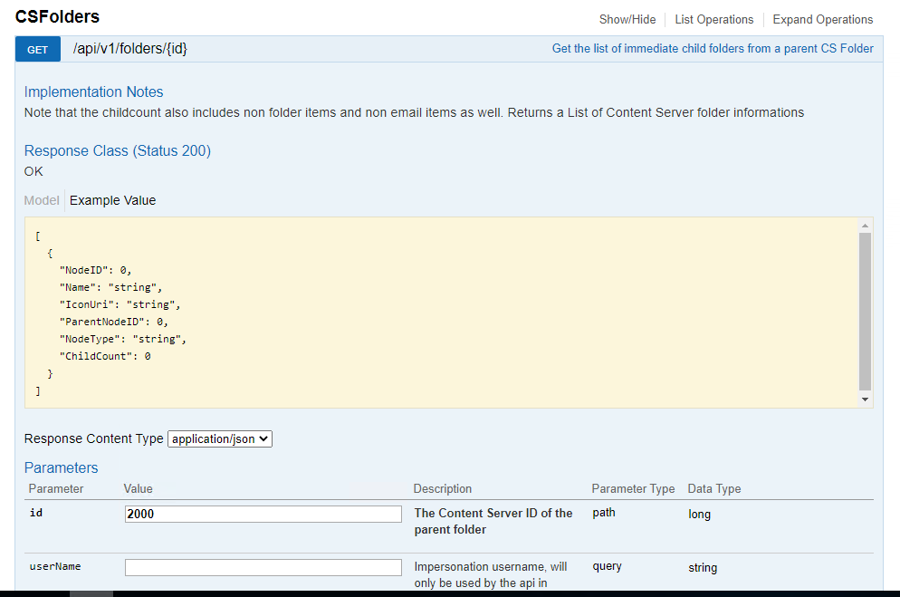

Which should return you the folders (try 2000 for enterprise workspace)  
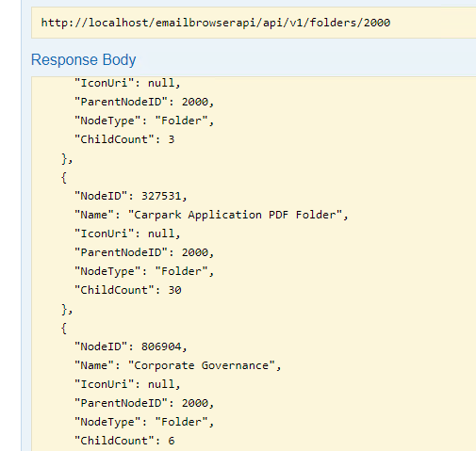

Next list out emails of a folder:  
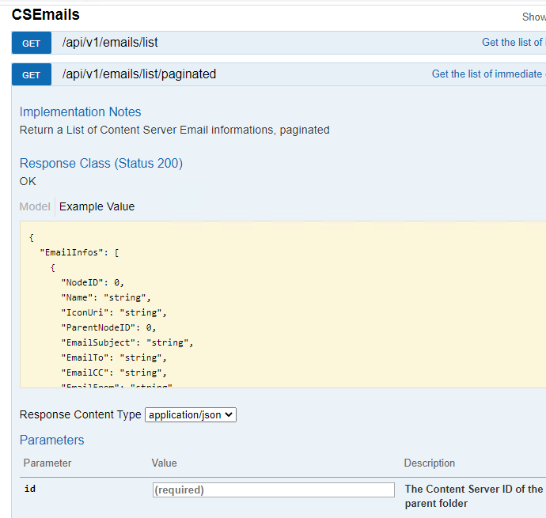

Next list out the attachments of an email (you can use the sample file provided)  
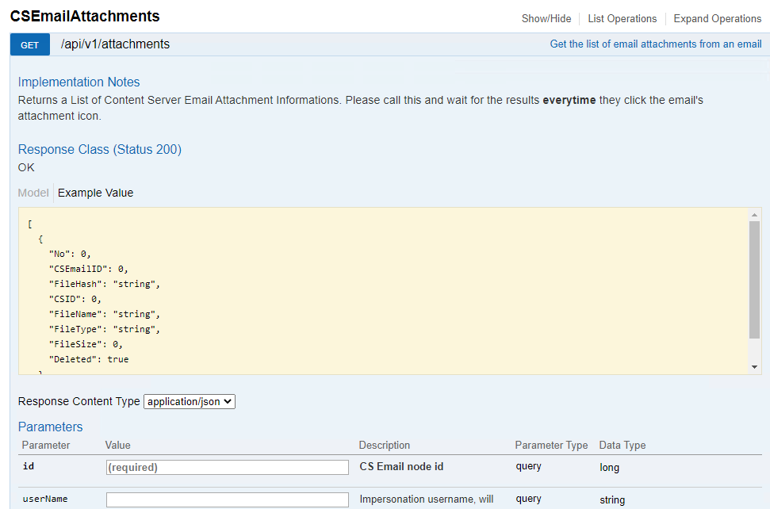

Once this is passed, it passes the smoke test, that means the web service calls and the rest api calls as well as the database calls are successful