Number 1
Question 1 (Array 1D, Statistics & Loop)
Write a C program to calculate the sum, average (mean), and find the maximum value of elements in an integer array using a for loop.
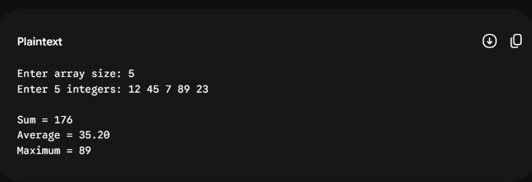
#include <stdio.h>

int main(void) {
int size = 0;

printf("Enter array size: ");
scanf("%d", &size);

int a[size]; // Variable-length array (VLA)
int sum = 0;

printf("Enter %d integers: ", size);
for (int i = 0; i < size; ++i) {
scanf("%d", &a[i]);
sum += a[i]; // Hitung total
}

// Mencari nilai maksimum
int max = a[0];
for (int i = 1; i < size; ++i) {
if (a[i] > max) {
max = a[i];
}
}

double average = (double)sum / size; // Casting ke double

printf("\nSum = %d\n", sum);
printf("Average = %.2f\n", average);
printf("Maximum = %d\n", max);

return 0;
}
Number 2
Question 2 (2D Array / Matrix)
Write a C program to calculate the row sum and total sum of a $3×3$ matrix using nested for loops.
Sample Output:
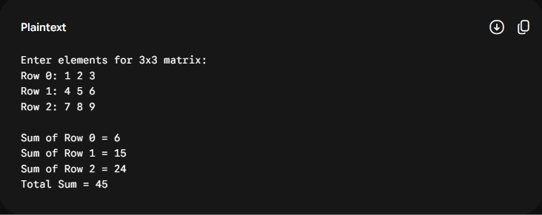
#include <stdio.h>

#define ROWS 3
#define COLS 3

int main(void) {
int matrix[ROWS][COLS];
int totalSum = 0;

printf("Enter elements for 3x3 matrix:\n");
for (int i = 0; i < ROWS; ++i) {
printf("Row %d: ", i);
for (int j = 0; j < COLS; ++j) {
scanf("%d", &matrix[i][j]);
}
}

puts("");

// Hitung jumlah tiap baris dan total keseluruhan
for (int i = 0; i < ROWS; ++i) {
int rowSum = 0;
for (int j = 0; j < COLS; ++j) {
rowSum += matrix[i][j];
}
printf("Sum of Row %d = %d\n", i, rowSum);
totalSum += rowSum;
}

printf("Total Sum = %d\n", totalSum);

return 0;
}
Number 3
Question 3 (Sorting & Searching / Recursion)
Write a C program to sort an array in ascending order using Bubble Sort, or write a recursive function to calculate the $N$-th Fibonacci number.
Pilihan A: Bubble Sort Array
Sample Output:
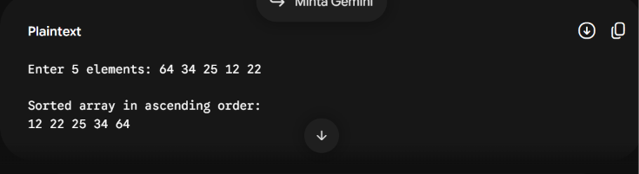
#include <stdio.h>

int main(void) {
int n = 5;
int a[5];

printf("Enter 5 elements: ");
for (int i = 0; i < n; ++i) {
scanf("%d", &a[i]);
}

// Algoritma Bubble Sort
for (int pass = 1; pass < n; ++pass) {
for (int i = 0; i < n - 1; ++i) {
if (a[i] > a[i + 1]) {
int hold = a[i];
a[i] = a[i + 1];
a[i + 1] = hold;
}
}
}

printf("\nSorted array in ascending order:\n");
for (int i = 0; i < n; ++i) {
printf("%d ", a[i]);
}
puts("");

return 0;
}

