New York Temperature Data Sheets;

C14710491: Processing Assignment

This is a graph to show fluxuations in temperature between 5 year periods over the years 1900-2015.

The data set is shown using line graphs, both showing hot and cold temperatures.

The data for this graph was obtained here with some of the data being omitted to make the graphs easier to read (going on every 5 years as opposed to every year):

<http://weather-warehouse.com/WeatherHistory/PastWeatherData_IthacaCornellUniv_Ithaca_NY_January.html>

The program uses the ControlP5 library in order to mute/unmute the music playing on the program.

The music was chosen due to time of year, and relevance to New York.

The rest of the navigation can be completed using the number keys on your keyboard.

There is 5 options:

1. Home page: displays a bar graph across the screen in multiple colours, while text showing instructions.
2. Line Graph Hot: which displays the line graph for the warm weather, configured to that data set
3. Line Graph Cold : which displays the line graph for the cold weather, configured to that data set
4. The overall line graph: which displays the line graphs for both warm and cold weather, on a scale of 0-80.
5. This page shows spinning circles/objects which are made up from the data provided in the data set.
6. This prints out a list of the data from the data set.

This project makes use of the following libraries

ControlP5 : for GUI

Ddf.Minim : for music

Screen Shots of the Project:

Home Page:

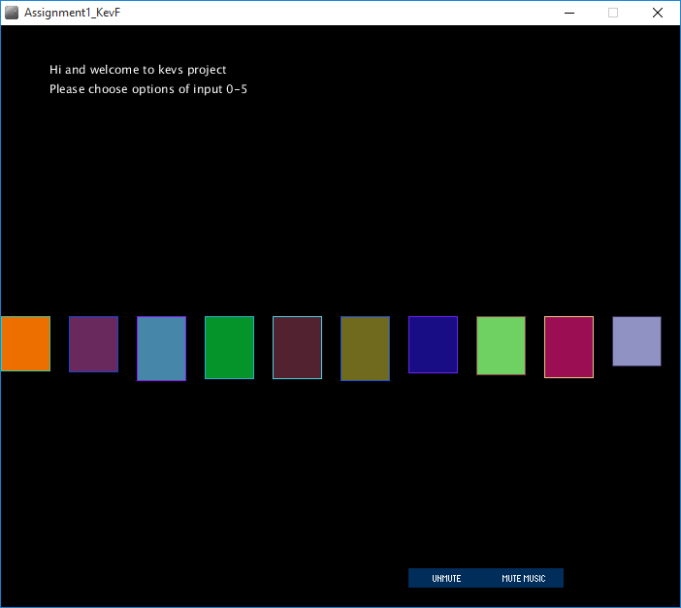

LineGraphHot:

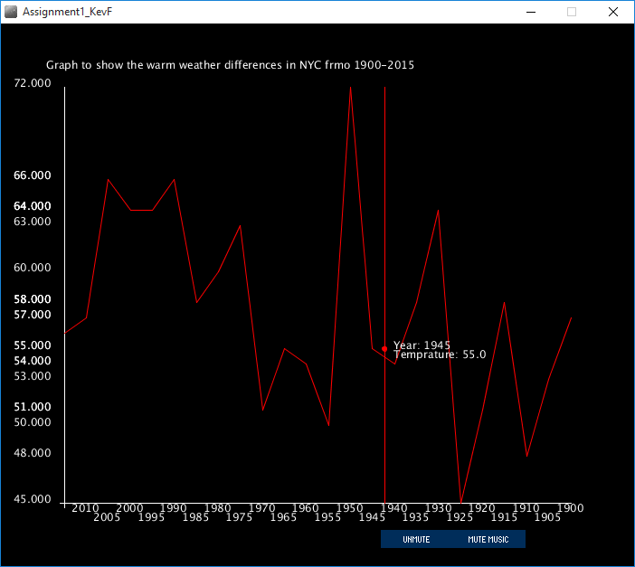

LineGraphCold:

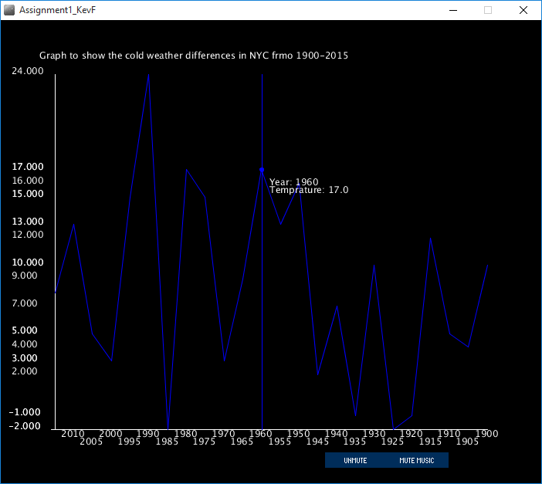

LineGraphOverall:

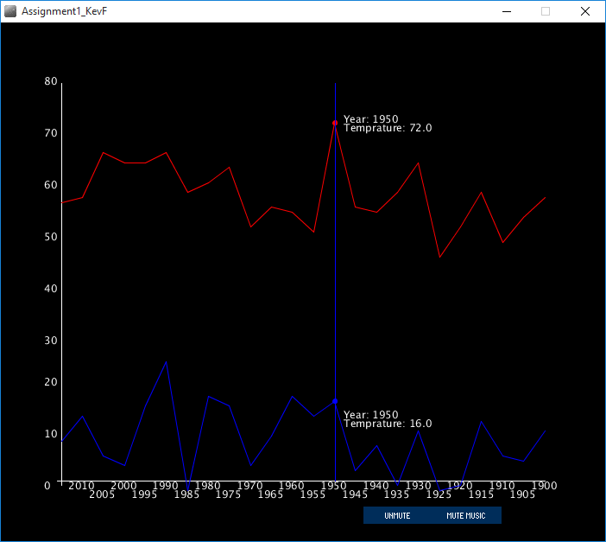

Circles:

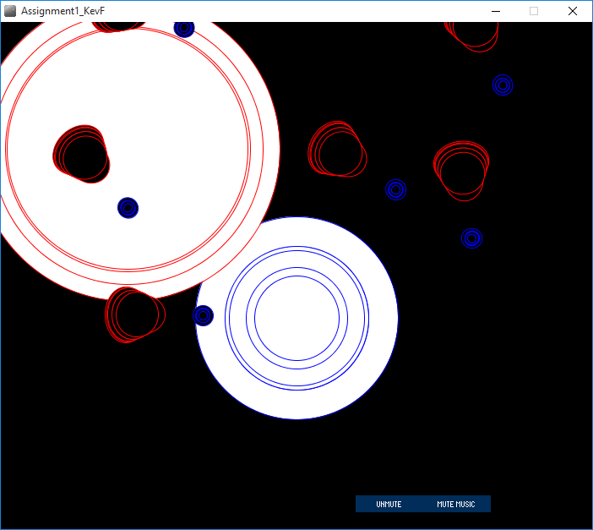

List:

