AI on Chip 2024

LAB Ⅳ Processing Elements

REPORT

Student name: __胡家豪_________

Student ID: __N26122246________

目錄

一. Implementation Result 2

1. TB.0 2

2. TB.1 2

3. TB.2 2

二. Implementation Cycle Result 2

三. PE architecture and Design ideas 2

1. PE architecture 2

2. Spad storage space and functionality 2

3. FSM state and functionality 2

4. Waveform Result 2

四. Demonstrate Scenario B dataflow 3

五. Compare scenario A,B,C from different aspects 3

六. Share your thoughts 3

1. Implementation Result
2. TB.0

1. TB.1

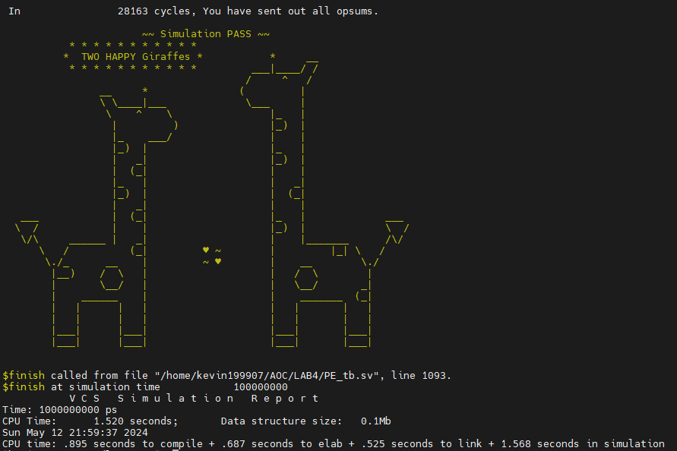

1. TB.2

1. Implementation Cycle Result

|  |  |  |  |  |
| --- | --- | --- | --- | --- |
| Testbench | Tb0 | Tb1 | Tb2 | Tb3 |
| Clock Cycle | 922 | 28163 | 8109 | - |

1. PE architecture and Design ideas
2. PE architecture一張含有 文字, 圖表, 螢幕擷取畫面, Rectangle 的圖片

   自動產生的描述
3. Spad storage space and functionality
4. FSM state and functionality
5. Waveform Result
6. Demonstrate Scenario B dataflow
7. Compare scenario A,B,C from different aspects
8. Share your thoughts