TUGAS-3 PAM Kevin Tanuwijaya (119140207)

Link Github: <https://github.com/kevin207/Tugas_PAM>

**Aplikasi Pencarian Pesawat**

* 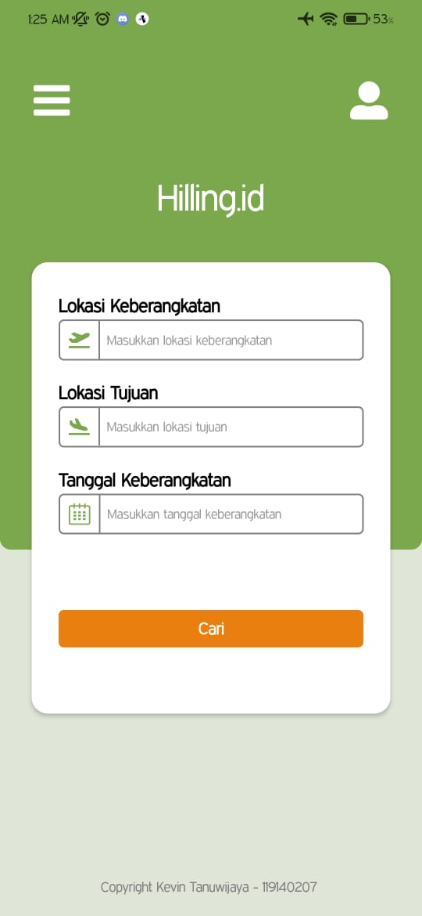Tampilan Home Screen
* Tampilan HomeScreen (Input Keyboard)

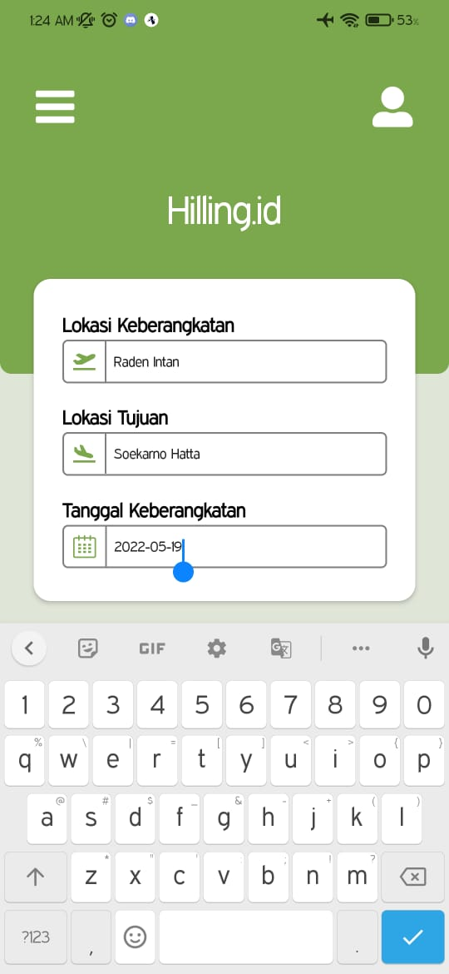

* 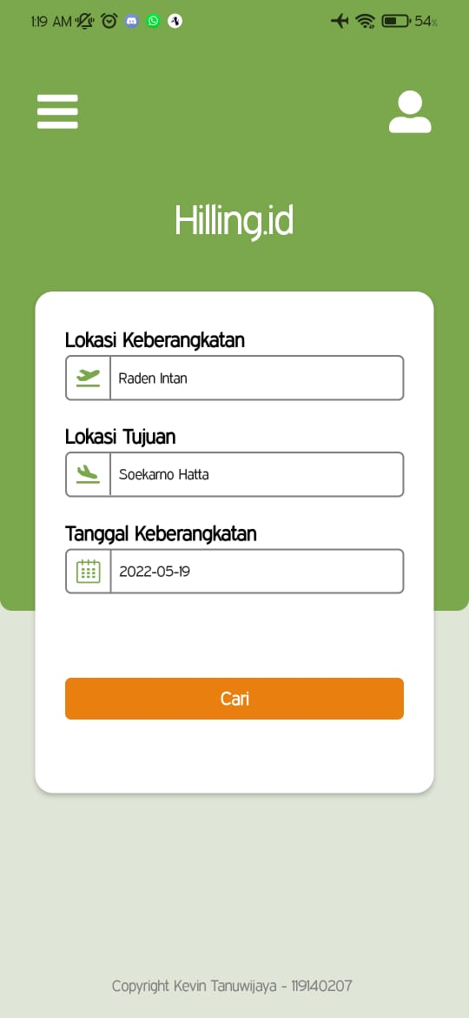Tampilan HomeScreen (Input-1) -> Raden Intan – Soekarno Hatta (2022-05-19)
* Tampilan ListScreen (Input-1)

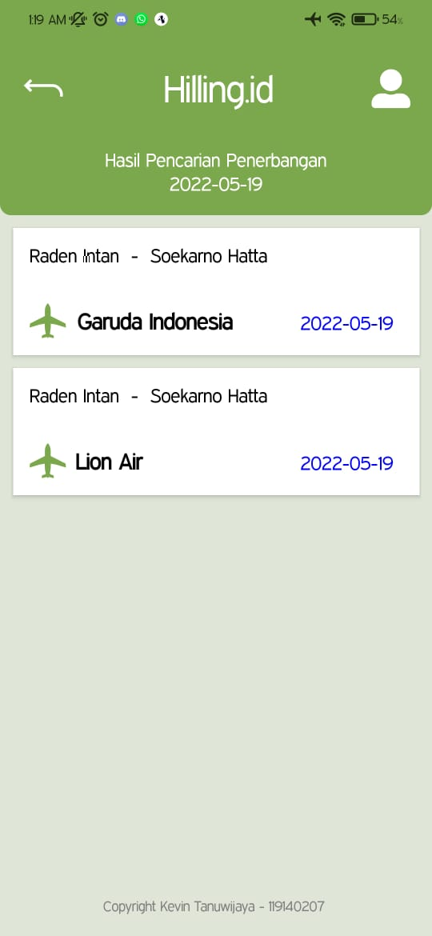

* 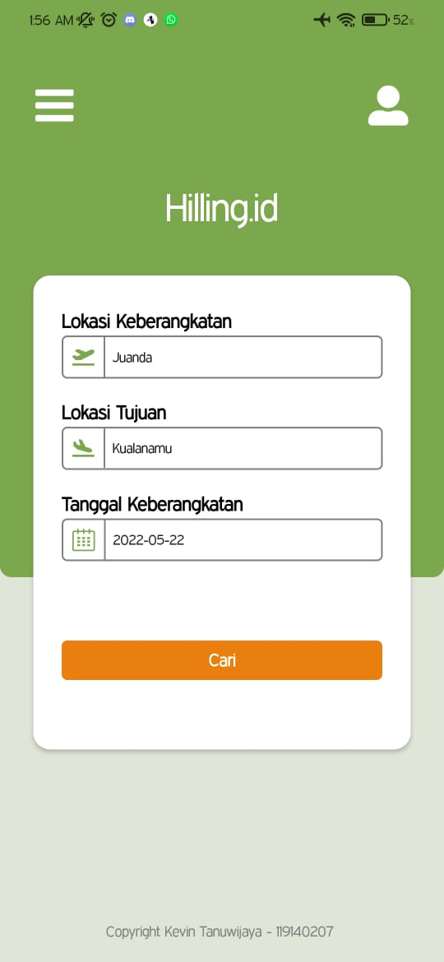Tampilan Homescreen (input-2) -> Juanda – Kualanamu (2022-05-22)
* Tampilan ListScreen (input-2)

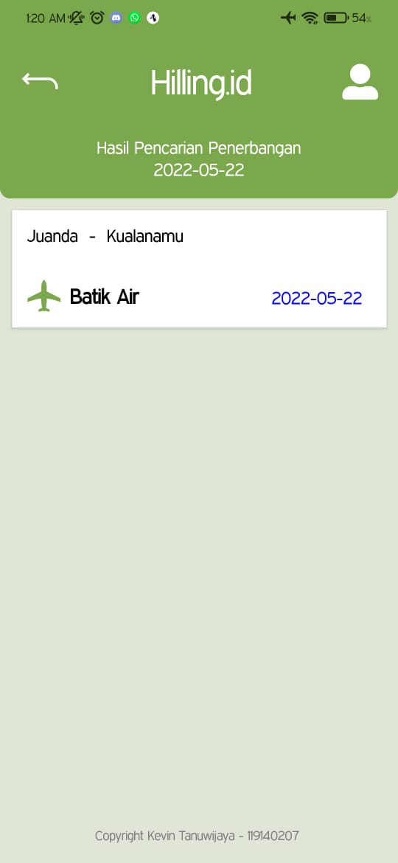

* Tampilan Homescreen (Input 3) -> Jadwal Kosong

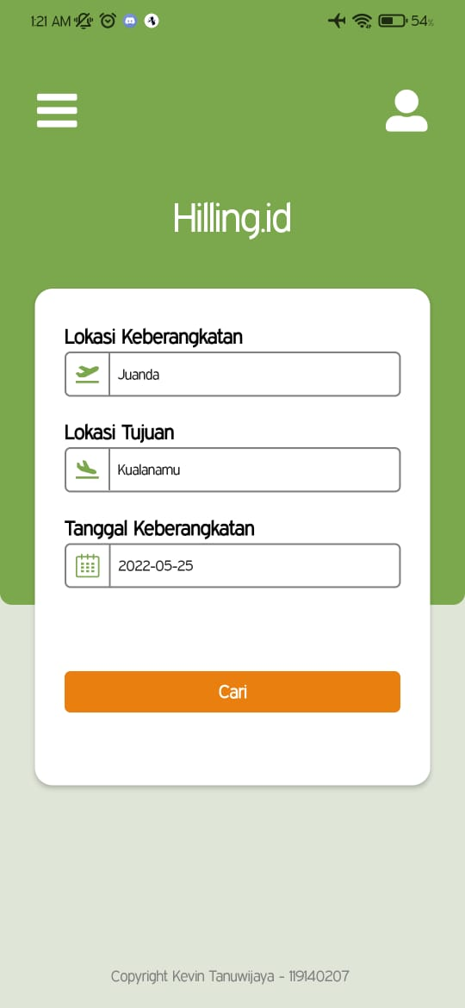

* Tampilan ListScreen (Input-3)

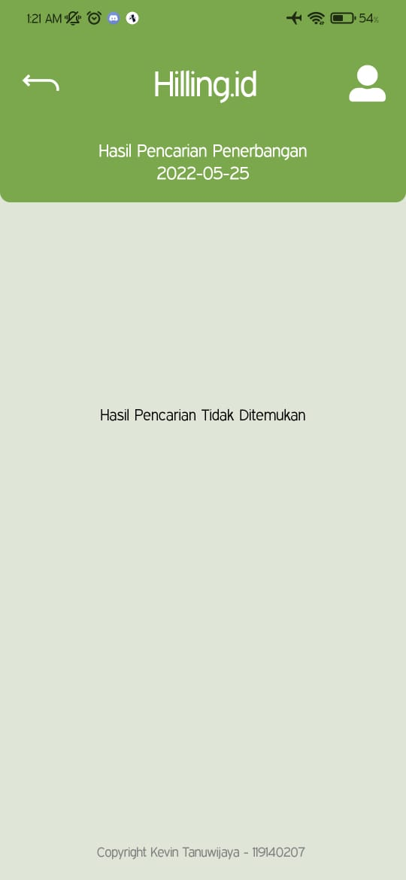

* Tampilan Homescreen (Wrong Input / Error)

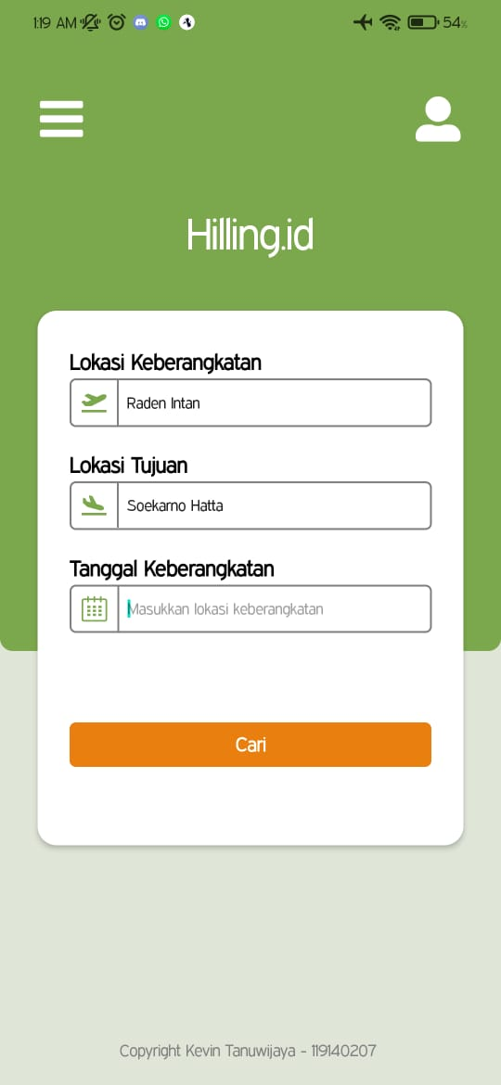

* 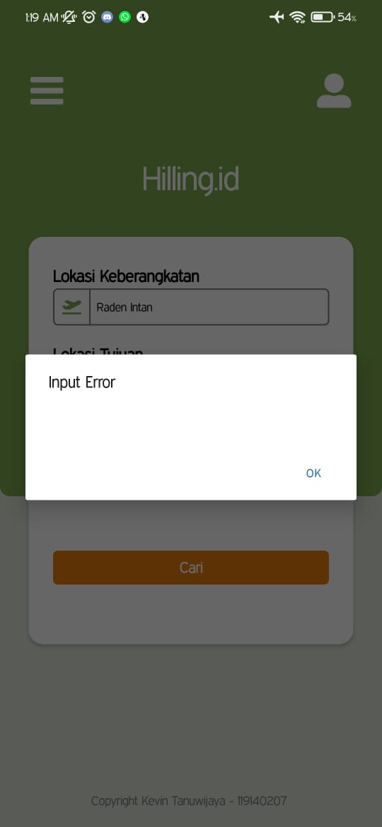Tampilan ListScreen (Wrong Input / Error)