**FACULTY OF COMPUTER SCIENCE AND IT**

**SOFTWARE ANALYSIS AND DESIGN**

**GROUP MEMBERS:**

Aleksandros Sinani

Kevin Ali

Gerald Domnori

**Project:** FuelMe



**Accepted by:** Dr. Igli Hakrama

Copyright © 2023 FuelMe All Rights Reserved

All files and information contained in this Website or Blog are copyright by FuelMe, and may not be duplicated, copied, modified or adapted, in any way without our written permission. Our application may contain our service marks or trademarks as well as those of our affiliates or other companies, in the form of words, graphics, and logos.

Your use of our Application or Services does not constitute any right or license for you to use our service marks or trademarks, without the prior written permission of FuelMe.

Our Content, as found within our Application, and Services, is protected under copyrights. The copying, redistribution, use or publication by you of any such Content, is strictly prohibited. Your use of our Application and Services does not grant you any ownership rights to our Content.

© 2023 - 2023 FuelMe - All Rights Reserved.

**Table of Contents**

1 Executive Summary...............................................................................5

1.1 Project Overview.......................................................................................................................5

1.2 Purpose and Scope of this Specification...................................................................................5

2 Product/Service Description..................................................................6

2.1 Service description6

2.2 Product description6

2.3 User Characteristics...................................................................................................................6

2.4 Assumptions...............................................................................................................................9

2.5 Constraints...............................................................................................................................10

2.6 Dependencies...........................................................................................................................10

3 Requirements.......................................................................................11

3.1 Functional Requirements.........................................................................................................11

3.2 Non-Functional Requirements.................................................................................................15

3.2.1 Product Requirements...........................................................................................................15

3.2.1.1 User Interface Requirements..............................................................................................15

3.2.1.2 Usability.............................................................................................................................16

3.2.1.3 Efficiency...........................................................................................................................17

3.2.1.3.1 Performance....................................................................................................................17

3.2.1.3.2 Space Requirements........................................................................................................17

3.2.1.4 Dependability Requirements..............................................................................................18

3.2.1.5 Manageability/Maintainability...........................................................................................18

3.2.1.6 Security..............................................................................................................................20

3.2.2 Organizational Requirements................................................................................................21

3.2.2.1 Environmental Requirements.............................................................................................21

3.2.2.2 Operational Requirements.................................................................................................21

3.2.3 External Requirements..........................................................................................................22

3.2.3.1 Regulatory Requirements...................................................................................................22

3.2.3.2 Ethical Requirements.........................................................................................................22

3.3 Domain Requirements.............................................................................................................23

4 Software Designs.................................................................................24

4.1 User Scenarios........................................................................................................................24

5 Diagrams.............................................................................................27

5.1 User Case Diagrams................................................................................................................27

5.2 BPMN......................................................................................................................................28

5.3 Activity Diagrams....................................................................................................................29

5.4 State Diagrams........................................................................................................................36

5.5 Sequence Diagrams................................................................................................................39

5.6 Collaboration Diagrams..........................................................................................................44

5.7 Data Flow Diagrams................................................................................................................48

5.8 Entity Relation Diagrams........................................................................................................50

5.9 Package Diagram....................................................................................................................51

6.0 Components Diagram.............................................................................................................52

6.1 Class Diagram..........................................................................................................................53

6.2 Deployment Diagram..............................................................................................................54

6.3 Interaction Overview Data......................................................................................................55

6.4 Screenshots & Sketches..........................................................................................................56

**1.Executive Summary**

**1.1 Project Overview**

Are you tired of being stranded on the side of the road because you ran out of gas? Are you tired of waiting in long lines at the gas station just to fill up your tank? Well, "FuelMe" has got you covered! With just a few taps on your phone, you can have one of our vehicles loaded with premium fuel sent straight to your location. No more walking to the gas station in the rain, no more dirty bathrooms, and rude attendants. With "FuelMe" you can enjoy high-quality, untainted fuel delivered right to your doorstep. Plus, think of how cool it will look when they see a vehicle with "FuelMe" logo on it pull up to your location. So why waste your time at the gas station when you can have fuel delivered to you like a boss with "FuelMe"!

“FuelMe” is a project that aims to develop an application for a fuel delivery company. This application will allow customers to place and track their orders and make payments through the application. This application will also allow the company to manage and track its fleet of vehicles, track inventory and notify distributors whenever they are needed.

This application will be easily accessible for anyone with a mobile device and internet connection, allowing for simple and convenient ordering with just a few clicks.

**1.2 Purpose and Scope of this Specification**

The purpose of this application is to simplify and make the process for customers as easy as possible to request fuel delivery and monitor the status of their order while also giving the company the ability to oversee its vehicle fleet and keep track of its inventory.

The scope of this fuel delivery application will include the following features:

• A user-friendly interface for customers to place orders and track them

• A system for managing and tracking the company's fleet of vehicles

• A system for monitoring and tracking inventory

• A system for accepting and processing customer payments

• The application will be designed for use on both web and mobile platforms

• The application will include a secure login for customers to access their accounts and track deliveries

**2.Product/Service Description**

**2.1 Service Description**

Our fuel delivery application is a service that allows customers to easily place orders for fuel deliveries and track the status of their deliveries in real time. The service is typically accessed via a web or mobile application and provides a convenient and efficient way for customers to manage their fuel needs. With the application, customers can schedule a delivery at a convenient time and location, choose their preferred type of fuel, and pay for their order securely and efficiently. The application also allows the customers to track their order status and see an estimated time of arrival for their delivery.

**2.2 Product description**

The product is intended for individuals and businesses that rely on fuel deliveries, such as construction companies, farming operations, and emergency services. The product is also useful for customers who live in remote areas and have limited access to fuel stations, or for those who prefer the convenience of having fuel delivered to their location.

**2.3 User Characteristics**

This application is intended to be used from the following users:

• **Guests** (no login required)

Guest users have limited access to the application's features and functionalities compared to registered users. Guest users are able to view the fuel delivery company's pricing, services, and delivery coverage area, but they are not able to place an order or track the status of a delivery. Guest users are also able to contact the company’s support if they have any questions but their information will not be saved for future reference.

• **Registered Users**

Registered users are guests that have created and verified their accounts. Registered users have access to a wider range of features and functionalities compared to guest users.

Registered users are able to:

• Place orders for fuel deliveries:

(Registered users can place orders for fuel deliveries and select their preferred type of fuel, delivery location, and delivery time)

• Track delivery status:

(Registered users can track the status of their deliveries in real-time and see an estimated time of arrival for their delivery)

• Manage account information

(Registered users can update their account information, such as their contact information, delivery location, and payment information)

• Manage payment and billing information:

(Registered users can securely store their payment information and view their billing history)

• Access order history:

(Registered users can view their order history and see past deliveries)

• Receive special offers and promotions

(Registered users may receive special offers and promotions from the fuel delivery company)

• Receive customer support

(Registered users can contact the fuel delivery company for customer support and have the ability to save their contact information for future reference)

• **Delivery Team**

The delivery team consists of a group of workers that are responsible for delivering fuel to customers. The delivery team users have access to specific features and functionalities within the application that is tailored to their role.

The delivery team is able to:

• View and manage a schedule of deliveries

(The delivery team can view the schedule of upcoming deliveries and update the status of deliveries as they are completed)

• Communicate with customers

(The delivery team can communicate with customers via the application, to provide updates on the delivery status and resolve any issues that may arise)

• Manage fleet and inventory

(The delivery team can view the status of the fuel delivery company's fleet and inventory levels in real-time, and update the information as necessary)

• Route optimization

(The delivery team can optimize the routes of their deliveries and make adjustments as necessary based on traffic or other factors)

• **Fleet Managers**

The Fleet Manager team consists of a group of individuals who are responsible for managing the company’s fleet of vehicles. The Fleet Manager users have access to specific features and functionalities within the application that is tailored to their role.

Fleet Managers are able to:

• Manage drivers

(Fleet Managers can manage the drivers' schedules, assign deliveries, and monitor their performance)

• View and manage the fleet

(Fleet Managers can view the status of the company's fleet of vehicles in real-time, including the location, fuel level, and maintenance status of each vehicle)

• Track vehicle usage

(Fleet Managers can track the usage of each vehicle, such as the number of miles driven and the fuel consumption, and use this information to plan for maintenance and replacement)

• Manage vehicle maintenance

(Fleet Managers can schedule and manage maintenance for the company's fleet of vehicles, such as regular service and repairs)

• **Customer Support**

The Customer Support team consists of a group of individuals who are responsible for assisting customers with any issues or questions they may have related to the company's products or services. The Customer Support users have access to specific features and functionalities within the application that is tailored to their role.

Customer Support is able to:

• View and access customer information

• View and access delivery information

(update or make changes)

• Manage emails, calls & messages

• **Admins/ HR**

The Admin/HR users consist of a group of individuals who are responsible for everything in the application. Admins/HR have the highest level of access and privileges within the application.

Admins/HR are able to:

• Manage and access all data

(financial information, inventory data, customer information)

• Manage other users

(adding and managing roles or permissions for the other users)

• Manage delivery routes & schedules

• Manage backups, set up integrations & troubleshoot any issues

• Create & Modify the application’s rules, policies, and settings

**2.4** **Assumptions**

• It is assumed that every user has a smartphone or/and a computer with an internet connection.

• It is assumed that the users have basic knowledge of smartphones.

• It is assumed that the users know how to navigate the application.

• It is assumed that the users have an email account.

• It is assumed that the information provided by the users is confidential.

• It is assumed that all the workers go through proper training.

• It is assumed that the company has made a business and financial plan.

• It is assumed that the company has an active bank account that is used to pay the employees.

• It is assumed that every employee in the company has his/her own account created by the System Admin.

**2.5 Constraints**

• All users must have basic knowledge in order to not make any mistakes.

• The system can only be accessed through a stable internet connection.

• All users must log in or/and sign-up with only their personal information.

• The application is designed in different sections where each user has access to the corresponding role.

**2.6 Dependencies**

• The customer must be logged in to have full access to all the functionalities.

• The customer must have internet access at all times.

• The customer can not make an order unless he/she is logged in.

• The order can not be completed unless the payment goes through.

• The order can not be completed if inventory is not available.

• The order can not be completed unless the user confirms his/her location.

• All users must have their assigned role in order to view and access all the features and functionalities in the application.

**3.Requirements**

**3.1 Functional Requirements**

|  |  |  |  |  |  |
| --- | --- | --- | --- | --- | --- |
| Req # | Requirement | Comments | Priority | Date reviewed | SME reviewed/approved |
| R_01 | The application offers different views for different types of users corresponding to their roles. | Depending on the role of the user, the application will show different views. | 1 | 19.01.2023 | A.Sinani  K.Ali  G.Domnori |
| R_02 | A user can access the application even though he may not be registered. | The users will be able to access the application without being registered but with limited features. | 1 | 19.01.2023 | A.Sinani  K.Ali  G.Domnori |
| R_03 | Users should accept the terms & conditions to proceed with the registration. | To create an account all users must accept the terms & conditions. | 1 | 19.01.2023 | A.Sinani  K.Ali  G.Domnori |
| R_04 | Users must log in with their personal information. | All users should use only their email & password. | 1 | 19.01.2023 | A.Sinani  K.Ali  G.Domnori |
| R_05 | Users must complete full verification after creating their account in order to make a purchase. | When an account is created all users will receive a verification email. | 2 | 19.01.2023 | A.Sinani  K.Ali  G.Domnori |
| R_06 | All users with a higher role must verify their account with an ID. | Part of the verification process for workers. | 1 | 19.01.2023 | A.Sinani  K.Ali  G.Domnori |
| R_07 | The application should allow users to give feedback. | The rating will be between 0-5 stars. | 2 | 19.01.2023 | A.Sinani  K.Ali  G.Domnori |
| R_08 | The application will have a search feature for all users. | The search bar will allow all users to navigate more easily. | 1 | 19.01.2023 | A.Sinani  K.Ali  G.Domnori |
| R_09 | All users with higher roles will have a different menu that will show them more details. | All workers will have a different application menu to navigate easier and have more details. | 2 | 19.01.2023 | A.Sinani  K.Ali  G.Domnori |
| R_10 | The system should allow users to auto login if they allow the application to save their information. | All users will be able to save their login information to save time. This will include their email & password. | 2 | 19.01.2023 | A.Sinani  K.Ali  G.Domnori |
| R_11 | The application will allow all users to add a profile photo and nickname. | All users can add a profile photo and a nickname to their profile. | 2 | 19.01.2023 | A.Sinani  K.Ali  G.Domnori |
| R_12 | All admin users can access and modify everything in the application. | Admin users have full access to the application and they can add, remove or modify information if needed. | 1 | 19.01.2023 | A.Sinani  K.Ali  G.Domnori |
| R_13 | All users with a higher role can access customer information if needed but not all can modify it. | Workers will be able to read customers’ information such as type of fuel & location. | 2 | 19.01.2023 | A.Sinani  K.Ali  G.Domnori |
| R_14 | To make an order all users must turn on their location. | All customers must turn their locations on for the delivery teams. | 1 | 19.01.2023 | A.Sinani  K.Ali  G.Domnori |
| R_15 | All users will be able to contact customer support if they have any questions. | Customer support will be available 24/7 and all users can contact them. | 2 | 19.01.2023 | A.Sinani  K.Ali  G.Domnori |
| R_16 | All users will receive updates regarding their orders. | After customers place an order they will be able to see their delivery. | 2 | 19.01.2023 | A.Sinani  K.Ali  G.Domnori |
| R_17 | All users will have the option to repurchase their previous order. | If a customer wants to order the same product again he will be able to use the “repurchase” menu. This will save him time. | 2 | 19.01.2023 | A.Sinani  K.Ali  G.Domnori |
| R_18 | All users will receive a copy of their receipt in their emails. | After purchase, a receipt will be sent automatically to the customer’s email. | 1 | 19.01.2023 | A.Sinani  K.Ali  G.Domnori |
| R_19 | All users will be able to link their preferred payment method. | Payment methods include all types of credit cards or any other type of payment (PayPal, Skrill, etc) | 1 | 19.01.2023 | A.Sinani  K.Ali  G.Domnori |
| R_20 | All users with a higher role will be able to work with each other and see the order’s progress. | All workers will be able to see the progress of orders. | 2 | 19.01.2023 | A.Sinani  K.Ali  G.Domnori |

**3.2 Non – Functional Requirements**

**3.2.1 Product Requirements**

***3.2.1.1 User Interface Requirements***

All UI requirements:

• Login/Registration

(Users are able to create an account or log in to an existing account)

• User account management

(Users are able to edit their account information, such as shipping address, and change their password)

• Order placement

(Users are able to select the type of fuel they need, the quantity, and the delivery location)

• Order tracking

(Users are able to track the status of their order, including delivery time and location)

• Order history

(Users are able to view a history of their past orders)

• Payment

(Users are able to enter their payment information and submit the order)

• Notifications

(Users receive notifications of order status updates, such as when the order is confirmed, dispatched, and delivered)

• Customer support

(Users are able to contact customer support if they have any issues or questions)

• Rating and feedback system

(Users are able to rate their experience and provide feedback)

• Maps and route optimization

(Users are able to view a map of the delivery route and optimize the route for the fastest delivery time)

***3.2.1.2 Usability***

These are considered some key requirements for the usability of the application.

• Easy navigation

(The interface is easy to navigate and intuitive to use)

• Responsive design

(The application works well on various devices, including smartphones and tablets)

• Simple ordering process

(The order placement process is straightforward and easy to complete)

• Clear instructions

(The application provides clear instructions for users to follow)

• Fast loading times

(The application loads quickly, even on slower internet connections)

• Consistent layout

(The layout of the interface is consistent throughout the application, making it easy for users to find what they are looking for)

• Accessibility

(The application is accessible to users with disabilities, and includes screen readers and keyboard navigation)

• Search and filter options

(Users are able to search and filter through the products and orders easily)

• Feedback and rating system

(Simple and easy to use)

• Map and route optimization

(Intuitive and easy to understand)

**3.2.1.3 Efficiency**

***3.2.1.3.1 Performance***

These are considered some key requirements for the performance of the application.

• Reliability

• Fast order processing

• Real-time tracking

• Accurate and real-time fuel price updates are provided to the users.

• The application is able to provide detailed analytics and reports on the performance of the delivery service.

• Integration with the fuel supplier or third-party logistics providers is seamless and real-time updates are provided to the users.

• The application is able to handle peak traffic, with minimal delays and errors.

• The application is able to handle a large number of orders and deliveries.

• Security

(The application protects user data and financial information, and ensures that all transactions are secure)

• Offline functionality

(The application is able to function even if the device is offline and automatically syncs data when the device is back online)

***3.2.1.3.2 Space Requirements***

• Android

(At least 150MB of storage space)

• iOS

(At least 100MB of storage space)

**3.2.1.4 Dependability Requirements**

• Inventory management

(An efficient inventory management system that ensures fuel is always available and that stock levels are maintained)

• Consistent delivery schedule

(Ensures that fuel is delivered on a consistent and predictable schedule, with minimal delays)

• Delivery reliability rate

(A high delivery reliability rate, which is the percentage of deliveries that are made on time and as scheduled)

• Communication

(Clear and timely updates on delivery status and inventory levels to ensure that customers can plan accordingly)

• Emergency fuel needs

(The capability to handle unexpected or emergency fuel needs and provide fuel quickly)

**3.2.1.5 Manageability/Maintainability**

***Monitoring***

Monitoring is an important aspect of any fuel delivery application, as it allows the application to be tracked and maintained efficiently.

• Performance monitoring

(The application is able to monitor its performance and identify any issues that may affect the delivery service)

• Service availability monitoring

(The application is able to monitor the availability of the service, and ensure that it is always up and running)

• Log monitoring

(The application is able to monitor and analyze logs, which can help identify issues and improve the delivery service)

• Alerts and notifications

(The application is able to send alerts and notifications when there are issues that need to be addressed)

• Automated testing

(The application is able to perform automated tests to ensure that it is working correctly and that the service is meeting the requirements)

• Integration with third-party tools

(The application is able to integrate with other monitoring tools, such as log analyzers, performance monitoring tools, and incident management systems)

• Monitoring the fuel level of the tank trucks in real-time

***Maintenance***

Maintenance is an important aspect of any fuel delivery application, as it ensures that the application remains functional and efficient over time.

• Performance optimization

(The application is optimized for performance, to ensure that it runs efficiently and can handle a large number of users and orders)

• Software updates

(The application is able to receive software updates to fix bugs, improve performance and add new features)

• Regular testing

(The application is tested regularly to ensure that it is functioning correctly and that the service is meeting the requirements)

• Data backup

(The application has a robust data backup system in place to ensure that user data and order information are protected in case of any issues)

• Database management

(The application has a database management system in place to ensure that data is stored and retrieved efficiently)

• Security

(The application has a security system in place to protect user data and financial information, and ensure that all transactions are secure)

• Monitoring and troubleshooting

(The application has a monitoring system in place to identify and troubleshoot any issues that may affect the delivery service)

• Fleet maintenance

(The application is able to monitor and schedule maintenance for the delivery trucks, to ensure that they are running efficiently and safely)

• Fuel inventory management

(The application is able to manage and monitor the fuel inventory, to ensure that there is enough fuel to meet the demand)

***Integrity***

• Every credential created by the system admin will be integrated into a secret environment that no user or developer can access.

• Each manager on each section depending on the privileges that he/she has can add new lower-level users to the system only if the user is in the same department.

• Each user should provide their created credentials such as email, and password in order to get access to the system features and their profile.

**3.2.1.6 Security**

• Each user will be able to see only their personal data unless they have a higher role.

• Each user is responsible for their personal data authenticity that they enter.

• All admins can access the user’s personal data.

• All users with a higher role will have access to the customer’s location when they make an order.

• To ensure high security for users it will be mandatory for them to make the password based on some conditions(numbers, symbols).

• Encryption should be applied to sensitive information such as passwords.

**3.2.2 Organizational Requirements**

***3.2.2.1 Environmental Requirements***

• Spill response and containment measures to prevent fuel leaks and spills from reaching the environment

• Air and water quality regulations that limit emissions and discharge of pollutants from fuel storage and transportation

• Restrictions on the use of certain types of fuels or fuel additives that are known to have a negative impact on the environment

• Regulations on the handling and disposal of hazardous waste, such as used oil or contaminated soil

• Compliance with regulations established by local government

***3.2.2.2 Operational Requirements***

• Safety protocols for handling and storing fuel, including personal protective equipment, fire prevention measures, and emergency response procedures.

• Training and certification requirements for employees involved in fuel delivery operations.

• Quality control procedures to ensure that the fuel meets relevant standards and specifications.

• Maintenance and calibration requirements for fuel delivery equipment, including vehicles, pumps, and storage tanks.

• Compliance with regulatory requirements, including those related to the transportation and handling of hazardous materials.

• Logistical requirements, including scheduling, routing, and inventory management.

• Cybersecurity measures to protect against unauthorized access, theft, and other cyber threats.

**3.2.3 External Requirements**

***3.2.3.1 Regulatory Requirements***

• Consumer protection regulations

• Safety and environmental regulations

(Related to the storage and handling of fuel, as well as prevention of spills and other environmental hazards)

• Transportation regulations

(Related to the safe operation of vehicles, as well as requirements for driver training and certifications)

• Cybersecurity regulations

(Related to data privacy, and data protection)

• Licensing and permits

(Licenses or permits required for a fuel delivery business, such as a hazardous materials transportation permit)

• Insurance requirements

(Certain types of insurance, such as liability insurance in case of accidents or spills)

• Tax and reporting requirements

***3.2.3.2 Ethical Requirements***

• Fair competition

• Fair pricing

(Prices for fuel deliveries are fair and transparent, and customers are not being overcharged or taken advantage of)

• Transparency

(Everything in our operations is transparent, we are providing customers with accurate information about fuel prices and delivery times)

• Privacy and data security

(Customers' personal and financial information are protected from unauthorized access or misuse)

• Employee safety

(All workers involved in fuel delivery, such as drivers, are provided with a safe working environment and are properly trained to handle fuel deliveries)

• Inclusivity

(The application is accessible to all customers regardless of their backgrounds and is inclusive in its hiring and business practices)

**3.3 Domain Requirements**

This application operates in delivery, to be more exact fuel delivery. Users who enter the application will be able to navigate through different types of menus such as fuel type, orders, customer support, etc but not all users will be able to access them. To do that you must create an account or log in to an existing account. You will need to have internet access in order to use the application. This application is not only used by individuals but also by businesses or emergency services.

**4.Software Designs**

**4.1 User Scenarios**

**Scenario title: User signs up in the system**

1. User downloads and opens the application
2. User clicks on the sign up button
3. User writes the required credentials
4. The system checks the credentials and sends a verification message to the user’s email address
5. User checks the email
6. User enters the code
7. User gains access to the system

**Scenario title: User logs in to the system**

1. User downloads and opens the application
2. User clicks on the login button
3. User writes the credentials
4. The system recognizes the credentials
5. User gains access to the system

**Scenario title: User logs in to the system with the wrong credentials**

1. User opens application
2. User clicks on the login button
3. User writes the credentials
4. The system checks that a user with these credentials does not exist
5. The system prompts the user to contact the admin to create an account or try again

**Scenario title: User with a higher role (staff) logs in to the system**

1. User downloads and opens the application
2. User clicks on the log in button
3. User writes the credentials given by the admin
4. The system recognizes the credentials
5. User gains access to the system

**Scenario title: System admin creates a new account**

1. The admin goes to the admin section and adds the email of the employee that will have access to the system
2. The admin chooses the permissions of the user
3. The admin clicks on the create button
4. The system sends an email with token access to the email entered by the admin
5. The user receives the token access and creates his account password

**Scenario title: User wants to make an order**

1. User opens the application
2. User makes sure they are logged in
3. On top of the homepage there is a search bar
4. User clicks and searches for the fuel type
5. User chooses the fuel type
6. User clicks on order, enters all the details and location
7. User gets the receipt in their email

**Scenario title: Staff accepts user’s order**

1. Staff opens the application
2. Staff makes sure they are logged in
3. In the notifications menu staff checks for recent orders
4. If everything is available, staff accepts the user’s order
5. Staff notifies the other sections to finish the order
6. Staff notifies the user that the order is being prepared

**Scenario title: Staff rejects user’s order because there is not any inventory**

1. Staff opens the application
2. Staff makes sure they are logged in
3. In the notifications menu staff checks for recent orders
4. Inventory missing so staff rejects the offer
5. Staff notifies the other sections about the missing inventory
6. Staff notifies the user that the order is being canceled

**Scenario title: Order is ready to be delivered**

1. Staff opens the application
2. Staff makes sure they are logged in
3. Staff lets the user know that the order is ready to be delivered
4. Staff confirms that they are on their way
5. Staff delivers the order and confirms it on the application

**Scenario title: User wants to contact customer support**

1. User opens the application
2. User makes sure they are logged in
3. On the bottom of the homepage there is a chat icon
4. User clicks and writes their message
5. Staff replies after a couple of minutes
6. User can close the chat and leave a rating about their experience when they finish

**5. Diagrams**

**5.1 User Case Diagram**

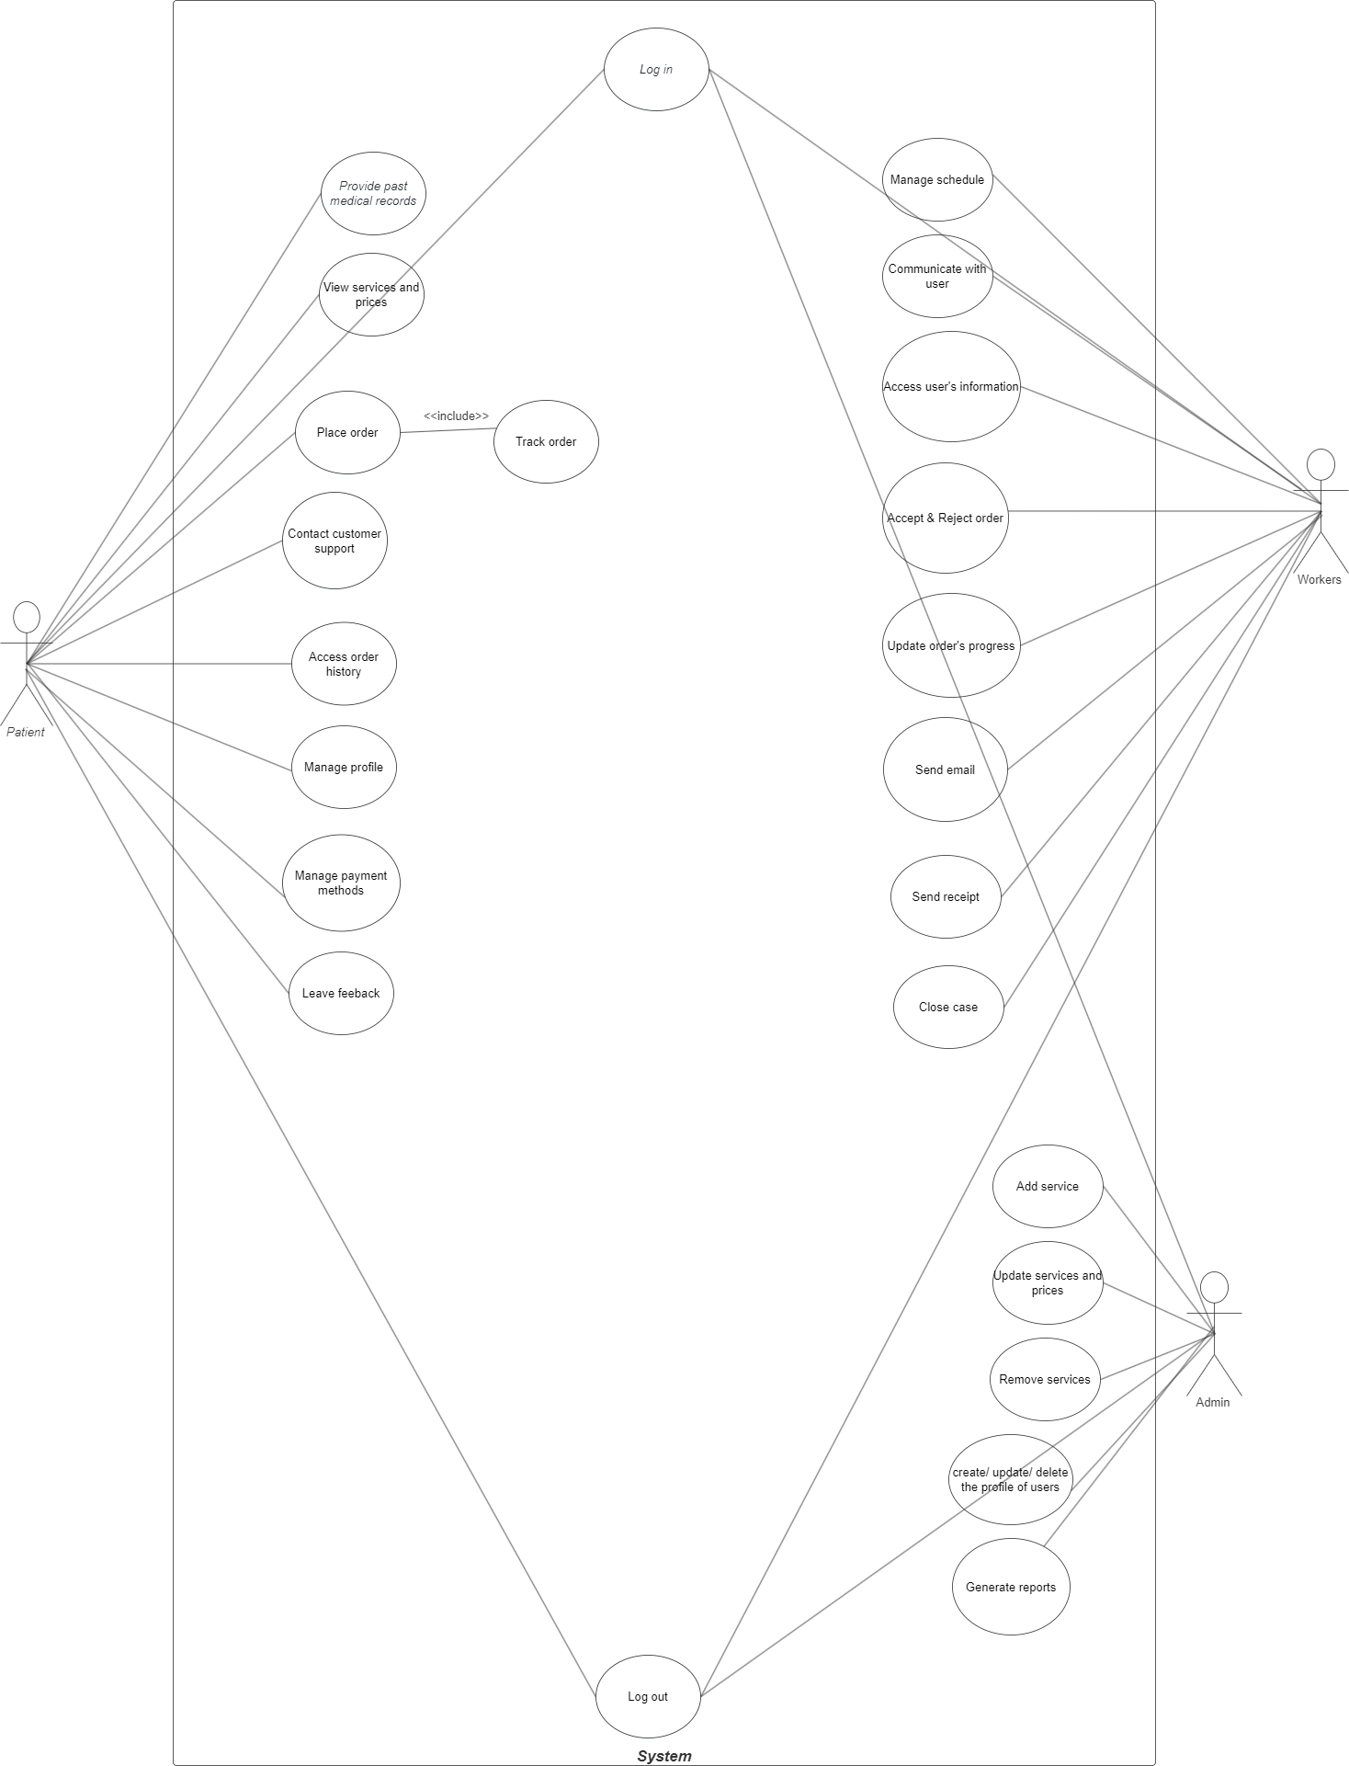

**5.2 BPMN**

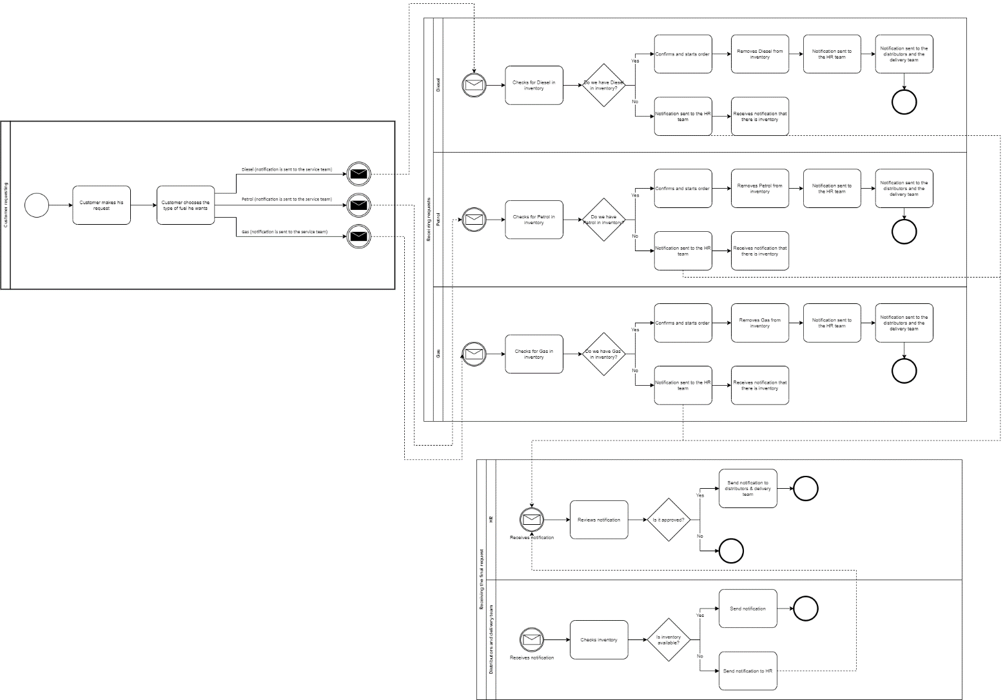

**5.3 Activity Diagrams**

**Log in Diagram**

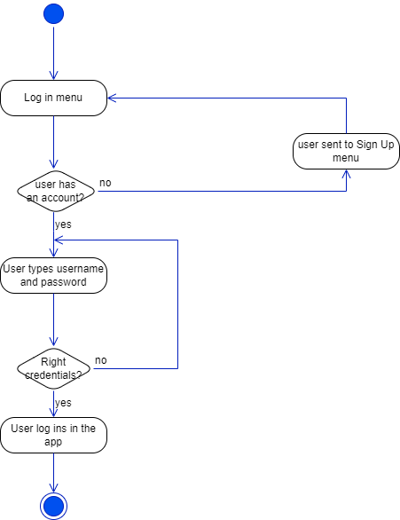

**Sign Up Diagram**

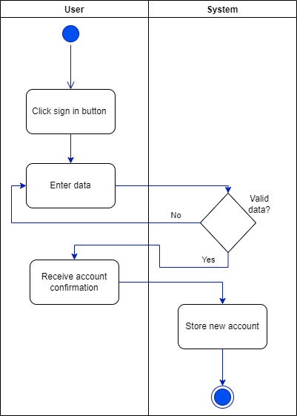

**Resetting Password Diagram**

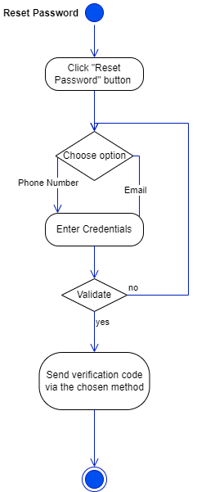

**Admin creating services Diagram**

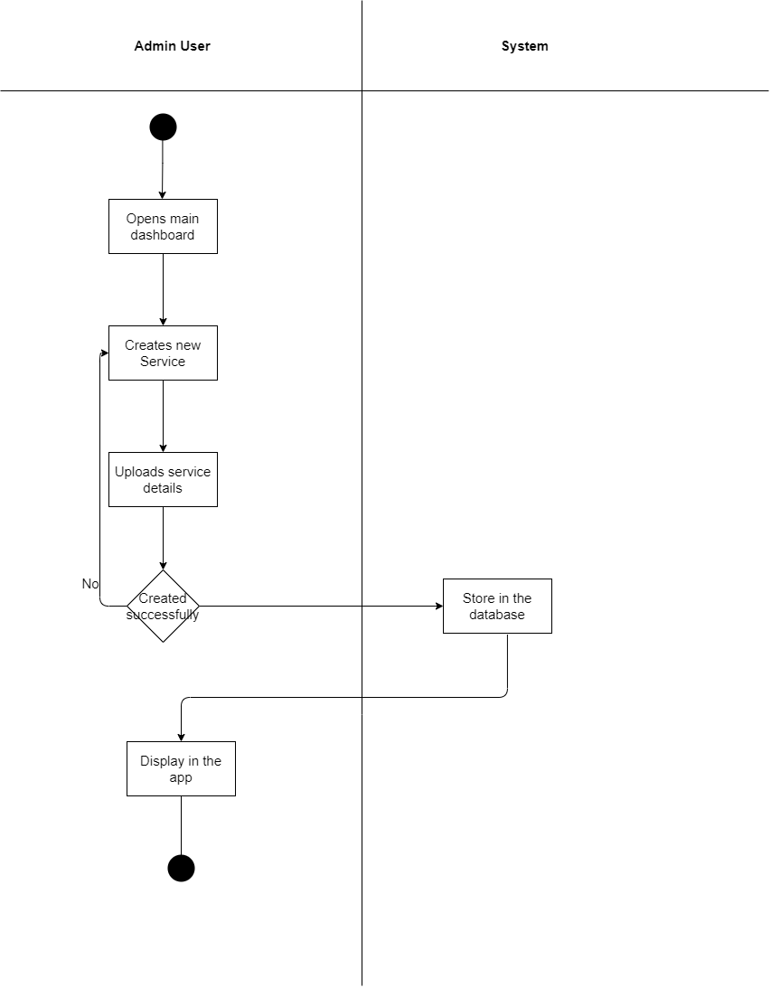

**Admin adding/editing or deleting a worker user Diagram**

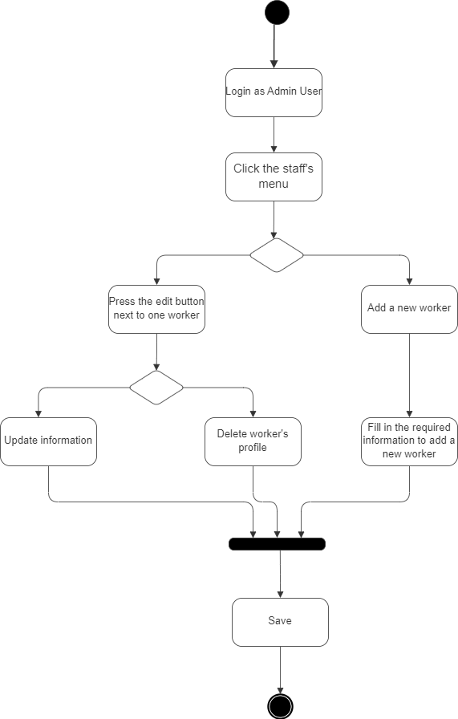

**User making an order Diagram**

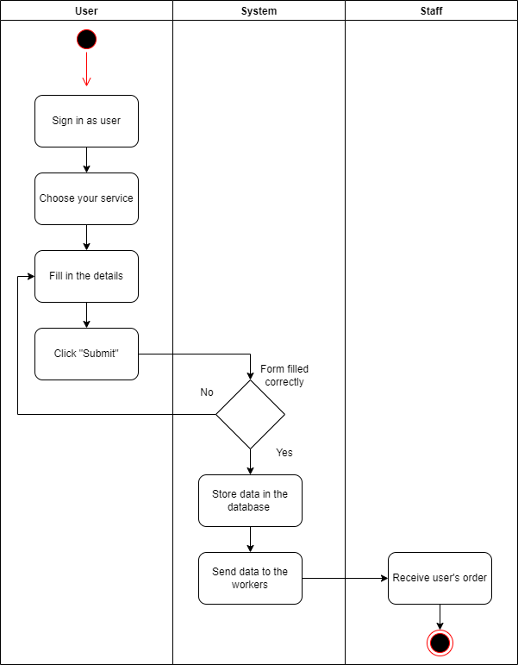

**Sending receipt Diagram**

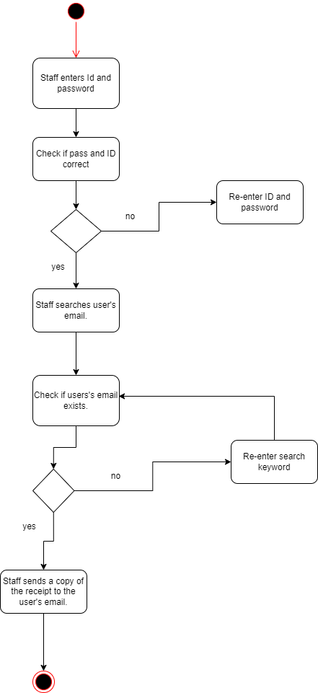

**5.4 State Diagrams**

**Changing password Diagram**

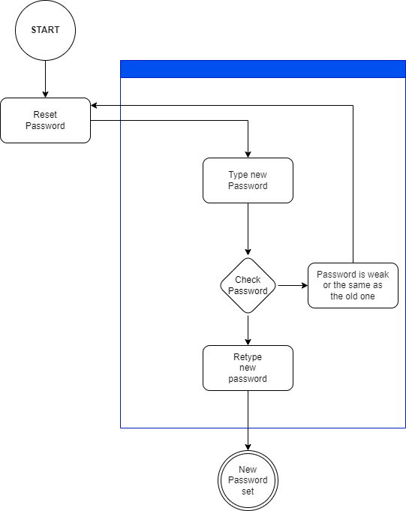

**Checking order Diagram**

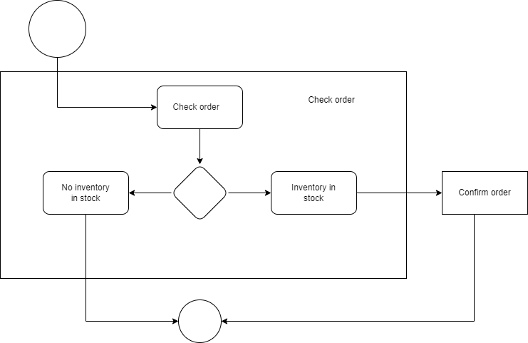

**Accepting/Rejecting orders Diagram**

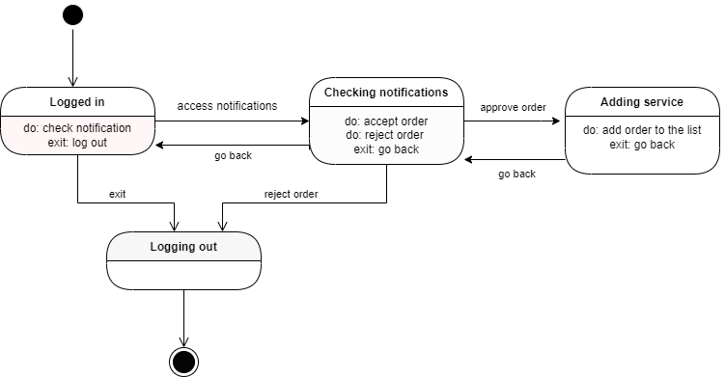

**Payment Diagram**

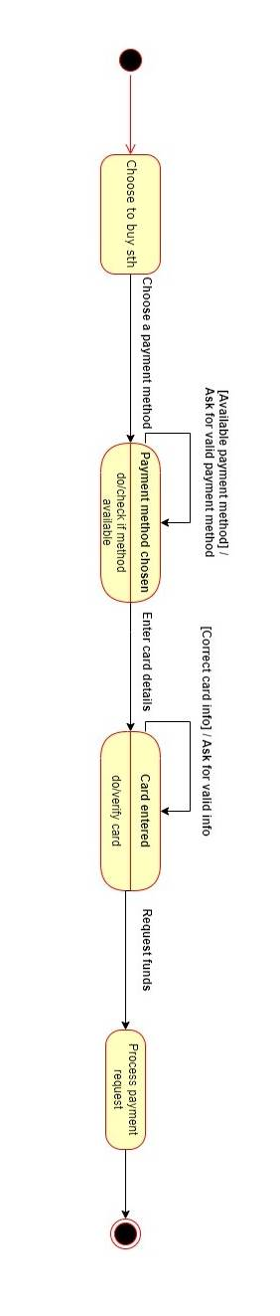

**5.5 Sequence Diagrams**

**Log in Diagram**

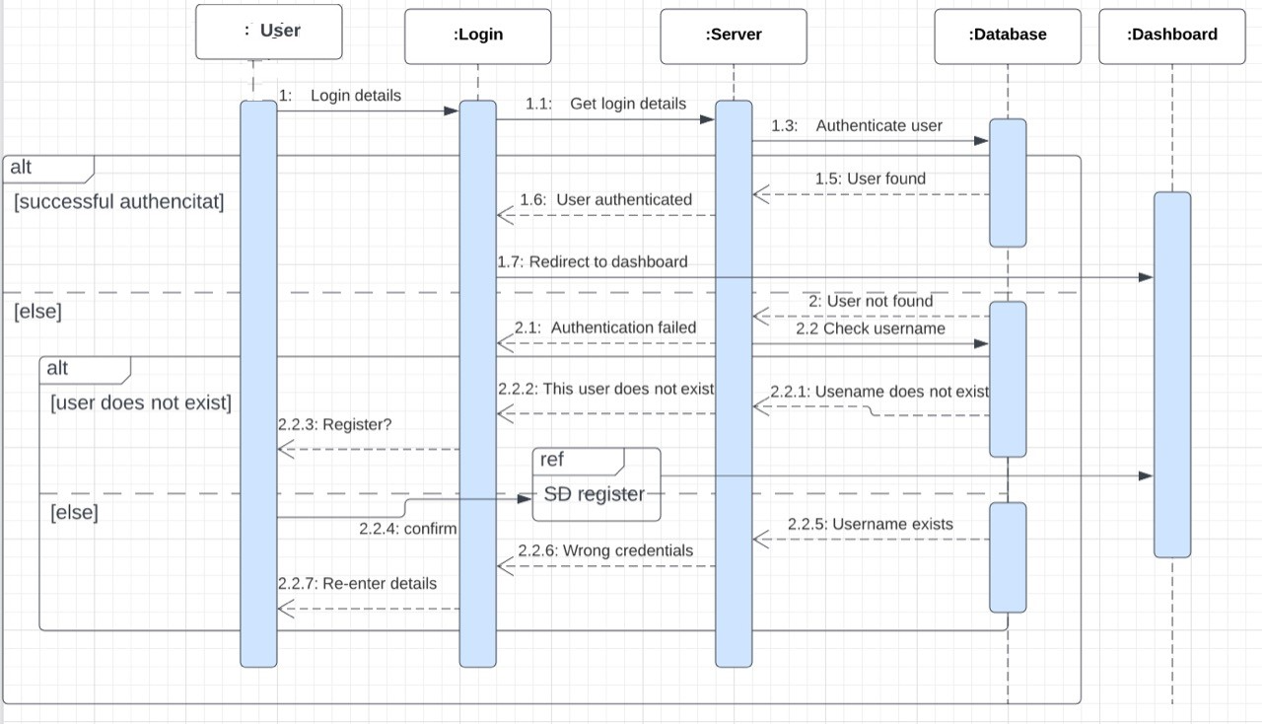

**Changing Password Diagram**

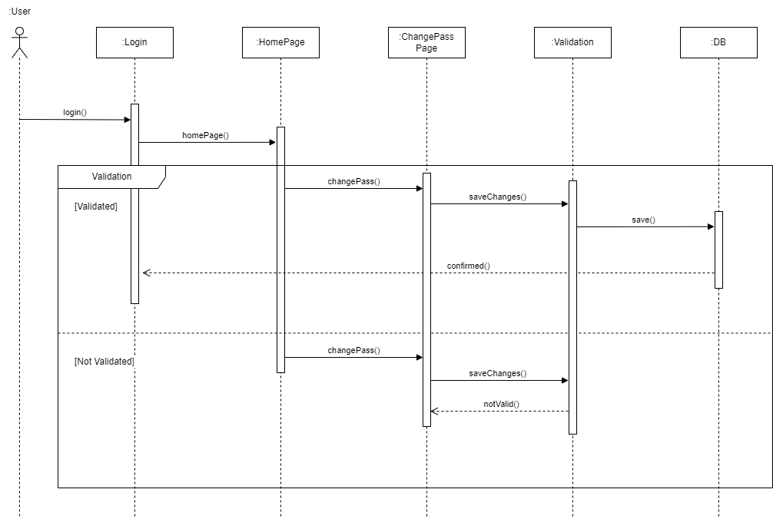

**Admin adding a service Diagram**

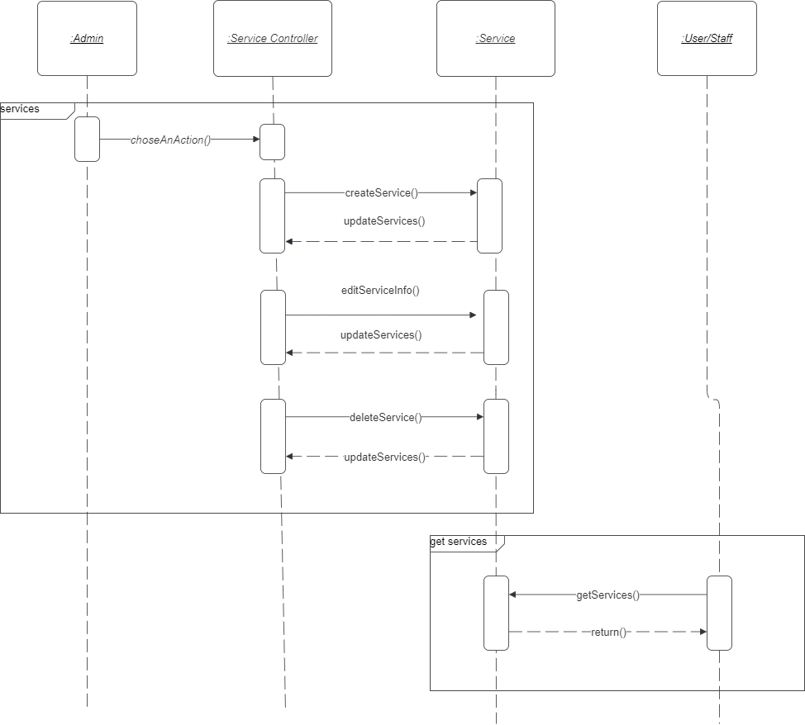

**Admin adding a user Diagram**

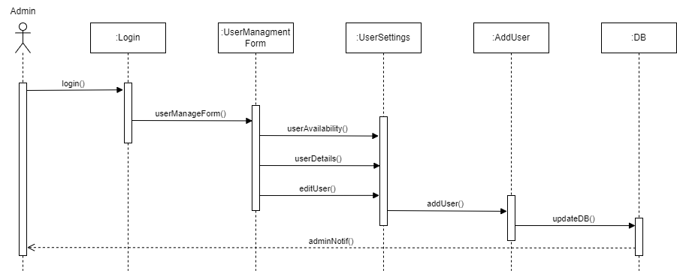

**Admin removing a user Diagram**

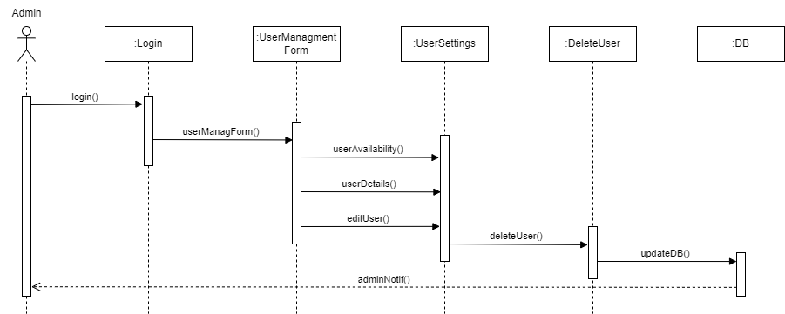

**Order being prepared Diagram**

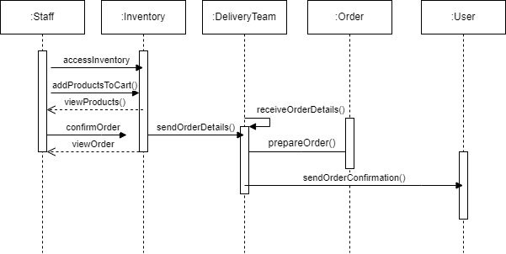

**Viewing inventory Diagram**

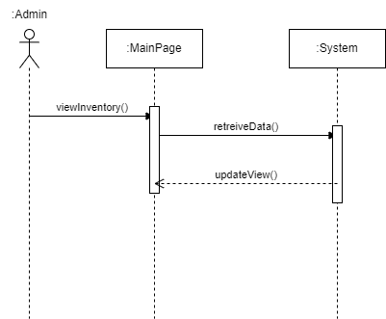

**5.6 Collaboration Diagrams**

**User Log in Diagram**

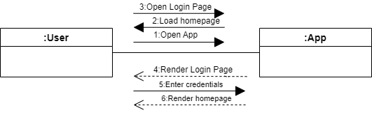

**Worker Log in Diagram**

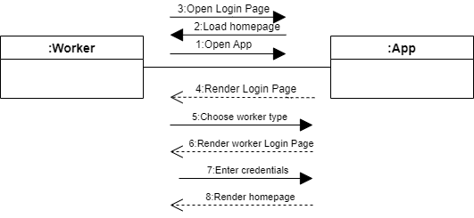

**Validating account Diagram**

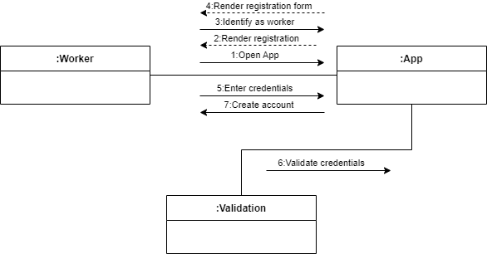

**Changing password Diagram**

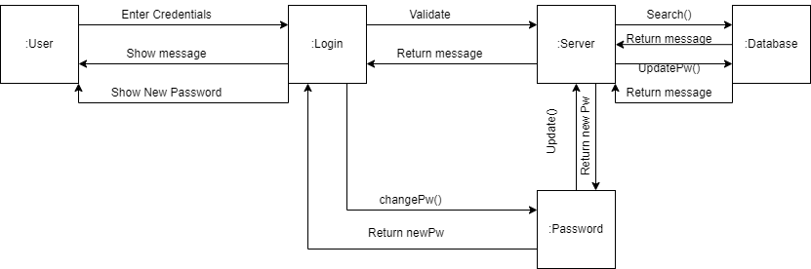

**Adding & Deleting products Diagram**

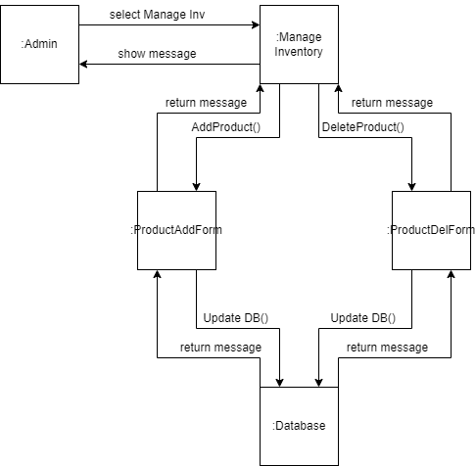

**Managing users Diagram**

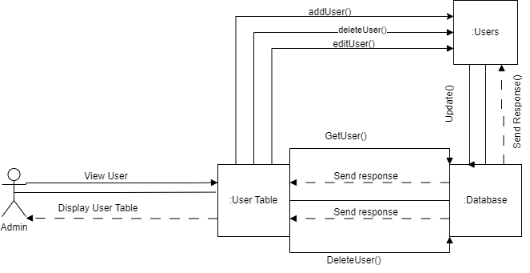

**User’s Feedback Diagram**

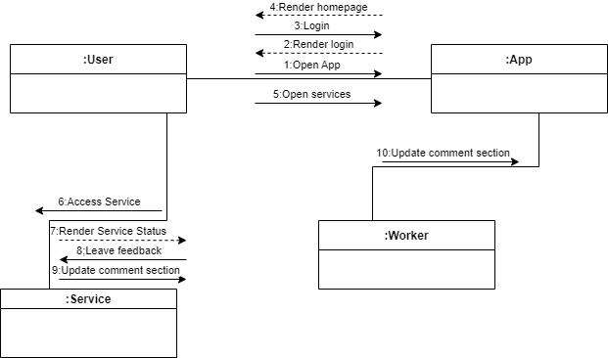

**5.7 Data Flow Diagrams**

**Level 0 of DFD**

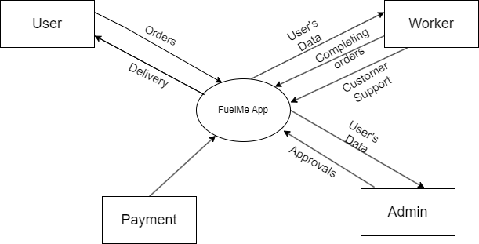

**Level 1 of DFD**

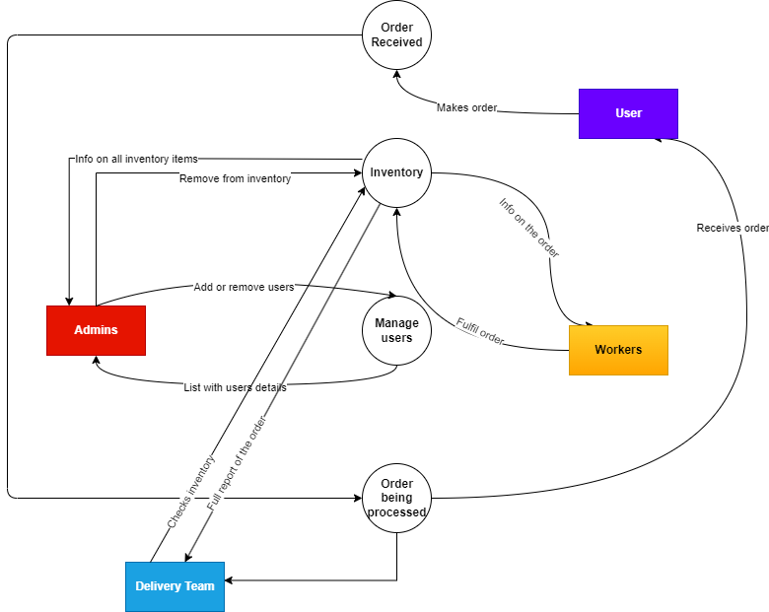

**5.8 Entity Relation Diagrams**

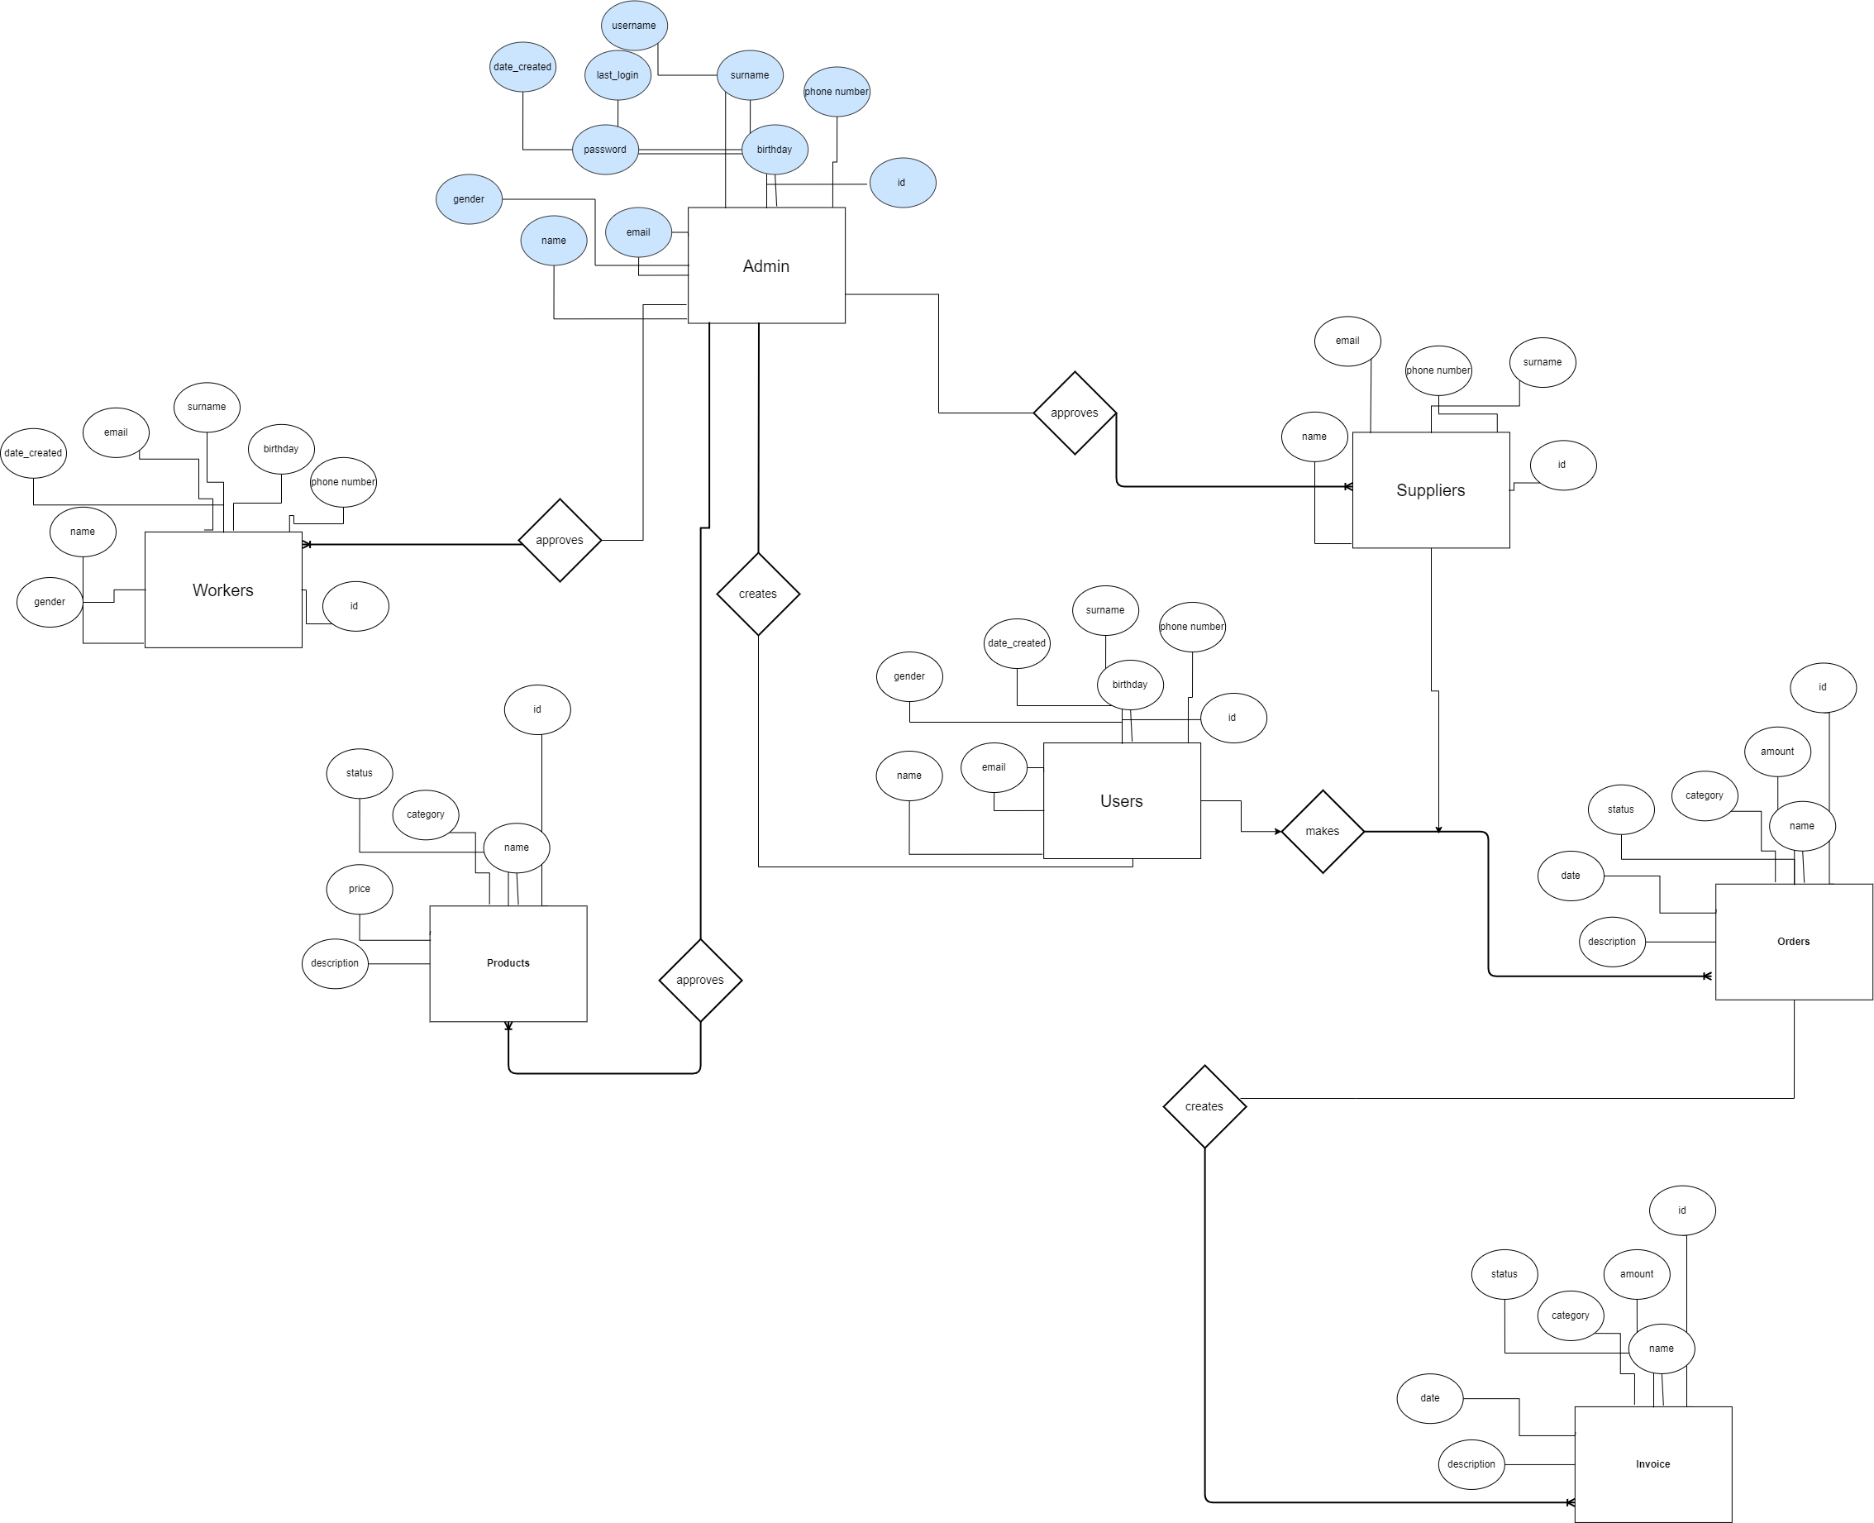

**5.9 Package Diagrams**

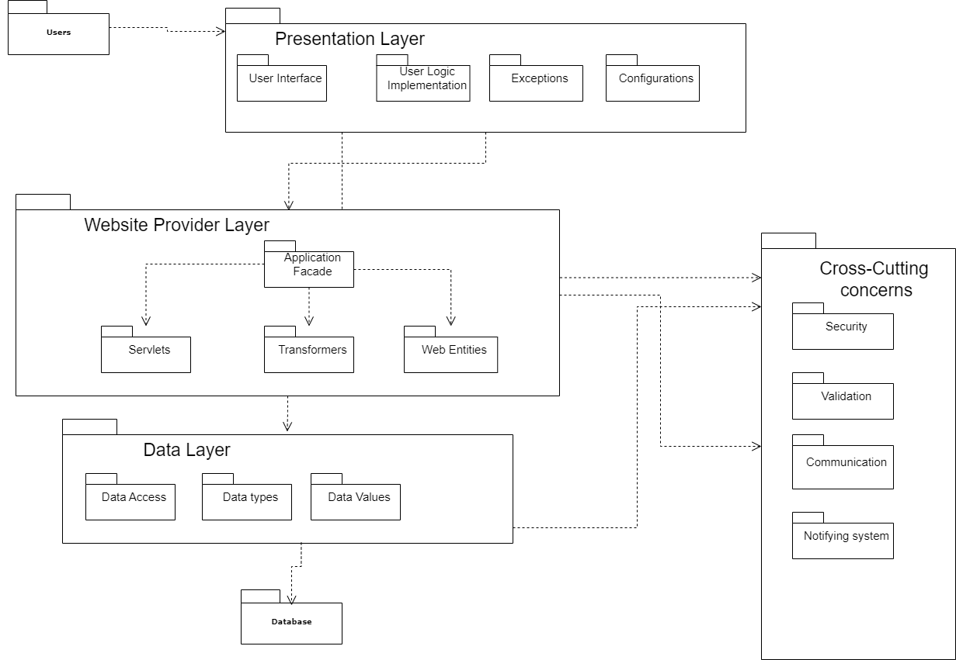

**6.0 Components Diagram**

**User’s Profile:**

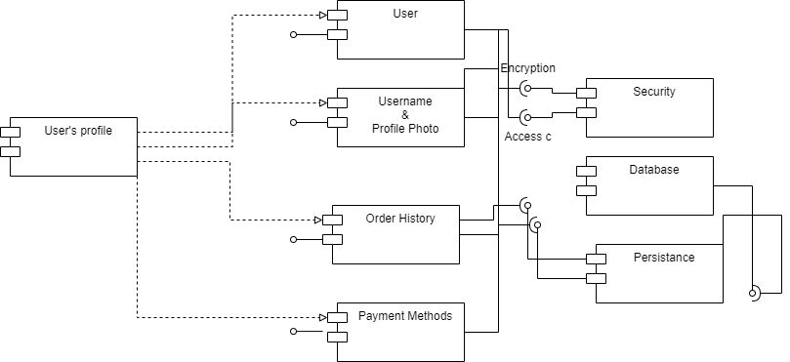

**Order Section 2:**

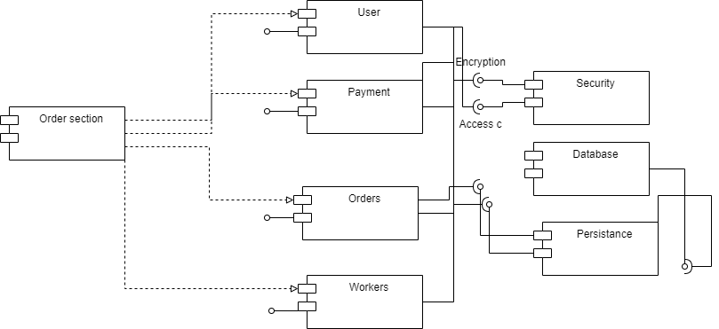

**6.1 Class Diagram**

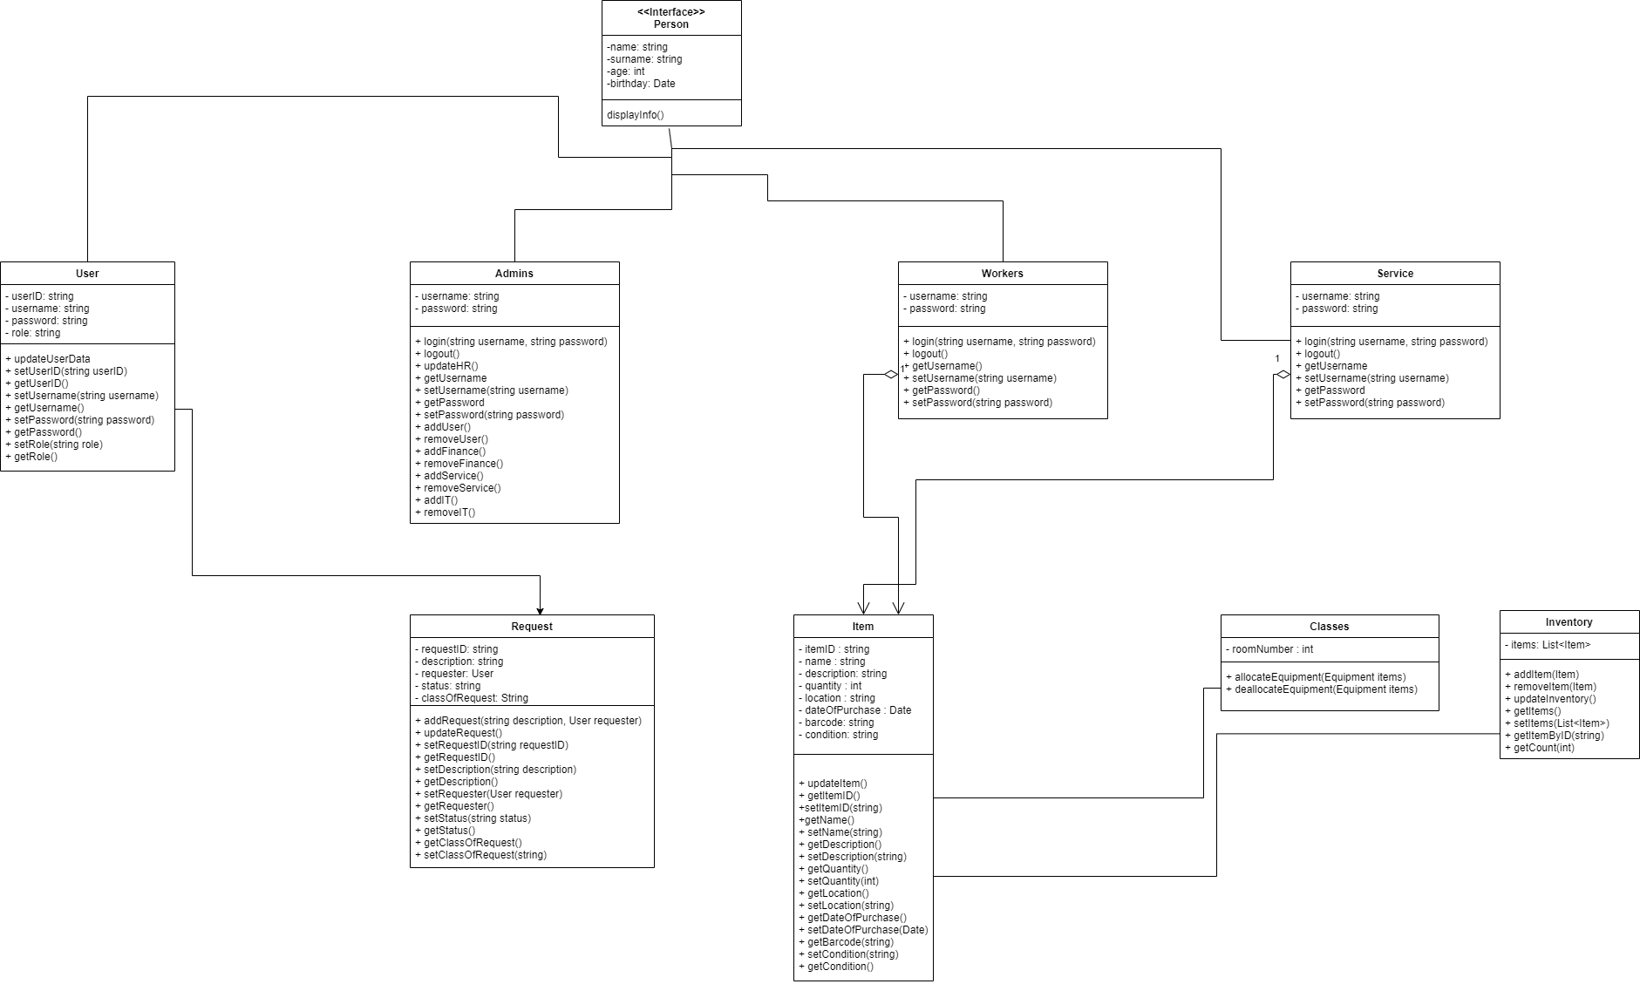

**6.2 Deployment**

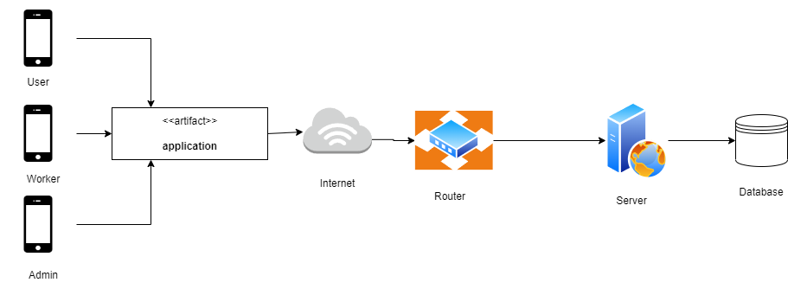

**6.3 Interaction Overview Data**

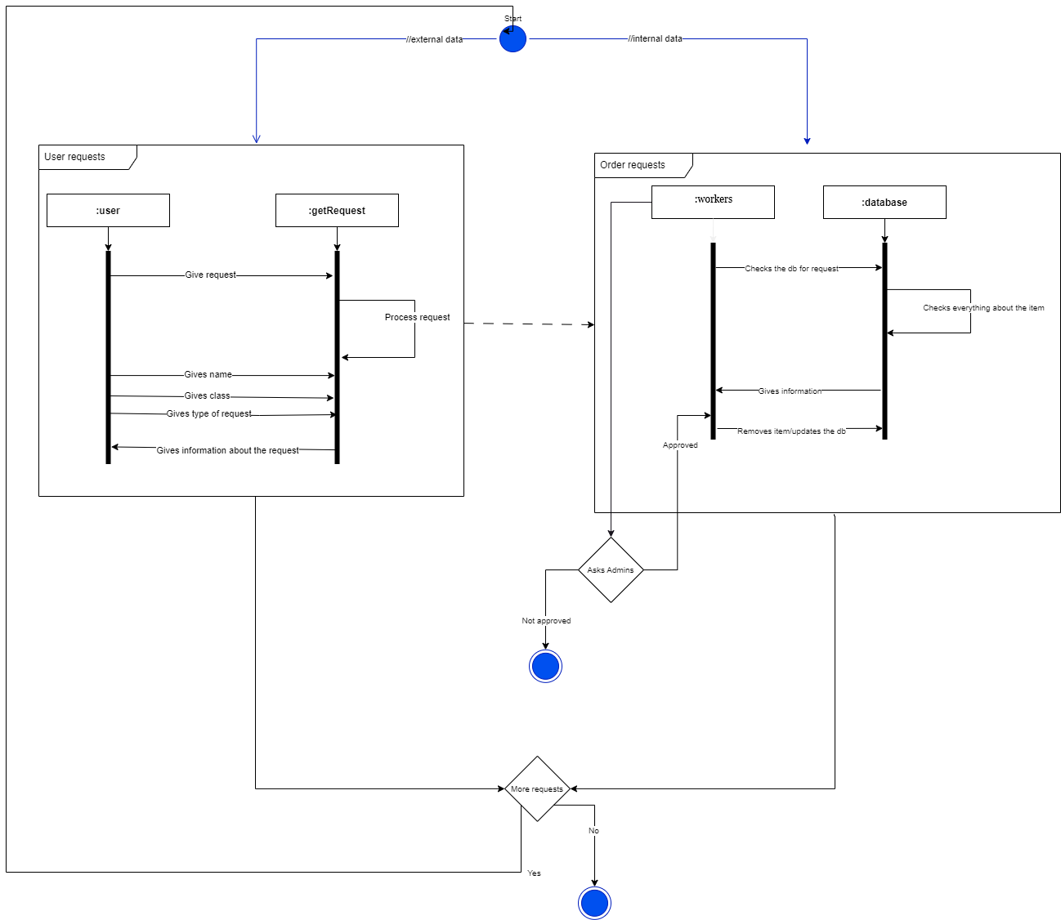

**6.4 Screenshots & Sketches**

**Menu**

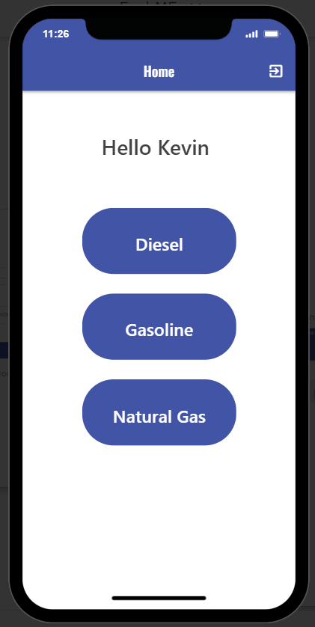

**Log in Sign Up**

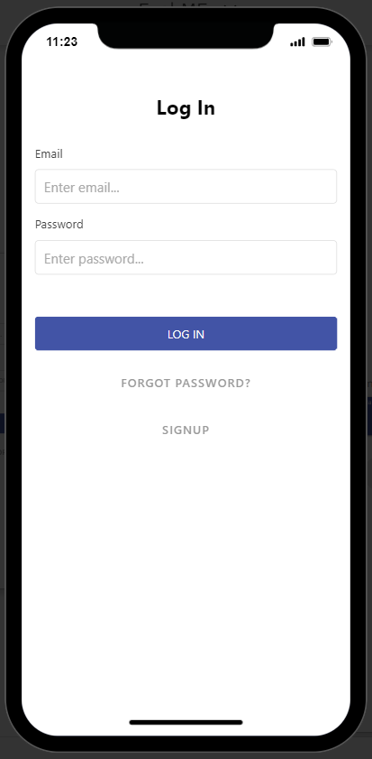

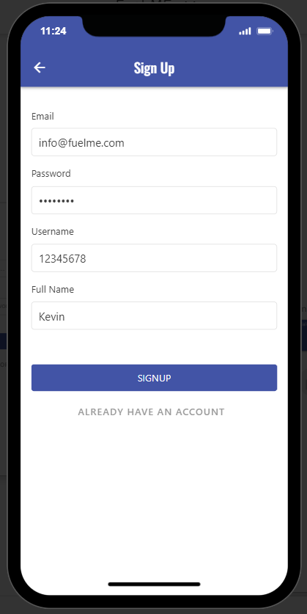

**Order Details**

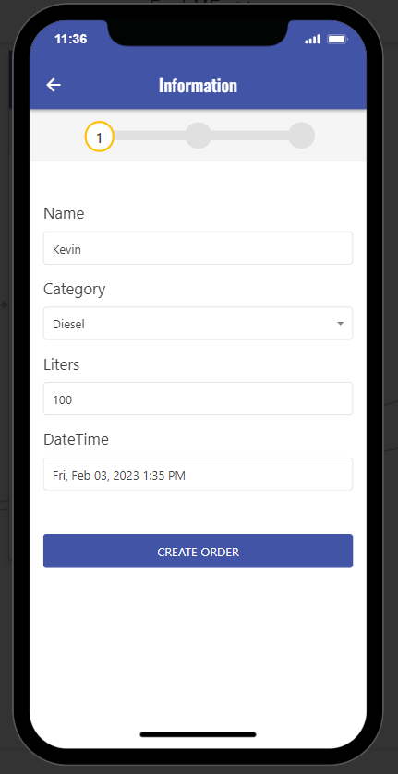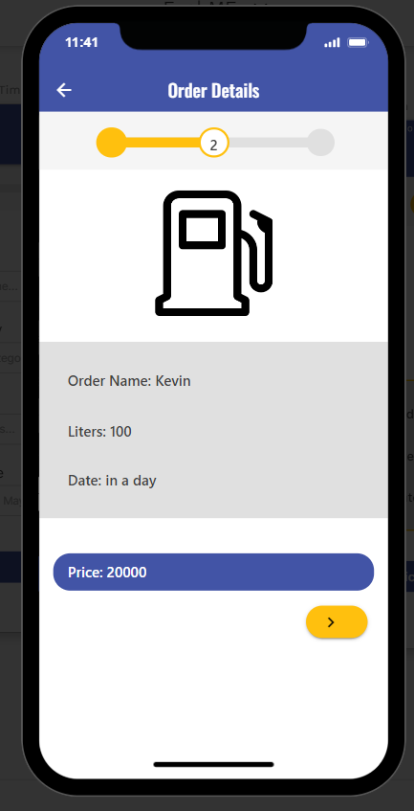

**Payment Order Successful**



