Starter Assets

Starter Assets is a Unity project that provides a foundation for building a first-person roaming experience with interactive elements and AI knowledge exploration. It utilizes the new input system for player control and offers various features and functionalities to enhance the gameplay.

The Starter Assets packages are compatible with Unity 2021.1x, it supports Unity 2021.1 or higher version. You need to utilize a Unity engine to open the file called project\_file, then you should reuse this program. Also if you stuck in the start animation, please try exe file called win(cut) in the operating\_file folder.

Meanwhile, I uploaded my game in this link : <https://sihan-guo.itch.io/ai-pedia-test>

Program code: <https://www.dropbox.com/scl/fi/otrhvhdjtv35e2hkiq9ga/project.zip?rlkey=3f0o2yq1pdnl6znm7nz4tpk22&dl=0>

Example video is here: <https://www.bilibili.com/video/BV11u4y1B7Mu/?spm_id_from=333.999.0.0&vd_source=9a1fbe73b754cdfb3b0384b36c128d35>

The question answers are presented below:

Scene1(ML\_unsupervised learning): BBABA

Scene2(NLP):CAAABCC

Scene3(ML\_supervised learning, CV):CABCB CBBCCC

Hope you can have a good game experience.

Table of contents:

1. Playground Scene
2. First-Person Roaming(New Input System)
3. URP/HDRP compatibility
4. Mini Map Design
5. Game Pause Menu
6. Interactive Objects

(1) Autogenerated UI for displaying text

(2) Autogenerated UI for switching between different texts

(3) Autogenerated UI for switching between different images

(4) Slide UI that can be dragged horizontally

1. NPC Navigation

(1) Smooth animation design

(2) Navigation functionality

1. NPC Dialogue Templates
2. Unlockable handbook
3. Background Music Control
4. Question and Answer Mechanism
5. Procedure Generation

Important note on package dependencies

The Starter Assets packages require the Input System and Cinemachine

packages to work.

The packages will automatically install when you import a Starter Assets package into your

project. This is handled by the PackageChecker.cs script.

Please accept the Input System pop-up and Editor restart to successfully install the New Input

System. If you accidentally decline, you can install the New Input System through the Package

Manager.

Switching input systems

If you want to use the Input System and Input Manager (Old) together, or switch your project

back to the old Input Manager, you will need to go to Edit > Project Settings, then select

Player.

Under Other settings, you will see that Input System Package (New) is selected. Here you

can switch to your preferred setup. Please bear in mind that the Starter Assets do not work with

the Input Manager (Old) setting.

**Playground Scene**

In Assets/Lowpoly Style, you will find six Playground scenes. Here you can use the Starter Assets controller in a simple playground environment.

**First-Person Roaming(New Input System)**

Set up the Starter Assets in a new Scene

If you want to add the character controller to a new Scene, you need to complete a simple

setup.

There are several ways to do this:

Drag and drop (Nested Prefab)

● Go to Assets/StarterAssets/FirstPersonController/Prefabs.

Locate the Nested Prefab you want, for example NestedParentArmature\_Unpack. This

is a Nested Prefab that contains everything you need to set up a PlayerArmature in a

new Scene.

● Drag the NestedParent Prefab into your Hierarchy, right-click, and select Unpack.

● Drag the contents of the nested parent out into the Scene, and you are ready to go.

Automated setup

● Go to Tools > Starter Assets and select the type of controller you want to set up, for

example Reset Third Person Controller Armature. This will set up a new

PlayerArmature in your Scene with everything hooked up.

● You can also use this tool to reset elements of your current Player back to default.

Manual setup

● Drag the PlayerCapsule or PlayerArmature into the new Scene.

● Drag the PlayerFollowCamera into the Scene.

● Under Follow in the CinemachineVirtualCamera in the Inspector, select the

PlayerCameraRoot object.

● Replace your Main Camera with the MainCamera prefab in the Prefabs folder, or assign

a CinemachineBrain to the existing Main Camera.

● Press Play and you’re good to go!

**URP/HDRP compatibility**

Free HDRP & URP Support Packages

While you can use Unity’s “Edit->Render Pipeline->Upgrade Project Materials”, but I recommend just using the HDRP and URP packages – they can be downloaded from the asset store for FREE if you own the standard-shader Ultra Pack!

HDRP: http://u3d.as/26oJ

URP: http://u3d.as/1X1n

Post Processing for Standard Pipeline

To get the same look as in the screenshots, please use the included post processing profiles. Enable

post processing by downloading the newest post-processing stack via the package manager in Unity,

via the asset store or from github, then assign the profiles.

I am not allowed to include the post processing stack packages in asset store submissions, please

refer to the resources below if you do not have experience with setting up post processing in Unity.

Depending on the version of the post processing stack (V1 or V2), you must use the profile labelled

V1 or V2.

All profiles can be found directly next to the demo scene of each theme.

IMPORTANT: Please use linear color space for proper results. (Project Settings > Player)

Further info here:

https://docs.unity3d.com/2018.3/Documentation/Manual/PostProcessing-Stack.html

https://docs.unity3d.com/Packages/com.unity.postprocessing@2.2/manual/index.html

Post Processing for HDRP / URP

HDRP and URP packages include post processing directly.

Lightmapping

To get the best results, you can lightmap the scene with rather low settings (this is the case on many of the screenshots).

**Mini Map Design**

● Go to GameObject > UI > Canvas and create a canvas.

● Go to Assets/prefabs/UI/mapMask and drag it into your canvas.

● Go to Assets/prefabs/miniMapCamera and drag it into your scene.

**Game Pause Menu**

● Go to Assets/prefabs/GameManager and drag it into the scene, in the inspector cancel the check of MeshRender.

● Go to Assets/prefabs/handbook, Assets/prefabs/Scroll View, Assets/prefabs/interaction, Assets/prefabs/pause and Assets/prefabs/dialog, drag those into the canvas and at the same time fulfill the option in the inspector of GameManager.

● Go to pause/ in the hierarchy and drag GameManager in the scene into the Onclick(), select the suitable function.

● Go to Scroll View/Viewport/content/ML/button in the hierarchy and drag GameManager in the scene into the Onclick(), select the PauseGame.ML() function.

● Go to Scroll View/back in the hierarchy and drag GameManager in the scene into the Onclick(), select the PauseGame.back() function.

● Go to handbook/back in the hierarchy and drag GameManager in the scene into the Onclick(), select the PauseGame.back\_ML() function.

● Go to handbook in the hierarchy and drag suitable image into options.

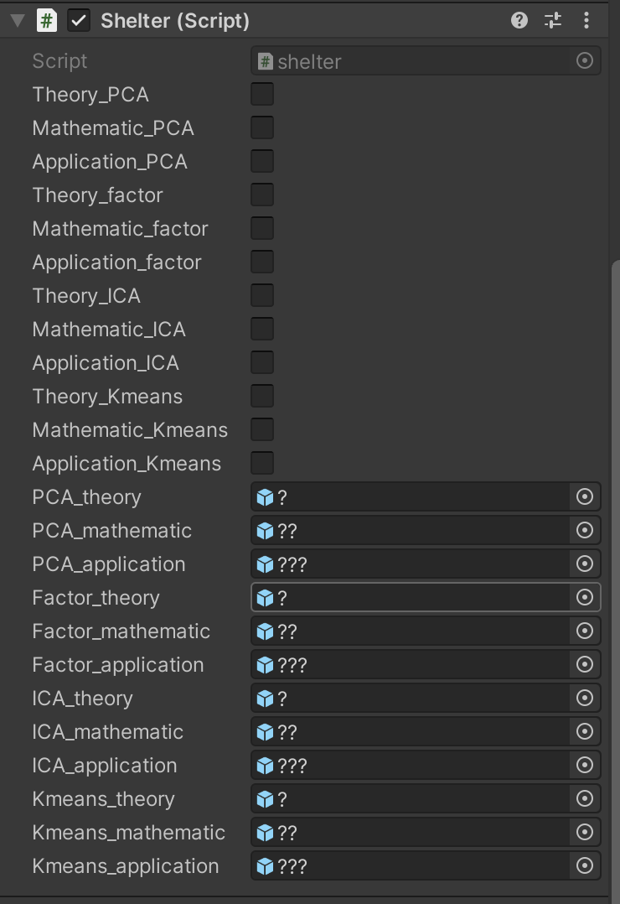

**Interactive Objects**

Autogenerated UI for displaying text

● Go to Assets/prefabs/mechanism/display\_text and drag it into the scene.

● Go to Assets/prefabs/UI/displayText\_UI and drag it into the canvas. Add text in the text component.

● Go to the inspector of display\_text, drag displayText\_UI, mapMask and handbook in the Trigger component.

Autogenerated UI for switching between different texts

● Go to Assets/prefabs/mechanism/switch\_text and drag it into the scene.

● Go to Assets/prefabs/UI/displayText\_UI and drag it into the canvas., Go to Assets/prefabs/UI/TextSwitcher and drag it under this displayText\_UI.

● In the inspector of TextSwitcher, drag Text displayText\_UI/Container/intro into Text component and add or reduce text element, drag switch\_text into Topic.

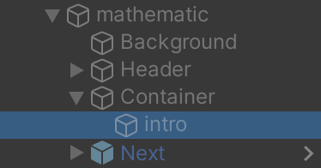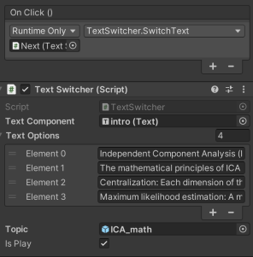

● In the inspector of switch\_text, drag displayText\_UI into MainContent, TextSwitcher into Button, so do it for the mapMask and handbook.

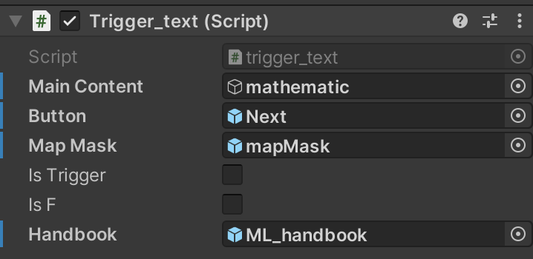

Autogenerated UI for switching between different images

● Go to Assets/prefabs/mechanism/switch\_image and drag it into the scene.

● Go to Assets/prefabs/UI/displayText\_UI and drag it into the canvas., Go to Assets/prefabs/UI/ImageSwitcher and drag it under this displayText\_UI. Delete displayText\_UI/Container/intro and replace with UI > Image.

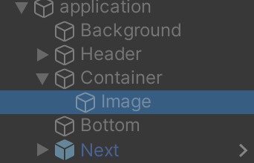

● In the inspector of ImageSwitcher, drag image you just created into image component and add or reduce sprites element, drag switch\_image into app.

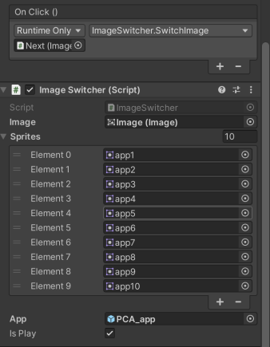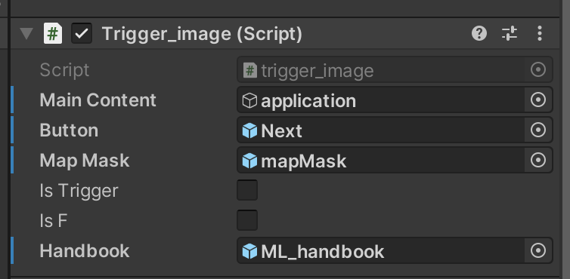

● In the inspector of switch\_image, drag displayText\_UI into MainContent, ImageSwitcher into Button, so do it for the mapMask and handbook.

Slide UI that can be dragged horizontally

● Go to Assets/prefabs/UI/text\_scroll and drag it into the canvas.

● In the hierarchy, we could see a clear relationship. Under text\_scroll/Viewport/Content, choose topic to change your text topic, choose GameObject/text to change your content.

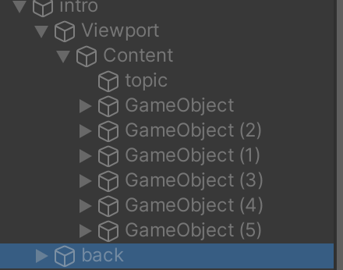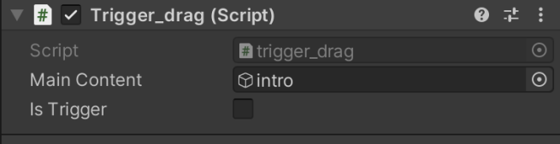  
● Go to Assets/prefabs/mechanism/drag\_text and drag it into the scene. Select its inspector, drag text\_scroll into the Trigger\_drag script.

● Select the inspector of text\_scroll/Viewport/back, drag drag\_text into the OnClick event.

**NPC Navigation**

Smooth animation design

● Right-click and create a new Animator Controller, rename it walk. Open the animator window, right mouse button to create a new state, set its motion to walk, and right mouse button to create transition to idle; Otherwise, click idle to set its motion to idle and create a new transition to walk.

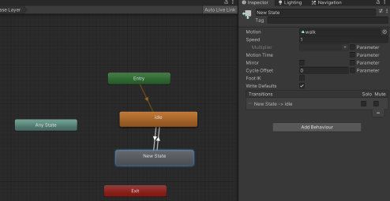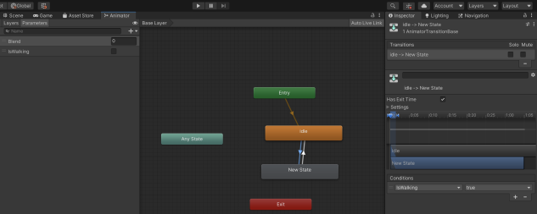

● Create a new Boolean variable in the Parameters panel called isWalking and uncheck it by default. In the condition of the idle to walk transition, add isWalking variable set to true; Otherwise, set it to false in the other transition.

Navigation functionality

● Go to Windows/AI/Navigation to show the navigation inspector, click bake to bake the scene.

● Select the npc, add NavMeshAgent component and NPCController scripts, set the parameters.

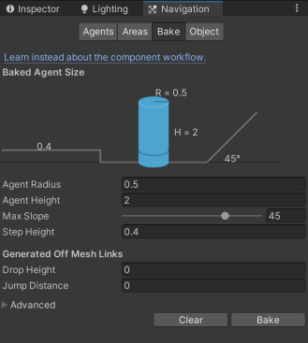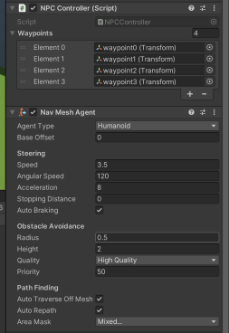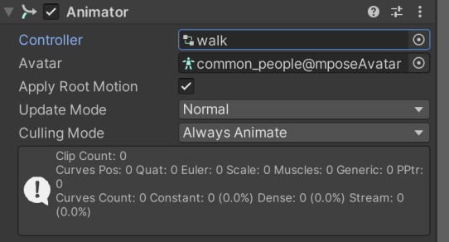

● Add animator component and drag walk into controller.

**NPC Dialogue Templates**

● Go to the NPC you want to make a dialogue and add NPCDialogue script.

● Create three buttons under an empty object in the canvas and drag them into the inspector of NPC.

● Create three txt documents to edit contents and drag them into the inspector of NPC.

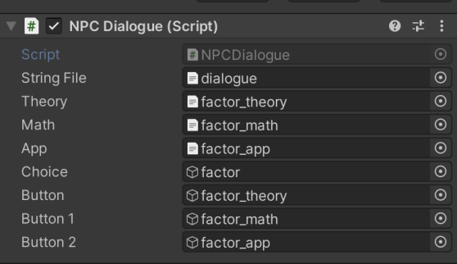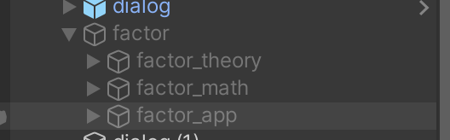

**Unlockable handbook**

● Drag 2D Game/Don’tDestroy into the scene. If you want to edit handbook content, double click it in the folder.

● if you want to add a new small block, copy an item and ?, paste them in the same hierarchy.

● Edit shelter script, create a new bool variable and GameObject, add a condition in the update function.

● Rename the object you want to trigger unlock event and add FindHandbook function in the script. Edit FindHandbook script, add a judgment statement that sets the bool variable you just created to true when the GameObject is called by a specific name.

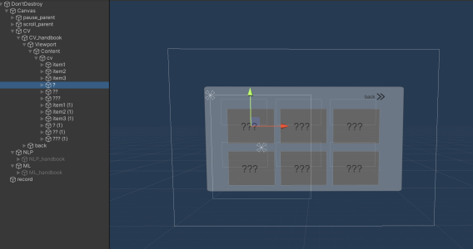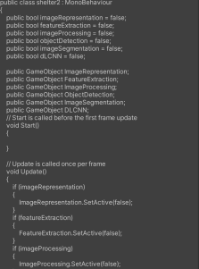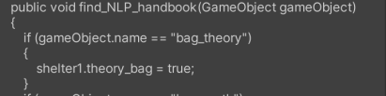

**Background Music Control**

● Drag prefabs/MusicManager into scene, edit areas of BoxCollider for every elements, which means editing the music areas.

● Import music you want to play and drag it into music clips.

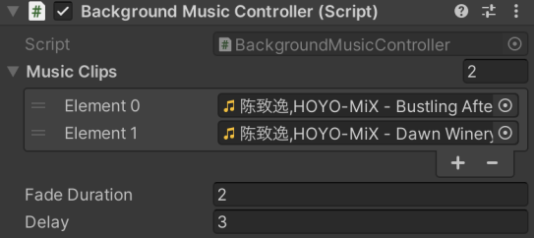

**Question and Answer Mechanism**

● Add FinalTest script into npc.

● Drag prefabs/UI/QA under the canvas and select QA/finalTest/Viewport/Content in the hierarchy to edit questions.

● Click finalTest and drag every right answer into the ToggleOptions list.

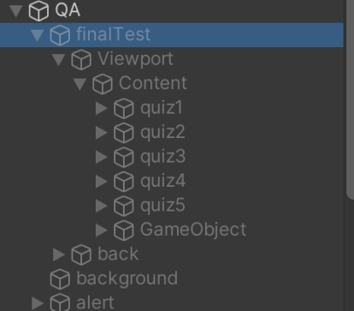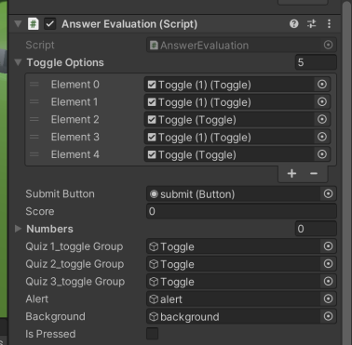

**Procedure Generation**

● Open Resources/music and import music clips, rename them like the following way.

● Open Resources/text and import documents, rename them like the following way.

● Open PolygonSciFiCity/text\_names and add every topic name as a matrix. The rows of the text matrix represent the number of documents, and the columns represent the six subtopics in each document. If you add new documents, you can create a new line and set the name of each topic according to the space.

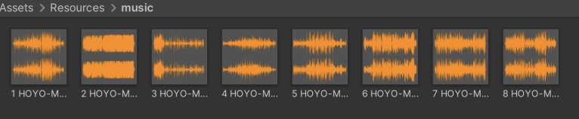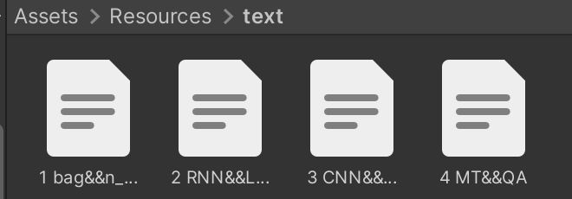

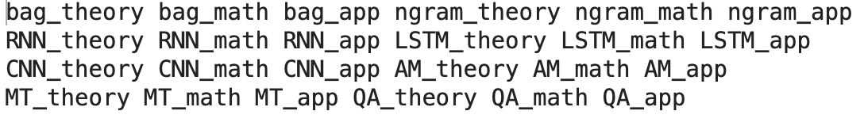

**Getting Started**

To get started with the Starter Assets project, follow these steps:

Clone or download the project repository from [GitHub](https://github.com/your-username/StarterAssets" \t "/Users/gsh/Documents\\x/_new).

Open the project in Unity version 2021.1x or later.

Explore the provided scene and assets to understand the project structure and functionality.

Refer to the documentation and code comments for detailed explanations of each feature.

Customize and expand the project according to your specific requirements.

Resources

Scene: Lowpoly Style Ultra Pack

Input system: Starter Assets

Thank you for choosing Starter Assets. We hope this project provides a solid foundation for your game development journey. If you have any questions or need assistance, please don't hesitate to reach out to me.

Happy game development!