Use Instruction

- Tool for ComScore Code Challenge

Author: Ran Zhao

Contents

1. Tool Functions 2

1.1 Function Summary 2

1.2 Tool Running Environment 2

2. IMPORT AND GENERATE DATA STORE 2

3. Run SELECT, FILTER, ORDER Query 4

3.1 SELECT 4

3.2 FILTER 4

3.3 ORDER 5

**3.3.1** Order By Date 5

**3.3.2** Order By Name 6

**3.3.3** Order By Date and Name 7

# 1. Tool Functions

## Function Summary

This tool has two functions:

* Import input sample, generate data store.
* Accept args command, run SELECT, FILTER, ORDER query against data store

## Tool Running Environment

This tool is implemented by Java. The development environment is **jdk1.8.0_0131**. To run this tool, it requires JRE version higher than 8.

# 2. IMPORT AND GENERATE DATA STORE

Please follow the below steps to import input data sample and generate data store.

**Step 1**: Put the input sample under folder {project}*resource\imports.* The input file should be in txt format.

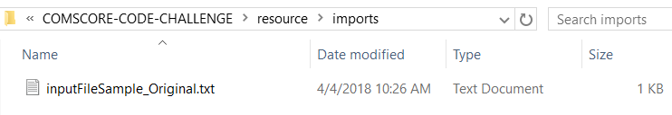

The content of the input file should be with format as:

*STB|TITLE|PROVIDER|DATE|REV|VIEW_TIME*

*stb1|the matrix|warner bros|2014-04-01|4.00|1:30*

*stb1|unbreakable|buena vista|2014-04-03|6.00|2:05*

*………*

**Step 2**: Run the tool entry. The entry is a simple Java main method.

The entry path is: *{project}\src\dataEngine\StartEngine.java*

To use the import feature, remove comment for line 15 and 16. Then run it.

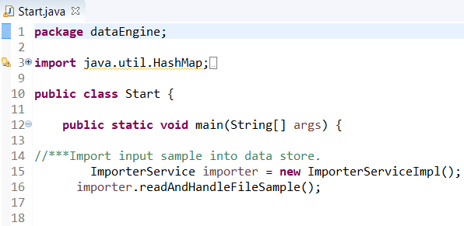

After running it, if import successfully, the IDE console will show below information.

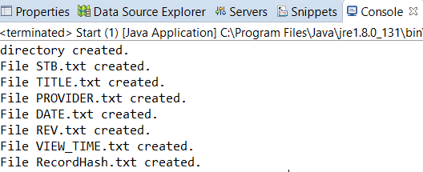

**Step 3**: Check the data store. This tool is designed to implement column-oriented storage, which is the similar concept on how PostgreSql stores the data.

Go to *{project}\resource\dataStore\{inputSampleName}* to check all data store files. Each file stores a corresponding column in input sample. The data store file is in txt format.

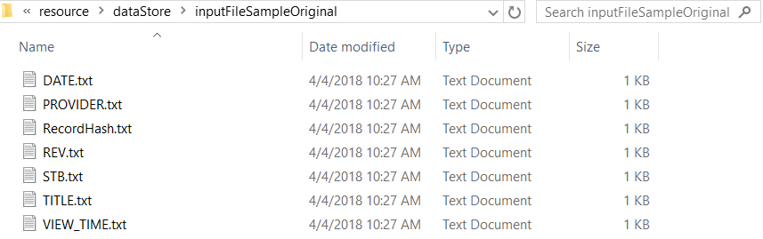

# 3. Run SELECT, FILTER, ORDER Query

## 3.1 SELECT

Please follow the below steps to run SELECT query against data store.

**Step 1**: Run the SELECT query entry. The entry path is: *{project}\src\dataEngine\StartEngine.java*

Remove the comment for line 20 – 24. Then run it.

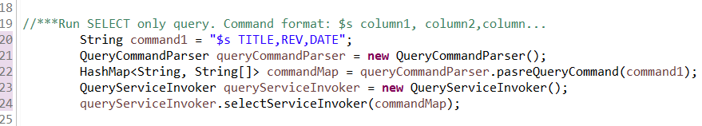

After running it, if query successfully, the IDE console will show below information.

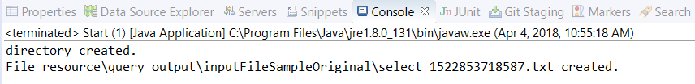

**Step 2**: Check the query output under output folder *{project}\resource\query_output\{inputSampleName}*

The output file is in txt format, the name of the file is select_{CurrentTimeMillisecond}.txt

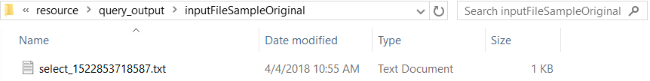

## 3.2 FILTER

Please follow the below steps to run SELECT query against data store.

**Step 1**: Run the FILTER query entry. The entry path is: *{project}\src\dataEngine\StartEngine.java*

Remove the comment for line 28 – 32. Then run it.

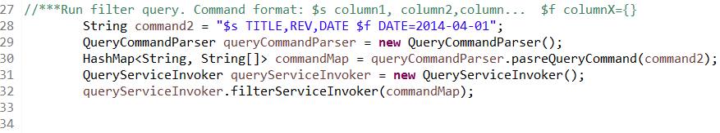

After running it, if query successfully, the IDE console will show below information.

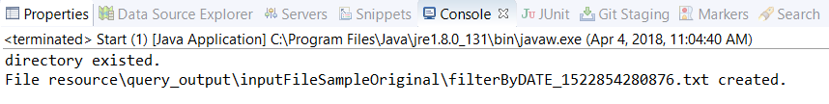

**Step 2**: Check the query output under output folder *{project}\resource\query_output\{inputSampleName}*

The output file is in txt format, the name of the file is *filterBy{COLUMN}_{CurrentTimeMillisecond}.txt*

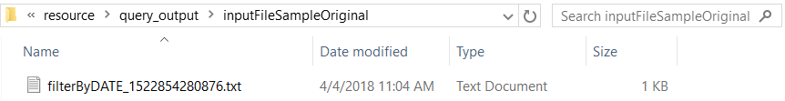

## 3.3 ORDER

### 3.3.1 Order By Date

**Step 1**: Run the Order query entry. The entry path is: *{project}\src\dataEngine\StartEngine.java*

Remove the comment for line 36 – 40. Then run it.

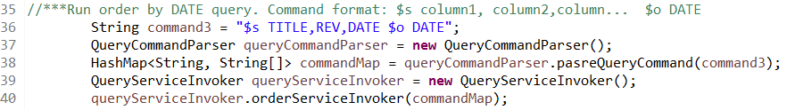

After running it, if query successfully, the IDE console will show below information.

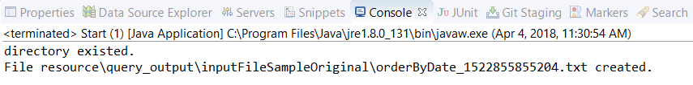

**Step 2**: Check the query output under output folder *{project}\resource\query_output\{inputSampleName}*

The output file is in txt format, the name of the file is *OrderByDate_{CurrentTimeMillisecond}.txt*

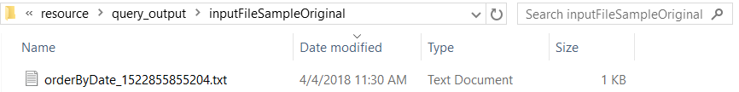

### 3.3.2 Order By Name

**Step 1**: Run the Order query entry. The entry path is: *{project}\src\dataEngine\StartEngine.java*

Remove the comment for line 44 – 48. Then run it.

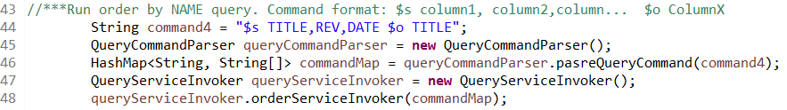

After running it, if query successfully, the IDE console will show below information.

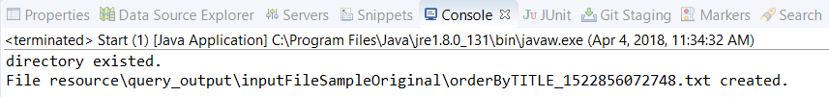

**Step 2**: Check the query output under output folder *{project}\resource\query_output\{inputSampleName}*

The output file is in txt format, the name of the file is *OrderBy{COLUMN}_{CurrentTimeMillisecond}.txt*

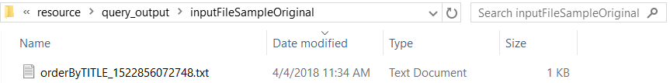

### 3.3.3 Order By Date and Name

**Step 1**: Run the Order query entry. The entry path is: *{project}\src\dataEngine\StartEngine.java*

Remove the comment for line 44 – 48. Then run it.

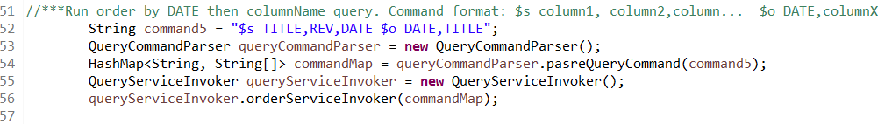

After running it, if query successfully, the IDE console will show below information.

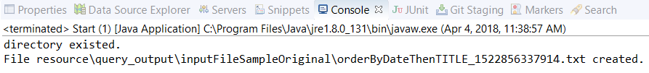

**Step 2**: Check the query output under output folder *{project}\resource\query_output\{inputSampleName}*

The output file is in txt format, the name of the file is *OrderByDateThen{COLUMN}_{CurrentTimeMillisecond}.txt*

