

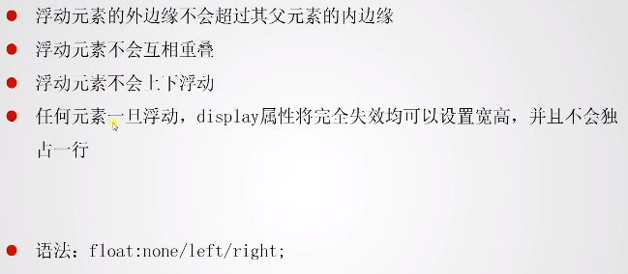

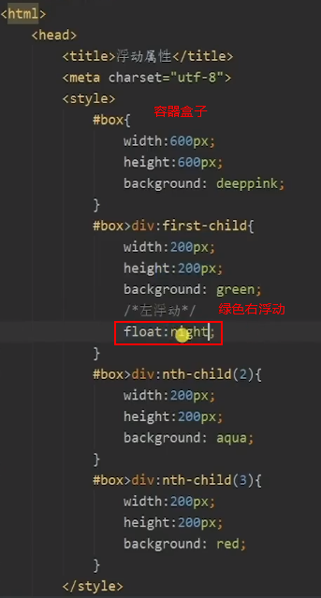

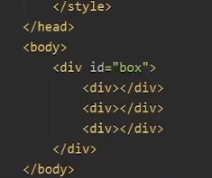

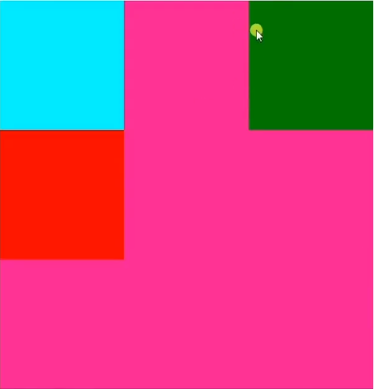

对SPAN标签设置浮动，设置line-height, 字体就可以垂直居中。

HTML

<div id="header">

        <div class="header">Main box

            <div class="header_left">

               <div>

                <span>IT</span>精品学习网

               </div>

            </div>

            <div class="header_right">right</div>

        </div>

CSS

.header_left>div{

    float:left;

    background: purple;

    line-height: 40px;

}



