Ⅰ.MatLab Code

1. Parameter setting

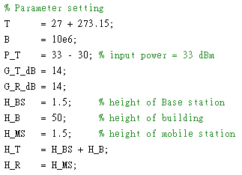

1. Functions
2. Number $↔$ dB

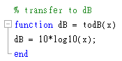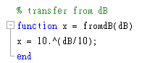

1. Two-ray-ground model

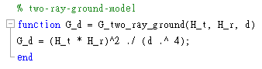

1. Thermal Noise

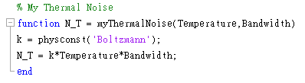

1. SINR

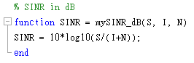

1. Modeling
2. only path loss : two-ray-ground model

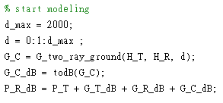

1. adding log-normal shadowing

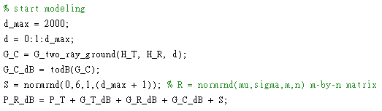

Ⅱ.Questions

1. *Consider the* ***path loss*** *only radio propagation (without shadowing and fading). Use Two-ray-ground model as the propagation model for your simulation.* 
   1. *Please plot a figure with the received power of the mobile device (in dB) as the y-axis and the distance (in meter) between the BS and the mobile device as the x-axis.*
   2. *According to 1-1, please plot a figure with* ***SINR*** *of the mobile device (in dB) as the y-axis and the distance between the BS and the mobile device (in meter) as the x-axis.*

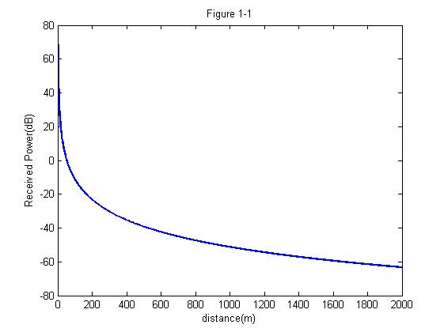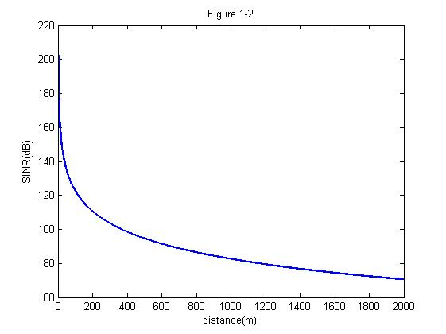

1. *Consider both the* ***path loss*** *and* ***shadowing*** *(without fading). Apply log-normal shadowing to model the shadowing effect. The path loss model should be the same as 1-1.*
   1. *Please plot a figure with the received power of the mobile device (in dB) as the y-axis and the distance (in meter) between the BS and the mobile device as the x-axis.*
   2. *According to 2-1, please plot a figure with* ***SINR*** *of the mobile device (in dB) as the y-axis and the distance between the BS and the mobile device (in meter) as the x-axis.*

