**Computer Vision HW3 Report**

B05901182 電機三 潘彥銘

**Part1:**

1. solve_homography(u, v):

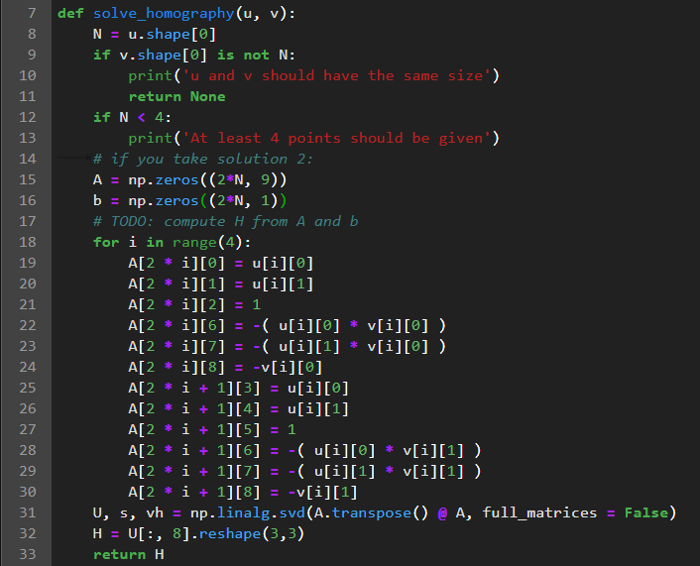

1. Answer:



**Part2:**

1. Answer:

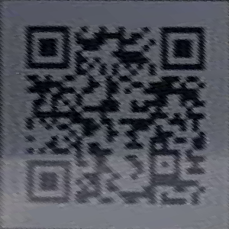

1. Decoded link:

<http://media.ee.ntu.edu.tw/courses/cv/18F/>

**Part3:**

1. Question: Can you get the parallel bars from the top view?
2. Answer: No, I can’t. Because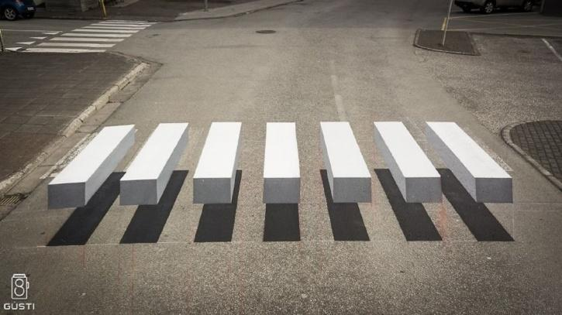 the red line in Fig.1 is not a straight line(like yellow line).

Fig.1

So if we use the four black corners in Fig.1 to do homography, we will get Fig.2 below, whose white bars is unparalleled.

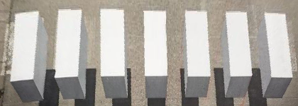Fig.2