Realtime Support Platform
Step-by-Step Developer Build Guide
Admin-controlled client screens • sessions • WebSockets • audit trail • secure integrations
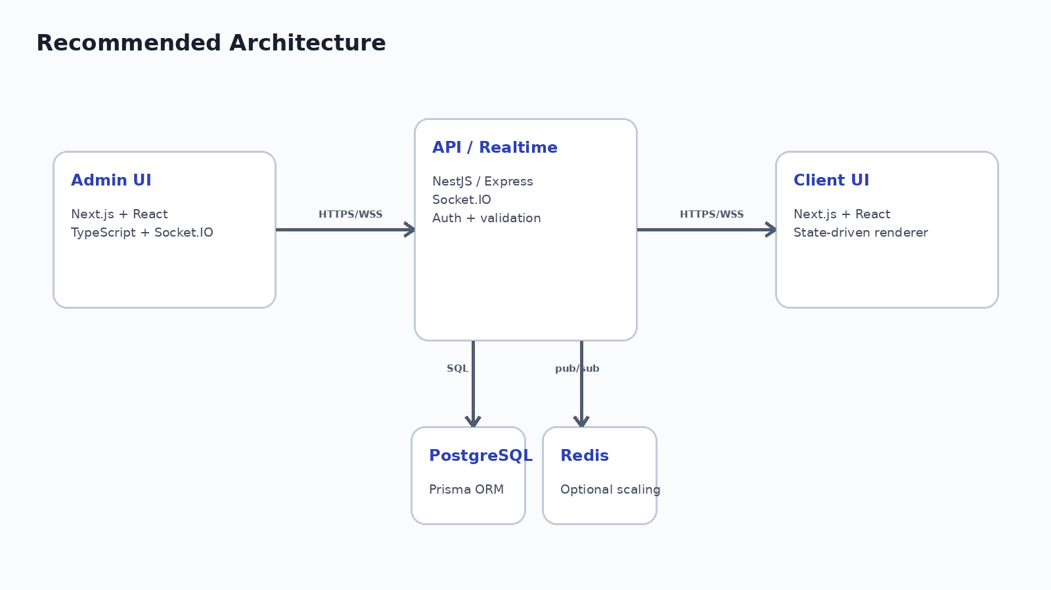

Prepared as a build-ready engineering blueprint

PROJECT BLUEPRINT

What you are building
A two-sided web application in which an authorized operator manages active support sessions and can move a client through approved, non-sensitive screens in real time. The backend owns the session state, validates every transition, records an audit trail, and broadcasts updates over WebSockets.
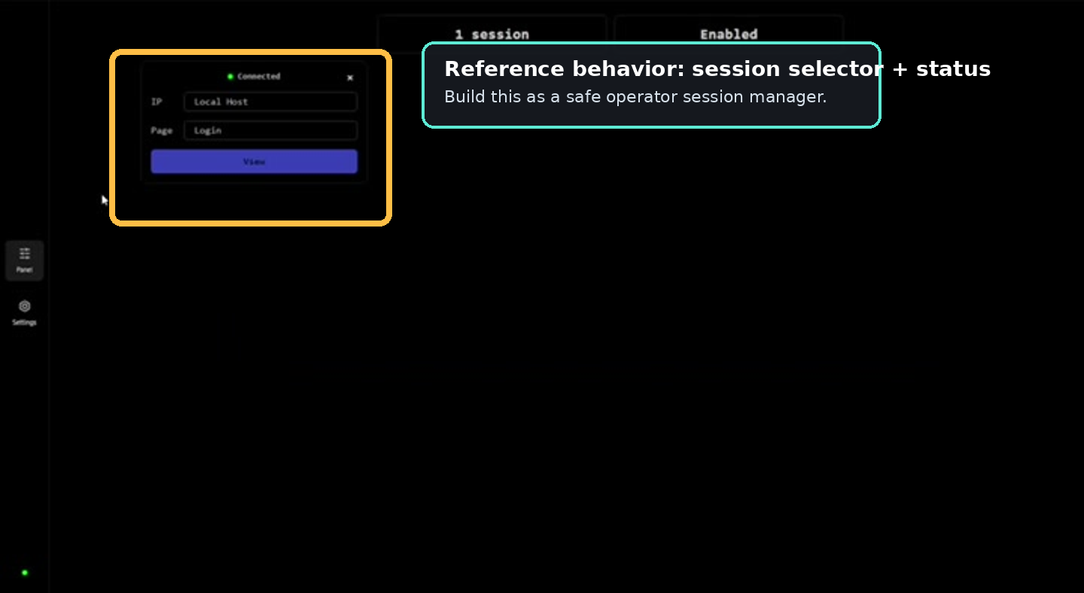
Reference from the supplied video: a compact session selector/status view. The guide reproduces this interaction pattern using safe support screens.
Core behaviors to reproduce:
- Create and identify a client session.
- Show connection status and the current screen to the operator.
- Let an authorized operator preview and send an approved screen state.
- Update the client browser immediately through Socket.IO.
- Record session events so the operator can see what happened and when.
- Support multiple concurrent sessions using Socket.IO rooms.
- Use safe account integrations instead of collecting authentication secrets.
Recommended stack: Next.js + TypeScript for both web apps, NestJS for the API, Socket.IO for realtime events, PostgreSQL + Prisma for persistence, Docker for local infrastructure, and Redis only when you need horizontal scaling.

Guide map
1. Define scope and states | 8. Add activity events and notifications
2. Create the monorepo | 9. Add operator authentication and RBAC
3. Start PostgreSQL + Prisma | 10. Replace sensitive login flows with OAuth
4. Build session APIs | 11. Test the system end-to-end
5. Add Socket.IO rooms | 12. Dockerize and deploy
6. Build the admin console | 13. Production hardening and milestones
7. Build the client renderer | 14. Final build checklist

Step 1 - Define the safe screen state machine
OUTCOME | You have a fixed list of approved client screens and explicit transition rules before building UI.

Target admin experience: session details on the left, approved screen actions on the right.
Treat the client page as a state machine, not as a collection of unrelated routes. The backend is the source of truth for the current state.
Files you will touch: packages/types/src/session.ts, apps/api/src/sessions/screen-state.ts
Shared TypeScript model
export type ClientScreen =
| "WELCOME"
| "CASE_CODE"
| "ACCOUNT_REVIEW"
| "WAITING"
| "SUCCESS";
export type SessionStatus =
| "ACTIVE"
| "CLOSED"
| "EXPIRED";

Use only non-sensitive fields. A case/support code may identify a support ticket, but it must not be an authentication code.

Definition of done
A developer can read one enum/type file and know every client state that the platform is allowed to display.

Step 2 - Create the monorepo
OUTCOME | Three runnable applications and shared packages exist with one package manager workspace.

Files you will touch: apps/admin, apps/client, apps/api, packages/types, packages/ui
Bootstrap commands
mkdir realtime-support-platform
cd realtime-support-platform
pnpm init
mkdir -p apps packages
pnpm create next-app apps/admin --ts --tailwind --eslint --app
pnpm create next-app apps/client --ts --tailwind --eslint --app
pnpm dlx @nestjs/cli new apps/api --package-manager pnpm
mkdir -p packages/types/src packages/ui/src

pnpm-workspace.yaml
packages:
- "apps/*"
- "packages/*"

Suggested repository structure:
realtime-support-platform/
├─ apps/
│ ├─ admin/ # operator console
│ ├─ client/ # customer/support session UI
│ └─ api/ # REST + Socket.IO + auth
├─ packages/
│ ├─ types/ # shared event and DTO types
│ └─ ui/ # optional shared components
├─ docker-compose.yml
└─ pnpm-workspace.yaml

Definition of done
`pnpm install` succeeds, and admin, client, and API can each start locally.

Step 3 - Start PostgreSQL and Prisma
OUTCOME | Sessions and events persist across browser refreshes and API restarts.

Files you will touch: docker-compose.yml, apps/api/prisma/schema.prisma, apps/api/.env
docker-compose.yml
services:
postgres:
image: postgres:16
environment:
POSTGRES_USER: support
POSTGRES_PASSWORD: localdev
POSTGRES_DB: support_platform
ports:
- "5432:5432"
volumes:
- pgdata:/var/lib/postgresql/data
volumes:
pgdata:

Prisma model
model Session {
id String @id @default(cuid())
status SessionStatus @default(ACTIVE)
currentScreen ClientScreen @default(WELCOME)
createdAt DateTime @default(now())
updatedAt DateTime @updatedAt
events SessionEvent[]
}
model SessionEvent {
id String @id @default(cuid())
sessionId String
type String
payload Json?
createdAt DateTime @default(now())
session Session @relation(fields: [sessionId], references: [id], onDelete: Cascade)
}

Initialize database
cd apps/api
pnpm add @prisma/client
pnpm add -D prisma
pnpm prisma migrate dev --name init

Definition of done
Create a session, restart the API, and confirm the same session and event history still exist.

Step 4 - Build the REST session API
OUTCOME | The admin UI can create, list, inspect, update, and close sessions through authenticated endpoints.

Files you will touch: apps/api/src/sessions/sessions.controller.ts, apps/api/src/sessions/sessions.service.ts, apps/api/src/sessions/dto
Minimal API surface
POST /api/sessions
GET /api/sessions
GET /api/sessions/:id
POST /api/sessions/:id/screen
GET /api/sessions/:id/events
POST /api/sessions/:id/close

Screen-change request
// POST /sessions/:id/screen
{
"screen": "ACCOUNT_REVIEW"
}

The service should perform the update and event insertion inside a database transaction so the visible state and audit log cannot drift apart.
Atomic state + event write
await prisma.$transaction(async (tx) => {
await tx.session.update({
where: { id: sessionId },
data: { currentScreen: screen },
});
await tx.sessionEvent.create({
data: {
sessionId,
type: "SCREEN_CHANGED",
payload: { screen },
},
});
});

Definition of done
Calling the screen endpoint changes `currentScreen` and appends exactly one `SCREEN_CHANGED` event.

Step 5 - Add Socket.IO session rooms
OUTCOME | The client updates immediately without polling when the operator changes screen state.

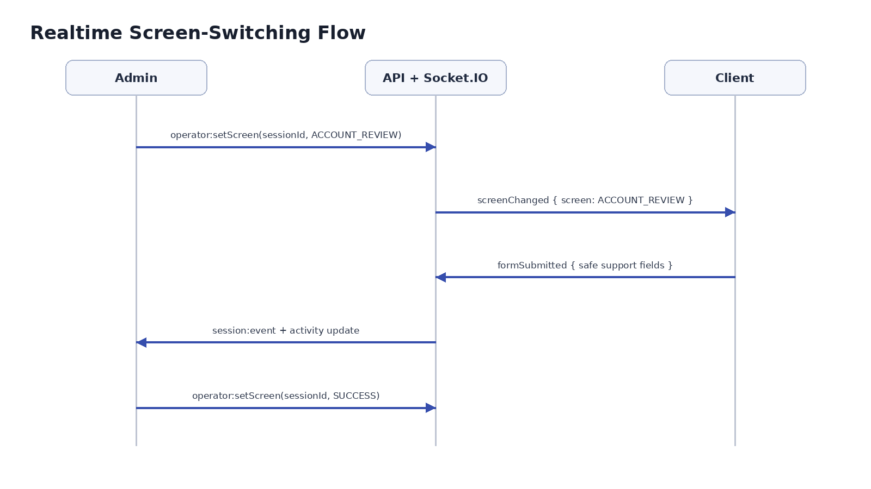
Recommended realtime event sequence. REST can own durable mutations; Socket.IO broadcasts the resulting state.
Files you will touch: apps/api/src/realtime/realtime.gateway.ts, apps/client/src/lib/socket.ts, apps/admin/src/lib/socket.ts
Server broadcast
// when a browser joins a session
socket.join(`session:${sessionId}`);
// after the server commits a screen change
io.to(`session:${sessionId}`).emit("screenChanged", {
screen: "ACCOUNT_REVIEW"
});

Client listener
socket.on("screenChanged", ({ screen }) => {
setCurrentScreen(screen);
});

Do not allow an arbitrary browser to join a room by guessing a session ID. Issue a short-lived signed session token and verify it during the WebSocket handshake.
Definition of done
Open admin and client in separate browsers. Changing the screen in admin updates only the intended session in under one second.

Step 6 - Build the admin console
OUTCOME | An operator can select a session, see its status, preview safe screens, and push a screen change.

Files you will touch: apps/admin/app/sessions/page.tsx, apps/admin/components/session-list.tsx, apps/admin/components/screen-actions.tsx, apps/admin/components/activity-timeline.tsx
Build the admin page in three logical areas:
- Session selector: connected/active sessions, short ID, status, and last activity.
- Session detail: device metadata that is necessary for support, current screen, timestamps, and assignment.
- Screen actions: Preview and Send buttons for the approved screen list plus an activity timeline.
Admin screen registry
const SAFE_SCREENS = [
{ id: "WELCOME", label: "Welcome" },
{ id: "CASE_CODE", label: "Case code" },
{ id: "ACCOUNT_REVIEW", label: "Account review" },
{ id: "WAITING", label: "Waiting" },
{ id: "SUCCESS", label: "Success" },
] as const;

Preview should render the screen inside the admin app without changing the client. Send should call the authenticated API, which persists the new state and then broadcasts it.
Definition of done
Preview never affects the client. Send changes the database, records an event, and updates the client.

Step 7 - Build the client renderer
OUTCOME | The client has one session shell that renders a safe component from the server-owned current screen.

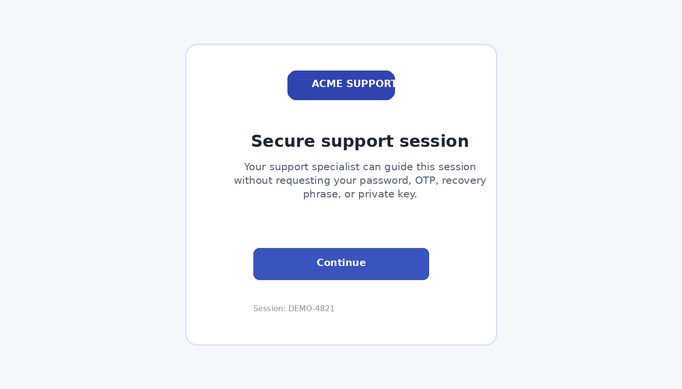
Example safe client screen. The UI explicitly tells users not to provide authentication secrets.
Files you will touch: apps/client/app/session/[id]/page.tsx, apps/client/components/screens/*, packages/types/src/session.ts
State-driven renderer
function SessionScreen({ screen }: { screen: ClientScreen }) {
switch (screen) {
case "WELCOME":
return <WelcomeScreen />;
case "CASE_CODE":
return <CaseCodeScreen />;
case "ACCOUNT_REVIEW":
return <AccountReviewScreen />;
case "WAITING":
return <WaitingScreen />;
case "SUCCESS":
return <SuccessScreen />;
}
}

On first load, fetch the authoritative session state from the API. Then connect to Socket.IO. This protects against missing an event during a refresh or temporary disconnect.
Client startup order
1. GET /api/public/sessions/:id/state
2. render currentScreen
3. connect WebSocket using signed session token
4. join session room
5. apply subsequent screenChanged events

Definition of done
Refreshing the client page returns to the correct current screen even if no new Socket.IO event is sent.

Step 8 - Add safe forms, events, and notifications
OUTCOME | The operator receives structured support data and a clear chronological timeline without storing secrets.

Files you will touch: apps/api/src/events, apps/admin/components/activity-timeline.tsx, apps/client/components/forms
Accept only fields required for the support workflow, such as case ID, issue category, error message, selected product/account, device type, and explicit consent.
Safe example payload
socket.emit("formSubmitted", {
sessionId,
form: "ACCOUNT_REVIEW",
values: {
issueCategory: "payment_error",
errorMessage: "Transfer failed",
},
});

Event types worth recording:
- SESSION_CREATED
- CLIENT_CONNECTED
- CLIENT_DISCONNECTED
- SCREEN_CHANGED
- FORM_SUBMITTED
- SESSION_ASSIGNED
- SESSION_CLOSED

Definition of done
The admin timeline shows timestamps and safe summaries; inspecting server logs reveals no authentication secrets.

Step 9 - Add operator authentication and RBAC
OUTCOME | Only authorized staff can view or control sessions, and every action is attributable to an operator.

Files you will touch: apps/api/src/auth, apps/api/src/guards, apps/admin/middleware.ts
Role model
enum OperatorRole {
ADMIN
SUPPORT_AGENT
VIEWER
}
// ADMIN: manage operators + all sessions
// SUPPORT_AGENT: control assigned sessions
// VIEWER: read-only

Recommended controls: HttpOnly Secure cookies for browser sessions, short expiry, CSRF protection where applicable, password hashing with Argon2/bcrypt, rate limiting, lockout/backoff, MFA for operators, and server-side authorization on every mutating endpoint.
Do not rely on hiding buttons in the frontend. The API must reject actions from users who lack permission.
Definition of done
A VIEWER cannot call the screen-change endpoint even by sending a crafted HTTP request manually.

Step 10 - Use OAuth and official wallet connections
OUTCOME | Real account authorization happens on the provider/wallet side; your application never receives passwords or recovery phrases.

For Google or similar services, use OAuth 2.0 / OpenID Connect:
Client -> "Continue with Provider"
-> provider authorization page
-> authorization code callback
-> backend exchanges code securely
-> store only required token material, encrypted
-> use provider API within granted scopes

For cryptocurrency wallets, use a standard connection/signature flow such as WalletConnect or the wallet provider's official SDK. A wallet may expose a public address and ask the user to approve/sign; your UI must never request the seed phrase or private key.

Definition of done
Account authorization can be completed without the application ever rendering an input for the provider password, OTP, private key, or recovery phrase.

Step 11 - Test the system end-to-end
OUTCOME | Automated and manual tests cover authorization, state transitions, reconnects, isolation, and failure recovery.

Minimum test matrix:
Test | Expected result | Priority
Create session | DB row + SESSION_CREATED event | P0
Send screen | DB updated + event + one client broadcast | P0
Refresh client | Restores authoritative current screen | P0
Two sessions | Events never cross rooms | P0
Unauthorized change | API returns 401/403 | P0
Socket reconnect | State is resynchronized | P1
API restart | Persisted sessions remain usable | P1
Invalid state | Validation rejects unknown screen | P1
Use Playwright for browser-level tests, Jest/Vitest for unit tests, and Supertest for API integration tests. Add a Socket.IO integration test that creates two rooms and proves isolation.
Definition of done
All P0 tests pass locally and in CI before deployment.

Step 12 - Dockerize and deploy
OUTCOME | Admin, client, API, and PostgreSQL run behind HTTPS with environment-specific secrets and health checks.

Deployment options include Vercel for the Next.js apps plus a container host for the NestJS WebSocket server, or one container platform for all services. Make sure your chosen host supports long-lived WebSocket connections.
- Use HTTPS/WSS everywhere in production.
- Keep secrets in the deployment platform's secret manager, never in git.
- Run database migrations as a controlled deployment step.
- Add `/health` and `/ready` endpoints.
- Configure allowed origins explicitly for CORS and Socket.IO.
- Use structured logs and request correlation IDs.
- Add Redis adapter only when running multiple API instances.
# example production environment names
DATABASE_URL=...
SESSION_SIGNING_SECRET=...
ADMIN_APP_ORIGIN=https://admin.example.com
CLIENT_APP_ORIGIN=https://support.example.com
REDIS_URL=... # only when scaling

Definition of done
Production browsers connect with WSS, sessions survive API restarts, health checks are green, and an unauthorized origin cannot open a privileged connection.

Step 13 - Production hardening and milestones
OUTCOME | You have a realistic implementation sequence that reaches a working MVP early and layers security/scaling afterward.

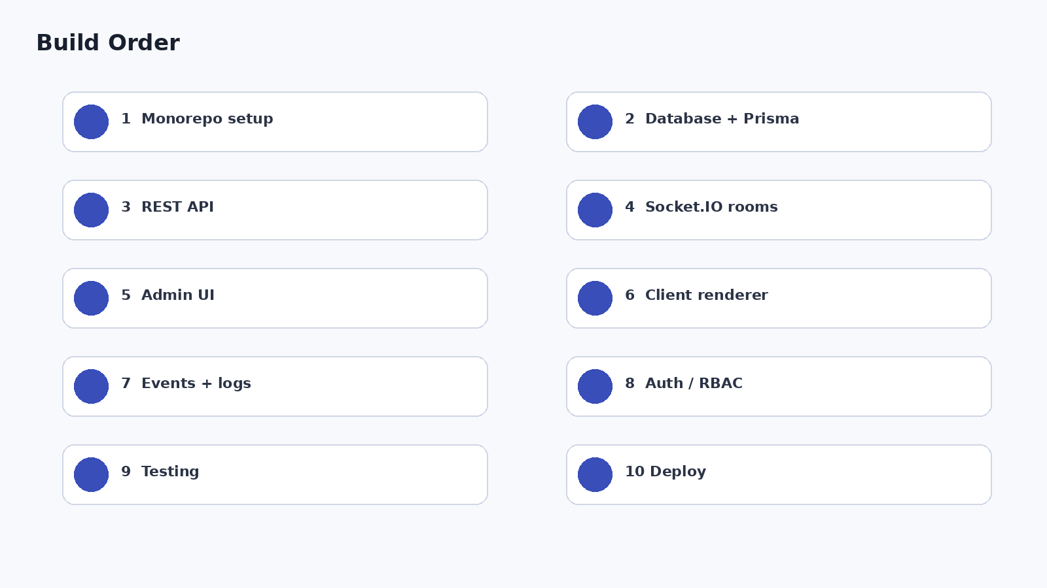

Suggested 10-day MVP plan
Day | Focus | Deliverable
1 | Repo + UX states | Three apps, shared types, safe screen list
2 | PostgreSQL + Prisma | Session/event schema + migrations
3 | REST API | Create/list/get/change/close session
4 | Socket.IO | Rooms, tokens, reconnect behavior
5 | Admin UI | Session list + detail + Send/Preview
6 | Client UI | State renderer + safe forms
7 | Timeline | Events + operator notifications
8 | Auth / RBAC | Admin login + permissions
9 | Tests | P0 end-to-end coverage
10 | Deploy | HTTPS/WSS + health checks + monitoring
After the MVP, add operator assignment, search/filtering, expiration rules, email notifications, metrics, Redis scaling, provider OAuth integrations, and richer audit reporting only as required.

Step 14 - Final build checklist
OUTCOME | You can verify the project is complete without relying on the original demo.

☐ Admin can sign in securely and sees only permitted sessions.
☐ Client receives a signed session URL/token and cannot access another session.
☐ Backend owns the authoritative current screen.
☐ Admin Preview is local-only; Send persists and broadcasts.
☐ Client reconnect/refetch restores the correct current screen.
☐ Every meaningful session action is written to an audit event.
☐ No password, OTP, recovery phrase, private key, or other authentication secret is requested or stored.
☐ OAuth/OpenID Connect is used for supported third-party account authorization.
☐ Official wallet connection/signature flow is used for wallet integrations.
☐ Multiple concurrent Socket.IO rooms are isolated.
☐ RBAC is enforced by the server, not only the UI.
☐ P0 tests run in CI.
☐ Production uses HTTPS/WSS, secrets management, rate limits, monitoring, and health checks.

Recommended first coding session
- Create the monorepo and the shared `ClientScreen` type.
- Start PostgreSQL with Docker and create the Session + SessionEvent models.
- Implement `POST /sessions` and `POST /sessions/:id/screen`.
- Add one Socket.IO room per session.
- Create only two screens first: WELCOME and SUCCESS.
- Build one admin Send button and prove the client changes in real time.
- Only after that works, add the remaining safe screens, activity timeline, auth, and tests.
Best milestone
Do not begin by reproducing every visual screen from the video. First prove this path: Admin clicks WELCOME/SUCCESS -> API persists state -> Socket.IO broadcasts -> client changes instantly -> event appears in the timeline. Once that loop is reliable, the rest is straightforward product work.

Appendix - Event contract
// server -> client
type ScreenChangedEvent = {
sessionId: string;
screen: ClientScreen;
version: number;
occurredAt: string;
};
// client -> server
type SafeFormSubmittedEvent = {
sessionId: string;
form: "CASE_CODE" | "ACCOUNT_REVIEW";
values: Record<string, string | boolean>;
};
// server -> admin
type SessionActivityEvent = {
sessionId: string;
type: string;
summary: string;
occurredAt: string;
};

Including a monotonically increasing `version` in state changes makes reconnect handling easier: the client can ignore an old event and refetch if it detects a gap.

