## ZPL相关程序（界面上没有的信息是从数据库抓出来的）

仓库发料：发料标签

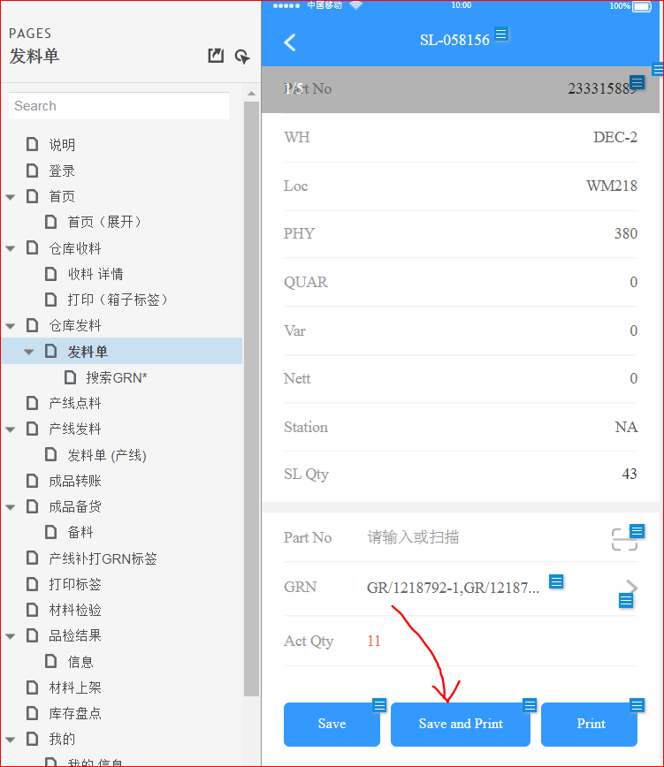

sb.Append("! 0 340 400 70 1\r\n");

sb.Append("IN-MILLIMETERS\r\n");

sb.Append("IN-DOTS\r\n");

sb.Append("T 5 0 30 10 TTEIMS ISSUE LABEL\r\n");

sb.Append("T 5 0 30 48 PN: " + pn + "\r\n");

sb.Append("T 5 0 30 86 GRN: " + grn + "\r\n");

sb.Append("B 128 1 1 48 30 122 " + grn + "\r\n");

sb.Append("T 5 0 30 182 QTY: " + qty + "\r\n");

sb.Append("T 5 0 30 212 DC: " + dc + "\r\n");

sb.Append("T 5 0 30 242 MSL: " + msl + "\r\n");

sb.Append("T 5 0 30 278 MPN: " + mpn + "\r\n");

sb.Append("T 5 0 30 308 Pick Date: " + DateTime.Now.ToString("yyyy-MMM-dd") + "\r\n");

sb.Append("T 5 0 30 338 SL No.: " + _currslno + "\r\n");

sb.Append("B QR 50 370 M 2 U 3\r\n");

sb.Append("MA," + grn + "\r\n");

sb.Append("ENDQR\r\n");

sb.Append("PRINT\r\n");

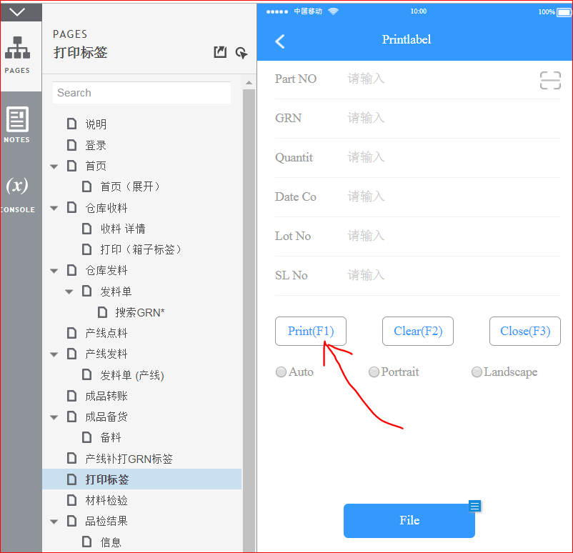标签打印：  
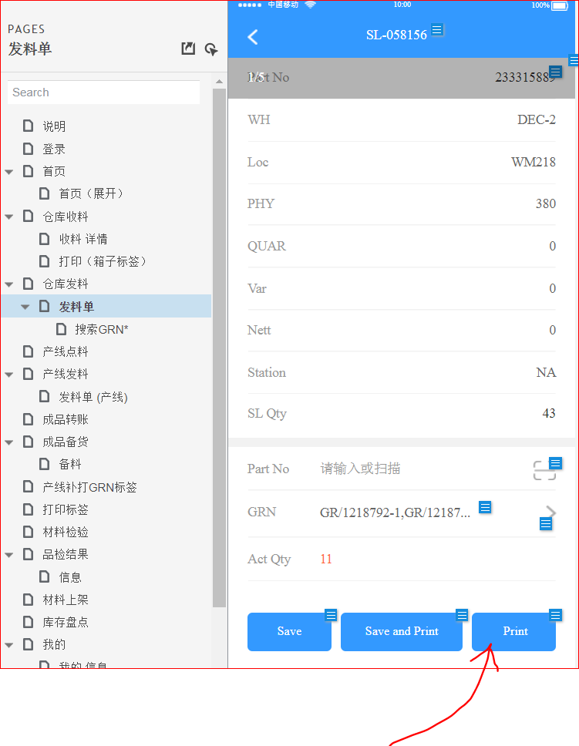

if (edtSLNo.Text.Length > 0)

if(grn.Length > 0)

sb.Append("! 0 200 200 72 1\r\n");

else

sb.Append("! 0 200 200 62 1\r\n");

else

sb.Append("! 0 200 200 56 1\r\n");

sb.Append("IN-MILLIMETERS\r\n");

sb.Append("IN-DOTS\r\n");

if (edtSLNo.Text.Length > 0)

sb.Append("T 5 0 30 10 ISSUE LABEL\r\n");

else

sb.Append("T 5 0 30 10 PART LABEL\r\n");

sb.Append("T 5 0 30 48 PN: " + pn + "\r\n");

sb.Append("B 128 1 1 48 30 82 " + pn + "\r\n");

sb.Append("T 5 0 30 142 GRN: " + grn + "\r\n");

sb.Append("B 128 1 1 48 30 172 " + grn + "\r\n");

sb.Append("T 5 0 30 232 QTY: " + qty + "\r\n");

sb.Append("T 5 0 30 268 DC: " + (dc.Length == 0 ? edtDateCode.Text : dc) + "\r\n");

sb.Append("T 5 0 30 302 MSL: " + msl + "\r\n");

sb.Append("T 5 0 30 338 MPN: " + mpn + "\r\n");

sb.Append("T 5 0 30 368 Date: " + DateTime.Now.ToString("yyyy-MMM-dd") + "\r\n");

if (edtSLNo.Text.Length > 0)

{

sb.Append("T 5 0 30 398 SL No: " + edtSLNo.Text + "\r\n");

if (grn.Length > 0)

{

sb.Append("B QR 50 430 M 2 U 3\r\n");

sb.Append("MA," + grn + "\r\n");

sb.Append("ENDQR\r\n");

}

}

sb.Append("PRINT\r\n");

重打标签：

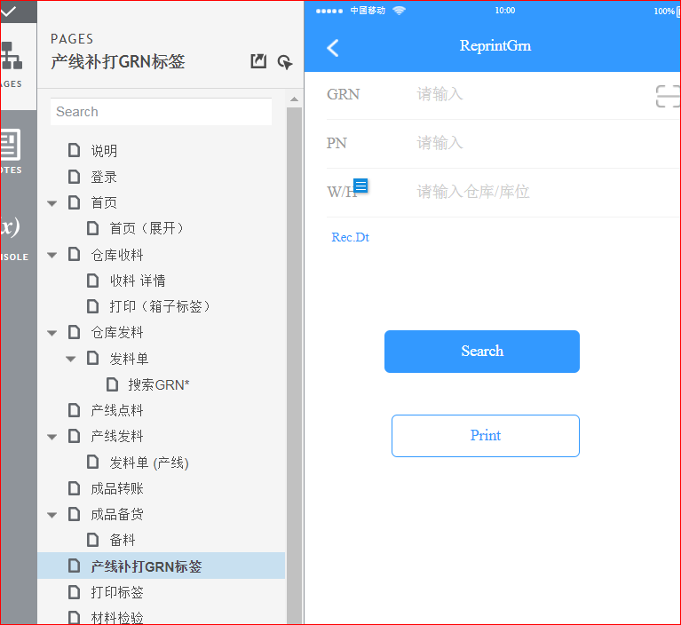

sb.Append("! 0 200 200 70 1\r\n");

sb.Append("IN-MILLIMETERS\r\n");

sb.Append("IN-DOTS\r\n");

sb.Append("T 5 0 10 10 TTIMS MES GRN Reprinted\r\n");

sb.Append("T 5 0 10 48 PN: " + pn + "\r\n");

sb.Append("B 128 1 1 48 16 88 " + pn + "\r\n");

sb.Append("T 5 0 10 150 GRN: " + grn + "\r\n");

sb.Append("B 128 1 1 48 16 190 " + grn + "\r\n");

sb.Append("T 5 0 10 254 WH: " + wh + "\r\n");

sb.Append("T 5 0 10 304 Loc.: " + loc + "\r\n");

sb.Append("T 5 0 10 354 Pick Date: " + DateTime.Now.ToString("yyyy-MMM-dd") + "\r\n");

sb.Append("B QR 100 404 M 2 U 3\r\n");

sb.Append("MA," + pn + "@" + grn + "@" + wh + "@" + loc + "\r\n");

sb.Append("ENDQR\r\n");

sb.Append("PRINT\r\n");