收料程序

1.栏位说明

Part/CN ：料号（应该是Part） 对应数据库partid

PO：订单号 对应数据库orderid

Supp:供应商 对应数据库traderid

BL：箱号 对应数据库H_BL_NO

Lin：订单编号 对应数据库itemnumber

LineState： 对应数据库linestatus

IsFrozen： 对应数据库isfrozen

OpenQty： 对应数据库orderqty

2.功能描述

仓库收到货后需要打印收料标签

3.主用户界面

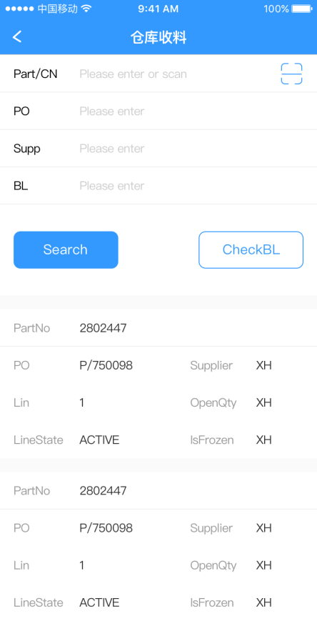

3.人机交互逻辑——点击Search按钮：

输入Part或者PO或者Supp或者BL，作为查询条件，点击Search按钮查询需收料清单

API调用地址:   
 /WarehouseManage/GetGRPoItems?PO=PO&Part=Part&Supplier=Supplier&BL=BL

{"code":0,"data":[{"selected":false,"traderid":"DGKC01","orderid":"P/766343","itemnumber":3,"partid":"0000002","linestatus":"ACTIVE","traderpartreference":"","responsibility":"JennyWang","prodgroup":"ELMNTTRA","orderqty":15.0,"uom":"EA","unitprice":8.40,"remainingqty":15.0,"demandqty":null,"moq":null,"mpq":null,"defaultwarehouseid":"DEC-2","defaultlocationid":"2","isfrozen":0,"qcflag":"YES","status":"QUARANTINE","H_BL_NO":"451249302216","manuf":"MOLEX","mpn":"0901301114","avl_status":"AVL","receivableqty":15.0,"receiveqty":"","bor":"","expiringdate":"","datecode":"","lotnumber":""}],"msg":"Successfully!"}

4.人机交互逻辑——点击CheckBL按钮,如果有差异，需将差异数据显示出来。

输入BL作为判断条件

API调用地址：

/WarehouseManage/CheckBL?BL=BL

如果Code返回0则，显示弹窗（这个窗体只用来显示数据，无其他操作），把data 显示出来

{"code":0,"data":[{"QUANTITY":540.0,"REC_QTY":0.0,"PART_ID":"301023001","PO":"P/699960","H_BL_NO":"451249302216","WH_STATUS":"","INNER_NO":"I2018072439"},{"QUANTITY":810.0,"REC_QTY":0.0,"PART_ID":"PP000207","PO":"P/708673","H_BL_NO":"451249302216","WH_STATUS":"","INNER_NO":"I2018072439"},{"QUANTITY":100.0,"REC_QTY":0.0,"PART_ID":"DEC376862","PO":"P/712681","H_BL_NO":"451249302216","WH_STATUS":"","INNER_NO":"I2018072439"},{"QUANTITY":100.0,"REC_QTY":0.0,"PART_ID":"222205657223","PO":"P/720734","H_BL_NO":"451249302216","WH_STATUS":"","INNER_NO":"I2018072439"},{"QUANTITY":1000.0,"REC_QTY":0.0,"PART_ID":"451369305003","PO":"P/727063","H_BL_NO":"451249302216","WH_STATUS":"","INNER_NO":"I2018072439"},{"QUANTITY":180.0,"REC_QTY":0.0,"PART_ID":"107708","PO":"P/729200","H_BL_NO":"451249302216","WH_STATUS":"","INNER_NO":"I2018072439"},{"QUANTITY":27.0,"REC_QTY":0.0,"PART_ID":"107723","PO":"P/736619","H_BL_NO":"451249302216","WH_STATUS":"","INNER_NO":"I2018072439"},{"QUANTITY":1000.0,"REC_QTY":0.0,"PART_ID":"TT0407000002S","PO":"P/736635","H_BL_NO":"451249302216","WH_STATUS":"","INNER_NO":"I2018072439"},{"QUANTITY":3000.0,"REC_QTY":0.0,"PART_ID":"ST3320-0101","PO":"P/738386","H_BL_NO":"451249302216","WH_STATUS":"","INNER_NO":"I2018072439"},{"QUANTITY":300.0,"REC_QTY":0.0,"PART_ID":"DEC370493","PO":"P/738422","H_BL_NO":"451249302216","WH_STATUS":"","INNER_NO":"I2018072439"},{"QUANTITY":65.0,"REC_QTY":0.0,"PART_ID":"107708","PO":"P/738451","H_BL_NO":"451249302216","WH_STATUS":"","INNER_NO":"I2018072439"},{"QUANTITY":200.0,"REC_QTY":0.0,"PART_ID":"PP000009","PO":"P/739996","H_BL_NO":"451249302216","WH_STATUS":"","INNER_NO":"I2018072439"},{"QUANTITY":10.0,"REC_QTY":0.0,"PART_ID":"172-025-102-031","PO":"P/746540","H_BL_NO":"451249302216","WH_STATUS":"","INNER_NO":"I2018072439"},{"QUANTITY":27.0,"REC_QTY":0.0,"PART_ID":"1025234","PO":"P/748957","H_BL_NO":"451249302216","WH_STATUS":"","INNER_NO":"I2018072439"},{"QUANTITY":50.0,"REC_QTY":0.0,"PART_ID":"AD000104","PO":"P/750846","H_BL_NO":"451249302216","WH_STATUS":"","INNER_NO":"I2018072439"},{"QUANTITY":500.0,"REC_QTY":0.0,"PART_ID":"DEC377370","PO":"P/750951","H_BL_NO":"451249302216","WH_STATUS":"","INNER_NO":"I2018072439"},{"QUANTITY":135.0,"REC_QTY":0.0,"PART_ID":"107707","PO":"P/751029","H_BL_NO":"451249302216","WH_STATUS":"","INNER_NO":"I2018072439"},{"QUANTITY":160.0,"REC_QTY":0.0,"PART_ID":"PAA238C-1041","PO":"P/753387","H_BL_NO":"451249302216","WH_STATUS":"","INNER_NO":"I2018072439"},{"QUANTITY":47.0,"REC_QTY":0.0,"PART_ID":"LA000015","PO":"P/753452","H_BL_NO":"451249302216","WH_STATUS":"","INNER_NO":"I2018072439"},{"QUANTITY":31.0,"REC_QTY":0.0,"PART_ID":"021801.6P","PO":"P/758385","H_BL_NO":"451249302216","WH_STATUS":"","INNER_NO":"I2018072439"},{"QUANTITY":220.0,"REC_QTY":0.0,"PART_ID":"470001H10","PO":"P/761667","H_BL_NO":"451249302216","WH_STATUS":"","INNER_NO":"I2018072439"},{"QUANTITY":300.0,"REC_QTY":0.0,"PART_ID":"470016H06","PO":"P/761668","H_BL_NO":"451249302216","WH_STATUS":"","INNER_NO":"I2018072439"},{"QUANTITY":200.0,"REC_QTY":0.0,"PART_ID":"0881569","PO":"P/761691","H_BL_NO":"451249302216","WH_STATUS":"","INNER_NO":"I2018072439"},{"QUANTITY":25.0,"REC_QTY":0.0,"PART_ID":"AP16569","PO":"P/763572","H_BL_NO":"451249302216","WH_STATUS":"","INNER_NO":"I2018072439"},{"QUANTITY":250.0,"REC_QTY":0.0,"PART_ID":"AP16570","PO":"P/763573","H_BL_NO":"451249302216","WH_STATUS":"","INNER_NO":"I2018072439"},{"QUANTITY":25.0,"REC_QTY":0.0,"PART_ID":"AP18308","PO":"P/763574","H_BL_NO":"451249302216","WH_STATUS":"","INNER_NO":"I2018072439"},{"QUANTITY":24.0,"REC_QTY":0.0,"PART_ID":"021801.6P","PO":"P/765253","H_BL_NO":"451249302216","WH_STATUS":"","INNER_NO":"I2018072439"},{"QUANTITY":100.0,"REC_QTY":0.0,"PART_ID":"DEC379084","PO":"P/765255","H_BL_NO":"451249302216","WH_STATUS":"","INNER_NO":"I2018072439"},{"QUANTITY":3.0,"REC_QTY":0.0,"PART_ID":"78-8998-7504-7","PO":"P/765258","H_BL_NO":"451249302216","WH_STATUS":"","INNER_NO":"I2018072439"},{"QUANTITY":15.0,"REC_QTY":0.0,"PART_ID":"0000002","PO":"P/766343","H_BL_NO":"451249302216","WH_STATUS":"","INNER_NO":"I2018072439"},{"QUANTITY":12.0,"REC_QTY":0.0,"PART_ID":"0000003","PO":"P/766343","H_BL_NO":"451249302216","WH_STATUS":"","INNER_NO":"I2018072439"},{"QUANTITY":100.0,"REC_QTY":0.0,"PART_ID":"0000004","PO":"P/766343","H_BL_NO":"451249302216","WH_STATUS":"","INNER_NO":"I2018072439"},{"QUANTITY":100.0,"REC_QTY":0.0,"PART_ID":"0000006","PO":"P/766343","H_BL_NO":"451249302216","WH_STATUS":"","INNER_NO":"I2018072439"},{"QUANTITY":100.0,"REC_QTY":0.0,"PART_ID":"0000007","PO":"P/766343","H_BL_NO":"451249302216","WH_STATUS":"","INNER_NO":"I2018072439"},{"QUANTITY":40.0,"REC_QTY":0.0,"PART_ID":"0000008","PO":"P/766343","H_BL_NO":"451249302216","WH_STATUS":"","INNER_NO":"I2018072439"},{"QUANTITY":100.0,"REC_QTY":0.0,"PART_ID":"0000012","PO":"P/766343","H_BL_NO":"451249302216","WH_STATUS":"","INNER_NO":"I2018072439"},{"QUANTITY":50.0,"REC_QTY":0.0,"PART_ID":"0000014","PO":"P/766343","H_BL_NO":"451249302216","WH_STATUS":"","INNER_NO":"I2018072439"},{"QUANTITY":200.0,"REC_QTY":0.0,"PART_ID":"0000104","PO":"P/766343","H_BL_NO":"451249302216","WH_STATUS":"","INNER_NO":"I2018072439"},{"QUANTITY":30.0,"REC_QTY":0.0,"PART_ID":"0000109","PO":"P/766343","H_BL_NO":"451249302216","WH_STATUS":"","INNER_NO":"I2018072439"},{"QUANTITY":20.0,"REC_QTY":0.0,"PART_ID":"0000110","PO":"P/766343","H_BL_NO":"451249302216","WH_STATUS":"","INNER_NO":"I2018072439"},{"QUANTITY":200.0,"REC_QTY":0.0,"PART_ID":"0000112","PO":"P/766343","H_BL_NO":"451249302216","WH_STATUS":"","INNER_NO":"I2018072439"},{"QUANTITY":200.0,"REC_QTY":0.0,"PART_ID":"0000205","PO":"P/766343","H_BL_NO":"451249302216","WH_STATUS":"","INNER_NO":"I2018072439"},{"QUANTITY":200.0,"REC_QTY":0.0,"PART_ID":"0000206","PO":"P/766343","H_BL_NO":"451249302216","WH_STATUS":"","INNER_NO":"I2018072439"},{"QUANTITY":200.0,"REC_QTY":0.0,"PART_ID":"0000213","PO":"P/766343","H_BL_NO":"451249302216","WH_STATUS":"","INNER_NO":"I2018072439"},{"QUANTITY":100.0,"REC_QTY":0.0,"PART_ID":"0000401","PO":"P/766343","H_BL_NO":"451249302216","WH_STATUS":"","INNER_NO":"I2018072439"},{"QUANTITY":500.0,"REC_QTY":0.0,"PART_ID":"0000403","PO":"P/766343","H_BL_NO":"451249302216","WH_STATUS":"","INNER_NO":"I2018072439"},{"QUANTITY":250.0,"REC_QTY":0.0,"PART_ID":"0000405","PO":"P/766343","H_BL_NO":"451249302216","WH_STATUS":"","INNER_NO":"I2018072439"},{"QUANTITY":100.0,"REC_QTY":0.0,"PART_ID":"0000406","PO":"P/766343","H_BL_NO":"451249302216","WH_STATUS":"","INNER_NO":"I2018072439"},{"QUANTITY":229.0,"REC_QTY":0.0,"PART_ID":"451362413014","PO":"P/766343","H_BL_NO":"451249302216","WH_STATUS":"","INNER_NO":"I2018072439"},{"QUANTITY":318.0,"REC_QTY":0.0,"PART_ID":"451369325012","PO":"P/766343","H_BL_NO":"451249302216","WH_STATUS":"","INNER_NO":"I2018072439"},{"QUANTITY":60.0,"REC_QTY":0.0,"PART_ID":"LA000015","PO":"P/767076","H_BL_NO":"451249302216","WH_STATUS":"","INNER_NO":"I2018072439"},{"QUANTITY":15.0,"REC_QTY":0.0,"PART_ID":"2115237","PO":"P/767103","H_BL_NO":"451249302216","WH_STATUS":"","INNER_NO":"I2018072439"},{"QUANTITY":15.0,"REC_QTY":0.0,"PART_ID":"0000016","PO":"P/768560","H_BL_NO":"451249302216","WH_STATUS":"","INNER_NO":"I2018072439"},{"QUANTITY":50.0,"REC_QTY":0.0,"PART_ID":"0000402","PO":"P/768560","H_BL_NO":"451249302216","WH_STATUS":"","INNER_NO":"I2018072439"},{"QUANTITY":15.0,"REC_QTY":0.0,"PART_ID":"0000501","PO":"P/768560","H_BL_NO":"451249302216","WH_STATUS":"","INNER_NO":"I2018072439"},{"QUANTITY":200.0,"REC_QTY":0.0,"PART_ID":"0000203","PO":"P/768703","H_BL_NO":"451249302216","WH_STATUS":"","INNER_NO":"I2018072439"},{"QUANTITY":250.0,"REC_QTY":0.0,"PART_ID":"TT0610000014A","PO":"P/768769","H_BL_NO":"451249302216","WH_STATUS":"","INNER_NO":"I2018072439"},{"QUANTITY":648.0,"REC_QTY":0.0,"PART_ID":"CA20121","PO":"P/769232","H_BL_NO":"451249302216","WH_STATUS":"","INNER_NO":"I2018072439"},{"QUANTITY":200.0,"REC_QTY":0.0,"PART_ID":"0000102","PO":"P/770373","H_BL_NO":"451249302216","WH_STATUS":"","INNER_NO":"I2018072439"},{"QUANTITY":200.0,"REC_QTY":0.0,"PART_ID":"0000103","PO":"P/770373","H_BL_NO":"451249302216","WH_STATUS":"","INNER_NO":"I2018072439"},{"QUANTITY":200.0,"REC_QTY":0.0,"PART_ID":"0000113","PO":"P/770373","H_BL_NO":"451249302216","WH_STATUS":"","INNER_NO":"I2018072439"},{"QUANTITY":2.0,"REC_QTY":0.0,"PART_ID":"09974430","PO":"P/770534","H_BL_NO":"451249302216","WH_STATUS":"","INNER_NO":"I2018072439"},{"QUANTITY":45.0,"REC_QTY":0.0,"PART_ID":"E61000553","PO":"P/770560","H_BL_NO":"451249302216","WH_STATUS":"","INNER_NO":"I2018072439"},{"QUANTITY":1500.0,"REC_QTY":0.0,"PART_ID":"PAB208-410","PO":"P/771827","H_BL_NO":"451249302216","WH_STATUS":"","INNER_NO":"I2018072439"},{"QUANTITY":1000.0,"REC_QTY":0.0,"PART_ID":"220-00341","PO":"P/771843","H_BL_NO":"451249302216","WH_STATUS":"","INNER_NO":"I2018072439"},{"QUANTITY":3000.0,"REC_QTY":0.0,"PART_ID":"SN74LVC8T245RHLR","PO":"P/771848","H_BL_NO":"451249302216","WH_STATUS":"","INNER_NO":"I2018072439"},{"QUANTITY":1917.0,"REC_QTY":0.0,"PART_ID":"TPS76301DBVR","PO":"P/771850","H_BL_NO":"451249302216","WH_STATUS":"","INNER_NO":"I2018072439"}],"msg":"Successfully!"}

双击进入仓库收料页面（增加一个Status，数据库栏位就是Status）

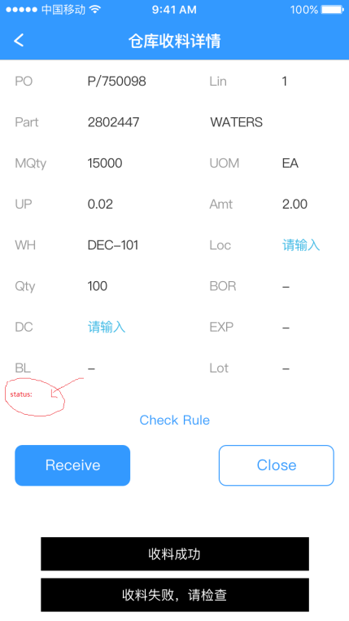

Part ：料号 对应数据库partid

Part后面一个栏位对应数据库prodgroup

PO：订单号 对应数据库orderid

BL：箱号 对应数据库H_BL_NO

Lin：订单编号 对应数据库itemnumber

MQTY： 对应数据库receivableqty

UOM： 对应数据库uom

UP： 对应数据库unitprice

Amt：输入的qty*UP 对应数据库

WH： 对应数据库defaultwarehouseid

Loc： 对应数据库defaultlocationid

Qty： 对应数据库receiveqty

BOR： 对应数据库bor

EXP： 对应数据库expiringdate

BL： 对应数据库H_BL_NO

Lot： 对应数据库lotnumber

Status： 对应数据库status

DC： 对应数据库datecode

初始化数据：  
2. 获取收料单信息，API调用地址：  
/WarehouseManage/GetGRPoItems?PO=PO&Part=Part&Supplier=Supplier&Itemnumber=Itemnumber

{"code":0,"data":[{"selected":false,"traderid":"DGKC01","orderid":"P/699960","itemnumber":1,"partid":"301023001","linestatus":"ACTIVE","traderpartreference":"","responsibility":"RainGu","prodgroup":"EDWREDG4","orderqty":660.0,"uom":"EA","unitprice":4.31,"remainingqty":660.0,"demandqty":null,"moq":null,"mpq":null,"defaultwarehouseid":"DEC-2","defaultlocationid":"XB105","isfrozen":0,"qcflag":"NO","status":"QUARANTINE","H_BL_NO":"451249302216","manuf":"ST","mpn":"MD2001FX","avl_status":"AVL","receivableqty":660.0,"receiveqty":"","bor":"","expiringdate":"","datecode":"","lotnumber":""}],"msg":"Successfully!"}

Top of Form



Bottom of Form

5.人机交互逻辑

1.焦点在loc的时候，扫描判断当前loc是否可用

/WarehouseManage/CheckLoc?WH=WH&LOC=LOC&Status=status

{"code":0,"data":{} ,"msg":"sucessful!"}  
返回结果：

Code返回0，代表是有效的

Code返回1，代表是无效的，并清空loc：

Code返回2，代表错误，并清空loc：

2.焦点离开qty的时候，判断输入的数量是否大于mqty

如果小于等于，则Amt等于qty*UP

如果大于，清空qty：

3.焦点在EXP的时候，判断EXP是不是时间格式

4.焦点在DC的时候，判断根据DC计算出来的有效期是否小于90条

/WarehouseManage/CheckDC?DC=DC&Supplier=Supplier&Part=Part&EXP=EXP&WH=WH

返回结果：  
code=3代表是小于90天的,给出一个提醒.但不影响下一步操作

{"code":3,"data":[{"overdue":"1","exp":"2018-10-11","error":""}],"msg":"The validity is less than 90 days,are you sure you want to receive it? 有效期小于90天，是否确定要进行收料"}

code=0对操作无影响

{"code":0,"data":[{"overdue":"0","exp":"","error":""}],"msg":"Successfully!"}

code=1代表是出现错误。需要清空DC：

code=2无效，无数据

5.人机交互逻辑—点击Receive

当loc或者qty或者DC没有数据的时候不能保存

点击Receive的时候保存数据

API调用地址：

/WarehouseManage/ReceiveStock?PN=Part&DateCode=DC&Traderid=Supplier&Orderid=PO& Itemnumber=Lin&WH=WH&LOC=Loc&Status=Status&Qty=Qty&Bor=Bor&Exp=EXP&User=User& Lot=lot&BL=BL

返回：

{"code":0,"data":[{"id":"8429d337-e624-4d12-9332-3c5fab1792b5","process":"1","error":null}],"msg":"Successfully!"}

code 0则显示保存成功，并得到id

code 1则显示保存失败

code 2则显示保存失败

Receive成功后询问是否跳转到打印页面

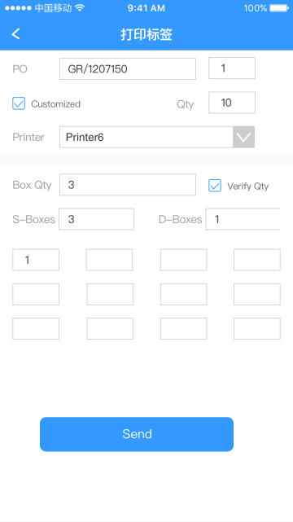

初始化数据：

API调用地址：

/WarehouseManage/GetPrintDetail?id=id

{"code":0,"data":[{"traderid":"test","seq":1,"orderid":"P/113456","itemnumber":1,"partid":"test111","defaultwarehouseid":"DEC-101","defaultlocationid":"SMT","status":"q","receiveqty":1.0,"bor":"","expiringdate":"2018-01-02","username":"","datecode":"20180101","lotnumber":"1","id":"8429d337-e624-4d12-9332-3c5fab1792b5","isused":1,"grn":"GR/1207151","blno":"11111"}],"msg":"Successfully!"}

栏位说明

PO：GRN 数据库栏位grn

PO: GRN_Line 后面一个栏位是默认1

Print：Print 打印机选项

QTY：receiveqty数据库栏位receiveqty

Customized: IsCustomized 数据库栏位IsCustomized

S-Boxes: SBoxes数据库栏位SBoxes

D-Boxes: DBoxes数据库栏位DBoxes

1. 人机交互逻辑—点击Send

点击Send的时候保存数据

API调用地址：

/WarehouseManage/PrintGRNLabel?GRN=GRN&GRN_Line=GRN_Line&IsCustomized=IsCustomized&BoxQty= BoxQty&SBoxes=SBoxes&DBoxes=DBoxes&Print=Print&&User=User

如果返回code是1则显示保存成功，并清空所有数据

{"code":0,"data":{},"msg":"Successfully!"}