系统登录

栏位解释：   
UserName: 用户名  
Password：密码

1. 功能描述：使用程序前需登录系统，登录成功后显示用户菜单
2. UI  
   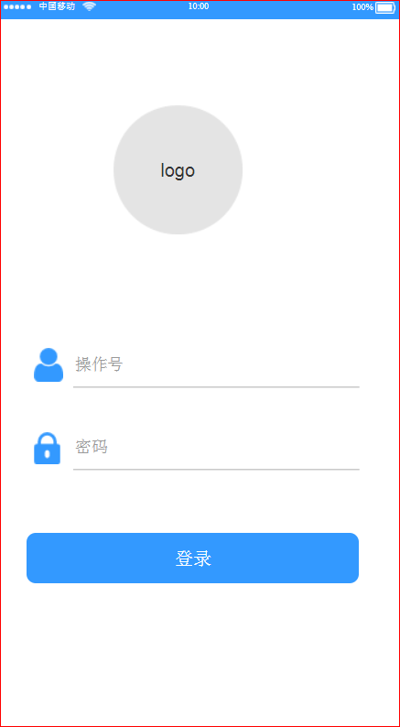
3. 人机交互逻辑——输入\扫描用户名，密码点击登录  
   登录调用API地址：  
   https://eportal.ttelectronicschina.com/TTSZ_WebService/Authorization/Login?username=mapp&password=123456  
   验证通过后返回"{\"code\":\"0\",\"data\":[{\"token\":\"RFR3V2ZRQzVQQVM3ZWFrMUcyY1JJL09XOSs2bGl4dVgvbkVYK0hnVFp4VT06bWFwcDo2MzY3Mzg2ODE2NTY1OTAwMDA=\",\"ExpirationMinutes\":\"240\"}],\"msg\":\"Successfully!\"}"  
   其中token动态生成，目前有效期为8小时
4. 获取用户菜单  
   Api:https://eportal.ttelectronicschina.com/TTSZ_WebService/Authorization/GetUserMenu?username=mapp  
   HttpRequest.Headers需增加token属性， token属性的值为登录成功返回的token字符串  
   返回信息：  
   {"code":"0","data":[{"id":"15E54021-10DD-4AEF-BA7B-B786DABEE1B3","text":"MoblieAppMenu","state":"open","checked":false,"iconCls":"","attributes":{"url":"","sort":0},"children":[{"id":"E2AB15D7-42C7-4E7F-A47B-4D0B120EA3D8","text":"原料库","state":"open","checked":false,"iconCls":"","attributes":{"url":"","sort":1},"children":[{"id":"8B44EBC8-BD1E-4C2B-9015-1C9543069582","text":"仓库收料","state":"open","checked":false,"iconCls":"","attributes":{"url":"","sort":1},"children":[]},{"id":"9AAC6D61-C02C-4D39-9D7F-8A342FF85C6A","text":"仓库发料","state":"open","checked":false,"iconCls":"","attributes":{"url":"","sort":2},"children":[]},{"id":"08FC751C-1084-4AE7-A534-ABAE323EEBAC","text":"材料检验","state":"open","checked":false,"iconCls":"","attributes":{"url":"","sort":3},"children":[]},{"id":"7C22F7B6-EDF3-4DB9-B0C5-E3AC6C722677","text":"品检结果","state":"open","checked":false,"iconCls":"","attributes":{"url":"","sort":4},"children":[]},{"id":"4194C86E-76E5-43E2-8D63-E0A79750146E","text":"材料上架","state":"open","checked":false,"iconCls":"","attributes":{"url":"","sort":5},"children":[]},{"id":"F9A0D5A6-86F1-4C9E-A9B1-8F98ADDC2A2F","text":"标签打印","state":"open","checked":false,"iconCls":"","attributes":{"url":"","sort":6},"children":[]},{"id":"3CF1FE49-7BED-43DF-9074-9CEC6929E24F","text":"库存盘点","state":"open","checked":false,"iconCls":"","attributes":{"url":"","sort":7},"children":[]}]},{"id":"486CE188-4D21-42F5-AA0F-5D02AAE684B1","text":"成品库","state":"open","checked":false,"iconCls":"","attributes":{"url":"","sort":2},"children":[{"id":"8F293EE5-72FD-45FF-88E5-A5EB591AA3FD","text":"成品转账","state":"open","checked":false,"iconCls":"","attributes":{"url":"","sort":1},"children":[]},{"id":"76345DFB-1498-40EA-BDCC-F09AF15F32AF","text":"成品备货","state":"open","checked":false,"iconCls":"","attributes":{"url":"","sort":2},"children":[]},{"id":"9B3426BF-D091-4755-9FCC-DE839FEE7C40","text":"库存盘点","state":"open","checked":false,"iconCls":"","attributes":{"url":"","sort":3},"children":[]}]},{"id":"B996D978-AC72-4531-9EEF-7626A1D94F0E","text":"制造部","state":"open","checked":false,"iconCls":"","attributes":{"url":"","sort":3},"children":[{"id":"943F8FFB-1AAF-4069-95F6-7306C308E6D8","text":"产线点料","state":"open","checked":false,"iconCls":"","attributes":{"url":"","sort":1},"children":[]},{"id":"C194283F-CD50-4242-9448-7ECA776A1ADA","text":"产线发料","state":"open","checked":false,"iconCls":"","attributes":{"url":"","sort":2},"children":[]},{"id":"12606495-B083-429F-91C1-1CE82E7F93EF","text":"补打标签","state":"open","checked":false,"iconCls":"","attributes":{"url":"","sort":3},"children":[]},{"id":"F4956E0D-01C0-4C56-B624-241032E0391C","text":"库存盘点","state":"open","checked":false,"iconCls":"","attributes":{"url":"","sort":4},"children":[]}]}]}],"msg":"Successfully!"}
5. 显示用户菜单
6. 访问API时如果返回代码为9001时，代表token已过期，需更新token数据  
   "{\"code\":\"9001\",\"data\":[{\"token\":\"R2FXelNLRzF6ejVRY09ncFpEdFFlZHhSeEoyNU80RjBYMUF4eDBMTENlQT06bWFwcDo2MzY3Mzg3Mjk4OTkwNDAwMDA=\"],\"msg\":\"The token is expired, please update it!\"}"
7. 获取用户信息  
   <https://eportal.ttelectronicschina.com/TTSZ_WebService/Authorization/GetUserInfo>  
   返回：  
   {"code":0,"data":{"UserID":"mapp","Name":"mapp","Department":"WAREHOUSE","Email":"Kevin.Li@ttelectronics.com"},"msg":"Successfully!"}
8. 退出登录  
   <https://eportal.ttelectronicschina.com/TTSZ_WebService/Authorization/Logoff>  
   返回：  
   {"code":"0","status":"offline","msg":"Successfully!"}

目前给你们的测试账号：用户名：mapp 密码：123456

产线点料（领料确认）业务逻辑

栏位解释：  
SL NO: 发料单号 （Shortage List Number）  
Part No：料号  
Toplevel: 成品料号   
GRN: 收料单号 （Goods receiving number）  
WO: 工单号码 （Work order）  
Station: 工位

1. 功能描述：仓库按照发料单发料完成后交接实物给产线人员，产生人员领料时按清单进行确认（仅对料号进行确认）
2. UI  
   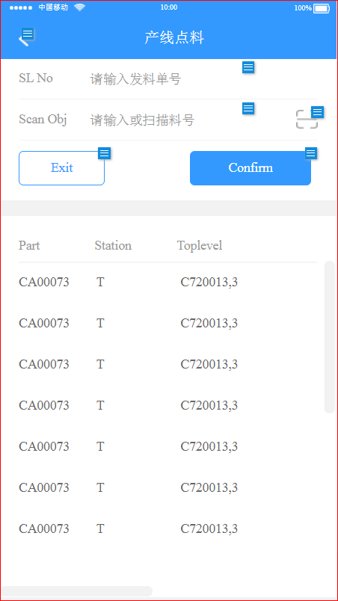  
   Grid Column:Part,Station,Toplevel,Checker,CheckStatus  
   Toplevel= Toplevel Part+ Rev
3. 人机交互逻辑——SL No输入框：  
   3.1 在SL No栏位输入发料单号，回车或点击查询按钮  
   3.2 查询调用地址：  
   https://eportal.ttelectronicschina.com/TTSZ_WebService/ProductionLineManage/getProdMatListBySl?slno=SLNo  
   3.3 返回Json字符串  
   {\"code\":0,\"data\":[{\"partid\":\"202001290934\",\"workstation\":\"PW\",\"toplevel\":\"45133903514,03\",\"checker\":\"\",\"chk_status\":\"\",\"sl_no\":\"SL-059808\"}],\"msg\":\"Successfully!\" ,\"itemnumber\":\"18\"}  
   3.4 将查询结果显示在表格中
4. 人机交互逻辑——Scan Obj输入框 （1D\2D barcode）：  
   4.1 扫描或输入  
   4.2 当Scan Obj文本开头三个字符是以“GR/”开头的，需根据GRN到数据库找出该GRN对应的料号并显示在Scan Obj文本框，同时查询列表里是否存在该料号，如果存在需高亮度显示，并将Scan Obj为全选状态方便扫描下一颗料  
   查询调用地址：  
   https://eportal.ttelectronicschina.com/TTSZ_WebService/ProductionLineManage/ GetPartNoByGRN?grn=GRN  
   返回Json字符串格式  
   {\"code\":0,\"data\":[{\"partid\":\"202001290934\"}],\"msg\":\"Successfully!\"}  
   4.3 当Scan Obj文本内容中包含多个“@”符号,程序将字符串按@字符拆分后抓第1个字符串显示在Scan Obj文本框，同时查询列表里是否存在该料号，如果存在需高亮度显示，并将Scan Obj为全选状态方便扫描下一颗料  
   4.4 如果不符合4.1,4.2时，用Scan Obj内容查询列表里是否存在该料号，如果存在需高亮度显示，并将Scan Obj为全选状态方便扫描下一颗料
5. 人机交互逻辑——Exit按钮  
   退出当前界面，返回到上级界面，如果有未提交数据需提示用户是否要提交已处理数据，如果选择是，保存数据到数据库后退出当前窗体
6. 人机交互逻辑——Confirm按钮  
   点击Confirm按钮，保存数据到数据库，完成后刷新数据（执行交互3）  
   数据发送地址：  
   https://eportal.ttelectronicschina.com/TTSZ_WebService/ProductionLineManage/SaveCheckedData  
   Json格式（待确定）：  
   {\"update\":[{\"partid\":\"202001290934\",\"workstation\":\"PW\",\"toplevel\":\"45133903514,03\",\"checker\":\"\",\"chk_status\":\"\",\"sl_no\":\"SL-059808\",\"itemnumber\":\"18\"}],\"delete\":[{\"partid\":\"202001290934\",\"workstation\":\"PW\",\"toplevel\":\"45133903514,03\",\"checker\":\"\",\"chk_status\":\"\",\"sl_no\":\"SL-059808\",\"itemnumber\":\"18\"}],\"add\":[{\"partid\":\"202001290934\",\"workstation\":\"PW\",\"toplevel\":\"45133903514,03\",\"checker\":\"\",\"chk_status\":\"\",\"sl_no\":\"SL-059808\",\"itemnumber\":\"18\"}]}  
   注：当前程序只有update操作
7. 获取用户信息API地址：  
   <https://eportal.ttelectronicschina.com/TTSZ_WebService/Authorization/GetUserInfo>  
   返回：  
   {"code":0,"data":{"UserID":"mapp","Name":"mapp","Department":"WAREHOUSE","Email":"Kevin.Li@ttelectronics.com"},"msg":"Successfully!"}

产线发料业务逻辑

栏位解释：

SL No: 发料单号 （Shortage List Number）

ReqDate: 需求日期 （Request date）

Memo: 备注

TotalQty：总个数（发料料号个数）

PickedQty（已发个数）

1. 功能描述：  
   仓库发料完成后，如果缺料单上存在Common\Wip Enough料则需要产线发这部分料  
   Common Part需要进行转账操作（DEC-101 Normal—>DEC-101 SMT）  
   WIP Enough部分只需记录GRN即可（追溯要求）  
   现有程序是将查询结果以XML文件保存在本地，当初是为了支持离线操作、批量处理数据、设备或程序异常数据找回而设计的，如果变更设计，离线操作可以不予考虑。
2. UI:

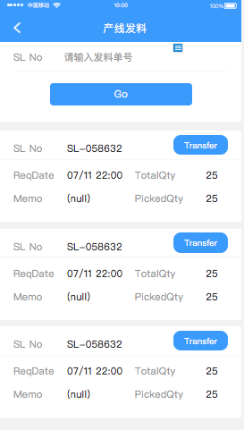  
Grid Column: SL No,ReqDate,Memo,TotalQty,PickedQty  
注：一个SL No一行数据

1. 人机交互逻辑——SL No输入框  
   3.1 SL No: 输入SL No,点击Go按钮，查询当前发料单号下Common、WIP Enough料清单。  
   3.2 查询调用地址：  
   https://eportal.ttelectronicschina.com/TTSZ_WebService/ProductionLineManage/GetProdMatKitSlList?slno=SLNo  
   3.3 返回Json字符串  
   {\"code\":0,\"data\":[ {\"sl_no\":\"SL-059808\",\"itemnumber\":4,\"partid\":\"933663310772\",\"sl_qty\":400.0,\"reqdate\":\"2018-07-31T14:30:00\",\"memo\":\"ELPCBA SMT\",\"mf_whse\":\"DEC-101\",\"mf_loc\":\"PW-74\",\"grn\":\"\",\"workshop\":\"SMT\",\"picker\":null,\"pickeddate\":null,\"wo\":\"WO-211315\",\"linked_to\":null,\"remark\":\"COMMON\",\"toplevel\":\"45133903514\",\"workstation\":\"PW\"}],\"msg\":\"Successfully!\"}  
   3.4 将查询结果显示在表格中
2. 人机交互逻辑——双击Grid记录进入发料界面,并带出发料信息  
   （数据源：List中带出或以SL No+itemnumber重新获取数据）
3. 人机交互逻辑——点击Transfer按钮  
   5.1 判断发料数量和已发料数量是否一致，如果不一致，提示用户“未全部完成”  
   5.2 发送转账数据  
   https://eportal.ttelectronicschina.com/TTSZ_WebService/ProductionLineManage/TransferProdMatKitSlList  
   {\"transfer\":[{\"slno\":\"SL-0001\",\"userid\":\"John\"},{\"slno\":\"SL-0002\",\"userid\":\"John\"}]}  
   返回信息：  
   {\"code\":0,\"data\":[{\"affectedrows\":\"2\"}],\"msg\":\"Successfully!\"}  
   affectedrows:受影响行数  
   5.3 刷新界面数据
4. 发料UI（返回主界面，主界面数据自动刷新（更新已发料个数））:  
   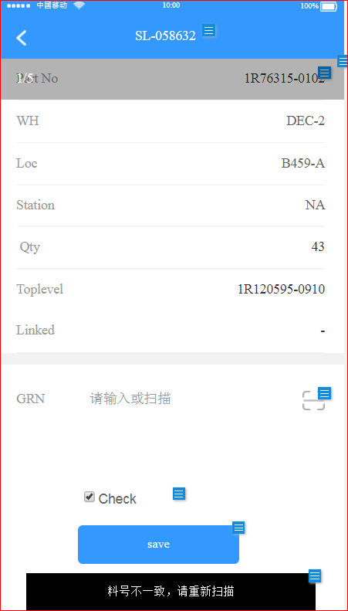
5. 人机交互逻辑——扫描GRN  
   7.1 如果扫描内容前两个字符为GR时，直接将扫描内容显示在GRN文本框  
   7.2 如果扫描内容中包含多个“@”符号,程序将字符串按@字符拆分后抓第1个字符串显示在GRN文本框  
   7.3 GRN文本框可以为多个GRN,每个GRN用逗号分隔
6. 人机交互逻辑——点击保存按钮：  
   8.1 如果Check是选择状态，则需要校验GRN是否正确  
   调用方法：  
   https://eportal.ttelectronicschina.com/TTSZ_WebService/ProductionLineManage/ GetCheckGRNResult?grn=GRNs  
   GRNs可以是个GRN，也可以是多个GRN (GR/0001,GR/0002)  
   返回Json字符串格式  
   {\"code\":0,\"data\":[{\"result\":\"1\"}],\"msg\":\"Successfully!\"}  
   result 1: 通过验证 0：未通过验证  
   8.2 验证通过后，发送发料数据  
   https://eportal.ttelectronicschina.com/TTSZ_WebService/ProductionLineManage/SavePickedData  
   Json格式（待确定）：  
   {\"update\":[{\"partid\":\"202001290934\",\"workstation\":\"PW\",\"toplevel\":\"45133903514,03\",\"checker\":\"KevinLi\",\"chk_status\":\"CHECKED\",\"sl_no\":\"SL-059808\"}]}  
   8.3 保存成功后返回：  
   {\"code\":0,\"data\":[{\"affectedrows\":\"2\"}],\"msg\":\"Successfully!\"}  
   affectedrows:受影响行数

**注意：  
除了登录操作外，所以访问Api的操作都需要在HttpReques.Headers中提供token信息**

**提交数据：将Json写入HttpRequest.Content**