1. LABEL-ETIQUETAR

|  | **Present** | **Past** | **Future** |
| --- | --- | --- | --- |
|  |  |  |  |
| **you** | label | labelled | will label |
| **he/she** | labels | labelled | will label |
| **we** | label | labelled | will label |
| **you** | label | labelled | will label |
| **they** | label | labelled | will label |

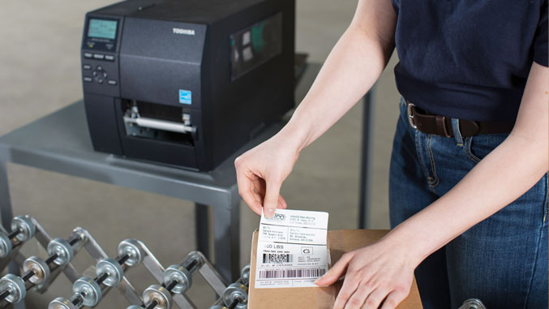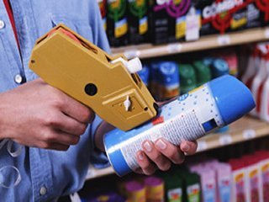

1. LAUNCH > LANZAR

| **Present** | **Past** | **Future** |
| --- | --- | --- |
|  |  |  |
| **I** | launch | launched | will launch |
| **you** | launch | launched | will launch |
| **he/she** | launches | launched | will launch |
| **we** | launch | launched | will launch |
| **you** | launch | launched | will launch |
| **they** | launch | launched | will launch |

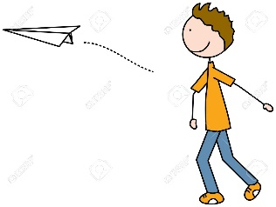

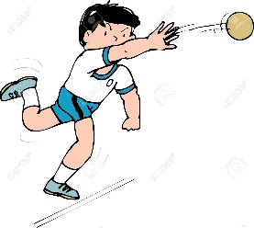

3.LEARN>APRENDER

| **Present** | **Past** | **Future** |
| --- | --- | --- |
|  |  |  |
| **I** | learn | learned | will learn |
| **you** | learn | learned | will learn |
| **he/she** | learns | learned | will learn |
| **we** | learn | learned | will learn |
| **you** | learn | learned | will learn |
| **they** | learn | learned | will learn |

 

1. LIE>MENTIR

|  | **Present** | **Past** | **Future** |
| --- | --- | --- | --- |
|  |  |  |  |
| **I** | lie | lied | will lie |
| **you** | lie | lied | will lie |
| **he/she** | lies | lied | will lie |
| **we** | lie | lied | will lie |
| **you** | lie | lied | will lie |
| **they** | lie | lied | will lie |



1. Listen>escuchar

|  | **Present** | **Past** | **Future** |
| --- | --- | --- | --- |
|  |  |  |  |
| **I** | listen | listened | will listen |
| **you** | listen | listened | will listen |
| **he/she** | listens | listened | will listen |
| **we** | listen | listened | will listen |
| **you** | listen | listened | will listen |
| **they** | listen | listened | will listen |

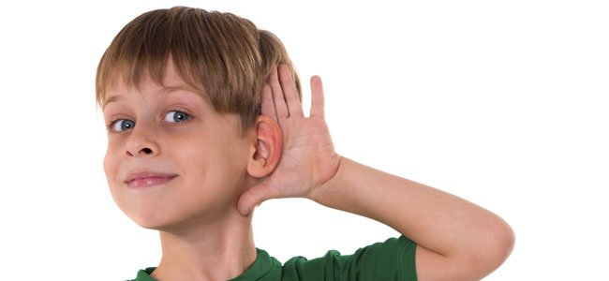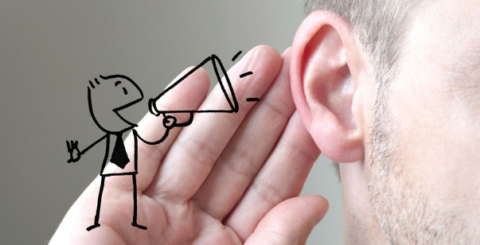

Lighten>aligerar

|  | **Present** | **Past** | **Future** |
| --- | --- | --- | --- |
|  |  |  |  |
| **I** | lighten | lightened | will lighten |
| **you** | lighten | lightened | will lighten |
| **he/she** | lightens | lightened | will lighten |
| **we** | lighten | lightened | will lighten |
| **you** | lighten | lightened | will lighten |
| **they** | lighten | lightened | will lighten |

Live>vivir

| **Present** | **Past** | **Future** |
| --- | --- | --- |
|  |  |  |
| **I** | live | lived | will live |
| **you** | live | lived | will live |
| **he/she** | lives | lived | will live |
| **we** | live | lived | will live |
| **you** | live | lived | will live |
| **they** | live | lived | will live |



Laugh> risa

|  | **Present** | **Past** | **Future** |
| --- | --- | --- | --- |
|  |  |  |  |
| **I** | laugh | laughed | will laugh |
| **you** | laugh | laughed | will laugh |
| **he/she** | laughs | laughed | will laugh |
| **we** | laugh | laughed | will laugh |
| **you** | laugh | laughed | will laugh |
| **they** | laugh | laughed | will laugh |





Load>cargar

| **Present** | **Past** | **Future** |
| --- | --- | --- |
|  |  |  |
| **I** | load | loaded | will load |
| **you** | load | loaded | will load |
| **he/she** | loads | loaded | will load |
| **we** | load | loaded | will load |
| **you** | load | loaded | will load |
| **they** | load | loaded | will load |

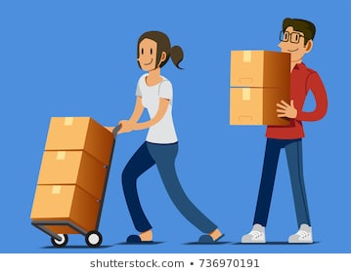

Love>amor

| **Present** | **Past** | **Future** |
| --- | --- | --- |
|  |  |  |
| **I** | love | loved | will love |
| **you** | love | loved | will love |
| **he/she** | loves | loved | will love |
| **we** | love | loved | will love |
| **you** | love | loved | will love |
| **they** | love | loved | will love |

