200 = TWO HUNDRED

300 = TREE HUNDRED

400 = FOUR HUNDRED

500 = FIVE HUNDRED

600 = SIX HUNDRED

700 = SEVEN HUNDRED

**CABEZA = HEAD**



**OJOS = EYES**

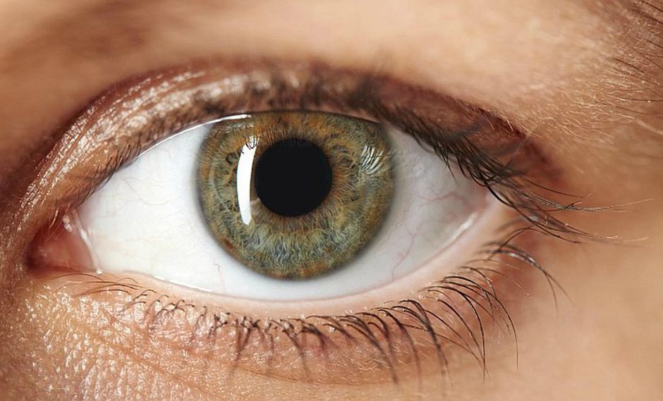

**BOCA = MOUTH**

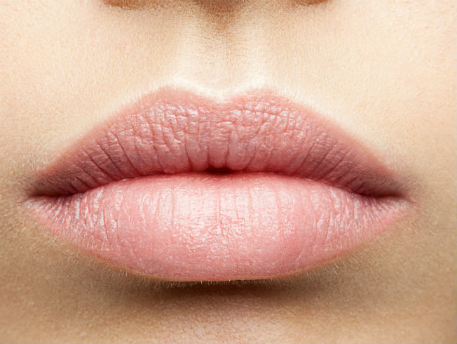

**NARIZ = NOSE**

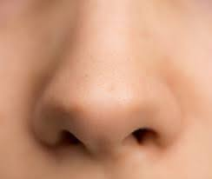

**CABELLO=HAIR**



**OREJAS=EARS**

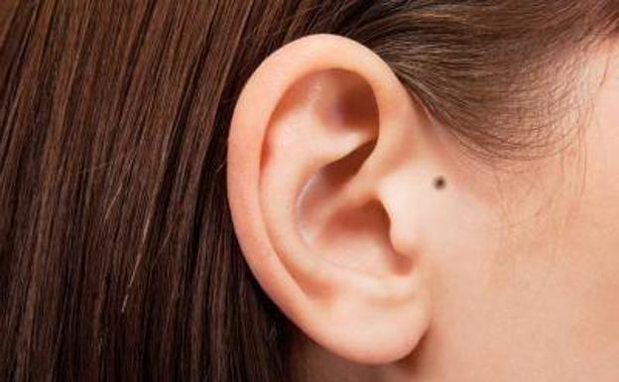

**MEJILLAS=CHEEKS**



**MENTON = CHIN**

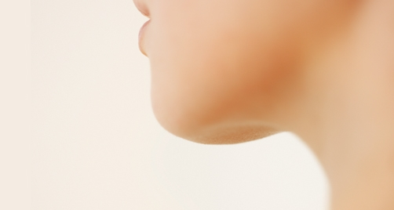

**BRAZO = ARM**

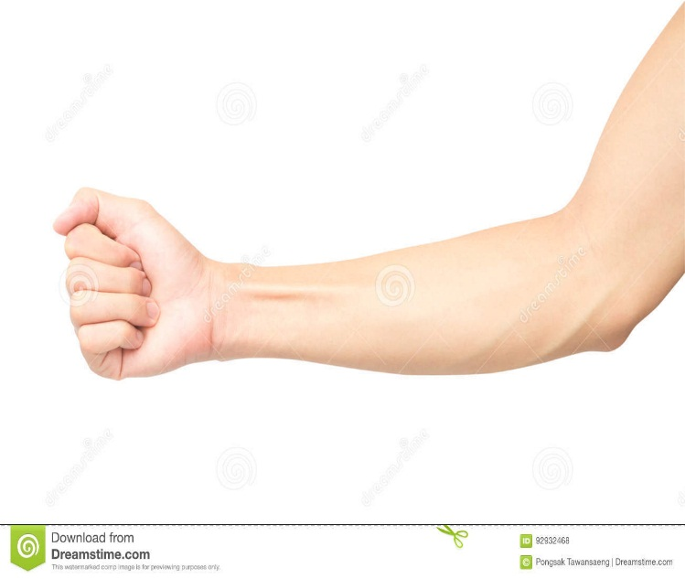

**ANTEBRAZO = FOREARM**

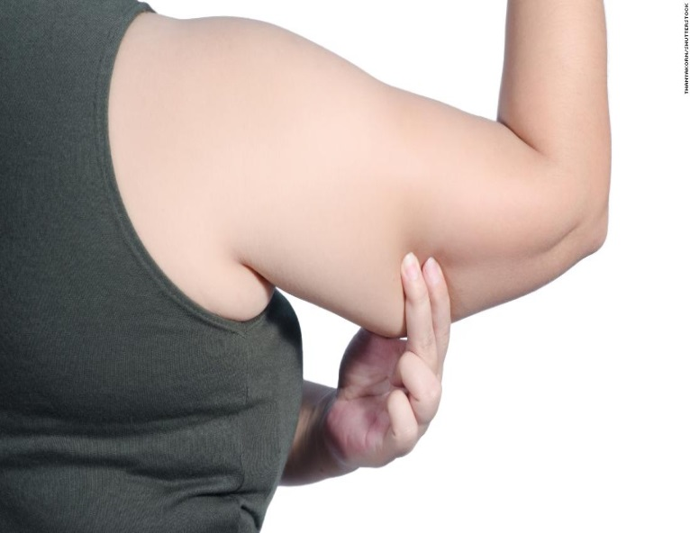

**CODO = ELBOW**

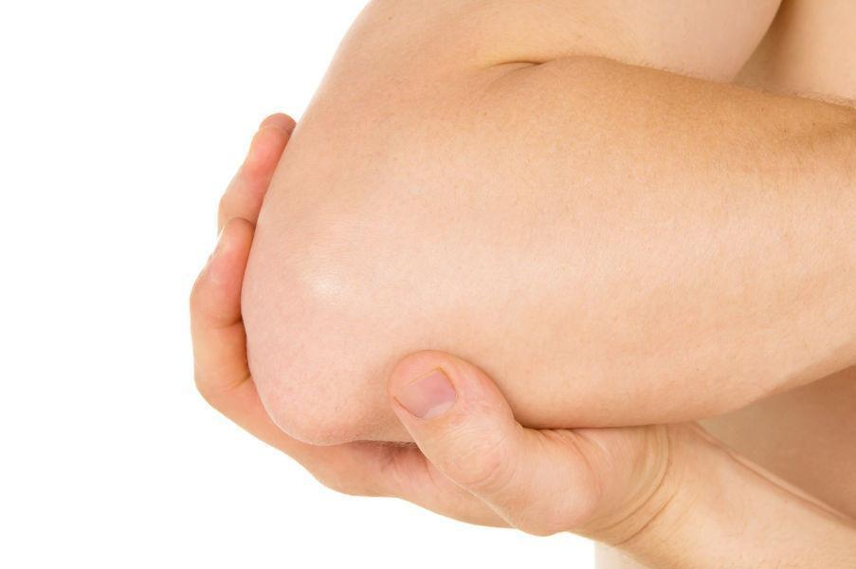

**MUÑECA = DOLL**

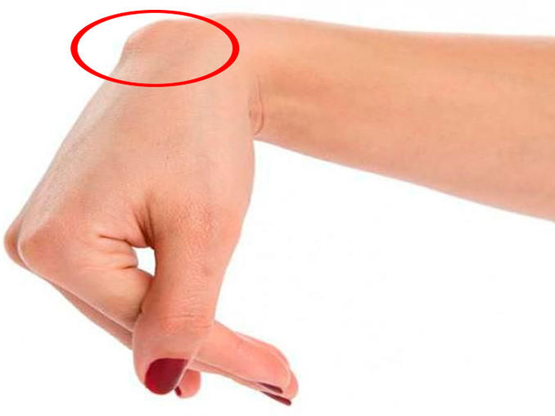

**MANO = HAND**

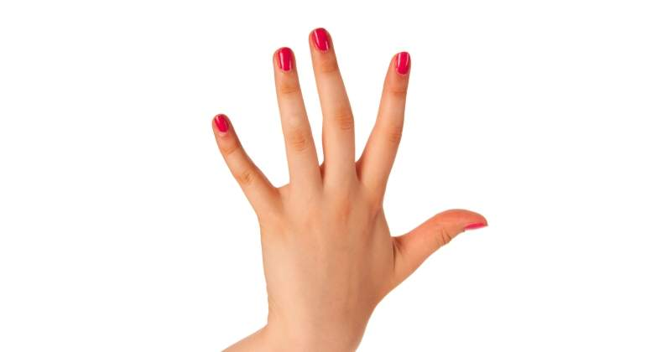

**PALMA = PALM**

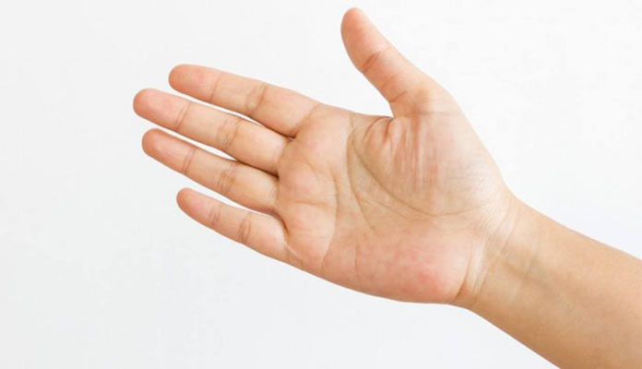

**DEDOS = FINGERS**

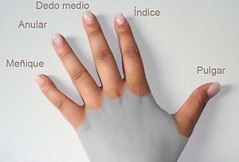

**CUELLO = NECK**



**PECHO = CHEST**



**ABDOMEN = ABDOMEN**

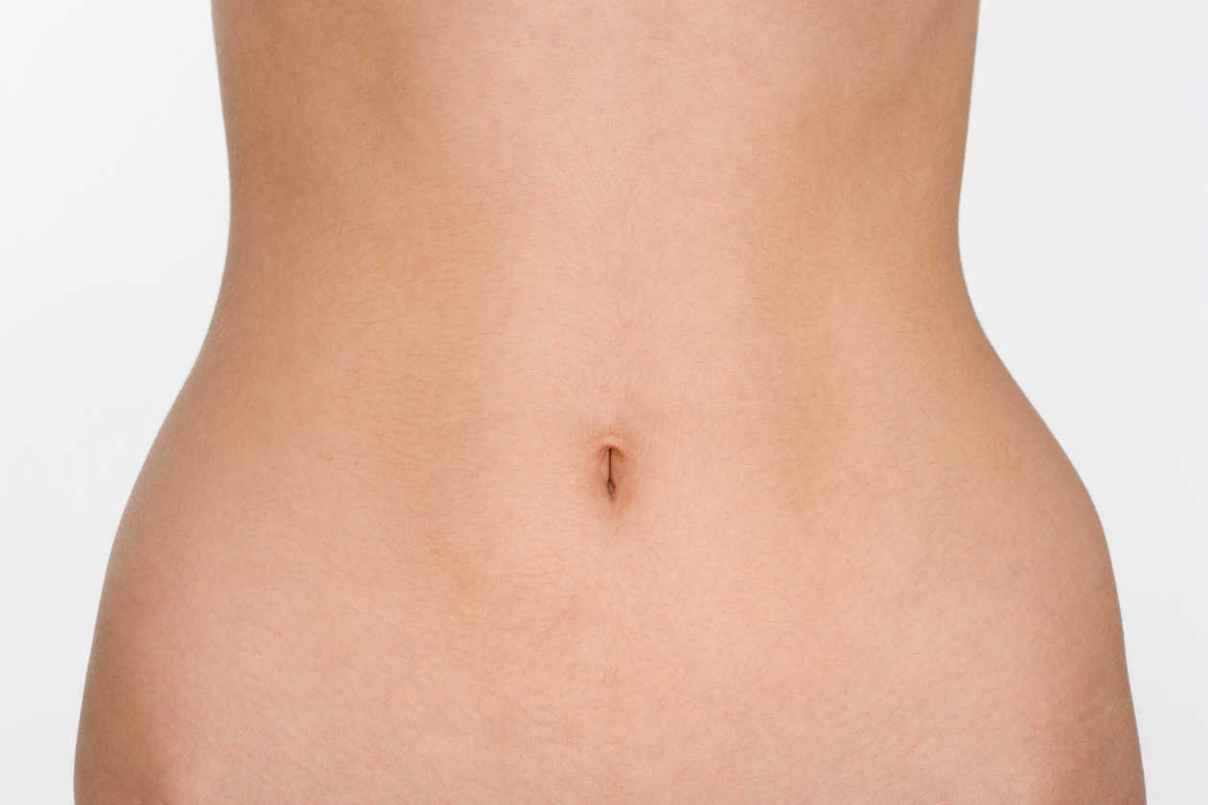

**ESPALDA = BACK**



**NUCA = NAPE**

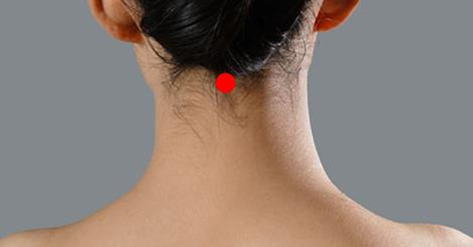

**TORSO = TORSO**



**PARPADO = EYELID**

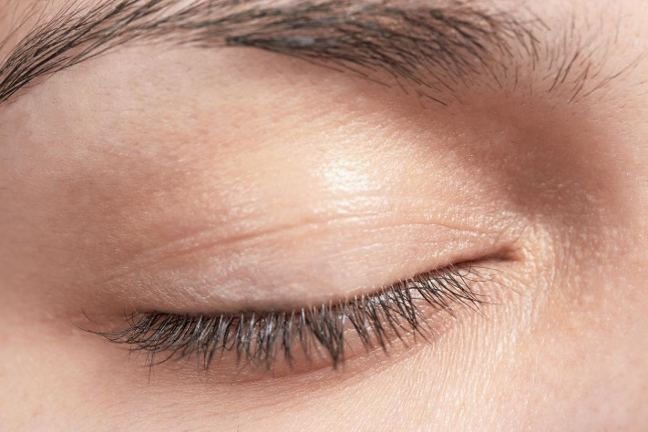

**PUPILA = PUPIL**

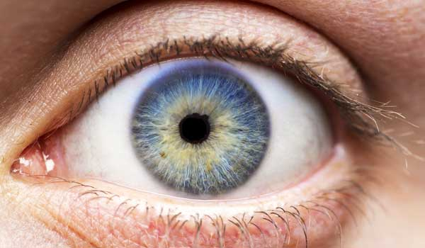

**IRIS = IRIS**

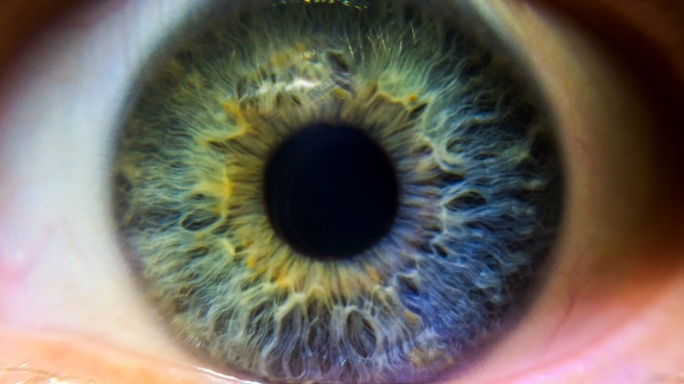

**DIENTES = TEETH**

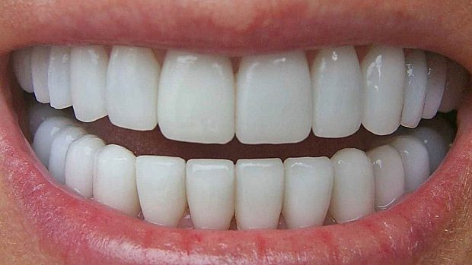

**CEJAS = EYEBROWS**

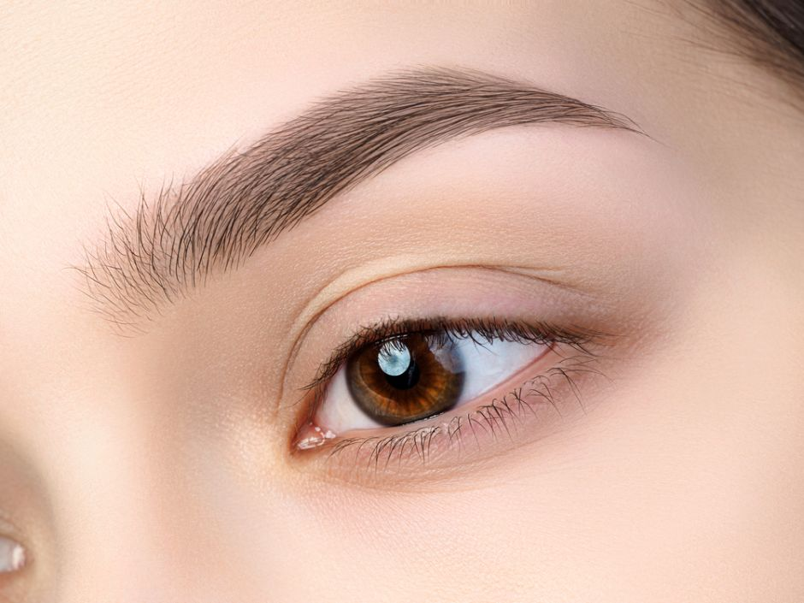

**PESTAÑAS = TABS**

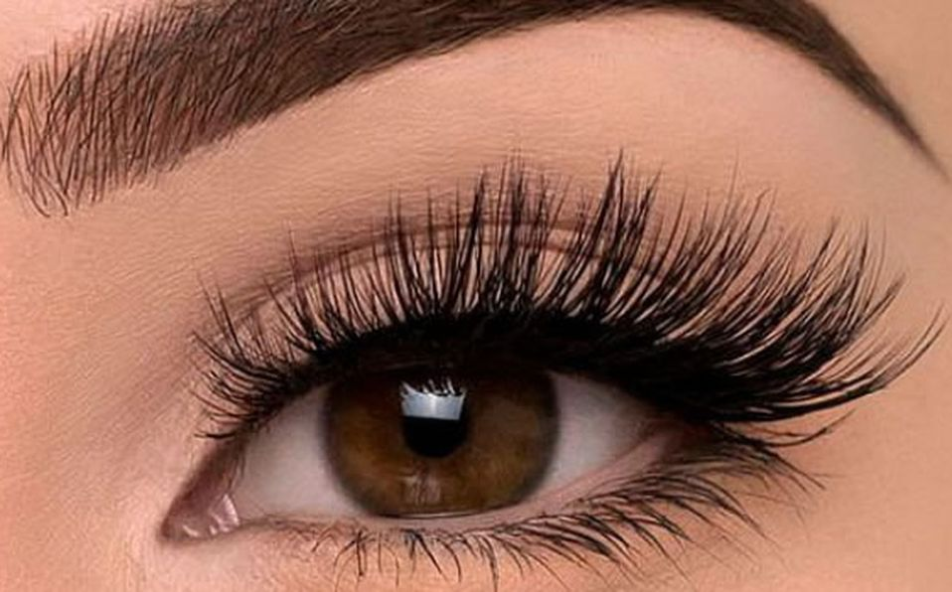

**HOMBRO = SHOULDER**

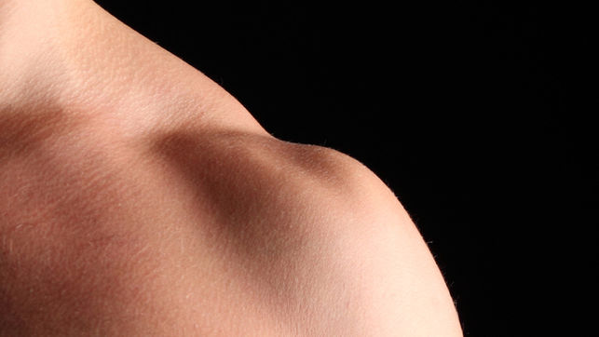

**CLAVICULA = CLAVICLE**

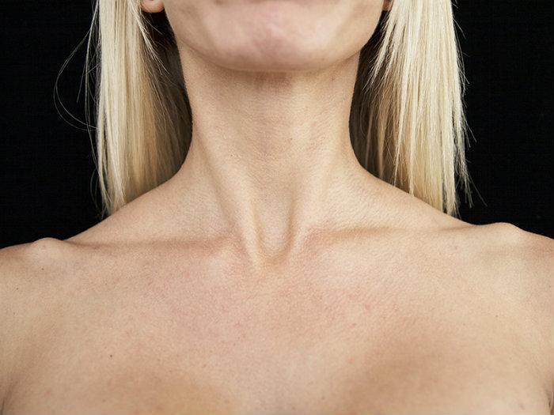

**COSTILLAS = RIBS**

