**VERBOS RGULARES E IRREGULARES**

1. **Act= actuar**
2. **Add=sumar, añadir**
3. **Ask=preguntar, pedir**
4. **Answer=responder**
5. **Arrive=llegar**
6. **Arise =surgir**
7. **Awake=despertarse**
8. **Abort =abortar**
9. **Absconda=fugarse**
10. **accommodate= alojar**

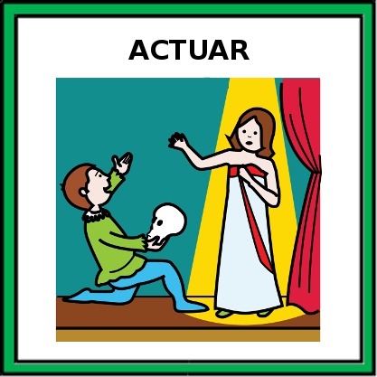imag1

Imag2

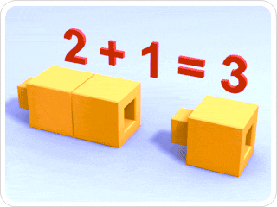

Imag3

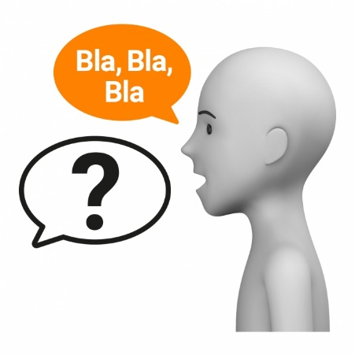Imag4

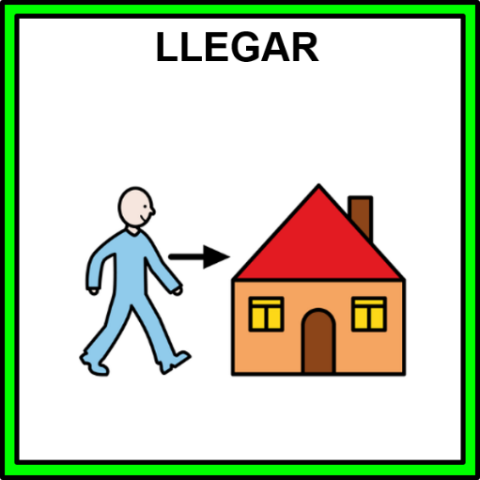Imag5

Imag6



Imag7



Imag8

Imag9

Imag10

