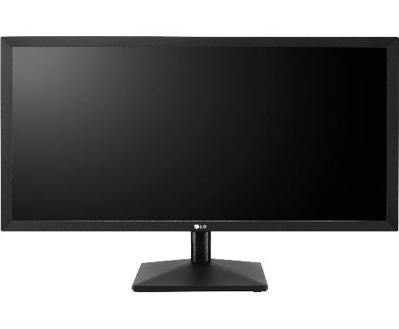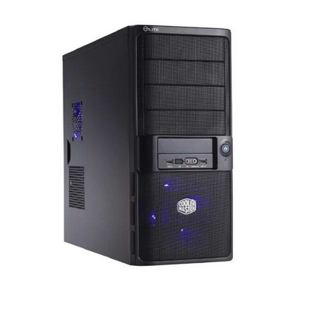

Unidad central de proceso

Pantalla

Central processing unit

Screen

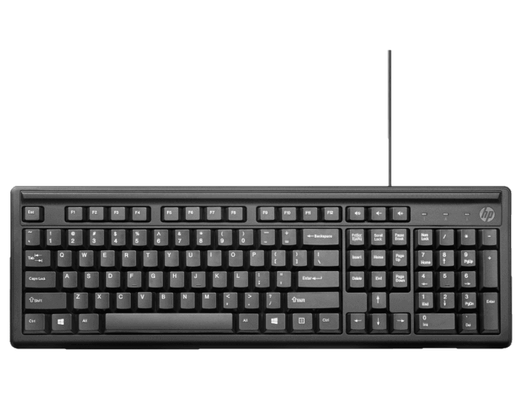

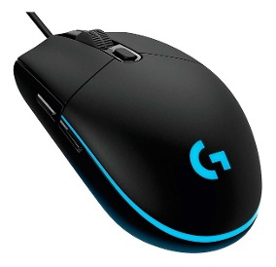

Teclado

Raton

Mouse

keyboard

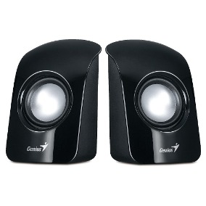

Speakers

Parlantes

800 = EIGHT HUNDRED

900 = NINE HUNDRED

1000 = ONE THOUSAND

**Laptop = Laptop**

**Celular = Cellphone**

**Tableta = Tablet**