PRESENTE / PASADO / PARTICIPIO = SIGNIFICADO

BAKE / BAKED / BAKED = HORNEAR



BLAST / BLASTED / BLASTED = EXPLORAR



BATTER / BATTERED / BATTERED = GOLPEAR



BECOME / BECAME / BECOME = CONVERTIRSE



BEFALL / BEFELL / BEFALLEN = ACONTECER



BEND / BENT / BENT = DOBLAR



BESPEAK / BESPOKE / BESPOKEN = ENCARGAR

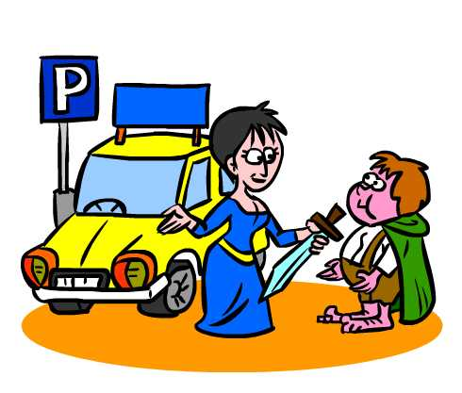

BET / BET / BET = APOSTAR



BLOW / BLEW / BLOWN = SOPLAR



BRING / BROUGHT / BROUGHT = TRAER

