Name: Kevin Nunez 00323217 Linux Administration SebLab Adrianna Holden Gouveia 09/20/2026
Important steps: When you do this assignment move to the directory of your virtual machine the SedLab file, because if you don’t do this step correctly is going to be really difficult execute commands, and the name is important because if the name is different of which one you are executing, the command not going to work correctly.
1. Change the name Jo to Josephine
The command is sed -e 's/Jo/Josephine/g' SedLab.
sed -e: Means expression. It tells sed to execute the line or argument that is coming after this command.
s = Substitutes one string for another
g = Global substitution on a line
In this case, this means, we are replacing the name of Jo for Josephine using these expressions.
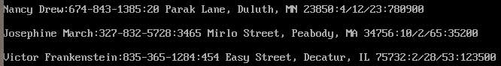

2. Delete the last 5 lines.
The command is sed '$d;$d;$d,$d,$d' SedLab
$ = End-of-line anchor
d = delete
If we repeat this command $d is how many lines, we want to delete or how many lines we want to delete. Then the same command applies at the end making it delete the last 5 lines.

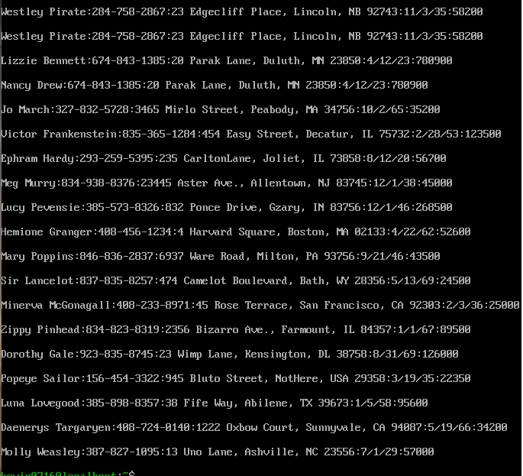

3. Print lines 3-15.
The command is sed -n -e '3,15p' SedLab
-n = Disables the automatic printing all the lines and only prints the lines you do tell to print it.
sed -e: Means expression. It tells sed to execute the line or argument that is coming after this command.
p = print
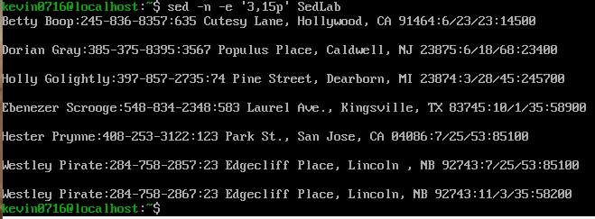

4. Delete lines for people who live in California
The command is sed -e '/CA/d' SedLab
Or the command can be sed -e '/California/d' SedLab if you document don’t have abbreviations.
sed -e: Means expression. It tells sed to execute the line or argument that is coming after this command.
d=deletes lines.
By putting together this command place and the combination of the function d. It will delete the lanes with that specific deleting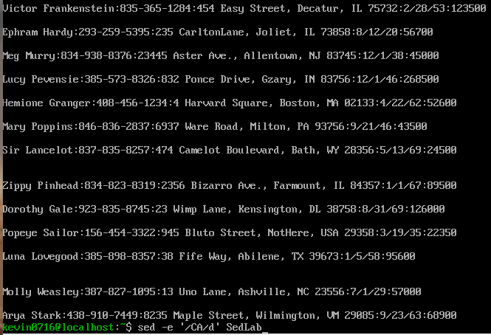
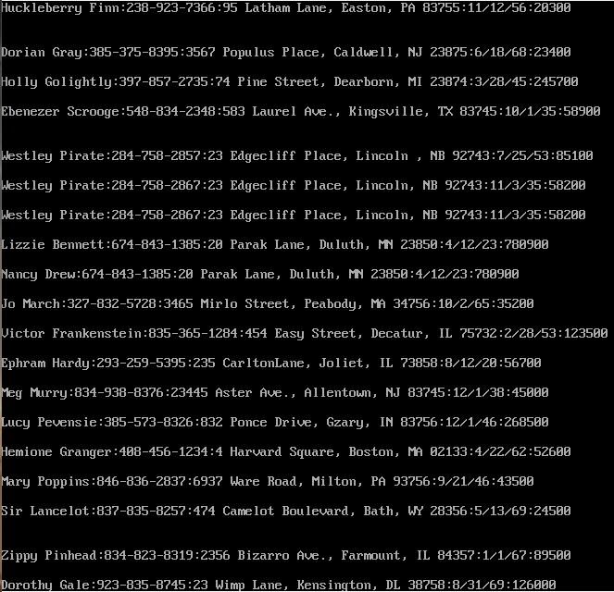

5. Print all lines where the birthdays are in the first week of the month. Be careful of the dates for birthdays, the format is MM/DD/YY
The command is sed -n -r '/[0-9]{5}\:[0-9]+\/[1-7]\//p' SedLab
This one was much too hard. I need to list all birthdays which begin in the first week of the month.
-n: silence the automatic output. In normal working sed print all the lines, but with this we say don’t print nothing, just print what I want in specific.
-r: activate the regular expression. This permit uses advanced symbols like {5} or + without putting inverted bars.
/…/p: The / enclose what we want, and the p(print) order “if the lane has coincidence, print the line”.
[0-9]{5}: the scanner searches for a block with 5 continuous digits.
\: - This by obligation want the existence of (:). The inverted bar \ is used to sed interpret the two points in literal form.
[0-9]: this search one or more digits, this represents the month.
\/: this means the expression keep going.
[1-7] : this means the day of the first week.
\/: this means the start of the year.
With this code we make sure we hit the date when we put [0-9]+\/[1-7]\/, we obligate the system to search numbers-bar-numbers1to7-bar. This structure imitates the date mm/dd/,
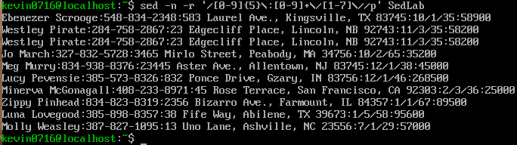

6. Append three asterisks (*) to the end of lines starting with Sir
The command is sed -e '/^Sir/a\*** ' datebook
sed -e: Means expression. It tells sed to execute the line or argument that is coming after this command.
^: Beginning of the word. If we write ^Messi, any line that contains Messi at the beginning will be searched on the whole file.
a\ : Appending text after a line.
So, the combination of ^ at the beginning + a that equals append. Will put any desired word at the beginning of our search and then we can see where this word is and filtrate the document. In this asterisk will be added at the beginning of Sir but can be different thing.
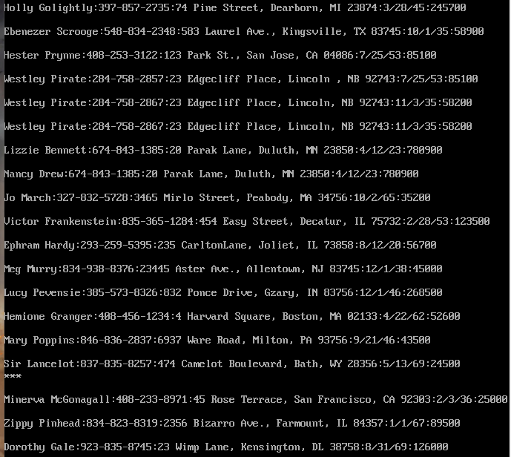

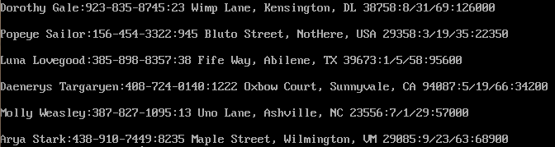

7. Replace the line containing” Westley Pirate” with the phrase” As you wish.” Make sure you replace the whole line not just the name
The command is sed -e '/Westley Pirate/c\As you Wish' datebook
c: Replace the line with text
Explanation: We start writing sed -e, to tell sed that we are going to use expression how we did it in the last command. Then we enclosed the word /Westly Pirate/ with forward slashes. Because this is the word that we want to replace. c\ allows to replace the line that contains Westly Pirate with the following text after the \ back slash and in this case going to be “As you Wish”, but you can use wherever you want.
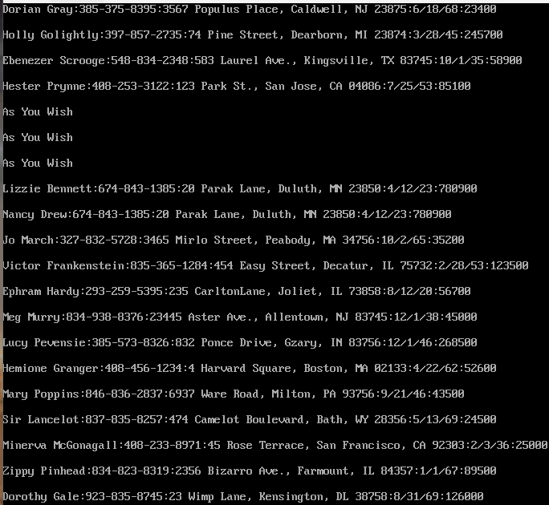

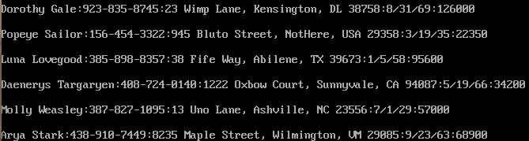
8. Change Minerva McGonagall’s birthday to 10/04/1935. Assume you don’t know Minerva’s original birthday. Use a regular expression to search for it.
The command is sed '/Minerva/s, [0-9] \+/ [0-9] \+/ [0-9] \+,10/04/1935,' SedLab
/Minerva/: the functions are used like a filter of searching. This says to say, “don’t touch nothing in the whole file, just look for this unique word ‘Minerva”. This makes sure you just alternate with one person.
s, …, …,: Normally with the command of substitution of sed, we write with diagonal bars, (s/search/replace/). But this date has bars (10/04/1935), and the use of bars maybe cause error. So sed permit to use comas like separators, so the architecture is: s,patron_to_search,new_text,.
10/04/1935: is the new text that is going to be injected with the new date.
[0-9]\+: means one o more sequence numbers. This means month.
/: separates the month from day.
[0-9]: search for the other block for day.
/: separates the day from year.
[0-9]\+: search for the last block that is year.

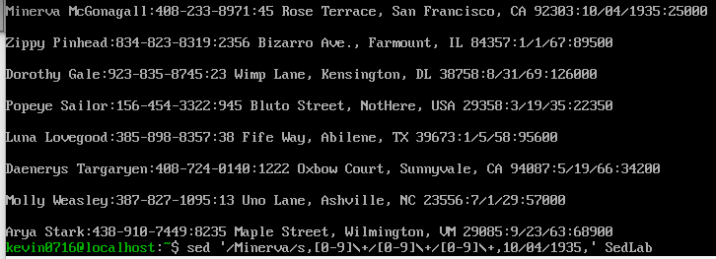

9. Delete all blank lines.
The command is sed '/^$/d' SedLab
Explanation: If we combine the commands, “^ beginning of the line” with not text, plus the command “$ at the end of the line” followed by the “command d”, this going to delete all the blank lines.
^: Beginning of the line anchor
$: End of the Line anchor
d = delete

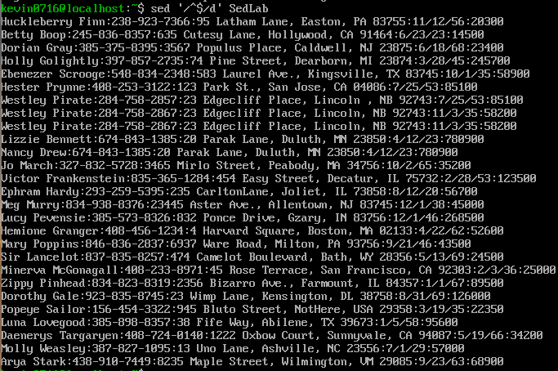

10. Write a sed script that will
(a) Insert above the first line the title - Great Literary Characters -.
1i\ - Great Literary Characters – The expression 1i means insert above the first line. \ This slash is used as the separator to start writing the desired text.
(b) Print the contents of the file, but instead of the phone number starting with an area code, have it start with a 1+, then include the area code and number. For example, (603)123-1234 would turn into 1+(603)123-1234
s/[0-9]\{3\}-[0-9]\{3\}-[0-9]\{4\}/1+&/g . With this command we want to add a number the structure of the numbers we already have in our file, the format of this phone number is for example 978-724-0907, we now [0-9] look a digit 0 to 9 and the \{3\} this means the past code need to repeat 3 times like is 978, and we repeat this two more times but in the last one is \{4\} . 1+ is the text we want in the front and the ‘&’ means put again the whole text after searching the format we used before but now, we add this other text ‘+1’. The ‘g’ say is global, so this is going to change all the information in the file.
(c) Append at the end of the file” Happily Ever after. The End”
$a\Happily Ever after. The End The expression $ means at the end of the line of the file. The combination of this makes it be at the end of the line of the file with the text we select. \ This slash is used as the separator to start writing the desired text.

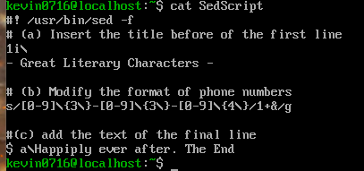
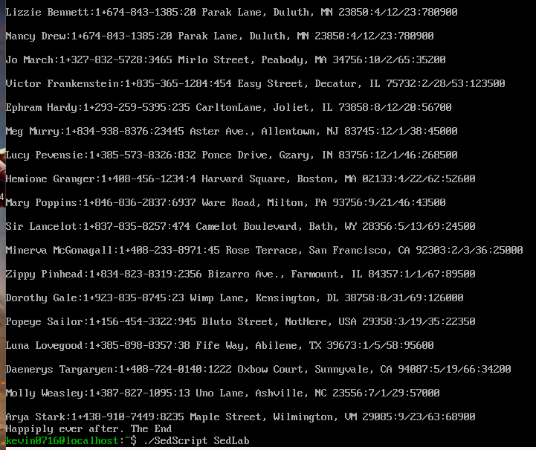
References
https://www.geeksforgeeks.org/cut-command-linux-examples/
https://www.linuxquestions.org/questions/programming-9/removing-duplicate-lines-with-sed-276169/
https://www.opensourceforu.com/2011/04/sed-explained-part-1/
https://flylib.com/books/en/4.356.1.40/1/
https://youtu.be/YMqOocY0ovs
https://www.geeksforgeeks.org/linux-unix/how-to-use-regular-expressions-regex-on-linux/

