Kevin Nunez Linux Administration Fall2026 9/13/2026
Grep Lab
1. Print all lines containing the string Lane
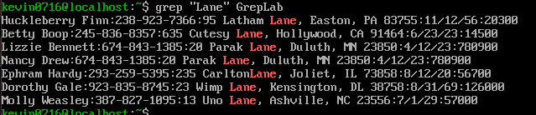
Code Line: grep “Lane” GrepLab, with this lane we search and show each lane that contain the exact “Lane” word and show it in the screen, the last word “GrepLab” is the name of the file.
2. Print all lines where the person’s first name starts with H
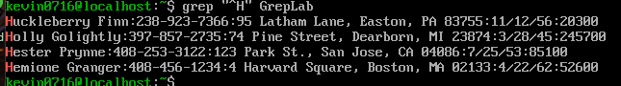
Code Line: grep “^H” GrepLab, with this command we show the lines start with the letter “H”, the symbol “^” is meaning ‘the start of the line’, so this mean obligate the ‘H’ need to be in the first in the line.
3. Print all lines ending in three zeros (000)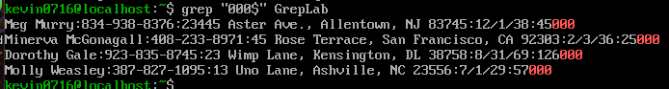
Code Line: grep “000$” GrepLab, this code shows the lines that end with the termination of (000), the dollar symbol is meaning the final of the lane, when I put 000$ this indicates show the lanes that end with the 000.

4. Print all lines that don’t contain 408
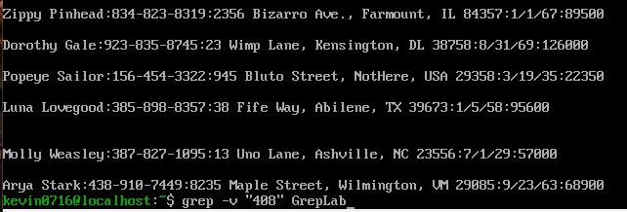
Code Line: grep -v”408” GrepLab, with this line we show all the lines except the lines have the number 408, the option -v change the behavior of grep, so the -v is inversed so this shows the opposite of the number we put on it.
5. Print all lines where birthdays are in the year 1935 (be careful of the date format! it’s MM/DD/YY)
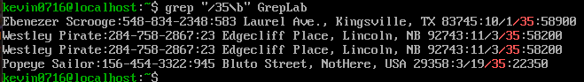
Code Line: grep “/35\b” GrepLab, this line code show the birthdays with 1935 this is identify with end /35, this search the diagonal bar and the number 35, the symbol \b mean ‘word boundary’, this avoid the command confuse if after 35 there is more other numbers like another 35 in a phone number, so we make sure the 35 be the final of the block of text.
6. Print all lines where the phone number is in an area code that starts with an 8
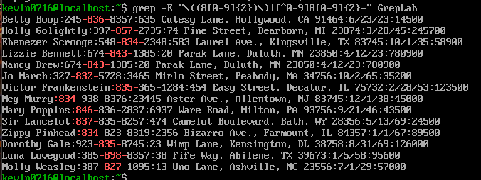
Code Line: grep -E "\((8[0-9]{2})\)|[^0-9]8[0-9]{2}-" GrepLab, search codes of telephone area that start with 8. The option -E activates the regular expression for use advance symbols. The symbol ‘|’ mean ‘O’ that means this look a format or other. The first part is ‘/((8[0-9]{2})\)’ search a parenthesis open ‘\(‘, one 8, two random numbers [0-9]{2} and a parenthesis close ‘\)’. This detects formats like (834). The second part’\((8[0-9]{2})\)’ search one eight follow be tow numbers and one script like ‘812-‘, and with this make sure [^0-9] there not be other number stick behind.
7. Print all lines containing an uppercase letter, followed by 4 lowercase letters, a space and one uppercase letter.
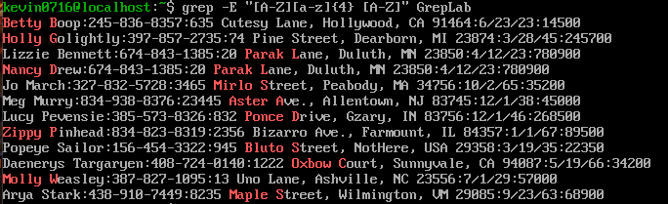
Code Line: grep -E "[A-Z][a-z]{4} [A-Z]" GrepLab, in this line of code we search for a specific patron of text: one uppercase letter and four minus letters, a space and other uppercase letters. [A-Z] search an uppercase letter, [a-z]{4} search exactly 4 minus letters consecutives, and a white space represents the obligatory white space, [A-Z] search another uppercase letter on the final the patron for example Green B.

8. Print lines where the address begins with a two or three digit number (so this would be 12 main st or 123 main street but not 1234 main street).
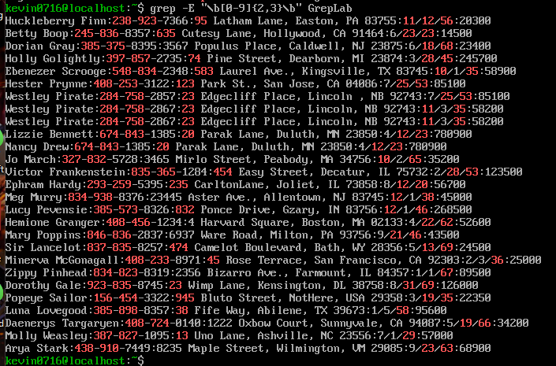
Code Line: grep -E "\b[0-9]{2,3}\b" GrepLab, in this line of code we are searching for numbers of houses or directions two or three digits, like 12 or 143, but ignores the one digit and 4 digits like 6 or 1783. The ‘{2,3}’ say to grep the number need to be repeated minimum two times and maximum three times, the limit ‘\b’ on the start and in the final unsecure the numbers for not be a big amount.
9. Print lines where the person lives in Mass or Illinois
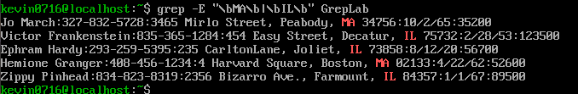
Code Line: grep -E "\bMA\b|\bIL\b" GrepLab, in this line of code we search lines where appears the MA/Il, the option -I make the search ignore all the lines that do not contain the letters MA/Il the symbol “| or ‘O’” indicate works if contain whatever of this two.
10. Print lines containing the addresses that aren’t on a street (You might see St as shorthand for street)

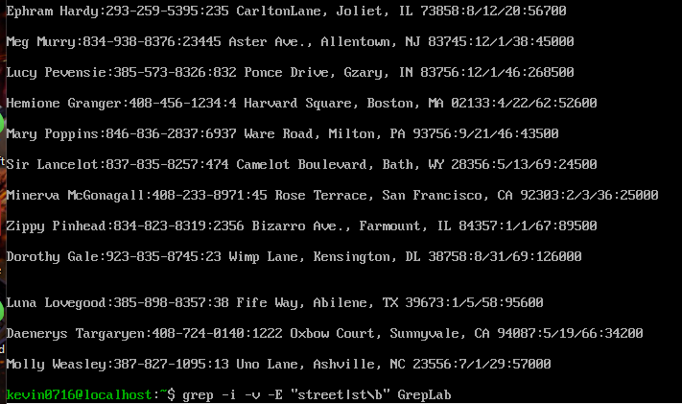
Code Line: grep -i -v -E "street|st\b" GrepLab, this code hides all the lines that contain the word “street” or the abbreviation “st”, showing only the directions that are not above the street like avenue or roads, etc. this works combining the option -I ignores uppercase letter and the option -v invert/exclude, search lines that have “street or st” aisle with a limit of word \b for not eliminate words like “first” and erase the result.
Sources used:
https://www.geeksforgeeks.org/linux-unix/grep-command-in-unixlinux/
https://www.linuxteck.com/grep-command-in-linux-with-examples/
https://stackoverflow.com/questions/8762274/can-i-grep-only-the-first-n-lines-of-a-file
https://www.freecodecamp.org/news/grep-command-in-linux-usage-options-and-syntax-examples/

