Kevin Nunez 00323217 Linux Administration Adrianna Holden Gouveia Server Security 10/31/2026
Instructions:
In this assignment we have access to AI tool, with this AI tool you need to create a script that follows the next requirements.
Your prompt must ask for a script that meets all these script requirements:
• It runs on both of your servers without any changes.
• It reports failed SSH logins from the last 24 hours.
• It lists all accounts with root privileges (UID 0) and any accounts with
empty passwords.
• It lists listening ports using ss.
• It saves its results to a timestamped file in a directory you choose, not
in /tmp.
• It works when run from cron.
• It does not install anything or change any system settings.
• It exits with a non-zero exit code if it finds a problem.

Questions:
What was the prompt you gave it?
I say to the AI tool to please create a script for CentOS and Ubuntu, a script that can run in both server without bugs and errors, I specified all the requirements above for creating the script.
What changes did you have to make to the script for it to work?
In the first time the script that make Copilot works without error, the script is running in both servers with no errors.
In the case of Gemini, is different in the CentOS server, the original prompt Server-Security.sh works without problems, but in Ubuntu the error date: invalid date appears and the script didn’t work, so in this case I replace section 1 of the code.
"date -d \"" $1 " " $2 " " $3 "\" +%s" | getline ts_log
CentOS and older Ubuntu systems log timestamps using the traditional System log format (example, Oct 31 12:00:00). The GNU date utility reads this perfectly.
Modern Ubuntu systems use the strict ISO 8601 format for system logs (example, 2026-10-31T12:00:00.123456+00:00).
The Error is because of the spaces and complex symbols inside that specific ISO string, feeding it into date -d inside an awk loop completely broke the syntax, flooding my terminal with the date: invalid date messages.

The Fix of this problem:
To fix it natively without introducing multi-platform parsing issues, we bypassed raw log file scraping entirely and implemented Systemd's native journal mechanism.
This is the exact snippet that makes the script work perfectly on both servers.

# Use journalctl to fetch sshd logs from the last 24 hours across both OS natively.
# This avoids 'invalid date' parsing errors caused by different OS log styles.
if command -v journalctl >/dev/null 2>&1; then
journalctl _SYSTEMD_UNIT=ssh.service _SYSTEMD_UNIT=sshd.service --since "24 hours ago" 2>/dev/null | grep -E "Failed|Invalid user" > /tmp/ssh_failed_temp.txt
else
# Fallback for older systems without systemd/journalctl
if [ -f /var/log/secure ]; then AUTH_LOG="/var/log/secure"; else AUTH_LOG="/var/log/auth.log"; fi
grep -E "Failed|Invalid user" "$AUTH_LOG" 2>/dev/null | grep -v "cron" > /tmp/ssh_failed_temp.txt
fi
Why this specific snippet work:
journalctl abstraction: Both modern CentOS and Ubuntu utilize systemd. journalctl talks directly to the system kernel database, meaning it tracks timestamps internally.
--since "24 hours ago": Instead of letting Bash or Awk calculate the math, journalctl handles the time calculation flawlessly regardless of how the system renders textual logs.
Distribution Agnostic: It looks for both ssh.service (Ubuntu naming convention) and sshd.service (CentOS naming convention) simultaneously, matching the requirements seamlessly.
What changes did you have to make to the prompt?
I added some comments, and I say to the tool some other changes to the script. I also need to change the code of the script to when the script run shows me the complete file in the terminal like how it looks in the file log, for this I change the code from:
} > "$REPORT_FILE" to } | tee "$REPORT_FILE"
With this change I can see the log in my terminal too.
How many tries did it take to get something that worked?
I use two tries, one for the original script that runs in CentOS but not in Ubuntu, so I make a change that works in Ubuntu.
Describe the whole conversation with the AI including all modifications and you’re testing on the servers.
I say to the AI to make the script, and the second change to make, I ask the AI how to convert a windows .txt file to a .sh file that can run in CentOs and Ubuntu, when I create the script I think it can be fast if I make the script ad then with the SmarTTY send the file to each server, but this files can’t be execute in Linux, so we need to convert the file from .txt to .sh file in the Linux system, and give them permissions, and convert the file to a Linux reader with the tool dos2unix (FileName), with this we convert the file and now can be executed in Linux.

CentOS-Gemini
The first step that I took in this assignment was to make the file Server-Security.txt in my host computer.
I opened SmarTTY to send the file to the CentOS server, after this step I used the command mv to rename the file to make the file executable, so I changed the name to Server-Security.sh
After running this command, I check if the file is correctly changed and in order.
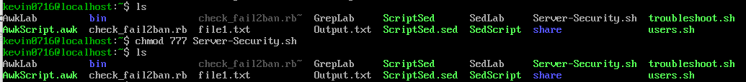
With the tools dos2unix, I change the windows format to a Linux format for executable.
If you don’t have the tool, you can install the tool with the command sudo install dos2unix.
I run the command dos2unix Server-Security.sh

After that I run the command sudo ./Server-Security.sh
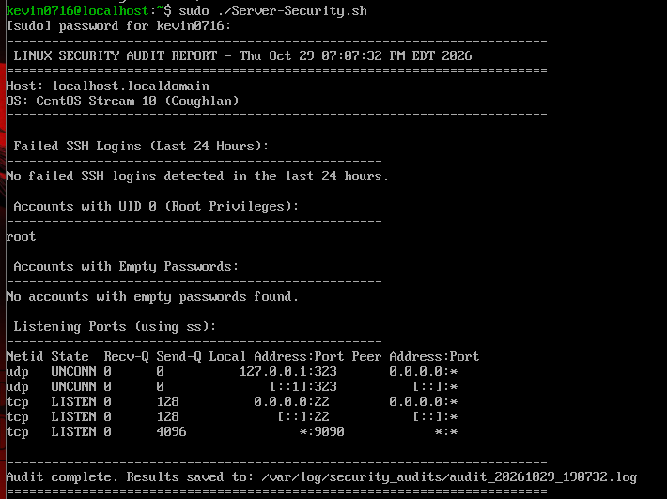
How you can see the file log goes to /var/log/security_audits/”unique file name”.log

CentOs-Copilot
Here I did the same but with a different file name, in this case I changed from mv Server-Security-Copilot.txt Server-Security-Copilot.sh
Now with dos2unix Server-Security-Copilot.sh to change to the Linux format.
Here I run the command sudo ./Server-Security-Copilot.sh for executing the script
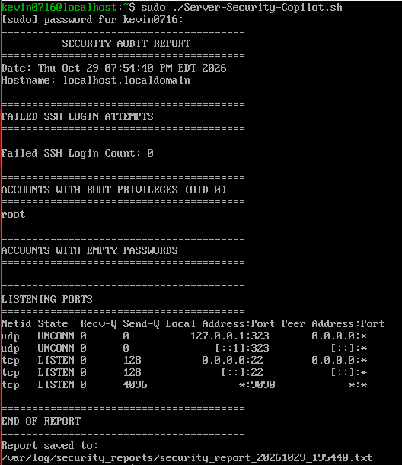
The log file is in /var/log/security_reports/”unique file name”.txt
Ubuntu-Gemini & Copilot
In this case for using the scripts I made something different, my scripts are already used and test in the CentOS server and has the Linux format, so I take them with SmarTTY from my CentOS server, and I download them to my Ubuntu Server, so I just give them permission in this case with the command chmod 777.
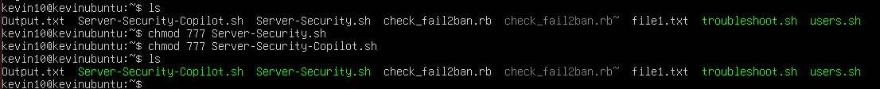
I run the command sudo ./Server-Security-Copilot.sh
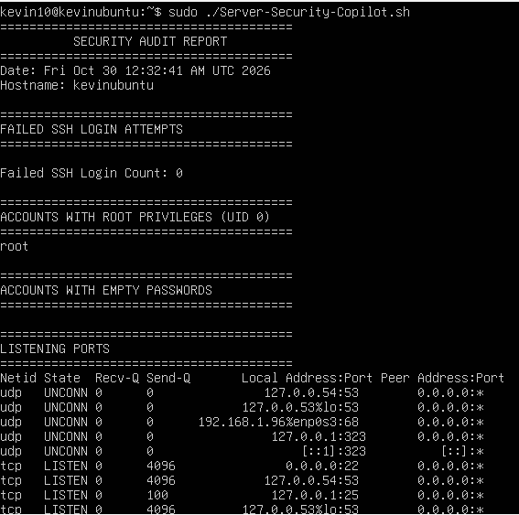
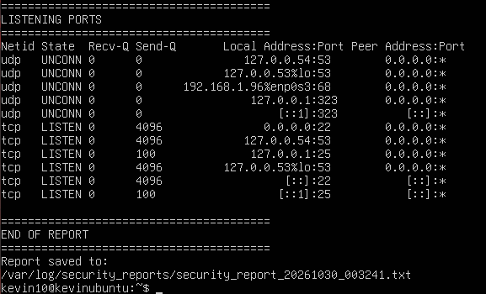
Here we have our output with the log file in this case is in /var/log/security_reports/”unique file name”.txt

Here I run the command sudo ./Server-Security2.sh (this script is the one we fix from the original Server-Security,sh)
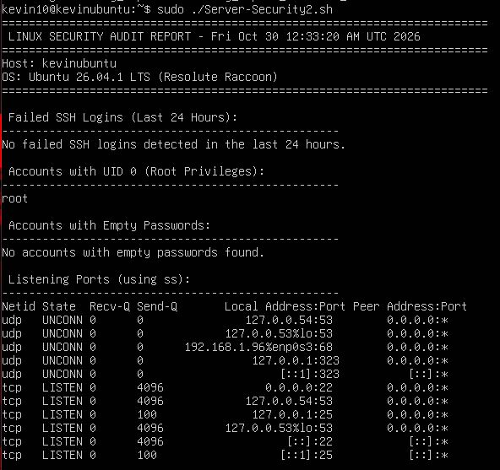
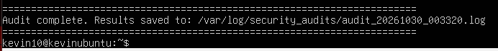
Now we have the file of the log located in /var/log/security_audits/”unique file name”.log

Server-Security2.sh Script
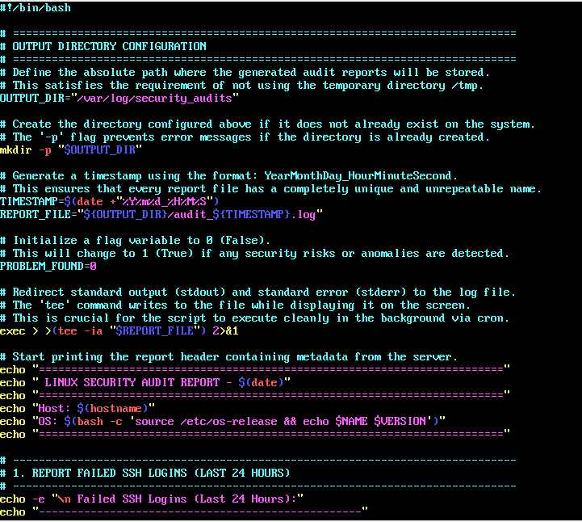
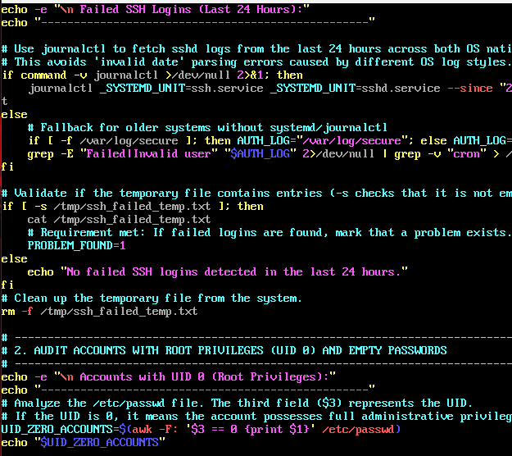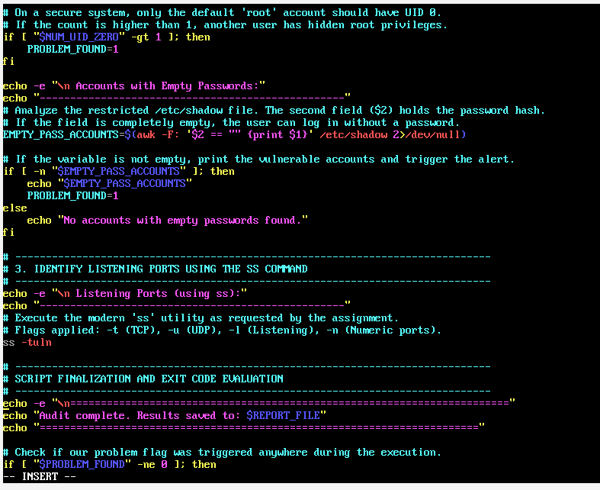

Server-Security-Copilot.sh Script
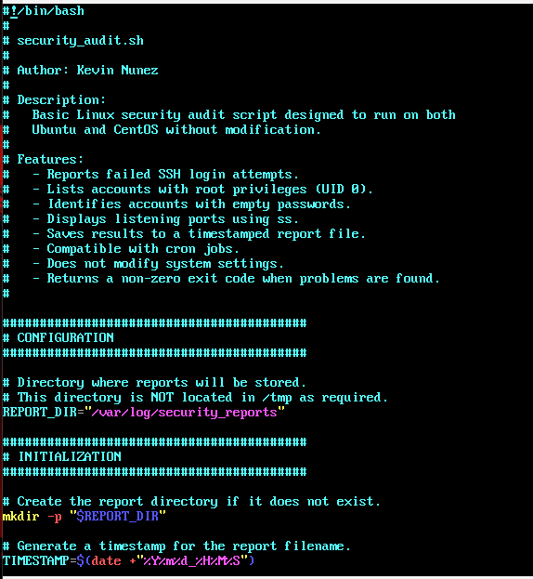
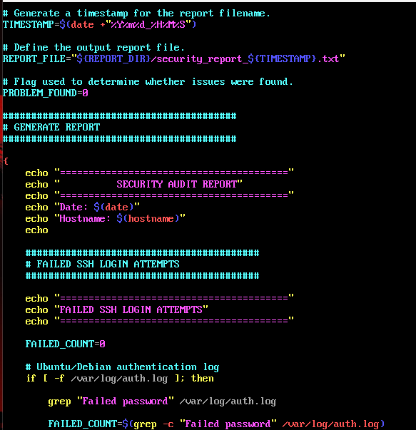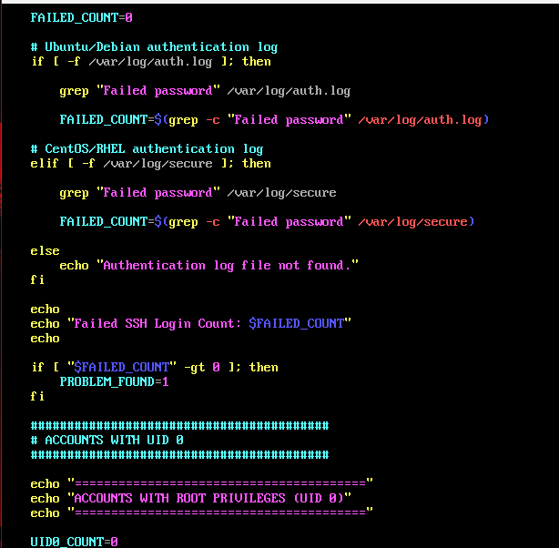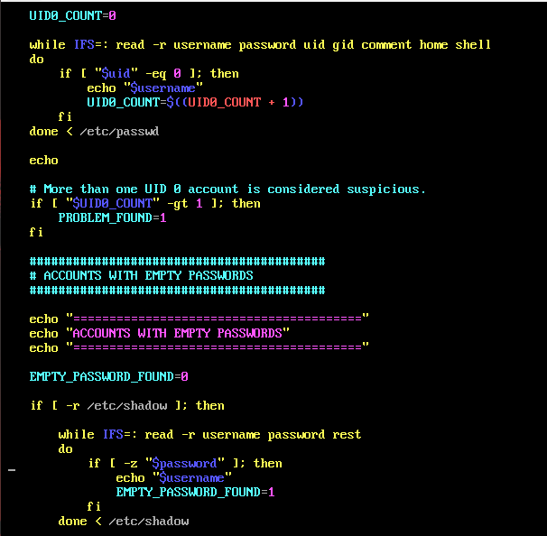
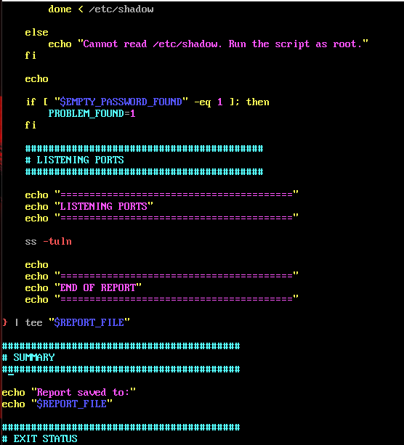
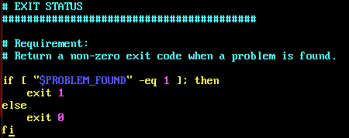

References:
https://man7.org/linux/man-pages/man8/ss.8.html
https://man7.org/linux/man-pages/man5/passwd.5.html
https://man7.org/linux/man-pages/man5/shadow.5.html
https://man7.org/linux/man-pages/man5/crontab.5.html
https://www.freedesktop.org/software/systemd/man/journalctl.html
https://www.gnu.org/software/bash/manual/
https://www.openssh.com/manual.html
https://man7.org/linux/man-pages/man1/journalctl.1.html
https://www.loggly.com/ultimate-guide/using-journalctl/
https://oneuptime.com/blog/post/2026-03-02-how-to-use-the-tee-command-for-output-redirection-on-ubuntu/view

