Architetture dei Sistemi di Elaborazione  [GRB-ZZZ] | Delivery date:  November 8th 2022
Laboratory  4 | Expected delivery of lab_04.zip must include:  - this document compiled possibly in pdf format.

- Introducing gem5

gem5 is freely available at: http://gem5.org/

the laboratory version uses the ALPHA CPU model previously compiled and placed at:

/opt/gem5/

the ALPHA compilation chain is available at:

/opt/alphaev67-unknown-linux-gnu/bin/

  - Write a hello world C program (hello.c). Then compile the program, using the ALPHA compiler, by running this command:

~/my_gem5Dir$ /opt/alphaev67-unknown-linux-gnu/bin/alphaev67-unknown-linux-gnu-gcc -static -o hello hello.c

  - Simulate the program

~/my_gem5Dir$ /opt/gem5/build/ALPHA/gem5.opt /opt/gem5/configs/example/se.py -c hello

In this simulation, gem5 uses AtomicSimpleCPU by default.

  - Check the results

your simulation output should be similar than the one provided in the following:

~/my_gem5Dir$ /opt/gem5/build/ALPHA/gem5.opt /opt/gem5/configs/example/se.py -c hello

gem5 Simulator System. http://gem5.org

gem5 is copyrighted software; use the --copyright option for details.

gem5 compiled Sep 20 2017 12:34:54

gem5 started Jan 19 2018 10:57:58

gem5 executing on this_pc, pid 5477

command line: /opt/gem5/build/ALPHA/gem5.opt /opt/gem5/configs/example/se.py -c hello

Global frequency set at 1000000000000 ticks per second

warn: DRAM device capacity (8192 Mbytes) does not match the address range assigned (512 Mbytes)

0: system.remote_gdb.listener: listening for remote gdb #0 on port 7000

warn: ClockedObject: More than one power state change request encountered within the same simulation tick

**** REAL SIMULATION ****

info: Entering event queue @ 0. Starting simulation...

info: Increasing stack size by one page.

hola mundo!

Exiting @ tick 2623000 because target called exit()

    - Check the output folder

in your working directory, gem5 creates an output folder (m5out), and saves there 3 files: config.ini, config.json, and stats.txt. In the following, some extracts of the produced files are reported.

    - Statistics (stats.txt)

---------- Begin Simulation Statistics ----------

sim_seconds 0.000003 # Number of seconds simulated

sim_ticks 2623000 # Number of ticks simulated

final_tick 2623000 # Number of ticks from beginning of simulation

sim_freq 1000000000000 # Frequency of simulated ticks

host_inst_rate 1128003 # Simulator instruction rate (inst/s)

host_op_rate 1124782 # Simulator op (including micro ops) rate(op/s)

host_tick_rate 564081291 # Simulator tick rate (ticks/s)

host_mem_usage 640392 # Number of bytes of host memory used

host_seconds 0.00 # Real time elapsed on the host

sim_insts 5217 # Number of instructions simulated

sim_ops 5217 # Number of ops (including micro ops) simulated

... ... ...

system.cpu_clk_domain.clock 500 # Clock period in ticks

... ... ...

    - Configuration file (config.ini)

... ... ...

[system.cpu]

type=AtomicSimpleCPU

children=dtb interrupts isa itb tracer workload

branchPred=Null

checker=Null

clk_domain=system.cpu_clk_domain

cpu_id=0

default_p_state=UNDEFINED

do_checkpoint_insts=true

do_quiesce=true

do_statistics_insts=true

dtb=system.cpu.dtb

eventq_index=0

fastmem=false

function_trace=false

- Simulate the same program using different CPU models.

Help command:
- ~/my_gem5Dir$ /opt/gem5/build/ALPHA/gem5.opt /opt/gem5/configs/example/se.py -h

List the CPU available models:

~/my_gem5Dir$ /opt/gem5/build/ALPHA/gem5.opt /opt/gem5/configs/example/se.py --list-cpu-types

  - TimingSimpleCPU simple CPU that includes an initial memory model interaction

~/my_gem5Dir$ /opt/gem5/build/ALPHA/gem5.opt /opt/gem5/configs/example/se.py --cpu-type=TimingSimpleCPU -c hello

  - MinorCPU the CPU is based on an in order pipeline including caches

~/my_gem5Dir$ /opt/gem5/build/ALPHA/gem5.opt /opt/gem5/configs/example/se.py --cpu-type=MinorCPU --caches -c hello

  - DerivO3CPU is a superscalar processor

~/my_gem5Dir$ /opt/gem5/build/ALPHA/gem5.opt /opt/gem5/configs/example/se.py --cpu-type=DerivO3CPU --caches -c hello

Create a table gathering for every simulated CPU the following information:
- Ticks
- Number of instructions simulated
- Number of CPU Clock Cycles
  - Number of CPU clock cycles = Number of ticks / CPU Clock period in ticks (usually 500)
- Clock Cycles per Instruction (CPI)
  - CPI = CPU Clock Cycles / instructions simulated
- Number of instructions committed
- Host time in seconds
- Number of instructions Fetch Unit has encountered (this should be gathered for the out-of-order processor only).

TABLE1: Hello program behavior on different CPU models
CPU  - Parameters | - AtomicSimpleCPU | - TimingSimpleCPU | - MinorCPU | - DeriveO3CPU
- Ticks | 2754000 | 398041000 | 34304500 | 20223500
- CPU clock domain | 500 | 500 | 500 | 500
- Clock Cycles | 5509 | 796082 | 68609 | 40448
- Instructions simulated | 5475 | 5475 | 5488 | 5276
- CPI | 1,006210046 | 145,403105023 | 12,501639942 | 7,66641395
- Committed instructions | 5475 | S5475 | 5488 | 5474
- Host seconds | 0.00 | 0.02 | 0.02 | 0.03
- Instructions encountered by Fetch Unit | no | no | no | 11250

- Download the test programs related to the automotive sector available in MiBench: basicmath, bitcount, qsort, and susan. These programs are freely available at https://github.com/embecosm/mibench
- compile the program basicmath using the provided Makefile using the ALPHA compiler

hint:

add a variable to the Makefile in order to use the ALPHA compiler:

CROSS_COMPILE = /opt/alphaev67-unknown-linux-gnu/bin/alphaev67-unknown-linux-gnu

CC=$(CROSS_COMPILE)-gcc

and substitute all the gcc occurrences with the new variable as follows:

gcc → $(CC)

then compile:

~/my_mybench_dir/automotive/basicmath/ make

- Simulate the program basicmath using the large set of inputs (i.e., compile basicmath_large.c) and the default processor (AtomicSimpleCPU), saving the output results. In the case the simulation time is higher than a couple of minutes (it is host-dependent!), modify the program in order to reduce the simulation time; for example, in the case of basicmath, it is necessary to reduce the number of iterations the program executes in order to reduce the computational time.

TODO (in case of long simulation time): To reduce the simulation time of basicmath_large.c, modify the number of iterations of the for loops as follows (RED arrow):

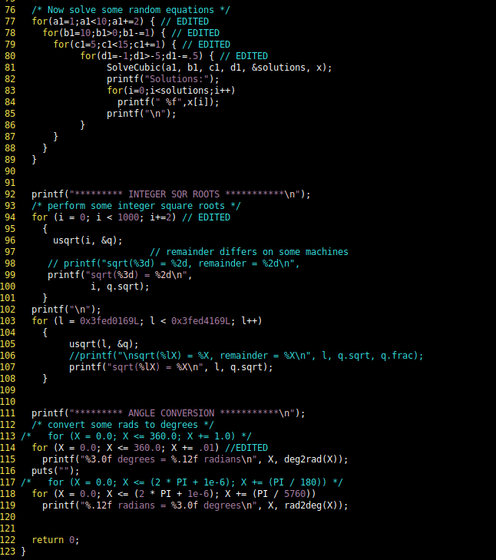

- Simulate the resulting program using the gem5 different CPU models and collect the following information:
  - Number of instructions simulated
  - Number of CPU Clock Cycles
  - Clock Cycles per Instruction (CPI)
  - Number of instructions committed
  - Host time in seconds
  - Prediction ratio for Conditional Branches (Number of Incorrect Predicted Conditional Branches / Number of Predicted Conditional Branches)
  - BTB hits
  - Number of instructions Fetch Unit has encountered.

Parameters f , g and h should be gathered exclusively for the out-of-order processor.

TABLE2: basicmath_large program behavior on different CPU models
CPUs  - Parameters | - AtomicSimpleCPU | - TimingSimpleCPU | - MinorCPU | - DerivO3CPU
- Ticks | 1809255076500 | 203803210682000
- CPU clock domain | 500 | 500 | 500 | 500
- Clock Cycles | 3618510154 | 407606421364 | 4288724507 | 1613967961
- Instructions simulated | 3618510091 | 2878382906 | 2878382932 | 2822662033
- CPI | 1,000000017 | 141,6095198 | 1,489977049 | 0,57178930
- Committed instructions | 3618510091 | 2878382906 | 2878382932 | 2878382905
- Host seconds | 1047.84 | 15245.69 | 8807.75 | 8340.62
- Prediction ratio |  |  |  | 3,9696477127
- BTB hits |  |  |  | 305471542
- Instructions encountered by Fetch Unit |  |  |  | 461563670

