**The Role of Different Levels of Multichannel Multimodal Learning Experience Delivery in Student Engagement**

**Abstract.** The present study aimed at exploring the pedagogical dimension of multichannel multimodal learning (MML) and its association with student engagement. 43 students of three courses taught in the same MML space at Shanghai Open University participated in the study and their behavioral, emotional, cognitive learning engagement was investigated. Although teaching in the same space, the three instructors developed different MML-integrated pedagogies and delivered different levels of MML experience (i.e. different numbers of modes and channels used and incorporated). A one-factor-three-level ANOVA with a Tukey HSD test was conducted to examine whether students’ behavioral, emotional, or cognitive learning engagement on three different levels of MML experience is different. The results showed behavioral and emotional engagement is significantly positively correlated (p-value = .0203 and .0262 respectively) to different MML-integrated pedagogies. Moreover, students’ perception of instructors’ integrating pedagogies into the MML environment were examined and shown to be significantly correlated (p-value = 0.0481) to that the present study identified. The present study pointed out the importance of instructors’ integrating pedagogies into MML environments. More modes and channels used and incorporated by instructors can better teaching quality by increasing learners’ behavioral and emotional engagement.

**Keywords**: multichannel multimodal learning, cognitive engagement, emotional engagement, behavioral engagement, pedagogical dimension

**1. Introduction**

Since learners represent different personality types, different learning styles and have different preferences for ways of course content delivery (Graham et al., 2005), there is a need to use “multichannel” approaches including face-to-face methods and online technologies delivering “multimodal” course content that meet the needs of a wide spectrum of learners and allow them to engage and experience learning in ways where they have preference, interest or ability and are most comfortable (Picciano, 2009). Multichannel multimodal learning (MML) environment is referred to an integrated multichannel access platform where learners can access to learning via attending in person, mobile apps, websites and so on, and course content is made and delivered available across a large range of modes (from single sensory experience to multisensory experience) to suit the varying learning styles of learners.

MML emphasizes how many channels and modes of learning a space can deliver at the same time instead of delivering them temporally complementarily. However, even teaching in the same MML space, different instructors may develop different MML-integrated pedagogies and deliver different levels of MML experience to learners. Literature rarely discussed the pedagogical dimension of MML, such as whether instructors’ levels of MML-integrated pedagogies are correlated to their teaching quality. Since many research results show that there is a significant relationship between student engagement and teaching quality (Hudley et al., 2003), the present study aimed at exploring the relationship between “numbers of channels and modes instructors used and integrated with their pedagogies” and “learners’ cognitive, behavioral, and emotional engagement.” Moreover, given that the former was identified by the researchers instead of learners, whether instructors’ levels of MML-integrated pedagogies can be perceived by students was also examined.

Therefore, the present study conducted a questionnaire survey on students at Shanghai Open University to examine their cognitive, behavioral, and emotional engagement. 43 students of three courses where instructors integrated the MML environment with their pedagogies at different levels (identified by the researchers) consented to participate in the study. Research questions about whether there is a statistically significant difference between students’ engagement at different levels of MML experience delivered by instructors will be answered (i.e., the number of channels and modes used by instructors and integrated into pedagogy).

**2. Literature Review**

2.1 Levels of Multichannel Multimodal Learning

Multichannel multimodal learning (MML) environment is referred to an integrated multichannel access platform where learners can access to learning via attending in person, mobile apps, websites and so on, and course content is made and delivered available across a large range of modes (from single sensory experience to multisensory experience) to suit the varying learning styles of learners (Mukhopadhyay & Parhar, 2001; Moreno & Mayer, 2007).

The concept is found used interchangeably with blended learning in current research (Malczyk, 2018). However, blended learning focuses on how complementary the relationship between face-to-face and distance learning is (Sankey et al., 2010). Ferdig et al. (2012) argued that in blended learning, computer/mobile-mediated activities are used to complement face-to-face teaching and learning in order to cut down inefficient time students spend in classrooms. On the other hand, MML emphasizes how many channels and modes of learning a space can deliver at the same time instead of delivering them temporally complementarily (Berland, 2014).

An MML space can be built with streaming media, multimodal recording and reproduction techniques, kinaesthetic communication tools, learning management platforms, mobile response systems and so on (i.e. hardware of MML) (Barbieri et al., 2005). However, how much an MML experience can be delivered to learners also depends on how instructors integrate their pedagogies with the MML environment. In other words, even supported by the same MML hardware and teaching in the same MML space, different instructors may develop different MML-integrated pedagogies (i.e. software of MML) and deliver different levels of MML experience to learners.

However, whether levels of MML experience delivery—i.e. numbers of channels and modes used by instructors—affect teaching and learning is seldom discussed in literature. Most current research focuses on the blended learning integration (i.e. how complementary offline and online pedagogies are) instead of the MML integration (i.e. how many channels and modes are integrated with pedagogies) (Sankey et al., 2010). Nonverbal modes are related to spatial orientation, body posture, hand gesture, glancing, and facial expression which can be presented by activities face-to-face discussion, live streaming interaction, and recorded lectures and so on (Fadel, 2008; Sprague & Dahl, 2009). And some studies stated that more nonverbal modes can help learners engage in course activities and thus help instructors enhance teaching quality (Naughton & Redfern, 2002; Chambers, 1999). Modes related to facial expression or eye contact are also found involving very important mechanisms for helping instructors engage learners in learning emotionally (Kyei-Blankson et al., 2016). Moreover, some studies further argued that more delivery channels (even carrying out the same content) will not lead to cognitive overloads but learning encouragement given that the current generation of students is get used to adopt a multichannel and multimodal way of experiencing their daily environment (Lloyd, 2013; Ganapathy & Seetharam, 2016); a course content that is primarily delivered in one channel (e.g., classroom or LMS) is not sufficient (Picciano, 2009). However, even so, whether more numbers of channels and modes instructors used and integrated with their pedagogies, delivering higher levels of MML experience to learners were associated with teaching quality still remains unexplored in literature.

2.2 Learning Engagement

Studies show that learning engagement of learners from K-12 to higher education is significantly positively correlated to teaching quality (Hudley et al., 2003). Therefore, when discussing the relationship between levels of MML experience and teaching quality, students' learning engagement plays an important role.

There are many definitions of learning engagement. Chapman (2003) and Klem & Connell (2004) described it as the tendency of voluntarily participating in learning activities in the dimensions of behavior, emotion, and cognition. Russell et al. (2005) defined it as “the energy in action to learn,” which connects learners to learning activities. The energy can be viewed from three perspectives: behavioral, emotional and cognitive learning engagement. Fredericks et al. (2004) regarded learning engagement as the reflection of learners’ attitude towards learning and the mental consumption on learning activities which can be also divided into three dimensions: behavior, emotion and cognition. Kuh (2009) also defined learning engagement as the reflection of energy consumption but emphasized the consumption on interaction with others during learning processes in the same three dimensions.

2.3 Behavioral, Emotional, and Cognitive Engagement

According to the literature above, learning engagement can be measured from three perspectives: behavioral, emotional, and cognitive engagement. In terms of behavioral engagement, time, attendance, and frequency of learners’ interaction with course materials, learning activities, peers and instructors are considered the embodiment of behavioral engagement (Greene et al., 2008). Studies have shown that the higher the frequency and the longer the time students devote to learning activities, the better their academic performance which reflects teaching quality (Kuh et al., 2005; Pascarella and Terenzini, 2005).

In terms of emotional engagement, studies have also shown that it can predict learning outcomes and reflect teaching quality (Mo & Singh, 2008; Lee, 2014; Furrer & Skinner, 2003). This dimension of learning engagement is related to learners’ identification with and attitude towards peers and instructors, and affective reactions to and interests in pedagogies and learning environments (Fredricks et al., 2004). Furthermore, Tai et al. (2014) found that learners’ emotional engagement can be used to measure teaching quality. Students’ emotional engagement is correlated to learning performance and students’ perceived teaching quality.

In terms of cognitive engagement, it is related to mental resources learners allocate on learning activities, their familiarity with course content, effectiveness of their learning strategies, and their persistence of pursuing learning effectiveness (Yazzie-Mintz and McCormick, 2012). Thiessen and Blasius (2008) and Walker and Greene (2009) also found that the higher the teaching quality and effectiveness in the pedagogical dimension is, the more students are willing to make adjustments to their learning strategies for the pedagogy, which shows high cognitive engagement and is correlated to their learning performance. Therefore, cognitive engagement can be used to predict learning performance as well as to measure teaching quality and effectiveness in the pedagogical dimension.

In conclusion, behavioral, emotional, and cognitive engagement can be regarded as one of the indicators of teaching quality and effectiveness especially in the pedagogical dimension. In order to evaluate the effectiveness of pedagogies in terms of the levels of MML integration, the present study will analyze students’ behavior, emotion and cognitive engagement as outcome variables of different MML-integrated pedagogies.

**3. Methods**

3.1 Participants and Cases

Three courses offered at different MML-integration levels at Shanghai Open University were selected as research cases (which were denoted by Case W, Case S, and Case Y). Instructors and students of the three cases consented to participate in the present research. There were 43 students in total, 15 students in Case W, 15 in Case S, and 13 in Case Y. Each student only took one of the three courses. The three cases were compared in Table 1 and shown the patterns (See Figure 1-3) of channels and modes the instructors used and integrated with their pedagogies, leading to different levels of MML experience to learners.

*Table 1*. Comparison of the Three Cases

|  |  |  |  |  |
| --- | --- | --- | --- | --- |
|  | MML-integration Level | Channels Used and Integrated | | Modes Used and Integrated |
| Case W | High | Classroom, Computer, & Smartphone | The instructor delivered course content in classroom and in a live-broadcasting platform. The live-broadcasting content would be recorded and uploaded on LMS. Moreover, students either in classroom or not can interact with the instructor synchronously via an IRS app. | Text (vision), Face-to-face lecture (vision, audition, & proprioception), Video (vision & audition), Live streaming (vision & audition), IRS app (vision & audition) |
| Case Y | Medium | Classroom & Computer | The instructor delivered course content in classroom and in a live-broadcasting platform. Students not in classroom can interact with the instructor via an online chat room on the platform with their computers. All the live-broadcasting and chatting content would be recorded and uploaded on LMS. | Text (vision), Face-to-face lecture (vision, audition, & proprioception), Video (vision & audition), Live streaming (vision & audition), Live chat room (vision) |
| Case S | Low | Classroom | Though teaching in an MML-support environment, the instructor greatly relied on delivering course content synchronously in classroom with printed materials, chalkboard, slides, and so on. | Text (vision), Face-to-face lecture (vision, audition, & proprioception) |

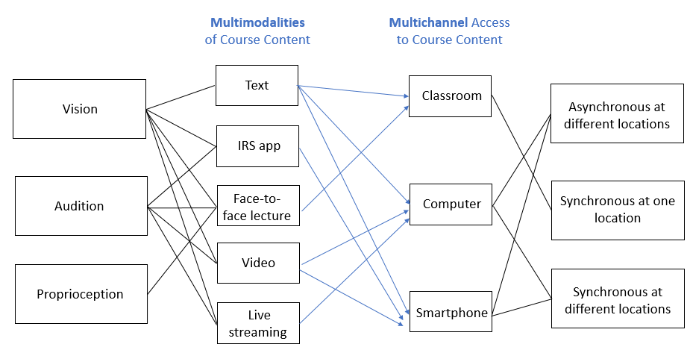

*Figure 1*. Pattern of Case W

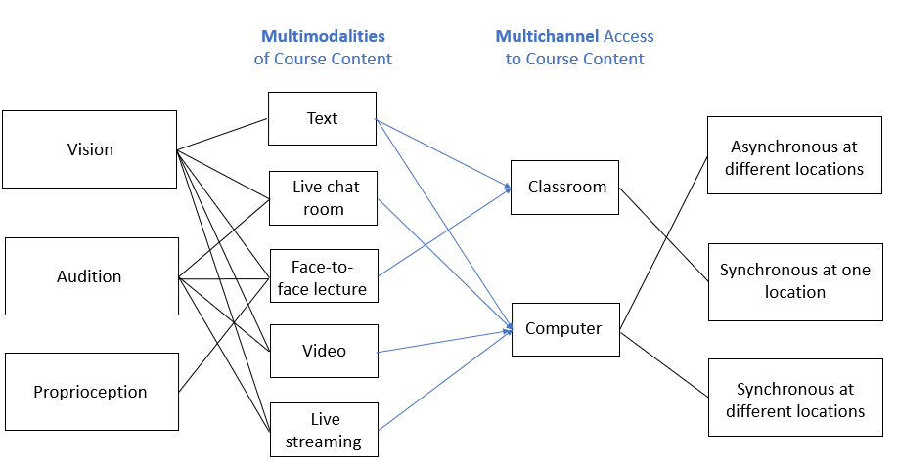

*Figure 2*. Pattern of Case Y

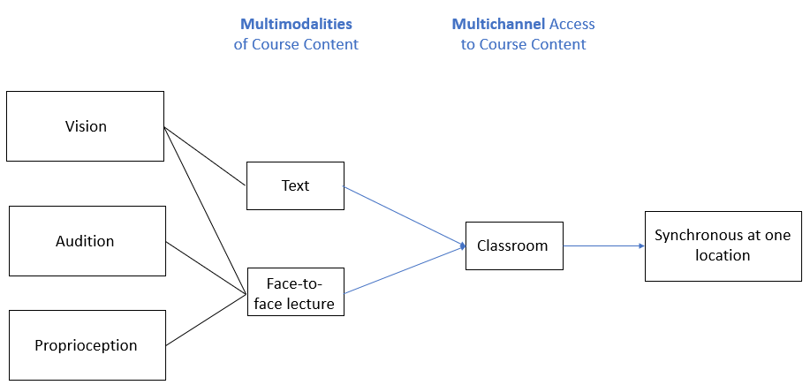

*Figure 3*. Pattern of Case S

3.2 Procedure, Instruments, and Questions

The present study conducted a questionnaire survey on 43 students to examine their cognitive, behavioral, and emotional engagement of the three courses offered at different MML-integration levels. The questionnaire included 5 items for the dimension of behavioral engagement, 7 items for that of cognitive engagement, and 7 items for that of emotional engagement in which a 5-point Likert scale was adopted. All 19 items were selected and adjusted from the Dogan’s (2014) Student Engagement Scale (SES). A reliability analysis was conducted for the items in each dimension (See Table 2). The results showed that in the three dimensions (i.e., behavioral, cognitive, and emotional engagement), Cronbach’s Alpha was .94, .89, and .87 respectively, which according to Kline (1999) indicated a good level of reliability (i.e. higher than .8).

Moreover, a statistical power analysis was conducted to make sure the same size is sufficient. According to Cohen (1988), the power was set to .8, the significant level was set to .05, *f* was set to .55 (i.e., large effect size), and *k* was set to 3 (i.e., three courses offered at different levels of MML-integrated pedagogy); finally, the minimum sample size for each course was determined to be 11.676. In the present study, each sample size is larger than 12, which indicated that it was conducted with sufficient statistical power.

*Table 2*. Reliability Analysis on Engagement Items

|  |  |  |  |  |  |
| --- | --- | --- | --- | --- | --- |
| Dimension | Cronbach’s *α* | Average inter-item correlation | Median inter-item correlation | Lower inter-item correlation | Upper inter-item correlation |
| Behavioral Engagement | 0.94 | 0.79 | 0.82 | 0.92 | 0.97 |
| Cognitive Engagement | 0.89 | 0.63 | 0.63 | 0.85 | 0.94 |
| Emotional Engagement | 0.87 | 0.63 | 0.61 | 0.83 | 0.92 |

To answer the research question that in the same MML environment (i.e., the number of channels and modes available for instructors to use), whether there is a statistically significant difference between students’ engagement at different MML-integrated pedagogies (i.e., different numbers of channels and modes used by instructors and incorporated into pedagogies). Corresponding hypotheses are shown below.

H01: In the same MML environment, there is no significant difference between students’ behavioral engagement at different levels of instructors’ incorporating pedagogies in the MML environment.

H02: In the same MML environment, there is no significant difference between students’ emotional engagement at different levels of instructors’ incorporating pedagogies in the MML environment.

H03: In the same MML environment, there is no significant difference between students’ cognitive engagement at different levels of instructors’ incorporating pedagogies in the MML environment.

1. **Data Analysis and Results**

To test the hypotheses, the data of each engagement dimension were analyzed by a one-factor-three-level ANOVA to explore whether there is a difference in terms of each engagement dimension between students of the three courses.

In the scope of descriptive statistics, students’ average emotional engagement was 4.80, 4.58, and 4.98 in the case W, S, and Y respectively. Students’ mean cognitive engagement was 4.70, 4.56, and 4.75 in the case W, S, and Y respectively. Finally, students’ average behavioral engagement was 4.83, 4.49, and 4.95 in the case W, S, and Y respectively. Furthermore, a one-factor-three-level ANOVA was conducted to examine whether the three distributions in the same dimension came from the same distribution—i.e., testing the three hypotheses. The results were shown in Table 3.

*Table 3.* One-Factor-Three-Level ANOVA in Each Engagement Dimension

|  |  |  |  |  |  |  |
| --- | --- | --- | --- | --- | --- | --- |
|  |  | Df | Sum Sq | Mean Sq | *F* value | Pr(>F) |
| Emotional Engagement | One factor:  Different Cases (Levels of MML Integration) | 2 | 1.110 | 0.5549 | 3.995 | 0.0262 * |
| Residuals | 40 | 5.556 | 0.1389 |  |  |
| Cognitive Engagement | One factor:  Different Cases (Levels of MML Integration) | 2 | 0.271 | 0.1354 | 0.684 | 0.511 |
| Residuals | 40 | 7.922 | 0.1981 |  |  |
| Behavioral Engagement | One factor:  Different Cases (Levels of MML Integration) | 2 | 1.616 | 0.8082 | 4.304 | 0.0203 * |
| Residuals | 40 | 7.511 | 0.1878 |  |  |

Signif. codes: 0 ‘***’ 0.001 ‘**’ 0.01 ‘*’ 0.05 ‘.’ 0.1 ‘ ’ 1

Based on the result, the present study rejected H01 and H02 that hypothesized that there is no significant difference between students’ behavioral (*p*-value = .0203 < .05) and emotional (*p*-value = .0262 < .05) engagement at different levels of MML experience delivered by instructors, but failed to reject H03 hypothesizing there is no significant difference between students’ cognitive engagement (*p*-value = .511). Therefore, In response to the research questions, through the one-factor-three-level ANOVA, the present study found that in the same MML environment, there is a significant difference between students in terms of their behavioral and emotional engagement at different levels of MML experience delivery.

The one-factor-three-level ANOVA informed that among the three cases overall, there was at least one case different from others in terms of students’ emotional and behavioral engagement. However, which case it was remained unknown. Therefore, the present study further conducted a post hoc analysis of Tukey's honestly significant difference (HSD) test for exploring where the difference lay (i.e. finding out which specific case’s means was different) in terms of students’ emotional and behavioral engagement. The test compared all possible pairs of means and the results are shown in *Table 4*.

*Table 4*. Results of Tukey's Test for Post-Hoc Analysis

|  |  |  |  |  |  |
| --- | --- | --- | --- | --- | --- |
| Tukey multiple comparisons of means  95% family-wise confidence level | | | | | |
| Emotional Engagement | Case Comparison (Pairwise) | diff | lwr  (95% family-wise confidence level) | upr  (95% family-wise confidence level) | *p* adj |
| S-W | -0.2190476 | -0.55026416 | 0.1121689 | 0.2533814 |
| Y-W | 0.1780220 | -0.16569767 | 0.5217416 | 0.4254140 |
| Y-S | 0.3970696 | 0.05334995 | 0.7407892 | 0.0203221 |
| Tukey multiple comparisons of means  95% family-wise confidence level | | | | | |
| Behavioral Engagement | Case Comparison (Pairwise) | diff | lwr  (95% family-wise confidence level) | upr  (95% family-wise confidence level) | *p* adj |
| S-W | -0.3333333 | -0.71845121 | 0.05178455 | 0.1012471 |
| Y-W | 0.1271795 | -0.27247623 | 0.52683520 | 0.7206431 |
| Y-S | 0.4605128 | 0.06085711 | 0.86016853 | 0.0206876 |

According to the results of the Tukey's HSD test (i.e. the case S is significantly different from the case Y and marginally significantly different from the case W) with the results of one-factor-three-level ANOVA (i.e. there is a significant difference among the three cases), it can be inferred that in terms of both students’ emotional and behavioral engagement, the case S is different from and less than the other two. Visualization of the Tukey's HSD test is shown in Figure 4 for emotional engagement and Figure 5 for behavioral engagement. This finding indicated that there is a relationship between the number of channels and modes used by instructors and integrated with pedagogies and learners’ emotional and behavioral engagement since students’ behavioral and emotional engagement was lower in the course of a lower level of MML experience delivery (i.e. the case S).

*Figure 4*. Visualization of the Tukey's HSD Test on Emotional Engagement

*Figure 5*. Visualization of the Tukey's HSD Test on Behavioral Engagement

1. **Discussions**

In light of the results, there are some points worth discussion. First of all, although the finding supported the relationship between levels of MML integration and learners’ behavioral and emotional, the levels were identified by the researchers instead of learners. Whether learners perceived the same way (i.e. whether their perceived levels of MML integration and experience are different between the courses) was unknown. Therefore, the present study conducted a post hoc exploration on the participants’ perception of instructors’ integrating their pedagogies with the MML environment (e.g. frequency of channels and modes use, familiarity with channels and modes use, etc.).

Learners’ perception of instructors’ integrating their pedagogies with the MML environment was measured by a following 6-item survey (with a .95 of Cronbach’s α shown in Table 5) based on the Perception of Learning (POL) Questionnaire (Sagayadevan & Jeyaraj, 2012). The result showed that the perception in the case W is 4.63, that in the case S is 4.44, and that in the case Y is 4.94, indicating perception of instructors’ integrating their pedagogies with the MML environment is lower in the case S than other ones on the scope of descriptive statistics. A further analysis of one-factor-three-level ANOVA was conducted and indicated that there is a significant difference (with a *p*-value = 0.0481) shown in Table 6. This finding can be inferred that learners’ perception of MML integration with pedagogies is different and that in the case S is lower than others, which is the same as the level of instructors’ integrating the MML environment with pedagogy the present study identified. This pointed out that the number of channels and modes used by instructors and integrated with pedagogies—either identified by the researchers or perceived by the learners—is correlated to students’ behavioral and emotional engagement.

*Table 5*. Reliability Test on Learners’ Perception of MML Integration

|  |  |  |  |  |
| --- | --- | --- | --- | --- |
| Cronbach’s *α* | Average inter-item correlation | Median inter-item correlation | Lower inter-item correlation | Upper inter-item correlation |
| 0.95 | 0.79 | 0.80 | 0.93 | 0.97 |

*Table 6*. One-factor-three-level ANOVA on Learners’ Perception of MML Integration

|  |  |  |  |  |  |  |
| --- | --- | --- | --- | --- | --- | --- |
|  |  | Df | Sum Sq | Mean Sq | *F* value | Pr(>F) |
| Learner perception of instructors’ integrating their pedagogies with the MML environment | One factor:  Different Cases (Levels of MML Integration) | 2 | 1.697 | 0.8486 | 3.278 | 0.0481 * |
| Residuals | 40 | 10.356 | 0.2589 |  |  |

Signif. codes: 0 ‘***’ 0.001 ‘**’ 0.01 ‘*’ 0.05 ‘.’ 0.1 ‘ ’ 1

The second point worth discussion is why cognitive engagement is not associated with levels of MML integration. Different numbers of channels and modes used by instructors and integrated with pedagogies have no effect (neither negative nor positive) on student cognitive engagement. This result can be inferred that although cognitive engagement is about the expenditure and reception of mental energy (Pintrich & DeGroot, 1990; Zimmerman, 2002), delivering more channels and modes of learning content will not put extra burden of mental resources on learners. This supported the findings (Picciano, 2009 ;Lloyd, 2013; Ganapathy & Seetharam, 2016) that more channels or modes of information consumption will not lead to cognitive overloads since the current generation of students is get used to adopt a multichannel and multimodal way of experiencing their daily environment. However, this does not mean that more channels or modes can reduce cognitive burden since the result also showed more channels or modes does not improve cognitive focus on learning or increase learning attention span either.

Finally, although the present study was conducted in an MML environment, learners’ engagement was measured self-reportedly. Given that MML is not only about inputs (e.g. multichannel multimodal course content) to learning, but also about outputs of learning (e.g. multichannel multimodal data collection of students’ learning), it is worth considering measuring students’ engagement by collecting multichannel multimodal data in an MML space. For example, Psaltis et al. (2017) conducted a novel methodology for the automatic recognition of gamers’ behavioral, cognitive and emotional engagement by body motion and facial expression sensor technologies (e.g. the Kinect sensor). Therefore, future works are recommended to combine self-report questionnaires with technologies (e.g. wearable cameras, wearable sensors, biosensors, gesture sensing, infrared imaging, and eye tracking) that collect MML data as outputs of learning (Blikstein & Worsley, 2016) to measure students’ real-time and minute-by-minute learning engagement or other learner dimensions especially those involving MML activities. These studies indicated that measuring learning behavior by multichannel multimodal output data of learning works and can be combined with self-reported data to enhance accuracy, which is worth considering for future works.

1. **Conclusions**

The key motivation for incorporating educational technologies into pedagogies is unquestionably the desire to help instructors improve the engagement of learners that reflects the teaching quality. Since the current generation of students has been getting used to a multichannel multimodal way of experiencing their daily environment, a learning space providing multichannel (i.e. multiple accesses to) and multimodal (i.e. multiple representations of) course content is assumed to enhance learners’ engagement.

The finding of the present study supported the assumption and indicated that there was a significant relationship between the number of channels and modes (used by instructors and integrated with pedagogies) and learners’ behavioral and emotional engagement. It pointed out the importance of instructors’ integrating pedagogies into MML environments. More modes and channels used and incorporated by instructors can better teaching quality by increasing learners’ behavioral and emotional engagement. The present study provided evidence encouraging institutional investments in MML implementation and instructors to leverage the power of MML facilities to improve their teaching quality.

**Reference**

Barbieri, T., Bianchi, A., Sbattella, L., Carella, F., & Ferra, M. (2005). Multiabile: A multimodal learning environment for the inclusion of impaired e-learners using tactile feedbacks, voice, gesturing, and text simplification. *Assist Technol: From Virtuality to Real, 16*(1), 406-10.

Berland, M., Baker, R. S., & Blikstein, P. (2014). Educational data mining and learning analytics: Applications to constructionist research. *Technology, Knowledge and Learning, 19*(1-2), 205-220.

Blikstein, P., & Worsley, M. (2016). Multimodal Learning Analytics and Education Data Mining: using computational technologies to measure complex learning tasks. *Journal of Learning Analytics, 3*(2), 220-238.

Chapman, E. (2003). Alternative approaches to assessing student engagement rates. *Practical assessment, research & evaluation, 8*(13), 1-10.

Chambers, M. (1999). The Efficacy and Ethics of Using Digital Multimedia for Educational Purposes. In Tait, A. & Mills, R. (eds): *The Convergence of Distance and Conventional Education: Patterns of Flexibility for the Individual Learner*. London: Routledge, 5-16.

Dogan, U. (2014). Validity and reliability of student engagement scale. *Bartin University Journal of Faculty of Education, 3*(2), 309-403.

Fadel, C. (2008). *Multimodal Learning Through Media: What the Research Says*. San Jose, CA: Cisco Systems.

Ferdig, R., Cavanaugh, C., & Freidhoff, J. (2012). *Lessons learned from blended programs: Experiences and recommendations from the field*. Vienna, VA: iNACOL.

Fredricks, J. A., Blumenfeld, P. C., & Paris, A. H. (2004). School engagement: Potential of the concept, state of the evidence. *Review of educational research, 74*(1), 59-109.

Furrer, C., & Skinner, E. (2003). Sense of relatedness as a factor in children's academic engagement and performance. *Journal of educational psychology, 95*(1), 148.

Ganapathy, M., & Seetharam, S. A. (2016). The Effects of Using Multimodal Approaches in Meaning-Making of 21st Century Literacy Texts among ESL Students in a Private School in Malaysia. *Advances in Language and Literary Studies, 7*(2), 143-155.

Graham, C. R., Allen, S., & Ure, D. (2005). *Benefits and challenges of blended learningenvironments. In M. Khosrow-Pour (Ed.)*, Encyclopedia of information science and technology (pp. 253-259). Hershey, PA: Idea Group Inc.

Greene, T. G., Marti, C. N., & McClenney, K. (2008). The effort—outcome gap: Differences for African American and Hispanic community college students in student engagement and academic achievement. *The Journal of Higher Education, 79*(5), 513-539.

Hudley, C., Daoud, A., Polanco, T., Wright-Castro, R., & Hershberg, R. (2003, April). Student engagement, school climate, and future expectations in high school. Paper presented at *the 2003 Biennial Meeting of the Society for Research in Child Development*, Tampa, FL.

Klem, A. M., & Connell, J. P. (2004). Relationships matter: Linking teacher support to student engagement and achievement. *Journal of school health, 74*(7), 262-273.

Kline, T. J. (1999). The team player inventory: Reliability and validity of a measure of predisposition toward organizational team-working environments. *Journal for specialists in Group Work, 24*(1), 102-112.

Kuh, G. D. (2009). What student affairs professionals need to know about student engagement. *Journal of college student development, 50*(6), 683-706.

Kuh, G. D., Kinzie, J., Schuh, J. H., & Whitt, E. J. (2005). Never let it rest lessons about student success from high-performing colleges and universities. *Change: The Magazine of Higher Learning, 37*(4), 44-51.

Kyei-Blankson, L., Ntuli, E., & Donnelly, H. (2016). Establishing the importance of interaction and presence to student learning in online environments. *World Journal of Educational Research, 3*(1), 48-65.

Lee, J. S. (2014). The relationship between student engagement and academic performance: Is it a myth or reality?. *The Journal of Educational Research, 107*(3), 177-185.

Lloyd, M. (2013). Something’s coming, something good: Identifying TPACK competence in preservice teachers’ analyses of learning objects. *Australian Educational Computing, 28*(1). Retrieved from http://journal.acce.edu.au/index.php/AEC/article/view/12/PDF

Malczyk, B. R. (2018). Multimodal Instruction: The New Hybrid. *Journal of Nonprofit Education and Leadership, 8*(1), 16-31.

Mo, Y., & Singh, K. (2008). Parents’ relationships and involvement: Effects on students’ school engagement and performance. *RMLE online, 31*(10), 1-11.

Moreno, R., & Mayer, R. (2007). Interactive multimodal learning environments. *Educational psychology review, 19*(3), 309-326.

Mukhopadhyay, M., & Parhar, M. (2001). Instructional design in multi‐channel learning system. *British Journal of Educational Technology, 32*(5), 543-556.

Pascarella, E. T., and Terenzini, P. T. (2005). *How College Affects Students: A Third Decade of Research*, San Francisco, CA: Jossey-Bass.

Picciano, A. G. (2009). Blending with purpose: The multimodal model. *Journal of asynchronous learning networks, 13*(1), 7-18.

Pintrich, P. R., & De Groot, E. V. (1990). Motivational and self-regulated learning components of classroom academic performance. *Journal of Educational Psychology, 82*(1), 33-40.

Psaltis, A., Apostolakis, K. C., Dimitropoulos, K., & Daras, P. (2017). Multimodal student engagement recognition in prosocial games. *IEEE Transactions on Games, 10*(3), 292-303.

Redfern, S., & Naughton, N. (2002). Collaborative virtual environments to support communication and community in internet-based distance education. *Journal of Information Technology Education, 1*(3), 210-220.

Russell, V. J., Ainley, M., & Frydenberg, E. (2005). Student motivation and engagement. *Schooling issues digest, 2*, 1-11.

Sagayadevan, V., & Jeyaraj, S. (2012). The Role of Emotional Engagement in Lecturer-Student Interaction and the Impact on Academic Outcomes of Student Achievement and Learning. *Journal of the Scholarship of Teaching and Learning, 12*(3), 1-30.

Sankey, M., Birch,D., & Gardiner, M. (2010). Engaging students through multimodal learning environments: The journey continues. In *Proceedings of ASCILITE Australian Society for Computers in Learning in Tertiary Education Annual Conference 2010* (pp. 852-863). Retrieved from http://www.editlib.org/p/45485

Sprague, E. W., & Dahl, D. W. (2009). Learning to click: An evaluation of the personal response system clicker technology in introductory marketing courses. *Journal of Marketing Education, 32*(1), 93-103.

Tai, D. W., Tai, V., & Wang, R. (2014). Assessment Criteria of Vocational College Students’ Learning Engagement. *International Journal of Technology and Engineering Education, 11*(1), 31-38.

Thiessen, V., & Blasius, J. (2008). Mathematics achievement and mathematics learning strategies: Cognitive competencies and construct differentiation. *International Journal of Educational Research, 47*(6), 362-371.

Walker, C. O., & Greene, B. A. (2009). The relations between student motivational beliefs and cognitive engagement in high school. The Journal of Educational Research*, 102*(6), 463-472.

Yazzie-Mintz, E., & McCormick, K. (2012). Finding the humanity in the data: Understanding, measuring, and strengthening student engagement. *Handbook of research on student engagement* (pp. 743-761). Boston, MA: Springer.

Zimmerman, B. J. (2002). Becoming a self-regulated learner: An overview. *Theory into Practice, 41*(2), 64-70.