**Exploring t****he Effect of Multichannel Multimodal Learning Environment on Student Motivation and Self-efficacy**

**Abstract.** Many multichannel multimodal learning (MML) spaces have been established since the current generation of learners has been getting used to a multichannel multimodal way of experiencing their daily environment. To evaluate the effectiveness of MML space implementation, the present study designed as intervention research examined the change of motivation and self-efficacy of 48 students at Shanghai Open University before and after their experiencing learning in an MML environment. The difference between students’ self-efficacy / intrinsic learning motivation before and after the MML intervention was shown significant (*p*-value = 0.01535 / 0.007103), but the difference in students’ extrinsic learning motivation was not (*p*-value = 0.2781). The results pointed out that MML environments enhance students’ perceived values of learning itself (compared with its extraneous values); more MML interactions make learning itself more valuable to students, which is evidence supporting the implementation of MML at institutions for learning promotion and teaching quality enhancement.

**Keywords**: multichannel multimodal learning, self-efficacy, intrinsic motivation, extrinsic motivation, learning environment

1 Introduction

Given the rising popularity of the Internet and Information Technology, the current generation of students has got used to adopting a multichannel and multimodal way of experiencing their daily environment. A course that primarily delivers one-mode experience (e.g. F2F lecture-based course content delivery) or is accessible on one channel (e.g. only in classrooms) is not sufficient. In response to the situation, a concept of multichannel multimodal learning (MML) environments is developed. Modality refers to a way of experiencing course content such as text (i.e. a mode of vision), videos (i.e. a mode of audio and vision), or lectures (i.e. (i.e. a mode of audio, vision, and likely proprioceptive interaction). Multimodality is a set of different modalities of course content (Moreno & Mayer, 2007). Channel refers to a medium for supporting a way of experiencing course content, such as classrooms, computers, or mobile phones. Multichannel learning space permits learners to access the same modality of course content through a variety of channels (Mukhopadhyay & Parhar, 2001). An MML environment is an integrated platform where learners can access to course content via attending in person, mobile apps, websites and so on, and course content can be experienced in a set of different modes to suit the varying learning styles of learners.

However, though an MML space theoretically benefits students and is assumed to be able to promote learning, the corresponding evaluation and empirical evidence are missing in literature. Many studies have examined how other learning spaces (e.g. MOOCs or traditional classrooms) promote learning by measuring learning motivation including self-efficacy (i.e. the expectation component), intrinsic and extrinsic motivation (i.e. the value component). Learners’ learning motivation and self-efficacy have thus been regarded as a factor to learning space evaluation (Pintrich & Schunk, 1996). Therefore, to fill the mentioned research gap, the present study conducted intervention research on 48 students at Shanghai Open University to explore the changes of their self-efficacy, intrinsic motivation, and extrinsic motivation after they experienced learning in an MML environment. The three variables of interest as indicators for the learning space evaluation will be measured and analyzed in order to answer the research question about whether an MML space enhances student motivation and self-efficacy that promote learning.

2 Literature Review

2.1 Multichannel Multimodal Learning Environment

Learning spaces used to be defined as "brick and mortar" educational institutions where course content was limited to be delivered synchronously (Graetz, 2006). However, given the increasing popularity of the Internet, the landscape of course content delivery has been shaped; concepts such as e-learning and distance learning were developed. These concepts represent a form of learning programmes that present physical classroom-based instructional content over the Internet. However, there still have been mixed results on which way (i.e., traditional classroom or e-learning) is better for students. Some studies showed e-learning is more likely to attract learners to experience and participate in learning activities than traditional learning (Klesius, 1997), some studies also found that learners are substantially less likely to complete online courses compared with face-to-face traditional ones (Carpenter et al., 2004; Xu & Jaggars, 2011; Zavarella, 2008), and others also showed that correlation between learner academic performance and the two learning spaces is not significant (Thomas, 2001).

In fact, the mixed results are not surprising or unexpected since learners represent different generations, different personality types, different learning styles and have different preferences for ways of course content delivery (Graham et al., 2005). According to Gardner (2011), intelligence is not a singular entity but is made up of multiple entities in different proportions used by individuals to understand and to learn about the world, which thus influences how people learn and leads to individual preferences in learning situations. In other words, there is no absolute one type of learning space that are suitable to all types of learners; instead, there is a need to use “multichannel” approaches including face-to-face methods and online technologies delivering “multimodal” course content that meet the needs of a wide spectrum of learners and allow them to engage and experience learning in ways where they have preference, interest or ability and are most comfortable (Picciano, 2009).

In this context, concepts such as multichannel and multimodal learning environment are developed. Modality refers to a way of experiencing course content such as text or live streaming; multimodality is a set of different modalities of the same course content (Moreno & Mayer, 2007). Channel refers to a device serving as a medium for supporting ways of experiencing course content, such as computers or mobile phones; multichannel learning space permits learners to access the same modality of course content through a variety of channels (Mukhopadhyay & Parhar, 2001). Accordingly, the present study defines an MML environment as a multichannel access platform where learners can access to learning via attending in person, mobile apps, websites and so on, and course content is made and delivered available across a large range of modes to suit the varying learning styles of learners (see Fig. 1). MML will allow learners to find the right mix for themselves out of all the possibilities in learning, no matter if they are offline or online, synchronous or asynchronous.

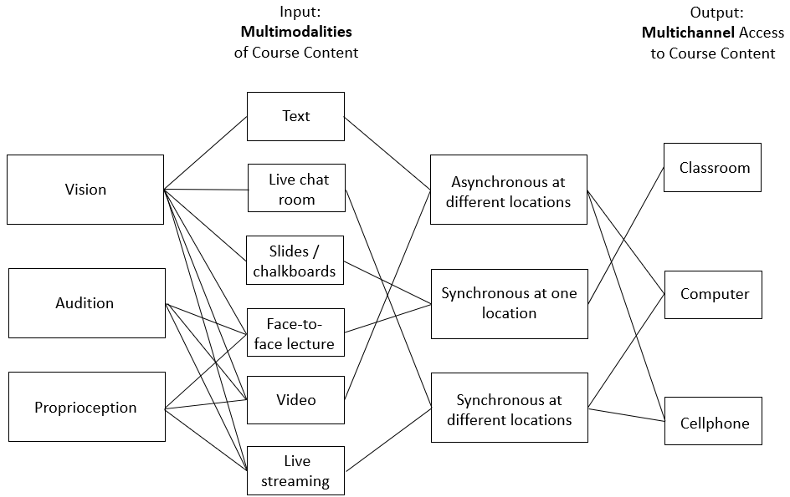

**Fig. 1.** MML environment integrating multi-modalities and multi-channels

2.2 Learning Motivation and Self-efficacy

Learning motivation has always been regarded as an important factor affecting learning behavior (Pintrich & Schunk, 1996) as well as an indicator to measure the quality of teaching (Lee, et al., 2010). From the perspective of learning motivation theory (Pintrich & De Groot, 1990), learning motivation that can be applied to predict learning behavior and measure teaching quality is mainly composed of two parts: the expectancy component and the value component.

The expectancy component refers to learners' individual belief in and self-judgment on whether they can achieve their learning goals, which is identified as self-efficacy. Self-efficacy was found to be highly correlated to learning motivation (Banfield & Wilkerson, 2014). Many empirical studies show that (Chentanez at al., 2004; Zimmerman, 1997; Schunk & Hanson, 1987), when students' learning motivation (as an independent variable) increases / decreases, their self-efficacy (as an outcome variable) also increases / decreases; when students' self-efficacy (as an independent variable) increases / decreases, their learning motivation as an outcome variable also increases / decreases. In addition, self-efficacy is in fact a context-based factor (Chentanez at al., 2004). For example, students with high self-efficacy in subject A may not have the same self-efficacy in subject B; because of this specificity, self-efficacy is regarded as a predictor to learning behavior in different contexts (e.g. different subjects or learning settings). Moreover, Multon, Brown & Lent (1991) conducting a meta-analysis on 39 studies, pointed out that self-efficacy as the expectancy component of learning motivation did have a significant impact on learning behavior to which teaching quality is correlated. Therefore, in terms of learning behavior and teaching quality evaluation, self-efficacy is an important indicator.

The value component can be divided into intrinsic motivation (internal goal orientation) and extrinsic motivation (external goal orientation). Intrinsic motivation means that conducting activities is driven by internal rewards that come from activities (such as learning), such as challenge seeking, so there is no need for extraneous incentives. Activities themselves are the major driving force (Husman & Lens, 1999). Intrinsic motivation was found correlated to and considered to have a positive impact on learning behavior (Pintrich & Schunk, 2002). On the contrary, extrinsic motivation refers to learning motivation driven by external factors. Learners are not interested in learning itself, but motivated by derivative values (e.g. praise or admiration) from its results (e.g. good performance) (Brophy, 2008). Similarly, extrinsic motivation was also found positively associated with learning behavior (Deci, Koestner, & Ryan, 1999). Therefore, in terms of learning behavior measurement and prediction, both intrinsic and extrinsic motivations are important indicators.

2.3 Learning Space Evaluation on Motivation and Self-efficacy

Learning space as a carrier of teaching and learning activities affects learning behavior and teaching quality. Theoretically, as indicators to learning behavior prediction and teaching quality measurement, self-efficacy (the expectation component), intrinsic and extrinsic motivation (the value component) can also be used to evaluate the effectiveness of learning spaces on learning behavior and teaching quality. That is to say, if learning behavior and teaching quality is affected by a learning space, this impact can be reflected by the change of learners’ learning motivation and self-efficacy.

Therefore, many studies have explored the correlation between learning motivation and self-efficacy and learning spaces as evaluation research. Lepper (1985) and Zhang et al. (2001) found that virtual learning spaces where learning activities were conducted on computers can make learning more intriguing (compared with that conducted in face-to-face ways) and increase the intrinsic motivation of learning. However, this result may be attributed to the curiosity for technology given that virtual learning was novel at the time. Mei and Hong (2011) established an online asynchronous learning spaces, where students can interact with each other through discussion forums and message boards. Designed as a learning space evaluation, the study found that the space did not increase learners’ intrinsic motivation but extrinsic motivation. The learners were found motivated to learn by a sense of achievement derived from publicly helping others solve exam and quiz problems, sharing good ideas and thoughts with others and so on. Following research of Lepper (1985), Zhang et al. (2001), and Mei and Hong (2011), more and more learning space evaluation studies (Sun & Rueda, 2012; Alqurashi, 2016; Valencia-Vallejo et al., 2019) have used learning motivation and self-efficacy as variables of interest to measure the effectiveness of learning spaces on learning behavior and teaching quality.

Most studies using learning motivation and self-efficacy for learning space evaluation in literature focused on single-channel (where course content is only accessible through one channel such as classrooms or websites) single-modal (where course materials are only delivered in one mode such as texts or videos) spaces. However, research on evaluating MML environments with learners’ motivation and self-efficacy is still limited. Therefore, in response to the research gap, this study will focus on MML spaces and explore their effect on students' intrinsic and extrinsic motivation and self-efficacy which reflects the spaces’ impact on learning behavior and teaching quality.

3 Methods

3.1 MML Environment at Shanghai Open University

In order to meet the needs of its diverse student body, Shanghai Open University has built MML environments where course content can be delivered in multimodal forms (e.g. text materials, videos, live streaming) across multichannel accesses to learning (e.g. classrooms on campus, LMS websites, LMS mobile apps, distance and on-site IRS). For example, a class can be delivered in classrooms (a channel) as a face-to-face lecture (a mode of vision, audition, and proprioception) and online through live streaming (a mode of vision and audition) on LMS websites (another channel) at the same time. Instructors and learners can also interact with each other through IRS mobile apps (another channel with a mode of vision and audition). And the class then can be recorded as a video (a mode of vision and audition) uploaded on LMS websites which learners can access via mobile phones as well. The MML environments support instructors and learners from the phase of course preparation through that of interaction during class to that of supervision after class (Fig. 2).

3.2 Research Design

The present study conducted intervention research where an MML space at Shanghai Open University is considered an intervention; in order to explore the effect of the intervention on the variables of interest (i.e., student learning intrinsic motivation, extrinsic motivation, and self-efficacy), the differences between the variables before and after experiencing learning in an MML space were analyzed.

48 students at Shanghai Open University consented to participate in the study. They experienced learning without the intervention in the first half of the semester and with the intervention (i.e. the MML space; see Section 3.1) in the second half of the semester. Their self-efficacy, intrinsic motivation, and extrinsic motivation with and without the intervention were surveyed through a questionnaire. The questionnaire was designed upon Lane, J. & Lane, A. (2001)’s self-efficacy survey and Duncan & McKeachie (2005)’s learning motivation survey and consisted of 14 items using a 5 point likert scale. There were 6 items for self-efficacy, 4 items for intrinsic motivation, and 4 items for extrinsic motivation. Cronbach's alpha for the self-efficacy items is 0.92 (shown in Table 1), that for the intrinsic motivation items is 0.85 (shown in Table 2), and that for the extrinsic motivation items is 0.84 (shown in Table 3). According to Kline (1999), the results indicated that each group of items has a good internal consistency (Cronbach's alpha of > 0.80), and the questionnaire is reliable.

**Table 1.** Result of Reliability Analysis on Self-efficacy Items

|  |  |  |  |  |  |  |  |  |  |  |
| --- | --- | --- | --- | --- | --- | --- | --- | --- | --- | --- |
| raw_alpha | std.alpha | G6(smc) | average_r | S/N | ase | mean | sd | median_r | lower | upper |
| 0.92 | 0.92 | 0.92 | 0.65 | 11 | 0.018 | 4.3 | 0.7 | 0.64 | 0.88 | 0.95 |

**Table 2.** Result of Reliability Analysis on Intrinsic Motivation Items

|  |  |  |  |  |  |  |  |  |  |  |
| --- | --- | --- | --- | --- | --- | --- | --- | --- | --- | --- |
| raw_alpha | std.alpha | G6(smc) | average_r | S/N | ase | mean | sd | median_r | lower | upper |
| 0.85 | 0.86 | 0.83 | 0.6 | 6.1 | 0.034 | 4.3 | 0.7 | 0.61 | 0.79 | 0.92 |

**Table 3.** Result of Reliability Analysis on Extrinsic Motivation Items

|  |  |  |  |  |  |  |  |  |  |  |
| --- | --- | --- | --- | --- | --- | --- | --- | --- | --- | --- |
| raw_alpha | std.alpha | G6(smc) | average_r | S/N | ase | mean | sd | median_r | lower | upper |
| 0.84 | 0.83 | 0.81 | 0.55 | 5 | 0.037 | 3.5 | 1.2 | 0.53 | 0.76 | 0.91 |

Moreover, a statistical power analysis is conducted to make sure the sample size is sufficient. According to Cohen (1988), the power is set to 0.8, the significant level is set to 0.05, and the Cohen's *d* is set to 0.8 (i.e. large effect size); finally, the minimum sample size is determined to be 20.033, than which the sample size of the present study is higher.

These three variables of interest as indicators for learning space evaluation will be measured and analyzed in order to answer the research question below:

Does an MML space enhance student motivation and self-efficacy that encourage learning behavior?

Given the research question, three hypotheses are developed below:

H01: Students’ self-efficacy after the intervention of being exposed to an MML environment is “less than or equal to” that before the intervention.

(Ha1: Students’ self-efficacy after the intervention of being exposed to an MML environment is “higher than” that before the intervention.)

H02: Students’ intrinsic motivation after the intervention of being exposed to an MML environment is “less than or equal to” that before the intervention.

(Ha2: Students’ intrinsic motivation after the intervention of being exposed to an MML environment is “higher than” that before the intervention.)

H03: Students’ extrinsic motivation after the intervention of being exposed to an MML environment is “less than or equal to” that before the intervention.

(Ha3: Students’ extrinsic motivation after the intervention of being exposed to an MML learning environment is “higher than” that before the intervention.)

4 Data Analysis and Results

To test the hypotheses, the present study conducted a one-tailed t-test to analyze mean differences between each of students’ self-efficacy, intrinsic motivation, and extrinsic motivation without the intervention and that with the intervention.

In the scope of descriptive statistics, self-efficacy, intrinsic motivation, and extrinsic motivation in the second half of the semester (i.e., after the intervention) is higher than that in the first half of the semester (i.e., before the intervention), see Fig. 2. Without experiencing learning in the MML environment, the mean self-efficacy of students is 4.347 (out of 5), the mean intrinsic motivation is 4.333, and the mean of extrinsic motivation is 3.469. On the other hand, with the intervention, the mean self-efficacy is 4.639, the mean intrinsic motivation is 4.661, and the mean extrinsic motivation is 3.630.

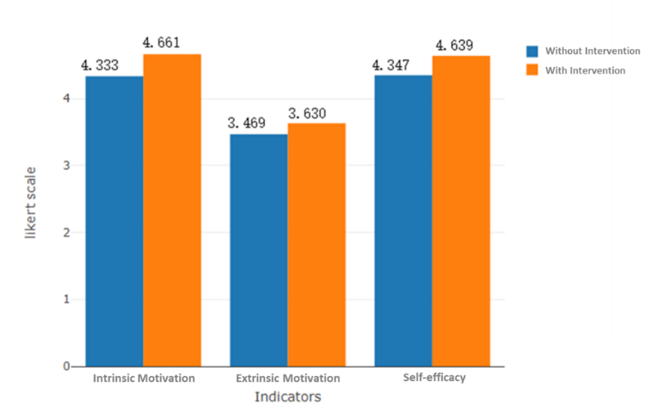

**Fig. 2.** Comparing students’ self-efficacy, intrinsic motivation, and extrinsic motivation before intervention (blue bars) with that after intervention (orange bars)

In order to examine whether the differences are statistically significant (more specifically, whether students’ self-efficacy, intrinsic motivation, and extrinsic motivation after the intervention of being exposed to the MML environment is “higher than” that before the intervention—i.e., rejecting the null hypotheses), a one-tailed t-test is conducted, and the results are shown in Table 4. In terms of students’ self-efficacy, the difference is significant (*p*-value = 0.01535 < 0.05); in terms of students’ intrinsic motivation, the difference is significant (*p*-value = 0.007103 < 0.05). However, in terms of students’ extrinsic motivation, the difference is not significant (*p*-value = 0.2781 > 0.05).

Therefore, according to the results which reject the first two null hypotheses (i.e., H01 & H02), but fail to reject the third hypothesis, the present study concludes that an MML space generally is capable of enhancing student motivation and self-efficacy that encourage learning behavior; although the improvement on extrinsic motivation is not statistically significant, in the scope of descriptive statistics, its change is still positive (at least not negative) after intervention implementation.

**Table 4.** One-tailed t-test on the Differences in Students’ Self-efficacy, Intrinsic Motivation, and Extrinsic Motivation between the Second (i.e., with the intervention) and First Half of the Semester (i.e., without the intervention)

|  |  |  |  |  |  |
| --- | --- | --- | --- | --- | --- |
| Indicators | Status | N | Mean | t-value | p-value |
| Self-efficacy | Without the Intervention | 48 | 4.347 | 2.1947 | 0.01535* |
| With the Intervention | 48 | 4.639 |
| Intrinsic Motivation | Without the Intervention | 48 | 4.333 | 2.5003 | 0.007103** |
| With the Intervention | 48 | 4.661 |
| Extrinsic Motivation | Without the Intervention | 48 | 3.469 | 0.59065 | 0.2781 |
| With the Intervention | 48 | 3.630 |

\**p*<0.05, \*\**p*<0.01.

5 Discussions

According the results, there are some points worth discussion. First of all, MML environments were found able to improve students’ self-efficacy and intrinsic motivation, but not extrinsic motivation. This indicates that creating an MML space can add “values on learning itself” but not create additional “instrumental value of learning.” For example, a student who watches course videos because she personally believes they are valuable for her chosen career is extrinsically motivated to learn. Being able to watch the videos through different channels or assimilate the same content in different modes will not affect the extrinsic motivation related to her career plan. On the other hand, since both learning self-efficacy and intrinsic motivation are about learning itself, creating an MML space can enhance the enjoyment of learning itself (i.e., increasing intrinsic motivation) and help overcome obstacles to learning itself (i.e., increasing self-efficacy). Students experiencing learning in the space will feel more efficacious and be motivated intrinsically to learn.

Second, in the scope of descriptive statistics, the participants’ self-efficacy and intrinsic motivation before the intervention were high (i.e. 4.347 and 4.333 on a 5-point Likert scale for self-efficacy and intrinsic motivation respectively). This points out a potential lack of external validity of present study, which may be attributed to participants’ self-selection bias that students consenting to make their learning-related behaviors be measured are those who already were confident in or enjoyed learning and thus would not mind their learning process to be analyzed. Moreover, it is also plausible that students consenting to participate in the study are those who were open-minded to studying in different spaces (including different modes and channels of learning), which may make the MML space have fewer negative effects on the sample than general learners.

Finally, since motivation and self-efficacy are not only two factors that promote learning, other factors such as self-regulation, self-determination, learning engagement should be explored in future works in order to more comprehensively evaluate the effect of MML environments on learning as a whole. Moreover, the factors were measured by questionnaires, which only generated self-reported data. Given that MML is not only about inputs (e.g. multichannel multimodal course content) to learning, but also about outputs of learning (e.g. multichannel multimodal data collection of students’ learning), it is worth considering measuring the factors by collecting multichannel multimodal data in an MML space. For example, self-regulation as a latent factor related to learning behavior was found measured through multichannel multimodal data in literature. Malmberg et al. (2019) conducted a study collecting multichannel multimodal data (including physiological data, video observations, and facial recognition data) to measure the types of regulation of learning. Wise and Hsiao (2019) examined students' regulation of listening and speaking by multichannel multimodal data such as click-stream data and manually coded post content for argumentation (Azevedo & Gašević, 2019). These studies pointed out that measuring learning behavior through multichannel multimodal output data of learning is promising and feasible for future works.

6 Conclusions

One of the core design principles of learning environments is to create settings strengthening the interaction between learners, course content, and instructors for enhancing learning motivation and self-efficacy. Thus, learners’ motivation and self-efficacy are usually measured to evaluate the effectiveness of learning space implementation. The present study evaluated an MML environment by conducting an intervention study on the change of learning motivation and self-efficacy of students at Shanghai Open University. The results showed that learners’ self-efficacy and intrinsic motivation can be enhanced after experiencing MML interactions with course content. This indicated that building learning spaces helping lecturers deliver MML experience is not only to meet learners’ needs (as the current generation of students has been getting used to a multichannel multimodal way of interacting with daily information), but also to make learning a more inherently interesting or enjoyable work that students feel more confident to do. The present study on effectiveness of MML environments provided evidence supporting the popularization of MML spaces at educational institutions.

**References**

Alqurashi, E. (2016). Self-efficacy in online learning environments: A literature review. *Contemporary Issues in Education Research, 9*(1), 45-51.

Azevedo, R., & Gašević, D. (2019). Analyzing multimodal multichannel data about self-regulated learning with advanced learning technologies: Issues and challenges. *Computers in Human Behavior, 96*, 207-210.

Banfield, J., & Wilkerson, B. (2014). Increasing student intrinsic motivation and self-efficacy through gamification pedagogy. *Contemporary Issues in Education Research, 7*(4), 291-298.

Barto, A. G., Singh, S., & Chentanez, N. (2004). Intrinsically motivated learning of hierarchical collections of skills. *In Proceedings of the 3rd International Conference on Development and Learning* (pp. 112-19).

Brophy, J. (2008). Developing students’ appreciation for what is taught. *Educational psychologist, 43*(3), 132-141.

Carpenter, T. G., Brown, W. L., & Hickman, R. C. (2004). Influences of online delivery on developmental writing outcomes. *Journal of Developmental Education, 28*(1), 14-16.

Cohen, J. (1988). *Statistical power analysis for the behavioral sciences (2nd ed.)*. Hillsdale, NJ: Erlbaum.

Deci, E. L., Koestner, R., & Ryan, R. M. (1999). A meta-analytic review of experiments examining the effects of extrinsic rewards on intrinsic motivation. *Psychological Bulletin, 125*, 627-668.

Duncan, T. G., & McKeachie, W. J. (2005). The making of the motivated strategies for learning questionnaire. *Educational psychologist, 40*(2), 117-128.

Gardner, H. (2011). *Frames of mind: The theory of multiple intelligences*. London: Hachette UK.

Graetz, K. A. (2006). The psychology of learning environments. *Educause Review*, *41*(6), 60-75.

Graham, C. R., Allen, S., & Ure, D. (2005). Benefits and challenges of blended learning environments. In M. Khosrow-Pour (Ed.), *Encyclopedia of information science and technology* (pp. 253-259). Hershey, PA: Idea Group Inc.

Husman, J., & Lens, W. (1999). The role of the future in student motivation. *Educational psychologist, 34*(2), 113-125.

Klesius, J. P., Homan, S., & Thompson, T. (1997). Distance education compared to traditional instruction: The students' view. *International Journal of Instructional Media, 24*(3), 207-227.

Kline, T. J. (1999). The team player inventory: Reliability and validity of a measure of predisposition toward organizational team-working environments. *Journal for specialists in Group Work, 24*(1), 102-112.

Lane, J., & Lane, A. (2001). Self-efficacy and academic performance. *Social Behavior and Personality: an international journal, 29*(7), 687-693.

Lee, J. C. K., Zhang, Z., & Yin, H. (2010). Using multidimensional Rasch analysis to validate the Chinese version of the Motivated Strategies for Learning Questionnaire (MSLQ-CV). *European journal of psychology of education, 25*(1), 141-155.

Lepper, M. R. (1985). Microcomputers in education: Motivational and social issues. *American Psychologist, 40*, 1-18.

Malmberg, J., Järvelä, S., Holappa, J., Haataja, E., Huang, X., & Siipo, A. (2019). Going beyond what is visible: What multichannel data can reveal about interaction in the context of collaborative learning? *Computers in Human Behavior, 96*, 235-245.

Mei, Z., & Hong J. (2011). Implementing theories in educational psychology in teaching and learning: How teachers facilitate students’ learning motivation through the use of e-learning. *Hong Kong Teachers’ Centre Journal, 10*, 27-33.

Moreno, R., & Mayer, R. (2007). Interactive multimodal learning environments. *Educational psychology review, 19*(3), 309-326.

Mukhopadhyay, M., & Parhar, M. (2001). Instructional design in multi‐channel learning system. *British Journal of Educational Technology, 32*(5), 543-556.

Multon, K. D., Brown, S. D., & Lent, R. W. (1991). Relation of self-efficacy beliefs to academic outcomes: A meta-analytic investigation. *Journal of counseling psychology, 38*(1), 30.

Picciano, A. G. (2009). Blending with purpose: The multimodal model. *Journal of asynchronous learning networks, 13*(1), 7-18.

Pintrich, P. R., & De Groot, E. V. (1990). Motivational and self-regulated learning components of classroom academic performance. *Journal of educational psychology, 82*(1), 33.

Pintrich, P. R., & Schunk, D. H. (2002). *Motivation in education: Theory, research, and applications*. Upper Saddle River, NJ: Prentice Hall.

Thomas, R. (2001). *The no significant difference phenomenon: A comparative research annotated bibliography on technology for distance education.* Montgomery, AL: IDECC.

Schunk, D. H., Hanson, A. R., & Cox, P. D. (1987). Peer-model attributes and children's achievement behaviors. *Journal of Educational Psychology, 79*(1), 54.

Sun, J. C. Y., & Rueda, R. (2012). Situational interest, computer self‐efficacy and self‐regulation: Their impact on student engagement in distance education. *British journal of educational technology, 43*(2), 191-204.

Valencia-Vallejo, N., López-Vargas, O., & Sanabria-Rodríguez, L. (2019). Effect of a metacognitive scaffolding on self-efficacy, metacognition, and achievement in e-learning environments. *Knowledge Management & E-Learning: An International Journal, 11*(1), 1-19.

Wise, A. F., & Hsiao, Y. T. (2019). Self-regulation in online discussions: Aligning data streams to investigate relationships between speaking, listening, and task conditions. *Computers in Human Behavior, 96*, 273–284.

Wong, L.‐H. (2012). A learner‐centric view of mobile seamless learning. *British Journal of Educational Technology, 43*(1), 19-23.

Xu, D., & Jaggars, S. S. (2011). *Online and hybrid course enrollment and performance in Washington State community and technical colleges.* New York, NY: Community College Research Center, Columbia University. Retrieved from http://ccrc.tc.columbia.edu/media/k2/attachments/online-hybridperformance-washington.pdf.

Zavarella, C. A. (2008). *Computer-based instruction and remedial mathematics: A study of student retention at a Florida community college* (Doctoral dissertation). Available from ProQuest Dissertations and Theses database (UMI No. ATT 33260369).

Zhang, J., Li, F., Duan, C., & Wu, G. (2001). Research on Self-efficacy of Distance Learning and its Influence to Learners’ Attainments. *In Proceedings of the International Conference on Computers in Education* (pp. 1510-1517).

Zimmerman, E. (1997). Building leadership roles for teachers in art education. *Journal of Art & Design Education, 16*(3), 282-284.