Part ll Labs
For this part, you are supposed to submit ONE doc/pdf file for all the questions. Label each question clearly.

Q9 Remove your public key from github and set up ssh authentication again. After setting up ssh connection again, create a cloud repo named CPSC254-23S-Final-YourOfficialName and clone it to local. Use screenshots of your terminal/browser to explain what you are doing at each step. (35)

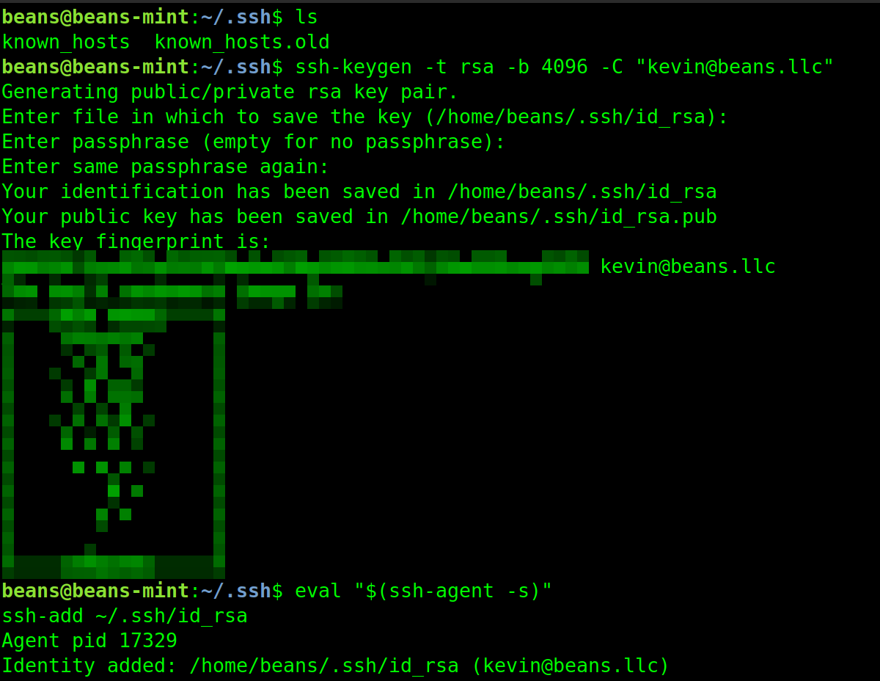
show I don’t have an existing key, then creates new key, then adds the new key
shows that my new key is, indeed, a great success.
Note: it should be the same as what you have done in lab, except that now you also need to explain each step. You may block sensitive info on screenshot, but commands should be clear.
1) repo url
If you do not know how to do Q9, you should still include a repo link here for the rest of questions.
A:https://github.com/kevinViers/CPSC254-23S-Final-KevinViers

2) screenshots & explanations
A:
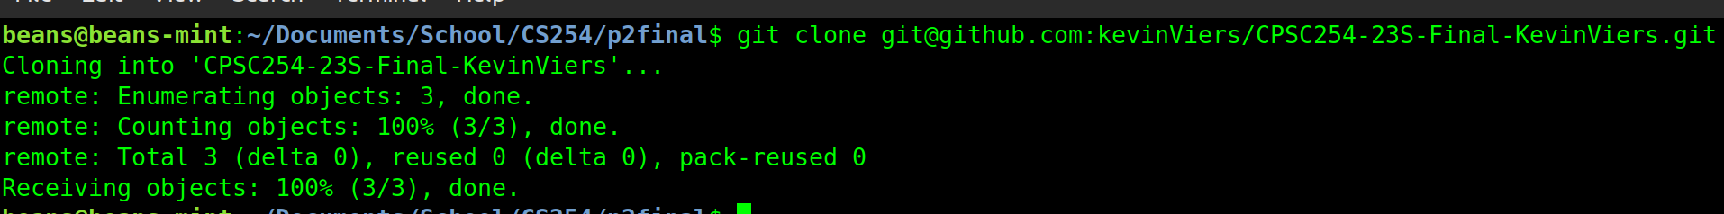
This clones the existing repo from github onto my local machine

Q10 Suppose you have the following files in your project:
main.cpp
header.h
mainDB.db
backupDB.db
config.yml
README.MD
Write a BASH script that generates a directories shown below and move files accordingly. You may create empty file
z
--- final
| --- src
| | --- main.cpp
| | --- header.h
| --- data
| | --- main
| | | --- mainDB.db
| | --- backup
| | | --- backupDB.db
| --- config
| | --- config.yml
| --- README.MD
Name the script q10_answer and push to the repo you created in Q9.
Submit a screenshot of your script, and a screenshot of tree command before & after you run the script. (25)
A:
before:
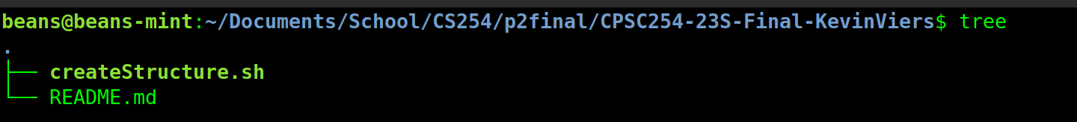
after:
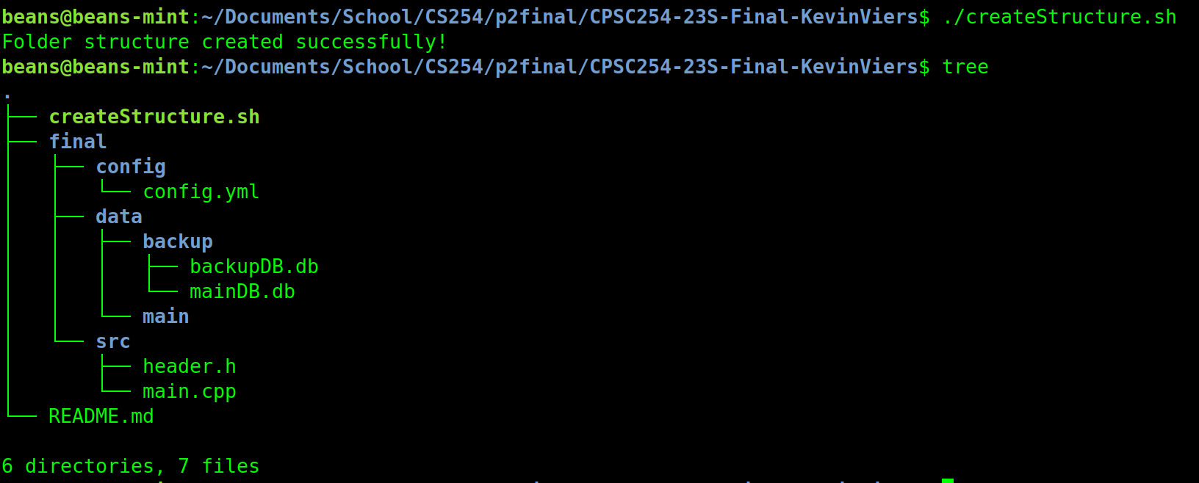

the script:
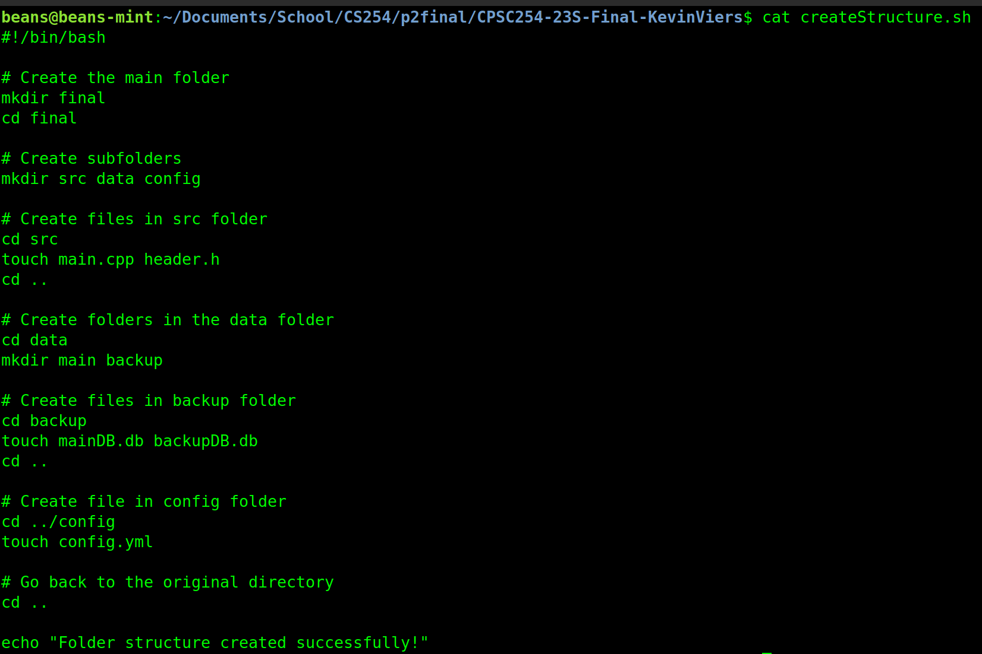

Q11 Design prototype of a terminal online banking simulator.
This simulator should:
1 have a login "page" that display a random ad.
2 can log user in from the login "page" if correct username & password are entered, and reject login in other cases.
3 has a member class/struct User that contains username & password & user activity history & balance information, and any other info/functions that you believe is necessary.
4 can deposit/withdraw balance after login.
create a folder named q11_answer in the repo you created in Q9, and push your works properly.
Note: this should be similar to what you have done in design compiler lab. You only need to include prototypes.
DO NOT do implementation unless you have too much time and decide to challenge yourself.
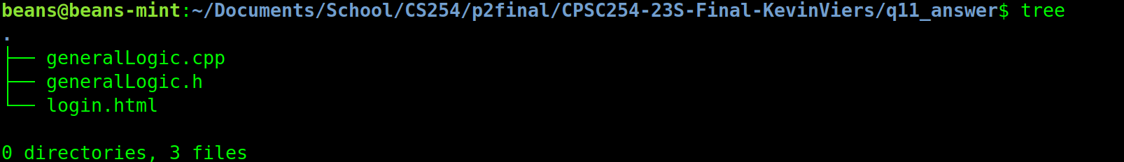
1) Justify your design. (25)
A: The overall design of my program is fairly basic. It contains an HTML doc that contains pseudocode for a login screen that shows a random ad and prompts for login. If the login is correct it proceeds and if the login is incorrect it asks to login again. The general logic of the program, aptly named generalLogic, contains the following: a constructor, deposit and withdraw functions, and a user activity function. There is also the accompanying header to make this all work (in theory). The code is well-documented, uses industry-norm naming conventions, and is formatted in readable yet compact way.
2) Prototype has proper structure & coding style (25)
yes

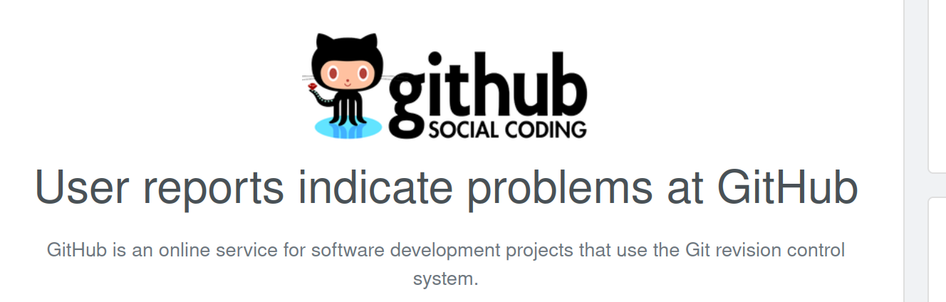
lol

