
COMPUTER SCIENCE AND ENGINEERING
Nov – 2026
ASSIGNMENT – 4
Course Code : CSA63
Course Name : THREAT INTELLIGENCE AND NETWORK SECURITY
Name : KEVINASHREE VK
Reg No : 192465057
Max Marks: 50
Answer all the Questions

1 | A small software company has an office network of about fifty users, a web server and a mail server that must be reachable from the Internet, an internal file server, and an administrator who manages the servers over SSH. The company has one Internet connection and wants to place a firewall at the edge. Apply the concepts of firewalls to this network. Explain the types of firewalls (stateless packet filtering, stateful inspection, application-level gateway or proxy, next-generation firewall and web application firewall) with their strengths and limits, and the role of a DMZ and of network address translation. Prepare an ordered firewall rule table of at least eight rules (action, source, destination, protocol and port, direction and reason) that allows only the required traffic, applies ingress and egress filtering and ends with a default-deny rule. Explain why the order of rules matters, and describe how the rules are tested, logged and reviewed. | (10) | (CO4) | (BL3)
2 | The SOC of a university receives about two thousand alerts a day from its intrusion detection system, and analysts estimate that more than ninety per cent are false positives, so a real intrusion in the student hostel network has gone unnoticed for two weeks. Analyse the situation using the concepts of IDS and IPS. Compare network-based and host-based systems, signature-based, anomaly-based and hybrid detection, and passive IDS (SPAN port or network tap) with inline IPS, and explain where sensors should be placed. Explain false positives and false negatives with examples and the cost of each. Interpret this Snort-style rule and say what it detects and how it could be tuned: alert tcp any any -> $HOME_NET 22 (msg:"SSH brute force"; flags:S; threshold:type both, track by_src, count 5, seconds 60; sid:1000001; rev:1;). Recommend a tuning and response process, and discuss how attackers try to evade detection (for example, fragmentation, encryption and slow scans). | (10) | (CO4) | (BL4)
3 | A retail company has a head office, ten branch stores and about two hundred staff who sometimes work from home. Branch stores send sales data to the head office, and remote staff need access to the internal inventory system. Apply VPN and secure communication techniques to this requirement. Explain site-to-site and remote-access VPNs, the working of IPsec (AH and ESP, transport and tunnel mode, security associations and IKE) and of SSL/TLS VPNs, and the difference between split tunnelling and full tunnelling. Draw a labelled diagram showing which VPN type is used for the branch stores and which for the remote staff, and justify the choice. Explain the role of TLS and SSH for secure communication of applications and administration, and discuss the security and operational issues of the design, such as multi-factor authentication, key and certificate management, logging, performance and the risk of a compromised home device. | (10) | (CO4) | (BL3)
4 | A manufacturing company runs its office computers, ERP servers, guest Wi-Fi, IP cameras and the production-line control systems on one flat network. Last month a ransomware infection on an office laptop spread to the ERP servers and stopped the production line for two days. Analyse how network segmentation and secure architecture design could have limited the damage. Explain VLANs, subnets, internal firewalls and access control lists, a DMZ and micro-segmentation, and design a zone-based architecture with at least five zones (for example, office, servers, DMZ, guest, camera and production) with a table of the traffic that is allowed between zones and the reason for each. Explain how administrators should reach the production zone (for example, through a jump host with multi-factor authentication). Discuss the principles of secure architecture design (least privilege, simplicity, fail-safe defaults, redundancy and separation of duties) and the costs and limits of segmentation. | (10) | (CO4) | (BL4)
5 | A financial services firm has moved most of its applications to the cloud and about half of its staff work remotely. A recent breach began with stolen VPN credentials, after which the attacker moved freely across the internal network because the firm trusted everything inside its perimeter. Evaluate the use of the Zero Trust model and the defense-in-depth strategy for this firm. Explain the principles of Zero Trust (never trust and always verify, least privilege, assume breach) and its components (identity provider, multi-factor authentication, device posture checks, policy decision and enforcement points, micro-segmentation and continuous monitoring). Explain the layers of defense in depth (physical, perimeter, network, host, application, data, people and policy) and map one control to each layer for this firm. Evaluate Zero Trust against the traditional perimeter model, explain how the two approaches complement each other, and recommend a phased roadmap with the difficulties the firm is likely to meet, such as legacy systems, user resistance and cost. | (10) | (CO4) | (BL5)

Question 1: Edge Firewall Design and Implementation

Firewall Types: Strengths and Limitations
Firewall Type | Working Mechanism | Key Strengths | Limitations & Weaknesses
Stateless Packet Filtering | Inspects IP/TCP/UDP packet headers (Source/Dest IP, Ports, Protocol) in isolation without tracking state. | High performance, ultra-low latency, low resource usage. | Cannot detect multi-packet attacks; susceptible to IP spoofing; requires wide port ranges for dynamic protocols.
Stateful Inspection | Maintains a connection state table to track TCP handshakes, sequence numbers, and UDP/ICMP sessions. | Drops unexpected/unsolicited inbound traffic automatically; secure session context awareness. | Cannot inspect application payloads; vulnerable to state-table exhaustion (DoS/DDoS) attacks.
Application-Level Gateway (Proxy) | Terminates inbound/outbound connections at layer 7 and re-initiates them on behalf of the client. | Deep payload inspection; completely hides internal network topology from external parties. | High resource consumption; CPU bound; latency overhead; requires proxy support per application protocol.
Next-Generation Firewall (NGFW) | Integrates stateful inspection with deep packet inspection (DPI), integrated IPS, user identity, and threat intelligence. | Identifies evasive applications on non-standard ports; inline malware prevention; context-aware rules. | High cost; potential performance bottleneck if DPI/SSL decryption is heavily unoptimized.
Web Application Firewall (WAF) | Specialized Layer 7 defense inspecting HTTP/HTTPS traffic targeting web applications. | Protects against OWASP Top 10 (SQLi, XSS, CSRF); understands HTTP parameters, headers, and cookies. | Only inspects web traffic (HTTP/HTTPS); requires continuous policy tuning to prevent false positives.
Role of DMZ and Network Address Translation (NAT)
- Demilitarized Zone (DMZ): A isolated network segment placed between the internal private network and the untrusted Internet. Publicly accessible servers (Web server on port 80/443, Mail server on port 25) are isolated inside the DMZ. If a DMZ server is compromised, direct lateral movement to the internal LAN is blocked by firewall policies.
- Network Address Translation (NAT / Port Forwarding):
  - Static NAT / Destination NAT (DNAT): Maps the single public IP address assigned by the ISP to internal DMZ IP addresses (e.g., Public IP port 80/443 $→$ DMZ Web Server IP; Public IP port 2222 $→$ Admin Jump Server IP).
  - Port Address Translation (PAT / SNAT): Translates all internal private IP addresses (50 users) to a single public IP using unique ephemeral source ports for outbound Internet browsing.
Ordered Firewall Rule Table (8 Rules)
Assumed Network Architecture:
- External (WAN): Public IP (203.0.113.1)
- DMZ Subnet: 192.168.2.0/24 (Web Server: 192.168.2.10, Mail Server: 192.168.2.20)
- Internal LAN: 192.168.1.0/24 (50 Workstations + File Server 192.168.1.50)
- Admin Host: 192.168.1.100
Rule # | Action | Source IP | Destination IP | Protocol & Port | Direction | Reason / Purpose
1 | ALLOW | Any (Internet) | 192.168.2.10 | TCP 80, 443 | Ingress | Allow public users to access the corporate Web Server in the DMZ.
2 | ALLOW | Any (Internet) | 192.168.2.20 | TCP 25 | Ingress | Allow inbound Internet SMTP email delivery to the DMZ Mail Server.
3 | ALLOW | 192.168.1.100 | 192.168.2.0/24, 192.168.1.50 | TCP 22 | Internal / Ingress | Allow the Administrator workstation to securely manage DMZ and File servers over SSH.
4 | ALLOW | 192.168.1.0/24 | 192.168.1.50 | TCP 445, 139 | Internal | Allow internal users to access shared files on the internal File Server.
5 | ALLOW | 192.168.1.0/24 | Any (Internet) | TCP 80, 443, UDP 53 | Egress | Egress filtering: Allow internal users web browsing (HTTP/HTTPS) and DNS resolution.
6 | ALLOW | 192.168.2.20 | Any (Internet) | TCP 25 | Egress | Egress filtering: Allow the DMZ Mail Server to relay outbound emails to the Internet.
7 | DENY | 192.168.2.0/24 | 192.168.1.0/24 | ANY | Internal | Strict DMZ isolation: Prevent compromised DMZ servers from initiating connections to the internal LAN.
8 | DENY (LOG) | ANY | ANY | ANY | Ingress / Egress | Implicit Default-Deny rule: Block all unapproved traffic and log violations.
Rule Ordering, Testing, Logging, and Review
- Importance of Rule Ordering: Firewalls evaluate rules sequentially from top to bottom (first-match execution). Placing specific rules (e.g., explicit HTTP/SSH permissions) above broad block rules ensures valid traffic is permitted before hitting restrictive policies. A default-deny rule at the top would block all traffic immediately.
- Rule Testing: Conducted in a sandbox using tools like nmap (port scanning), hping3 (crafted packet injection), and automated firewall verification scripts to ensure intended ports are open while unauthorized connections are dropped.
- Logging: Configure syslog auditing on explicit allow/deny rules (especially Rule 8). Logs must record timestamp, source/destination IP, source/destination port, protocol, rule ID, and action taken.
- Review Cycle: Perform quarterly policy audits to prune obsolete rules, verify adherence to least privilege, and analyze firewall change request logs against active change management tickets.

Question 2: SOC Alert Fatigue, IDS/IPS Analysis, and Rule Tuning

Architectural & Operational Comparison
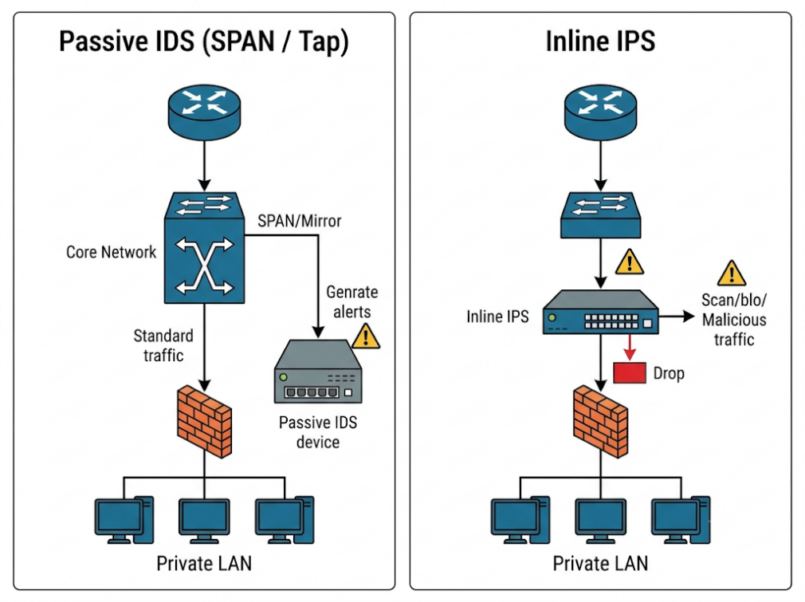

Dimension | Host-based (HIDS) | Network-based (NIDS) | Signature-Based | Anomaly-Based | Hybrid Detection
Scope | Monitors single endpoint system logs, file integrity (FIM), system calls. | Monitors network packet streams across entire subnets via SPAN/Taps. | Matches known attack patterns against a database of signatures. | Establishes a baseline of normal behavior; alerts on statistical deviations. | Blends signature matching with anomaly models to minimize false outputs.
Strengths | Analyzes decrypted traffic; detects local privilege escalation. | Low operational impact on endpoints; broad coverage. | Near-zero false positives for known threats; fast processing. | Detects novel (zero-day) exploits without prior signatures. | Combines high accuracy for known attacks with zero-day detection.
Limits | Consumes host CPU/RAM; agent failure disables monitoring. | Blind to encrypted traffic (TLS/SSH); high packet drop rate under high throughput. | Completely blind to modified or zero-day attack payloads. | High false positive rate due to variable user behavior baseline. | Complex configuration; higher computational and management overhead.
- Passive IDS vs. Inline IPS: A passive IDS connects to a SPAN/mirror port or network tap. It processes copies of traffic off-band and generates alerts without impacting live throughput, but it cannot drop malicious packets inline. An inline IPS sits directly in the physical traffic path; it inspects and can actively drop packets or terminate TCP resets (RST) in real time, though it introduces a single point of failure and minor processing latency.
- Sensor Placement: Sensors should be placed:
  - Behind the edge firewall (to monitor traffic that passed initial perimeter filters).
  - At the DMZ boundary (to monitor public-facing web/mail traffic).
  - At internal zone intersections (between the student hostel network and core administrative servers).
False Positives vs. False Negatives
- False Positive (FP): The IDS alerts on benign activity (e.g., a legitimate batch file transfer flagged as data exfiltration).
  - Cost: SOC alert fatigue, wasted analyst time, operational distraction, risk of analysts ignoring critical alerts.
- False Negative (FN): Malicious activity occurs without triggering an alert (e.g., a stealthy lateral movement undetected by signatures).
  - Cost: Severe security breach, undetected persistence, data theft, business disruption (as seen in the hostel breach going unnoticed for two weeks).
Snort Rule Interpretation & Tuning
Given Snort Rule:
Code snippet
alert tcp any any -> $HOME_NET 22 (msg:"SSH brute force"; flags:S; threshold:type both, track by_src, count 5, seconds 60; sid:1000001; rev:1;)
- Detailed Breakdown:
  - alert tcp any any -> $HOME_NET 22: Triggers an alert for TCP packets coming from any source IP and any source port destined for internal network ($HOME_NET) on port 22 (SSH).
  - msg:"SSH brute force": Sets the log message text to "SSH brute force".
  - flags:S: Inspects packets that have only the TCP SYN flag set (initiating connection requests).
  - threshold:type both, track by_src, count 5, seconds 60: Limits alerting to a maximum of 1 alert per 60-second window after a single source IP (track by_src) generates 5 SYN packets within those 60 seconds.
  - sid:1000001; rev:1;: Unique Signature ID 1000001, revision 1.
- Flaws & Tuning Strategy:
  - Why it fails: A count of 5 attempts in 60 seconds is too low for environments with legitimate automated tools (triggers high false positives). Conversely, slow brute-force tools performing 1 attempt every 65 seconds completely evade this rule (false negative).
  - Tuned Rule: Utilize modern detection state operators (detection_filter) and increase thresholds:
Code snippet
alert tcp $EXTERNAL_NET any -> $HOME_NET 22 (msg:"ET SCAN Potential SSH Brute Force Attempt"; flow:to_server,established; flags:S; detection_filter:track by_src, count 20, seconds 60; classtype:attempted-recon; sid:2000001; rev:2;)
SOC Tuning, Response Process, and Evasion Techniques
- SOC Tuning & Incident Response Process:
  - Baseline Auditing: Group identical alerts; suppress rules targeting non-existent services.
  - Rule Optimization: Replace loose threshold signatures with stateful protocol inspection and detection_filter modules.
  - Triage Automation: Integrate SOAR (Security Orchestration, Automation, and Response) to automatically query threat intelligence feeds and group alerts before alerting human analysts.
- Attacker Evasion Techniques:
  - IP Fragmentation: Breaking attack payloads into small IP fragments so NIDS signatures fail to reassemble and match signatures. Countermeasure: Enable IP defragmentation engines on NIDS preprocessors.
  - Encryption (TLS/SSH): Hiding malicious payloads inside encrypted streams. Countermeasure: Deploy SSL/TLS decryption proxies before traffic hits the NIDS/NIPS.
  - Slow Scans (Low and Slow): Distributing password attempts over days or weeks to bypass temporal threshold counters. Countermeasure: Use baseline anomaly tracking and SIEM correlation rules across long time windows (e.g., 24 hours to 7 days).

Question 3: VPN Architecture and Secure Communication for Distributed Enterprises

Enterprise VPN Architecture Diagram
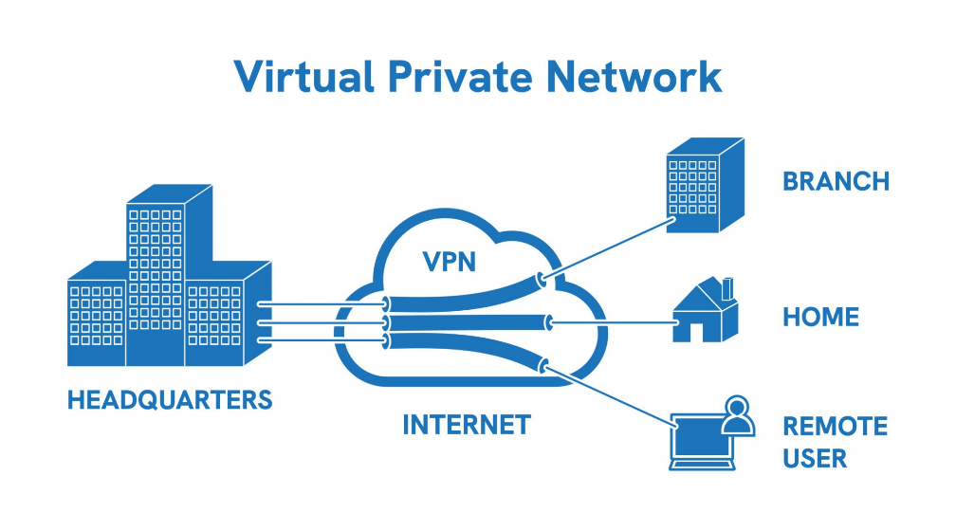
Technical Breakdown: IPsec, SSL/TLS VPNs, and Tunneling Modes
- Site-to-Site VPN (IPsec): Connects entire networks (Head Office firewall $↔$ Branch Office firewall). Operates transparently to endpoints without client software.
- Remote-Access VPN (SSL/TLS or IPsec): Connects individual remote user devices (laptops) back to the Head Office VPN Concentrator using a software client or web browser.
IPsec Architecture
- Protocols:
  - Authentication Header (AH): Provides connectionless integrity and data origin authentication for IP packets. It does not provide encryption (confidentiality). Rarely used today because it breaks NAT.
  - Encapsulating Security Payload (ESP): Provides origin authentication, data integrity, and payload encryption (confidentiality).
- Modes:
  - Transport Mode: Encrypts only the IP payload; leaves the original IP header intact. Used primarily for host-to-host communications.
  - Tunnel Mode: Encrypts the entire original IP packet (header + payload) and prepends a new outer IP header. Required for network-to-network (site-to-site) routing.
- Security Associations (SA) & IKE:
  - SA: A unidirectional agreement defining encryption algorithms, keys, and sequence numbers used for a connection (two SAs required for bidirectional traffic).
  - IKE (Internet Key Exchange - IKEv2):
    - Phase 1: Authenticates peers and establishes a secure IKE SA channel (Main Mode or Aggressive Mode).
    - Phase 2: Negotiates the child IPsec SAs for encrypting data traffic.
Tunneling Approaches
- Split Tunnelling: Only traffic destined for corporate IP ranges is routed through the VPN tunnel; general Internet traffic routes directly through the remote user's local ISP. Saves bandwidth, but leaves endpoints vulnerable to local network exploits.
- Full Tunnelling: All traffic from the client device (including external internet access) is encapsulated and routed through the corporate VPN tunnel to Head Office. Enforces central perimeter security inspection at the cost of higher bandwidth consumption.
Comparison of VPN Implementation & Justification
Feature / Criteria | Site-to-Site VPN (Head Office ↔ 10 Branches) | Remote-Access VPN (200 Home Staff)
Protocol Used | IPsec (ESP in Tunnel Mode with IKEv2) | SSL/TLS VPN (OpenVPN / WireGuard / TLS Portal)
Termination Points | Edge Gateway Router/Firewall at both sites. | Endpoint Client Software $→$ Head Office VPN Concentrator.
User Interaction | Completely persistent and transparent to end users. | On-demand authentication initiated by user login.
Design Justification | High throughput, continuous subnet-to-subnet traffic flow; automated tunnel recovery without user intervention. | Easy deployment across diverse home OS environments; works seamlessly through restrictive home NAT routers and firewalls.
Operational & Security Considerations
- Role of TLS & SSH:
  - TLS (Transport Layer Security): Encrypts application-layer session protocols (HTTPS, web portals) protecting inventory APIs and web services against eavesdropping and tampering.
  - SSH (Secure Shell): Provides encrypted terminal access for system administrators managing network devices and Linux servers securely over untrusted networks.
- Multi-Factor Authentication (MFA): Essential for Remote-Access VPNs to mitigate credential theft. Combines password authentication with TOTP tokens or FIDO2 hardware keys.
- Key & Certificate Management: PKI (Public Key Infrastructure) lifecycle management to issue, renew, and revoke digital X.509 certificates for VPN client/server authentication.
- Compromised Home Device Mitigation: Endpoint posture assessments (Host Checking) must verify that remote endpoints have active antivirus software, OS security patches, and disk encryption enabled before granting VPN tunnel access.

Question 4: Network Segmentation, Secure Architecture, and Zone Design

Impact Analysis: Flat Network vs. Segmented Architecture
In a flat network (Layer 2 broadcast domain), a compromise on one device allows unrestricted network scanning, ARP spoofing, and lateral movement to all connected hosts.
Network segmentation breaks the flat network into isolated containment zones. Placing stateful firewalls between zones stops automated lateral propagation (such as SMB/WMI-based ransomware like WannaCry or NotPetya) at the segment boundary.
Core Segmentation Concepts
- VLANs (Virtual LANs): Logically segment a physical switch into distinct Layer 2 broadcast domains (IEEE 802.1Q tagging).
- Subnets: Layer 3 IP address groupings assigned to individual VLANs to control inter-subnet routing.
- Internal Firewalls & Access Control Lists (ACLs): Filter traffic flowing between VLANs/subnets based on explicit protocol rules.
- Micro-segmentation: Granular security enforcement down to individual workloads or virtual machines inside the same subnet (preventing East-West host-to-host lateral movement).
Zone-Based Architecture Matrix (5 Zones)
Zone Name | Subnet / Scope | Allowed Destination Zone | Allowed Protocol/Ports | Technical Reason & Justification
1. Office Zone | 192.168.10.0/24 | Server Zone | TCP 443 (HTTPS), TCP 445 (SMB) | Staff access to ERP web app and central file share.
 |  | DMZ Zone | TCP 80, 443 | Access internal web applications.
 |  | Production Zone | NONE (DENY ALL) | Direct access to SCADA/ICS OT network is strictly forbidden.
2. Server Zone | 192.168.20.0/24 | Office Zone | TCP 443 | ERP return traffic and application responses.
3. DMZ Zone | 192.168.30.0/24 | Internet | TCP 80, 443, 25 | Public web and mail services delivery.
 |  | Server Zone | TCP 1433 / 5432 | Web frontend querying backend database server (strict DB IP binding).
4. Guest Wi-Fi | 192.168.40.0/24 | Internet | TCP 80, 443, UDP 53 | Visitor internet access only. Completely isolated from all internal zones.
5. IP Cameras | 192.168.50.0/24 | Server Zone (NVR) | TCP 554 (RTSP), 80 | Stream camera video feeds exclusively to the designated NVR recorder.
6. Production (OT) | 10.0.100.0/24 | Internal Zones | NONE (DENY ALL) | Air-gapped / strictly segmented control network for PLCs and SCADA nodes.
Secure Administrative Access to the Production Zone
Direct SSH/RDP connections from office workstations to the Production Zone are prohibited. Administrators must connect via a hardened Jump Host (Bastion Host) placed in a dedicated Management Zone:
- Authentication: Require Multi-Factor Authentication (MFA) and hardware token verification to log into the Jump Host.
- Protocol Isolation: The Jump Host acts as a proxy; session recording captures all admin screen sessions and CLI commands.
- Egress Control: The Jump Host is the only IP address permitted through the internal firewall into the Production OT network over dedicated management ports (e.g., SSH/HTTPS).
Guiding Architectural Principles and Trade-offs
- Principle of Least Privilege: Systems and users are granted only the minimum network access necessary to perform their roles.
- Simplicity: Keep network segment rules clean and maintainable to avoid misconfigurations.
- Fail-Safe Defaults: The default action for any unmapped zone-to-zone traffic is DENY ALL.
- Redundancy: Firewalls and core switches should be deployed in High Availability (HA) pairs to prevent single points of failure.
- Separation of Duties: Administrative controls for IT operations must be isolated from OT (Operational Technology) management accounts.
- Costs & Limits: Increased capital costs (NGFW hardware, VLAN switches) and operational complexity (managing rule bases, potential workflow friction for employees).

Question 5: Zero Trust Architecture vs. Perimeter Security in Cloud Systems

Zero Trust Core Principles and Architectural Components
Zero Trust shifts security from traditional location-based trust ("inside the perimeter is safe") to explicit, identity-driven verification ("never trust, always verify").
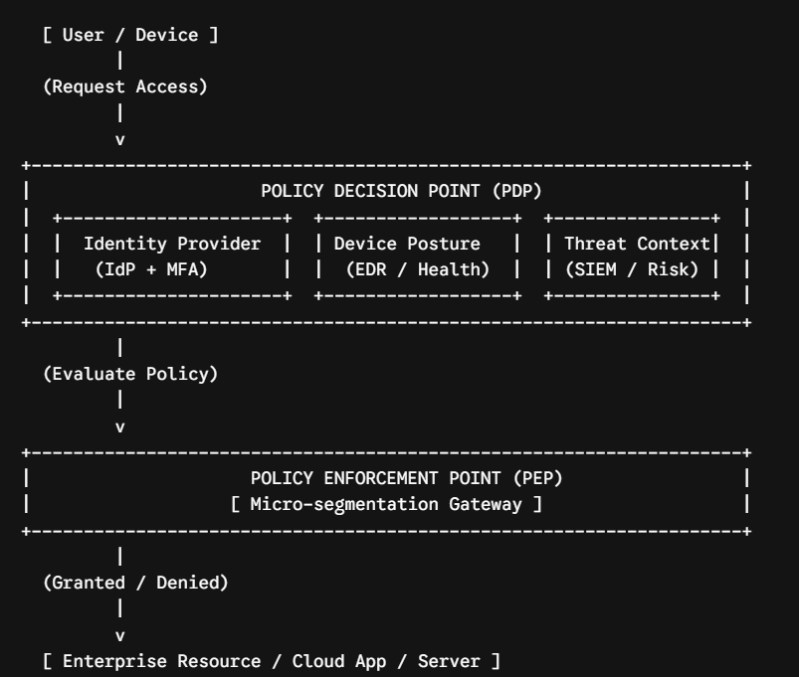
Principles:
  - Never Trust, Always Verify: Authenticate and authorize every access request continuously across all data points regardless of location.
  - Use Least Privilege Access: Limit user access with Just-In-Time (JIT) and Just-Enough-Access (JEA) policies.
  - Assume Breach: Design networks assuming attackers are already present inside the environment; encrypt all communications and perform continuous monitoring.
- Key Components:
  - Identity Provider (IdP): Central repository managing user identities, credentials, and attributes (e.g., Entra ID, Okta).
  - Multi-Factor Authentication (MFA): Enforces secondary proof of identity (FIDO2, push notifications).
  - Device Posture Checks: Validates endpoint integrity (patch level, active EDR agent, disk encryption state) before granting access.
  - Policy Decision Point (PDP): The brain that evaluates context rules (user, location, device health) to issue an access decision.
  - Policy Enforcement Point (PEP): Gatekeeper components (firewalls, proxies, ZTNA agents) that enforce PDP access decisions.
  - Micro-segmentation: Enforces isolation around sensitive resources to stop lateral movement.
  - Continuous Monitoring: Real-time log aggregation and user behavior analytics (UEBA) to detect post-authentication anomalies.
Defense-in-Depth Control Mapping
Defense Layer | Applied Control for Financial Services Firm
1. Physical Layer | Biometric access control and CCTV surveillance at data centers and office facilities.
2. Perimeter Layer | Cloud Access Security Broker (CASB) and Web Application Firewall (WAF) filtering external traffic.
3. Network Layer | Zero Trust Network Access (ZTNA) gateways replacing traditional remote-access VPNs.
4. Host Layer | Endpoint Detection and Response (EDR) agents enforcing disk encryption on staff laptops.
5. Application Layer | OAuth 2.0 / OpenID Connect single sign-on (SSO) with strict input validation.
6. Data Layer | AES-256 field-level data encryption at rest and TLS 1.3 encryption in transit for financial records.
7. People Layer | Mandatory role-based security awareness training and anti-phishing simulation exercises.
8. Policy Layer | Formally audited Information Security Policy, Incident Response Plan, and Compliance Mandates.
Evaluation: Zero Trust vs. Traditional Perimeter Model
Feature | Traditional Perimeter Model ("Castle and Moat") | Zero Trust Architecture
Trust Assumption | Implicit trust granted to any device inside the internal network. | Zero implicit trust; all connections are explicitly verified.
Access Control | Coarse-grained network level (IP/Subnet based via VPN). | Fine-grained application level (Identity & Context based).
Lateral Movement | Easy once perimeter firewall or VPN is breached. | Blocked via micro-segmentation and continuous session checks.
Cloud/Remote Suitability | Poor; hairpinning cloud traffic through HQ VPN degrades speed. | Built natively for distributed cloud apps and remote workforces.
- Complementary Coexistence: Zero Trust does not make perimeter security obsolete. Network firewalls and edge filters provide macro-segmentation (stopping volumetric attacks and port scanning), while Zero Trust enforces micro-level context checks on individual sessions inside those networks.
Phased Migration Roadmap & Operational Challenges
Phase 1: Foundation (Months 1-3)
├── Deploy Centralized IdP & Mandatory MFA
└── Enforce EDR Endpoint Posture Checks

Phase 2: Transition (Months 4-8)
├── Deploy ZTNA Gateway (Replace VPNs)
└── Implement Cloud CASB & WAF Controls

Phase 3: Optimization (Months 9-12)
├── Apply Internal Micro-segmentation
└── Integrate Continuous SIEM / UEBA Analytics
Implementation Challenges & Solutions
- Legacy Systems: Older financial applications may lack support for modern OAuth/SAML authentication standards. Mitigation: Wrap legacy apps in reverse-proxy ZTNA connectors.
- User Resistance: Friction caused by frequent authentication prompts. Mitigation: Deploy Passwordless FIDO2 keys and risk-based adaptive authentication (prompting for MFA only when risk scores shift).
- High Cost & Complexity: Significant operational cost and licensing required for IdP, ZTNA, and EDR suites. Mitigation: Roll out controls iteratively in phases, prioritizing high-risk application

