
COMPUTER SCIENCE AND ENGINEERING
Nov – 2026
ASSIGNMENT – 3
Course Code : CSA63
Course Name : THREAT INTELLIGENCE AND NETWORK SECURITY
Name : Kevinashree VK
Reg No : 192465057
Max Marks: 50
Answer all the Questions

1 | A small software company has an office network of about fifty users, a web server and a mail server that must be reachable from the Internet, an internal file server, and an administrator who manages the servers over SSH. The company has one Internet connection and wants to place a firewall at the edge. Apply the concepts of firewalls to this network. Explain the types of firewalls (stateless packet filtering, stateful inspection, application-level gateway or proxy, next-generation firewall and web application firewall) with their strengths and limits, and the role of a DMZ and of network address translation. Prepare an ordered firewall rule table of at least eight rules (action, source, destination, protocol and port, direction and reason) that allows only the required traffic, applies ingress and egress filtering and ends with a default-deny rule. Explain why the order of rules matters, and describe how the rules are tested, logged and reviewed. | (10) | (CO4) | (BL3)
2 | The SOC of a university receives about two thousand alerts a day from its intrusion detection system, and analysts estimate that more than ninety per cent are false positives, so a real intrusion in the student hostel network has gone unnoticed for two weeks. Analyse the situation using the concepts of IDS and IPS. Compare network-based and host-based systems, signature-based, anomaly-based and hybrid detection, and passive IDS (SPAN port or network tap) with inline IPS, and explain where sensors should be placed. Explain false positives and false negatives with examples and the cost of each. Interpret this Snort-style rule and say what it detects and how it could be tuned: alert tcp any any -> $HOME_NET 22 (msg:"SSH brute force"; flags:S; threshold:type both, track by_src, count 5, seconds 60; sid:1000001; rev:1;). Recommend a tuning and response process, and discuss how attackers try to evade detection (for example, fragmentation, encryption and slow scans). | (10) | (CO4) | (BL4)
3 | A retail company has a head office, ten branch stores and about two hundred staff who sometimes work from home. Branch stores send sales data to the head office, and remote staff need access to the internal inventory system. Apply VPN and secure communication techniques to this requirement. Explain site-to-site and remote-access VPNs, the working of IPsec (AH and ESP, transport and tunnel mode, security associations and IKE) and of SSL/TLS VPNs, and the difference between split tunnelling and full tunnelling. Draw a labelled diagram showing which VPN type is used for the branch stores and which for the remote staff, and justify the choice. Explain the role of TLS and SSH for secure communication of applications and administration, and discuss the security and operational issues of the design, such as multi-factor authentication, key and certificate management, logging, performance and the risk of a compromised home device. | (10) | (CO4) | (BL3)
4 | A manufacturing company runs its office computers, ERP servers, guest Wi-Fi, IP cameras and the production-line control systems on one flat network. Last month a ransomware infection on an office laptop spread to the ERP servers and stopped the production line for two days. Analyse how network segmentation and secure architecture design could have limited the damage. Explain VLANs, subnets, internal firewalls and access control lists, a DMZ and micro-segmentation, and design a zone-based architecture with at least five zones (for example, office, servers, DMZ, guest, camera and production) with a table of the traffic that is allowed between zones and the reason for each. Explain how administrators should reach the production zone (for example, through a jump host with multi-factor authentication). Discuss the principles of secure architecture design (least privilege, simplicity, fail-safe defaults, redundancy and separation of duties) and the costs and limits of segmentation. | (10) | (CO4) | (BL4)
5 | A financial services firm has moved most of its applications to the cloud and about half of its staff work remotely. A recent breach began with stolen VPN credentials, after which the attacker moved freely across the internal network because the firm trusted everything inside its perimeter. Evaluate the use of the Zero Trust model and the defense-in-depth strategy for this firm. Explain the principles of Zero Trust (never trust and always verify, least privilege, assume breach) and its components (identity provider, multi-factor authentication, device posture checks, policy decision and enforcement points, micro-segmentation and continuous monitoring). Explain the layers of defense in depth (physical, perimeter, network, host, application, data, people and policy) and map one control to each layer for this firm. Evaluate Zero Trust against the traditional perimeter model, explain how the two approaches complement each other, and recommend a phased roadmap with the difficulties the firm is likely to meet, such as legacy systems, user resistance and cost. | (10) | (CO4) | (BL5)
By:
Kevinashree VK
192465057
Question 1: Edge Firewall Design, Rule Base, and DMZ Architecture

1. Types of Firewalls
- Stateless Packet Filtering: Examines individual packet headers (source/destination IP, port, protocol) in isolation against static rules without tracking connection state.
  - Strengths: Extremely high throughput, minimal CPU/memory overhead.
  - Limits: Cannot track TCP session states; vulnerable to IP spoofing and crafted packet attacks.
- Stateful Inspection: Tracks the state of active network connections (e.g., TCP 3-way handshake sequence numbers, UDP pseudo-sessions) using a state table to validate whether incoming packets belong to established sessions.
  - Strengths: Offers much higher security than stateless filtering; dynamically opens ephemeral ports for legitimate return traffic.
  - Limits: Consumes state-table memory; vulnerable to Denial of Service (DoS) state-exhaustion attacks.
- Application-Level Gateway (Proxy Firewall): Intercepts and terminates incoming/outgoing traffic at the application layer (Layer 7), inspecting actual payload protocols (HTTP, FTP, SMTP) before relaying traffic.
  - Strengths: Complete payload analysis; masks internal network architecture from external clients.
  - Limits: Significant performance latency; requires specialized proxy modules for each supported application protocol.
- Next-Generation Firewall (NGFW): Combines stateful inspection with deep packet inspection (DPI), integrated Intrusion Prevention System (IPS), application awareness (identifying apps regardless of port), and live threat intelligence feeds.
  - Strengths: Granular application-level visibility (e.g., distinguishing web browsing from file sharing over port 443); integrated threat detection.
  - Limits: Higher licensing cost; requires careful tuning to prevent DPI processing bottlenecks under heavy traffic loads.
- Web Application Firewall (WAF): Specialized Layer 7 security proxy positioned in front of web servers to inspect HTTP/HTTPS traffic for web-specific attacks (SQL Injection, Cross-Site Scripting, CSRF).
  - Strengths: Protects vulnerable web application logic without altering underlying application source code.
  - Limits: Limited strictly to web traffic (HTTP/HTTPS); requires ongoing custom rule tuning to prevent false positives.
2. Role of DMZ and Network Address Translation (NAT)
- Demilitarized Zone (DMZ): A physical or logical isolated subnetwork that hosts an organization's external-facing services (Web, Mail, DNS). By isolating public-facing servers in a DMZ, an attacker who compromises a public server cannot directly access internal corporate assets.
- Network Address Translation (NAT): Converts private IPv4 addresses (RFC 1918) within the internal office network into one or more public IPv4 addresses at the firewall edge.
  - Static NAT / Port Forwarding: Maps public IPs/ports directly to specific DMZ servers (e.g., Public IP port 80/443 $→$ DMZ Web Server).
  - Dynamic PAT (Port Address Translation / NAT Overload): Maps all 50 internal office users to a single public IP address using dynamic ephemeral source ports, preventing direct inbound initiation of connections from the Internet to office workstations.
3. Ordered Firewall Rule Table
Assumed Addressing Scheme:
- WAN (Internet): 203.0.113.0/24 (Firewall Public IP: 203.0.113.1)
- DMZ Network: 192.168.10.0/24 (Web Server: .10, Mail Server: .20)
- Internal LAN (Office): 10.0.1.0/24 (File Server: 10.0.1.50, Admin Laptop: 10.0.1.100)
Rule # | Action | Source IP | Destination IP | Protocol & Port | Direction | Reason / Business Justification
1 | ALLOW | Any | 192.168.10.10 | TCP 80, 443 | Inbound | Public access to public web server in DMZ.
2 | ALLOW | Any | 192.168.10.20 | TCP 25 (SMTP) | Inbound | External mail servers delivering inbound email to DMZ mail server.
3 | ALLOW | 10.0.1.100 | 192.168.10.0/24, 10.0.1.50 | TCP 22 (SSH) | Internal / Outbound | Administrator SSH access to DMZ servers and internal file server.
4 | ALLOW | 10.0.1.0/24 | 192.168.10.20 | TCP 587 / 993 | Inbound | Office users sending/retrieving email via DMZ mail server.
5 | ALLOW | 10.0.1.0/24 | Any (WAN) | TCP 80, 443, UDP 53 | Outbound | Controlled outbound web and DNS access for office workstations (Egress filtering).
6 | ALLOW | 192.168.10.20 | Any (WAN) | TCP 25 (SMTP) | Outbound | DMZ mail server relaying outbound mail to the Internet.
7 | DENY | 192.168.10.0/24 | 10.0.1.0/24 | Any | Inbound | Strict DMZ Isolation: Prevents compromised DMZ servers from initiating connections to Internal LAN.
8 | DENY | Any | Any | Any | Any | Default-Deny (Implicit Cleanup): Drops all unauthorized incoming, outgoing, or inter-zone traffic.
4. Rule Order, Testing, Logging, and Auditing
- Why Rule Order Matters: Firewalls evaluate rule sets sequentially from top to bottom and execute the action of the first matching rule (First-Match Logic). Placing broad deny rules above specific allow rules will inadvertently block legitimate traffic, while placing overly permissive rules at the top bypasses subsequent security restrictions.
- Testing Rules: Validate rule bases in a staging environment using tools like Nmap (for port reachability) and hping3 (for packet crafting/state testing) to confirm that intended ports are accessible and unauthorized ports are blocked.
- Logging: Configure explicit drop rules (Rule 7 and Rule 8) to generate log alerts into a SIEM engine to monitor for reconnaissance scans, lateral movement attempts, and spoofed traffic.
- Review Process: Perform quarterly rule-base reviews to remove redundant, obsolete, or temporary rules, verify compliance with security baseline policies, and audit rule execution counters.

Question 2: IDS/IPS Analysis, Snort Rule Tuning, and Evasion Techniques

1. Architectural & Detection Method Comparisons
Network-Based (NIDS/NIPS) vs. Host-Based (HIDS/HIPS)
- NIDS/NIPS: Deployed at network choke points to analyze raw network traffic packets across all connected devices. Provides broad network visibility without requiring agent deployment on individual hosts, but cannot inspect encrypted payload traffic (HTTPS/TLS) without decryption proxies.
- HIDS/HIPS: Installed directly on endpoints (servers, workstations) to monitor system logs, file modifications, system calls, and local network sockets. Can inspect decrypted data and system behavior, but consumes local system resources and requires agent maintenance.
Detection Methodologies
- Signature-Based: Compares traffic patterns against a database of known attack signatures. Highly accurate for known threats with extremely low false positives, but completely blind to zero-day attacks and novel variants.
- Anomaly-Based: Establishes a baseline of normal network behavior and flags statistically significant deviations. Capable of detecting zero-day exploits, but generates high rates of false positives due to normal traffic fluctuations.
- Hybrid Detection: Combines signature matching with behavioral anomaly detection to balance accuracy and novel-threat discovery.
Sensor Placement & Deployment Modes
- Passive IDS (SPAN / Network Tap): Receives out-of-band mirrored network traffic copies via a Switch Port Analyzer (SPAN) or inline optical tap. It monitors traffic without introducing latency or network single points of failure, but cannot block malicious traffic in real time (can only generate alerts or send TCP resets).
- Inline IPS: Positioned directly in the network traffic path (in-band). Every packet must pass through the device, allowing it to actively drop malicious packets or tear down connection attempts in real time, though it introduces microsecond processing latencies and represents a potential physical point of network failure if fail-open mechanisms are absent.
[ Internet ]
│
▼
[ Edge Firewall ]
│
┌───────────────┴────────────┐
│ (Inline Path) │ (Mirrored SPAN Traffic)
▼ ▼
[ NIPS Sensor ] [ Passive NIDS ]
│
▼
[ Core Switch ]
2. False Positives vs. False Negatives
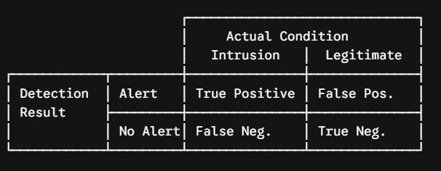
- False Positive (FP): The sensor incorrectly flags legitimate, benign traffic as an attack.
  - Example: A automated database backup script transferring bulk SQL files triggers an alert for SQL Data Exfiltration.
  - Cost: Causes alert fatigue among SOC analysts, wastes investigation time, and leads analysts to ignore genuine alerts (as seen in the university scenario).
- False Negative (FN): The sensor fails to detect a real, ongoing security intrusion.
  - Example: An attacker uses a novel zero-day buffer overflow or encrypted C2 traffic channel that bypasses signature matches.
  - Cost: Unnoticed network breach, system compromise, data theft, and ransomware propagation (as occurred in the student hostel network).
3. Snort Rule Analysis and Tuning
Rule Interpretation
Code snippet
alert tcp any any -> $HOME_NET 22 (msg:"SSH brute force"; flags:S; threshold:type both, track by_src, count 5, seconds 60; sid:1000001; rev:1;)
- Header: Inspects all TCP traffic originating from any external source IP/port destined for internal network servers ($HOME_NET) on TCP Port 22 (SSH).
- flags:S;: Looks specifically for TCP packets with only the SYN bit set (initiating connection attempts).
- threshold:...: Triggers an alert if a single source IP (track by_src) generates 5 or more TCP SYN connection requests to port 22 within a 60-second window.
- Purpose: Detects automated SSH brute-force login or port-scanning attempts.
Rule Flaws & Tuning Recommendations
- Flaws: A threshold of 5 connection attempts in 60 seconds is far too sensitive for enterprise/university environments. Legitimate administrative scripts, multi-threaded connection tools, or misconfigured SSH clients will cause massive false positive alerts.
- Tuned Snort Rule:
Code snippet
alert tcp $EXTERNAL_NET any -> $HOME_NET 22 (msg:"TA - SSH Brute Force Attempt"; flow:to_server,established; flags:S; threshold:type threshold, track by_src, count 20, seconds 60; sid:1000001; rev:2;)
  - Changes Made: Replaced any source with $EXTERNAL_NET, set threshold count to 20 attempts per 60 seconds, and added flow:to_server to ignore internal management traffic.
4. Detection Evasion Techniques
- IP Fragmentation: Attackers split malicious payloads across tiny IP fragments. NIDS sensors that fail to reassemble fragments in memory inspect incomplete chunks and miss signature matches.
- Payload Encryption & Obfuscation: Encrypting command-and-control communications over TLS/HTTPS hides packet payloads from signature engines.
- Low and Slow Attacks: Attackers perform brute-force or scanning attempts at extremely low rates (e.g., 1 attempt every 15 minutes), keeping activity well below automated threshold detection limits.

Question 3: VPN Architecture, IPsec/SSL Protocols, and Secure Remote Access

1. VPN Technical Fundamentals
- Site-to-Site VPN: Connects two static, permanent network locations (e.g., Branch Store network to Head Office network) over a public network using gateway-to-gateway routers/firewalls without requiring software installed on end-user endpoints.
- Remote-Access VPN: Connects individual remote user devices (laptops, mobile phones) to an organization's central network using client software or a web portal.
IPsec Protocol Architecture
- AH (Authentication Header): Provides data origin authentication and connection integrity, but provides no confidentiality/encryption. (Rarely used in modern deployments).
- ESP (Encapsulating Security Payload): Provides data confidentiality (encryption via AES-GCM), data origin authentication, and anti-replay protection.
- Transport Mode: Encrypts only the IP packet payload, preserving the original IP header. Used primarily for host-to-host communications.
- Tunnel Mode: Encrypts the entire original IP packet (header + payload) and encapsulates it inside a brand-new outer IP header. Required for gateway-to-gateway (Site-to-Site) VPNs.
- Security Associations (SA): A unidirectional set of security parameters (cryptographic algorithms, keys, SPI identifiers) agreed upon between two IPsec endpoints.
- IKE (Internet Key Exchange - IKEv2): Key management protocol used to authenticate endpoints and negotiate SAs:
  - Phase 1: Establishes a secure authenticated channel (IKE SA) between the security gateways.
  - Phase 2: Negotiates the specific IPsec SAs to encrypt operational data traffic.
SSL/TLS VPNs
- Operates at Layer 7 (Transport/Application layer). Allows remote users to access internal resources via standard web browsers (Clientless) or lightweight user-space client software over TCP port 443, easily traversing restrictive NATs and firewalls.
Tunnelling Modes
- Split Tunnelling: Routes only corporate-bound traffic through the encrypted VPN tunnel, while general internet traffic exits directly through the user's local ISP connection. Saves corporate bandwidth, but exposes the endpoint to local internet threats.
- Full Tunnelling: Routes 100% of network traffic from the remote device through the VPN tunnel back to head office firewalls for inspection. Ensures strict security policy enforcement, but increases central bandwidth consumption.
2. Retail Architecture Diagram & Justification
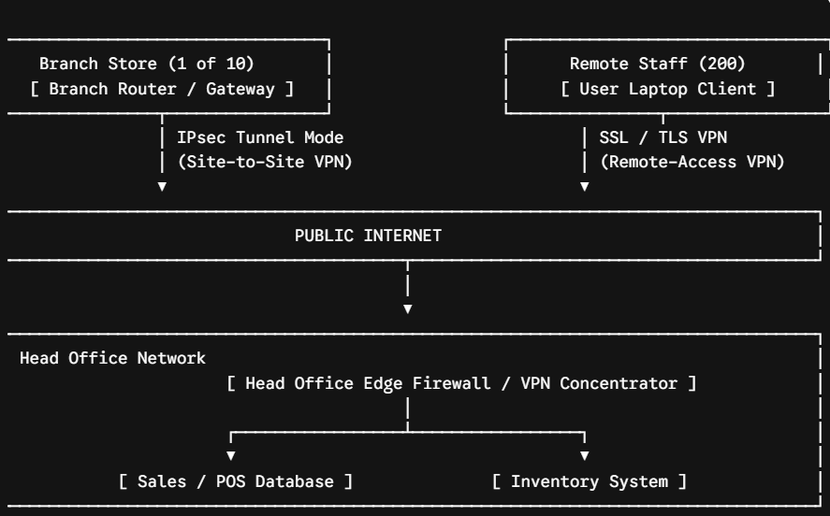
Architectural Justification
- Branch Stores (Site-to-Site IPsec Tunnel Mode): POS terminals in retail branches need transparent, automated, persistent, high-throughput connections to central head office servers. Hardware-based IPsec tunnel mode handles transparent network-to-network traffic efficiently without user intervention.
- Remote Staff (SSL/TLS Remote-Access VPN): Mobile staff work from diverse home/public networks. SSL/TLS client VPNs seamlessly traverse unknown NAT routers on port 443 and allow host-posture validation before granting access to internal resources.
3. Application Security Protocols & Operational Considerations
- Role of TLS & SSH:
  - TLS (Transport Layer Security): Encrypts web and application data in transit (HTTPS, secure API calls) to ensure data confidentiality and server identity validation.
  - SSH (Secure Shell): Provides cryptographically encrypted remote terminal management, secure file transfers (SFTP), and administrative access over TCP port 22.
Security & Operational Challenges
- Multi-Factor Authentication (MFA): Mandatory for all remote-access VPN endpoints to prevent unauthorized access stemming from stolen user credentials.
- Key and Certificate Management: Centralized Public Key Infrastructure (PKI) must manage automated certificate issuance, renewal, and validation (via CRL/OCSP) for all VPN endpoints and SSH keys.
- Compromised Un-managed Home Devices: Remote devices connected via VPN can act as a bridge for malware to traverse into the corporate network.
  - Mitigation: Implement strict Full Tunnelling, enforce mandatory Endpoint Detection & Response (EDR) agents, and perform pre-connection host posture checks (verifying OS patch level, active firewall, and antivirus status) prior to authorizing network tunnel establishment.

Question 4: Flat Network Analysis, Segmentation Architecture, and Design Principles

1. Network Segmentation Concepts
- VLAN (Virtual Local Area Network): Logically partitions a single physical Layer 2 switch into multiple distinct broadcast domains to isolate network traffic.
- Subnetting: Logically divides a Layer 3 IP network into smaller network segments, establishing routing boundaries between departments or host types.
- Internal Firewalls & Access Control Lists (ACLs): Enforce stateful traffic filtering rules between VLANs/subnets to restrict inter-segment communication.
- Micro-segmentation: Deep-level network security policy enforcement down to individual workload, container, or virtual machine levels, preventing lateral movement even within the same subnet.
2. Zone-Based Secure Network Architecture
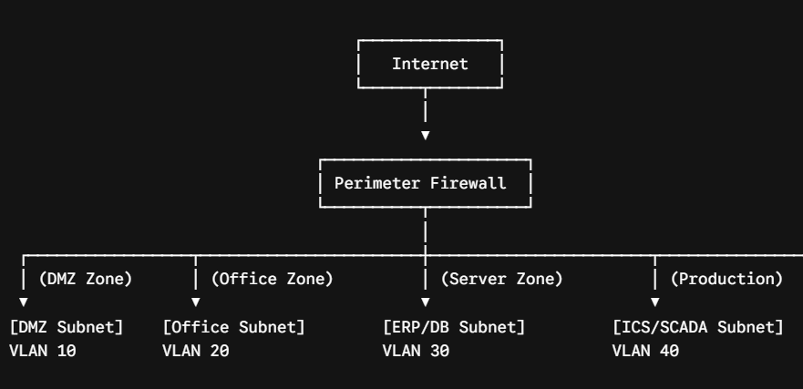
Zone Traffic Access Matrix
Source Zone | Destination Zone | Allowed Protocol / Port | Business Justification / Security Reason
Internet | DMZ Zone | TCP 80, 443 | Public users accessing external-facing web services.
Office Zone | DMZ Zone | TCP 443, 22 | Office users updating web content and accessing public services.
Office Zone | Server Zone | TCP 443 (HTTPS), TCP 1433 (SQL) | Office staff accessing ERP business application and database services.
Jump Host (DMZ/Mgmt) | Production Zone | TCP 22 (SSH), TCP 3389 (RDP) | Controlled Admin Access: Strictly managed administrative access to SCADA/ICS controls.
Camera Zone | Server Zone (NVR) | UDP 554 (RTSP), TCP 80 | CCTV cameras sending video streams exclusively to Network Video Recorder server.
Guest Wi-Fi Zone | Internet | TCP 80, 443, UDP 53 | Visitor internet browsing isolated entirely from internal corporate networks.
Any Zone | Production Zone | DENY ALL (Except Jump Host) | Air-gap isolation: Prevents ransomware on office laptops from reaching critical manufacturing controls.
3. Secure Administrative Access (Production Jump Host Protocol)
To reach systems in the Production Zone (VLAN 40), system administrators must follow a strict out-of-band management pathway:
[ Admin Laptop ] ──(1. MFA + SSH/RDP)──► [ Hardened Jump Host (VLAN 99) ] ──(2. Audited Session)──► [ Production ICS ]
- Admin authenticates to a dedicated, hardened Jump Host residing in a isolated Management VLAN.
- Authentication requires hardware-based Multi-Factor Authentication (MFA) and identity verification.
- The Jump Host enforces Privileged Access Management (PAM), logging, video-recording, and auditing all active administrative terminal sessions.
- Direct IP routing from the Office Zone or Guest Zone to the Production Zone is explicitly blocked at the internal firewall.
4. Principles of Secure Architecture Design & Trade-Offs
- Least Privilege: Systems and network entities are granted only the minimum access permissions necessary to perform their explicit function.
- Simplicity (Economy of Mechanism): Keep network architecture and security policies as simple and structured as possible to reduce misconfigurations.
- Fail-Safe Defaults: Access control decisions default to DENY unless explicitly permitted. If a device or firewall fails, it should fail in a secure closed state.
- Redundancy: Eliminate single points of failure by implementing redundant internal firewalls, high-availability switch links, and dual power paths.
- Separation of Duties: Divide critical operational processes across multiple roles (e.g., policy creation vs. policy approval) to prevent insider abuse.
Costs and Limitations of Network Segmentation
- Operational Complexity: Requires managing multiple VLANs, complex firewall rule sets, and internal routing tables.
- Performance Overhead: Internal stateful firewalls inspecting high-volume inter-VLAN traffic can introduce network throughput bottlenecks.
- Financial Cost: Increased hardware requirements (managed Layer 3 switches, internal next-generation firewalls, dedicated PAM software).

Question 5: Zero Trust Architecture, Defense in Depth, and Migration Roadmap

1. Core Principles of Zero Trust Architecture (ZTA)
- Never Trust, Always Verify: No user, device, or network location (whether inside or outside the physical corporate perimeter) is implicitly trusted. Every access request must be explicitly authenticated, authorized, and encrypted before access is granted.
- Enforce Least Privilege Access: Minimize user access rights using dynamic, contextual explicit permissions (Just-In-Time and Just-Enough Access).
- Assume Breach: Design networks assuming that attackers already exist inside the perimeter. Minimize blast radiuses by micro-segmenting networks, encrypting internal traffic, and continuously monitoring end-to-end sessions.
Key Architectural Components
[ Policy Engine (PDP) ]
│
▼
[ User + Device ] ──(Access Request)──► [ Policy Enforcement Point (PEP) ] ──►
[ Secure Resource ]
- Identity Provider (IdP): Centralized directory service (e.g., Entra ID, Okta) that authenticates user identity and issues secure tokens.
- Multi-Factor Authentication (MFA): Enforces strong authentication factors (FIDO2 keys, push notifications) to validate identity.
- Device Posture Checks: Endpoint management agents (EDR/MDM) evaluate host compliance (OS version, patch level, storage encryption status) prior to authorizing access.
- Policy Decision Point (PDP): The central engine that evaluates context rules (user, device health, location, time, resource sensitivity) and determines whether to grant access.
- Policy Enforcement Point (PEP): The gateway device (NGFW, API Gateway, Zero Trust Network Access broker) that actively enforces decisions made by the PDP.
- Micro-segmentation: Enforces granular isolated perimeters around individual cloud workloads and workloads.
- Continuous Monitoring: Audits user and entity behavior (UEBA) continuously during active sessions to detect anomalous activity.
2. Defense in Depth Framework & Control Mapping
Security Layer | Description | Applied Control for Financial Firm
1. Physical | Physical safeguards protecting IT infrastructure. | Biometric access control and CCTV monitoring at data center ingress points.
2. Perimeter | Edge defenses separating internal network from Internet. | Next-Generation Edge Firewall (NGFW) with integrated DDoS mitigation.
3. Network | Internal segment controls and routing boundaries. | Micro-segmentation of cloud VPCs and internal application VLANs.
4. Host | Endpoint security controls. | Endpoint Detection and Response (EDR) with real-time process monitoring.
5. Application | Code, API, and web interface security. | Web Application Firewall (WAF) inspecting application traffic for OWASP Top 10 vulnerabilities.
6. Data | Protection of stored and moving information assets. | AES-256 encryption at rest for customer databases and TLS 1.3 in transit.
7. People | Human operational security and awareness. | Mandatory anti-phishing training and role-based privilege access reviews.
8. Policy | Organizational governance and rules. | Formal Zero Trust Security Policy and mandatory incident response plans.
3. Zero Trust vs. Traditional Perimeter Model
- Traditional Perimeter Model ("Castle-and-Moat"): Relies on a hard external boundary (firewalls/VPNs). Once an user or device passes through the perimeter, everything inside the internal network is implicitly trusted.
  - Flaw: As seen in the firm's breach, stolen credentials allow an attacker to bypass the moat and move laterally across all internal assets unimpeded.
- Zero Trust Model: Removes implicit trust entirely. Perimeter checks are replaced with micro-perimeters around every individual resource.
- Complementary Relationship: Zero Trust does not make perimeter firewalls obsolete; instead, perimeter firewalls serve as the primary macro-level defense filter, while Zero Trust controls govern granular internal micro-level access.
4. Phased Implementation Roadmap & Adoption Challenges
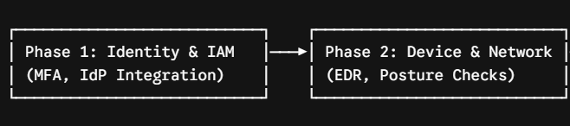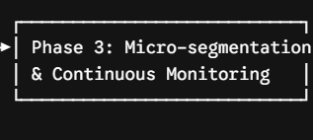
Phase 1: Identity Consolidation & Strong Authentication (Months 1–4)
- Deploy centralized Identity Provider (IdP) and mandate Phishing-Resistant MFA across all SaaS applications and VPNs.
- Establish complete asset inventory and data classification profiles.
Phase 2: Device Posture Enrolment & ZTNA Deployment (Months 5–8)
- Deploy EDR agents across all corporate endpoints.
- Replace legacy Remote-Access VPNs with Zero Trust Network Access (ZTNA) solutions enforcing device health posture checks.
Phase 3: Micro-segmentation & Continuous Analytics (Months 9–12)
- Implement granular micro-segmentation across cloud workloads and internal subnets.
- Integrate PDP/PEP systems with SIEM and UEBA for real-time automated access revocation during suspicious behavior.
Expected Implementation Challenges
- Legacy Applications: Older legacy internal applications may not support modern authentication protocols (SAML/OIDC), requiring wrapper proxies or custom middleware.
- User Resistance: Staff may push back against strict device health checks, mandatory MFA prompts, and restricted administrative privileges.
- High Financial & Migration Costs: Transitioning to Zero Trust infrastructure requires investment in modern IAM, ZTNA, and EDR tooling alongside extensive engineering overhead.

